Practical - 8
Practical Title: MySQL Schema Design, ER Model, PDO Connectivity, and Prepared Statements

Problem Definition: Design the database for StudentHub with students, events and registrations. Create PHP database connection using MySQL PDO statements.

Theory

1. Is the schema normalized properly?
Answer: Yes, the schema is normalized up to 3NF by decomposing data into independent entities: students, events, and a junction table registrations that resolves many-to-many relationships without data redundancy.
Source: https://dev.mysql.com/doc/refman/8.0/en/normalization.html

2. Are primary keys and foreign keys correctly defined?
Answer: Yes, each table has an auto-increment integer primary key (id). The registrations table enforces relational integrity with student_id and event_id referencing their parent tables with ON DELETE CASCADE constraints.
Source: https://dev.mysql.com/doc/refman/8.0/en/create-table-foreign-keys.html

3. Is the database connection handled securely?
Answer: Yes, the connection uses PHP Data Objects (PDO) with prepared statements, error mode configured to ERRMODE_EXCEPTION, and credentials isolated from presentation code.
Source: https://www.php.net/manual/en/book.pdo.php

Implementation

I designed the normalized MySQL schema studenthub.sql, established a secure connection in db.php using PHP PDO with exception handling, implemented parameterized registrations in insert_student.php, and created students_event.php using SQL INNER JOINs.

Evidence of Work (Screenshots)
Figure 8.1: Database Connection Test & Schema Setup
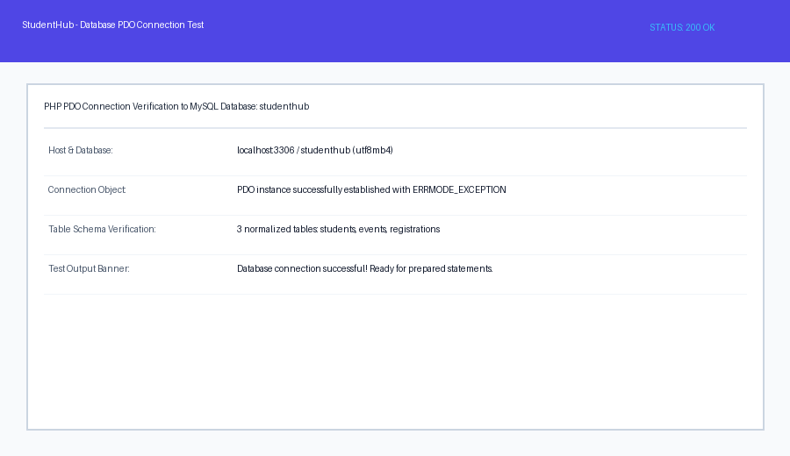
Description: Verification script test_connection.php confirming PDO connection and database selection.
Figure 8.2: Relational Table JOIN Output
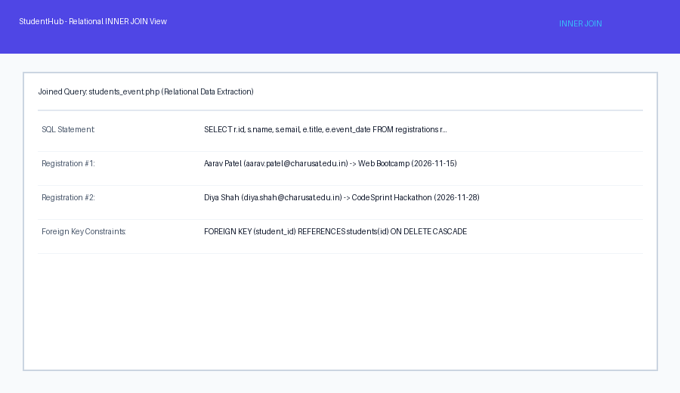

Description: Output of students_event.php displaying combined data from students, events, and registrations tables.

GitHub Repository Link: https://github.com/AmateurCoder9/Student-Hub-Portal/tree/main/Practical-8

Challenges Faced:

Foreign key constraint violations occurred when inserting registrations for non-existent student IDs. I solved this by catching PDOException with error code 23000 and displaying a clear user-friendly warning.

Learning Outcomes:

I learned how to design normalized relational database schemas in MySQL, establish secure PDO connections in PHP, and query joined tables using foreign keys.

Faculty Remarks: (Keep this blank for faculty)

