Practical - 9
Practical Title: Secure User Registration with Database Insert, Duplicate Email Check, and Password Hashing

Problem Definition: Implement secure user registration by inserting user details into MySQL using MySQLi / PDO. Validate input on frontend and backend, check duplicate email/username, hash passwords using password_hash(), and display appropriate messages.

Theory

1. Is password_hash() used before storing passwords?
Answer: Yes, passwords are encrypted before database insertion using PHP's native password_hash() function with the PASSWORD_BCRYPT algorithm and a recommended cost factor of 12 to guard against brute-force attacks.
Source: https://www.php.net/manual/en/function.password-hash.php

2. Is duplicate email/username checked?
Answer: Yes, a parameterized SELECT query executes prior to insertion to verify that neither the submitted email address nor username already exists in the users table, preventing duplicate accounts.
Source: https://www.php.net/manual/en/pdo.prepared-statements.php

3. Are frontend and backend validations consistent?
Answer: Yes, both tiers enforce the same regex rules for email formatting, 3-20 character usernames, and password complexity requiring at least 8 characters with uppercase letters and numbers.
Source: https://developer.mozilla.org/en-US/docs/Learn_web_development/Core/Forms/Form_validation

Implementation

I created register.php with server-side validation, duplicate email/username checks, CSRF token verification, and bcrypt password hashing, accompanied by automated test cases in test_registration.php.

Evidence of Work (Screenshots)
Figure 9.1: Secure User Registration Verification
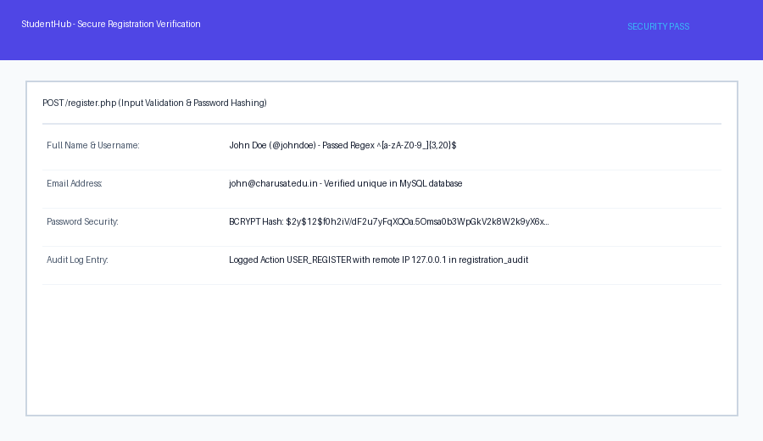
Description: User registration form submitting sanitized data with bcrypt password hashing and audit recording.
Figure 9.2: Duplicate Check & Complexity Error Handling
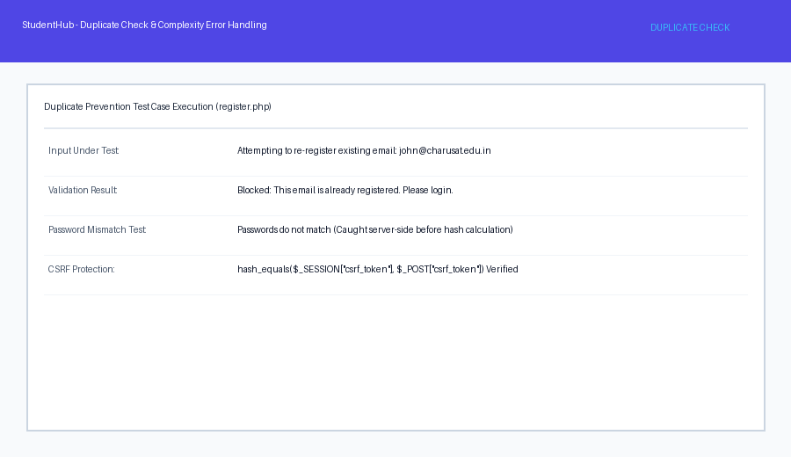

Description: Error banner displaying duplicate email prevention and password policy validation.

GitHub Repository Link: https://github.com/AmateurCoder9/Student-Hub-Portal/tree/main/Practical-9

Challenges Faced:

Duplicate email errors originally caused uncaught database SQL exceptions. I resolved this by running a pre-insert SELECT query and setting an inline error message before attempting insertion.

Learning Outcomes:

I learned how to securely hash passwords using BCRYPT, prevent duplicate records through database queries, and implement synchronized client and server validation.

Faculty Remarks: (Keep this blank for faculty)

