Android Mobile Application Development
Java Practical File | Code and Expected Output Only
Use each experiment in a separate Android Studio Empty Views Activity project. Replace com.example.mobilepracticals with your project package name. XML files belong in res/layout unless otherwise indicated.
Screenshot note: These Android Studio-style images are illustrative mockups, not genuine captures from a live Android Studio installation. Replace them with your own screenshots if your instructor requires actual execution evidence.

Practical 1: Creating a Hello World Application
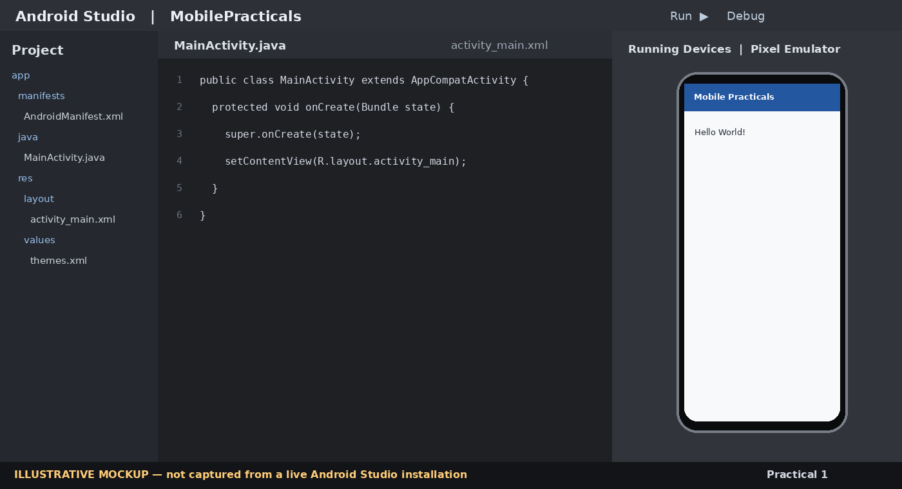
Figure 1: Illustrative Android Studio editor and emulator view for Practical 1.

Code

MainActivity.java
package com.example.mobilepracticals;

import android.os.Bundle;
import androidx.appcompat.app.AppCompatActivity;

public class MainActivity extends AppCompatActivity {
@Override
protected void onCreate(Bundle savedInstanceState) {
super.onCreate(savedInstanceState);
setContentView(R.layout.activity_main);
}
}

res/layout/activity_main.xml
<?xml version="1.0" encoding="utf-8"?>
<androidx.constraintlayout.widget.ConstraintLayout
xmlns:android="http://schemas.android.com/apk/res/android"
xmlns:app="http://schemas.android.com/apk/res-auto"
android:layout_width="match_parent"
android:layout_height="match_parent">

<TextView
android:id="@+id/helloText"
android:layout_width="wrap_content"
android:layout_height="wrap_content"
android:text="Hello World!"
android:textSize="28sp"
android:textStyle="bold"
app:layout_constraintTop_toTopOf="parent"
app:layout_constraintBottom_toBottomOf="parent"
app:layout_constraintStart_toStartOf="parent"
app:layout_constraintEnd_toEndOf="parent" />
</androidx.constraintlayout.widget.ConstraintLayout>

Expected Output
The app opens and displays “Hello World!” in the centre of the screen.

Practical 2: Implementing the Concept of Intent
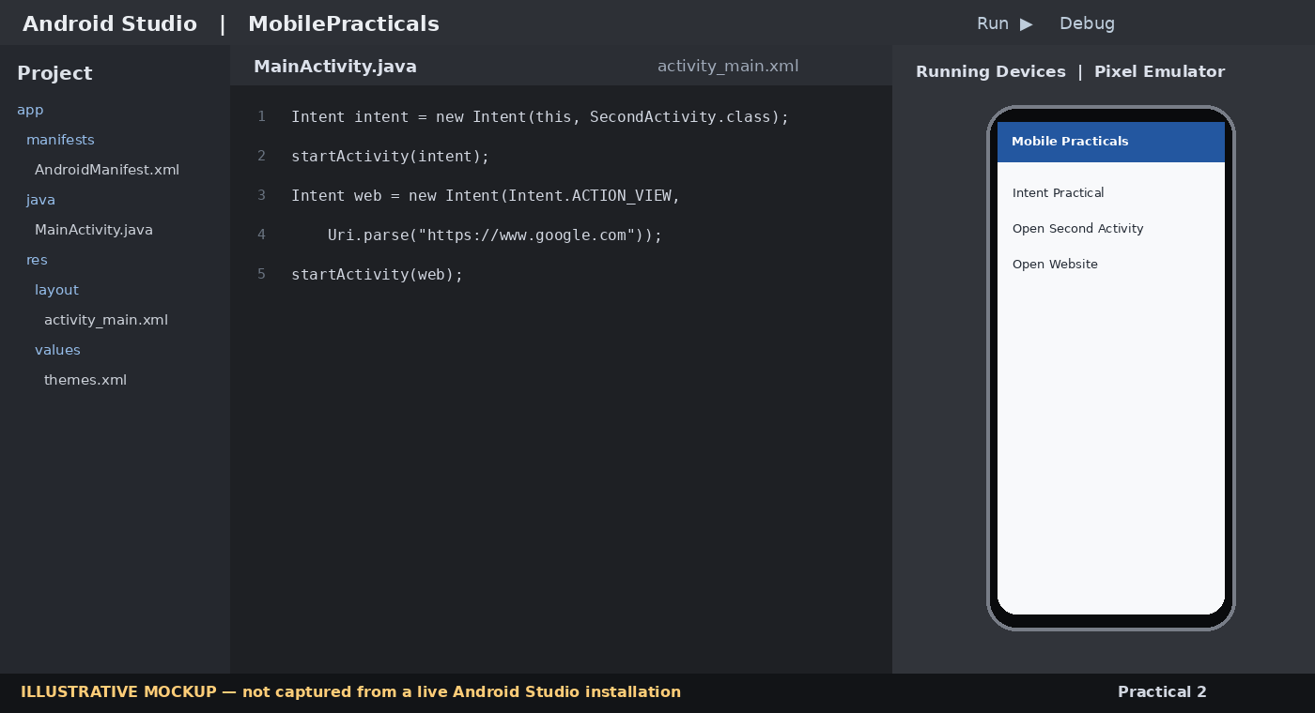
Figure 2: Illustrative Android Studio editor and emulator view for Practical 2.

Code

MainActivity.java
package com.example.mobilepracticals;

import android.content.Intent;
import android.net.Uri;
import android.os.Bundle;
import android.widget.Button;
import androidx.appcompat.app.AppCompatActivity;

public class MainActivity extends AppCompatActivity {
@Override
protected void onCreate(Bundle savedInstanceState) {
super.onCreate(savedInstanceState);
setContentView(R.layout.activity_main);

Button next = findViewById(R.id.btnNext);
Button web = findViewById(R.id.btnWeb);

next.setOnClickListener(v ->
startActivity(new Intent(MainActivity.this, SecondActivity.class)));

web.setOnClickListener(v -> {
Intent intent = new Intent(Intent.ACTION_VIEW,
Uri.parse("https://www.google.com"));
startActivity(intent);
});
}
}

SecondActivity.java
package com.example.mobilepracticals;

import android.os.Bundle;
import androidx.appcompat.app.AppCompatActivity;

public class SecondActivity extends AppCompatActivity {
@Override
protected void onCreate(Bundle savedInstanceState) {
super.onCreate(savedInstanceState);
setContentView(R.layout.activity_second);
}
}

res/layout/activity_main.xml
<?xml version="1.0" encoding="utf-8"?>
<LinearLayout xmlns:android="http://schemas.android.com/apk/res/android"
android:orientation="vertical" android:padding="24dp"
android:gravity="center" android:layout_width="match_parent"
android:layout_height="match_parent">
<Button android:id="@+id/btnNext" android:text="Open Second Activity"
android:layout_width="match_parent" android:layout_height="wrap_content"/>
<Button android:id="@+id/btnWeb" android:text="Open Website"
android:layout_width="match_parent" android:layout_height="wrap_content"/>
</LinearLayout>

res/layout/activity_second.xml
<?xml version="1.0" encoding="utf-8"?>
<LinearLayout xmlns:android="http://schemas.android.com/apk/res/android"
android:gravity="center" android:orientation="vertical"
android:layout_width="match_parent" android:layout_height="match_parent">
<TextView android:text="Welcome to Second Activity"
android:textSize="24sp" android:layout_width="wrap_content"
android:layout_height="wrap_content"/>
</LinearLayout>

AndroidManifest.xml – register the second Activity inside <application>
<activity android:name=".SecondActivity" android:exported="false" />

Expected Output
The first button opens the second screen. The second button opens a browser for the specified web address.

Practical 3: Displaying a Message Based on Screen Orientation
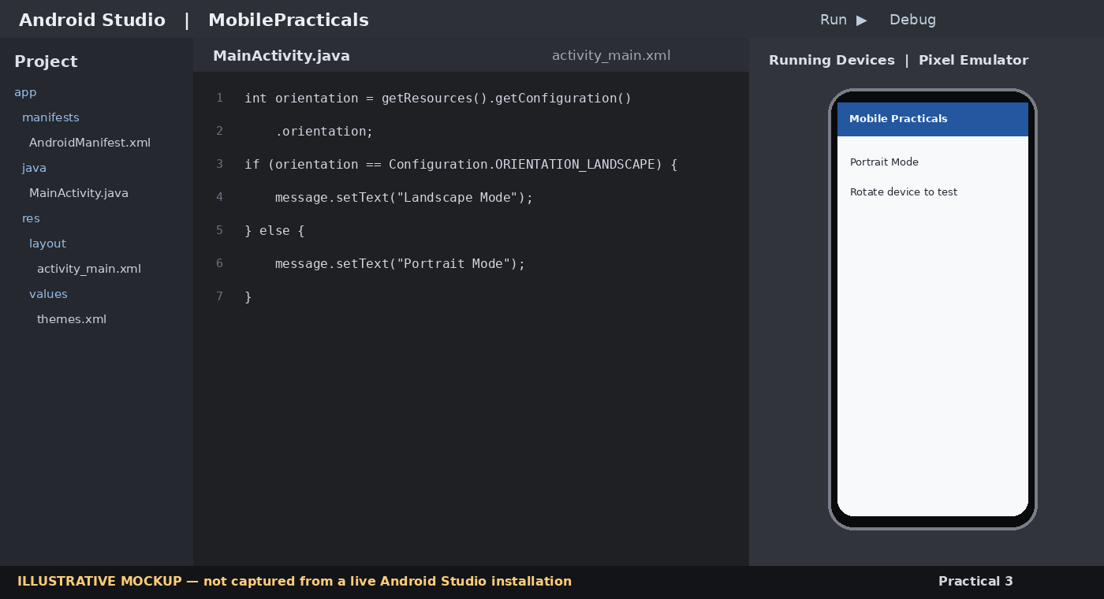
Figure 3: Illustrative Android Studio editor and emulator view for Practical 3.

Code

MainActivity.java
package com.example.mobilepracticals;

import android.content.res.Configuration;
import android.os.Bundle;
import android.widget.TextView;
import androidx.appcompat.app.AppCompatActivity;

public class MainActivity extends AppCompatActivity {
@Override
protected void onCreate(Bundle savedInstanceState) {
super.onCreate(savedInstanceState);
setContentView(R.layout.activity_main);
showOrientationMessage();
}

private void showOrientationMessage() {
TextView message = findViewById(R.id.txtOrientation);
int orientation = getResources().getConfiguration().orientation;

if (orientation == Configuration.ORIENTATION_LANDSCAPE) {
message.setText("Landscape Mode");
} else {
message.setText("Portrait Mode");
}
}
}

res/layout/activity_main.xml
<?xml version="1.0" encoding="utf-8"?>
<LinearLayout xmlns:android="http://schemas.android.com/apk/res/android"
android:gravity="center" android:orientation="vertical"
android:layout_width="match_parent" android:layout_height="match_parent">
<TextView android:id="@+id/txtOrientation"
android:text="Checking orientation..." android:textSize="26sp"
android:layout_width="wrap_content" android:layout_height="wrap_content"/>
</LinearLayout>

Expected Output
In portrait mode the message is “Portrait Mode”; in landscape mode it is “Landscape Mode”.

Practical 4: Developing an Application Using Picker View
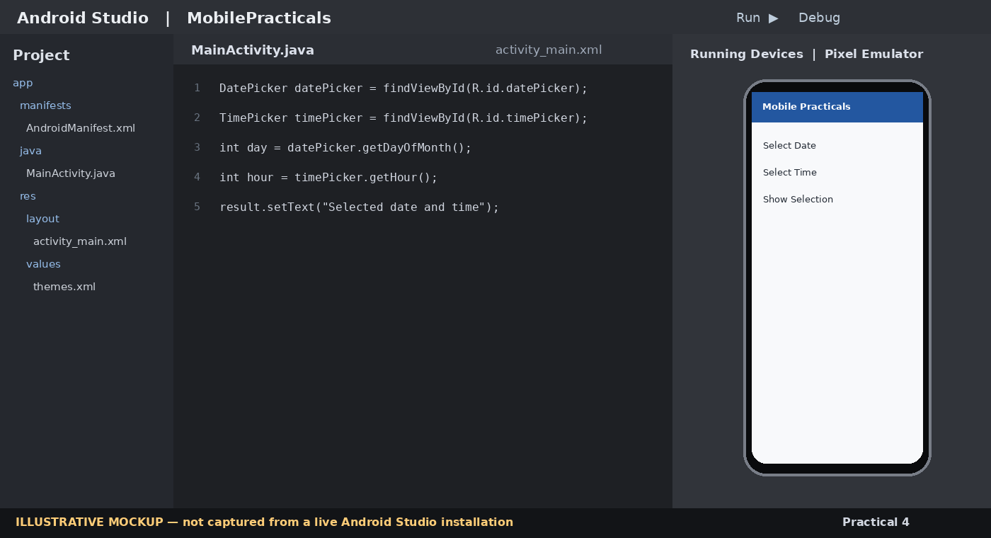
Figure 4: Illustrative Android Studio editor and emulator view for Practical 4.

Code

MainActivity.java
package com.example.mobilepracticals;

import android.os.Bundle;
import android.widget.Button;
import android.widget.DatePicker;
import android.widget.TimePicker;
import android.widget.TextView;
import androidx.appcompat.app.AppCompatActivity;

public class MainActivity extends AppCompatActivity {
@Override
protected void onCreate(Bundle savedInstanceState) {
super.onCreate(savedInstanceState);
setContentView(R.layout.activity_main);

DatePicker datePicker = findViewById(R.id.datePicker);
TimePicker timePicker = findViewById(R.id.timePicker);
TextView result = findViewById(R.id.txtResult);
Button show = findViewById(R.id.btnShow);

show.setOnClickListener(v -> {
int day = datePicker.getDayOfMonth();
int month = datePicker.getMonth() + 1;
int year = datePicker.getYear();
int hour = timePicker.getHour();
int minute = timePicker.getMinute();

result.setText(String.format(
"Date: %02d/%02d/%04d\nTime: %02d:%02d",
day, month, year, hour, minute));
});
}
}

res/layout/activity_main.xml
<?xml version="1.0" encoding="utf-8"?>
<ScrollView xmlns:android="http://schemas.android.com/apk/res/android"
android:layout_width="match_parent" android:layout_height="match_parent">
<LinearLayout android:orientation="vertical" android:padding="16dp"
android:gravity="center_horizontal"
android:layout_width="match_parent" android:layout_height="wrap_content">
<DatePicker android:id="@+id/datePicker"
android:calendarViewShown="true"
android:layout_width="wrap_content" android:layout_height="wrap_content"/>
<TimePicker android:id="@+id/timePicker" android:timePickerMode="spinner"
android:layout_width="wrap_content" android:layout_height="wrap_content"/>
<Button android:id="@+id/btnShow" android:text="Show Selection"
android:layout_width="wrap_content" android:layout_height="wrap_content"/>
<TextView android:id="@+id/txtResult" android:textSize="20sp"
android:padding="12dp" android:layout_width="wrap_content"
android:layout_height="wrap_content"/>
</LinearLayout>
</ScrollView>

Expected Output
The selected date and time are displayed below the picker controls.

Practical 5: Developing an Application Using ListView
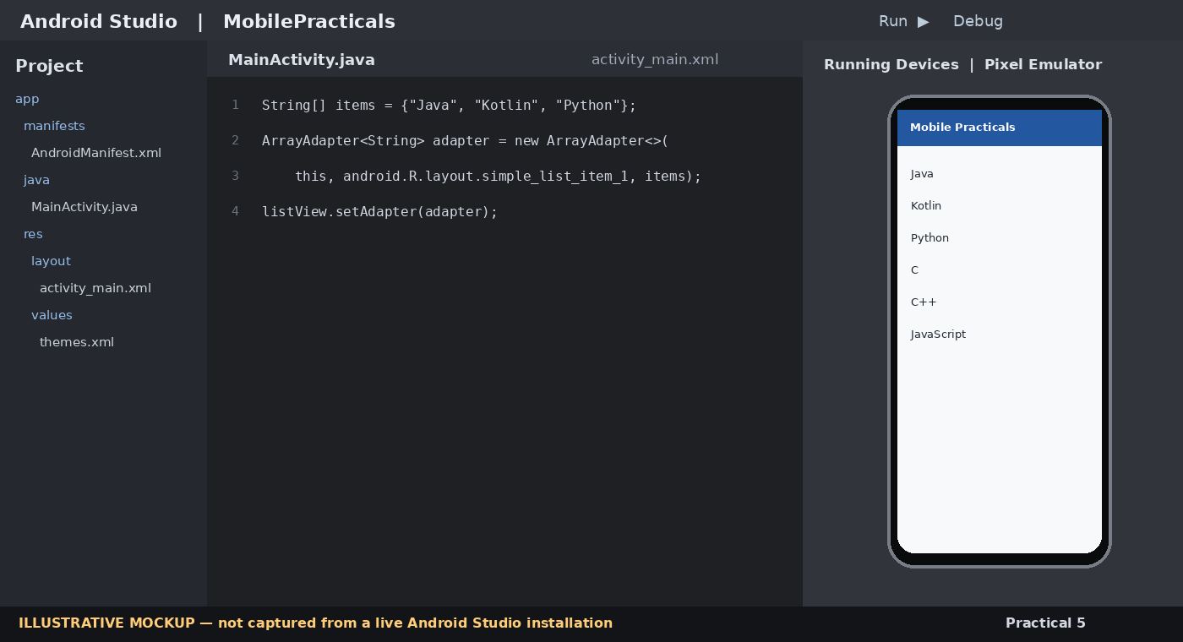
Figure 5: Illustrative Android Studio editor and emulator view for Practical 5.

Code

MainActivity.java
package com.example.mobilepracticals;

import android.os.Bundle;
import android.widget.ArrayAdapter;
import android.widget.ListView;
import android.widget.Toast;
import androidx.appcompat.app.AppCompatActivity;

public class MainActivity extends AppCompatActivity {
@Override
protected void onCreate(Bundle savedInstanceState) {
super.onCreate(savedInstanceState);
setContentView(R.layout.activity_main);

String[] languages = {"Java", "Kotlin", "Python", "C", "C++", "JavaScript"};
ListView listView = findViewById(R.id.listView);

ArrayAdapter<String> adapter = new ArrayAdapter<>(
this, android.R.layout.simple_list_item_1, languages);
listView.setAdapter(adapter);

listView.setOnItemClickListener((parent, view, position, id) ->
Toast.makeText(this, "Selected: " + languages[position],
Toast.LENGTH_SHORT).show());
}
}

res/layout/activity_main.xml
<?xml version="1.0" encoding="utf-8"?>
<LinearLayout xmlns:android="http://schemas.android.com/apk/res/android"
android:padding="16dp" android:orientation="vertical"
android:layout_width="match_parent" android:layout_height="match_parent">
<TextView android:text="Programming Languages" android:textSize="22sp"
android:textStyle="bold" android:layout_width="wrap_content"
android:layout_height="wrap_content"/>
<ListView android:id="@+id/listView"
android:layout_width="match_parent" android:layout_height="match_parent"/>
</LinearLayout>

Expected Output
A scrollable list of programming languages is displayed. Tapping an item shows its name in a Toast.

Practical 6: Applying a Theme in an Activity/Application
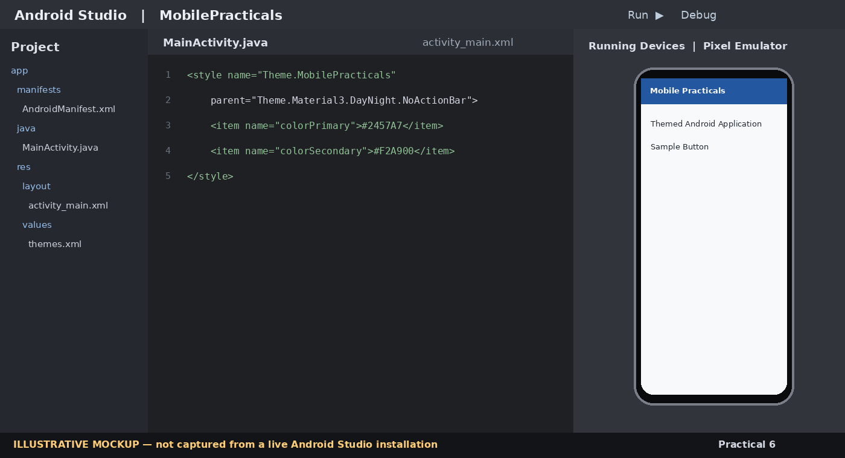
Figure 6: Illustrative Android Studio editor and emulator view for Practical 6.

Code

res/values/themes.xml – example (adapt parent to the theme already installed in your project)
<resources>
<style name="Theme.MobilePracticals" parent="Theme.Material3.DayNight.NoActionBar">
<item name="colorPrimary">#2457A7</item>
<item name="colorSecondary">#F2A900</item>
<item name="android:fontFamily">sans</item>
</style>
</resources>

AndroidManifest.xml – inside <application>
<application
android:theme="@style/Theme.MobilePracticals"
... >
</application>

res/layout/activity_main.xml
<?xml version="1.0" encoding="utf-8"?>
<LinearLayout xmlns:android="http://schemas.android.com/apk/res/android"
android:gravity="center" android:orientation="vertical"
android:background="#F3F6FA"
android:layout_width="match_parent" android:layout_height="match_parent">
<TextView android:text="Themed Android Application"
android:textColor="#2457A7" android:textStyle="bold"
android:textSize="24sp" android:layout_width="wrap_content"
android:layout_height="wrap_content"/>
<Button android:text="Sample Button"
android:layout_width="wrap_content" android:layout_height="wrap_content"/>
</LinearLayout>

Expected Output
The application opens using the selected theme and its configured colours.

Practical 7: Creating a Menu in an Android Application
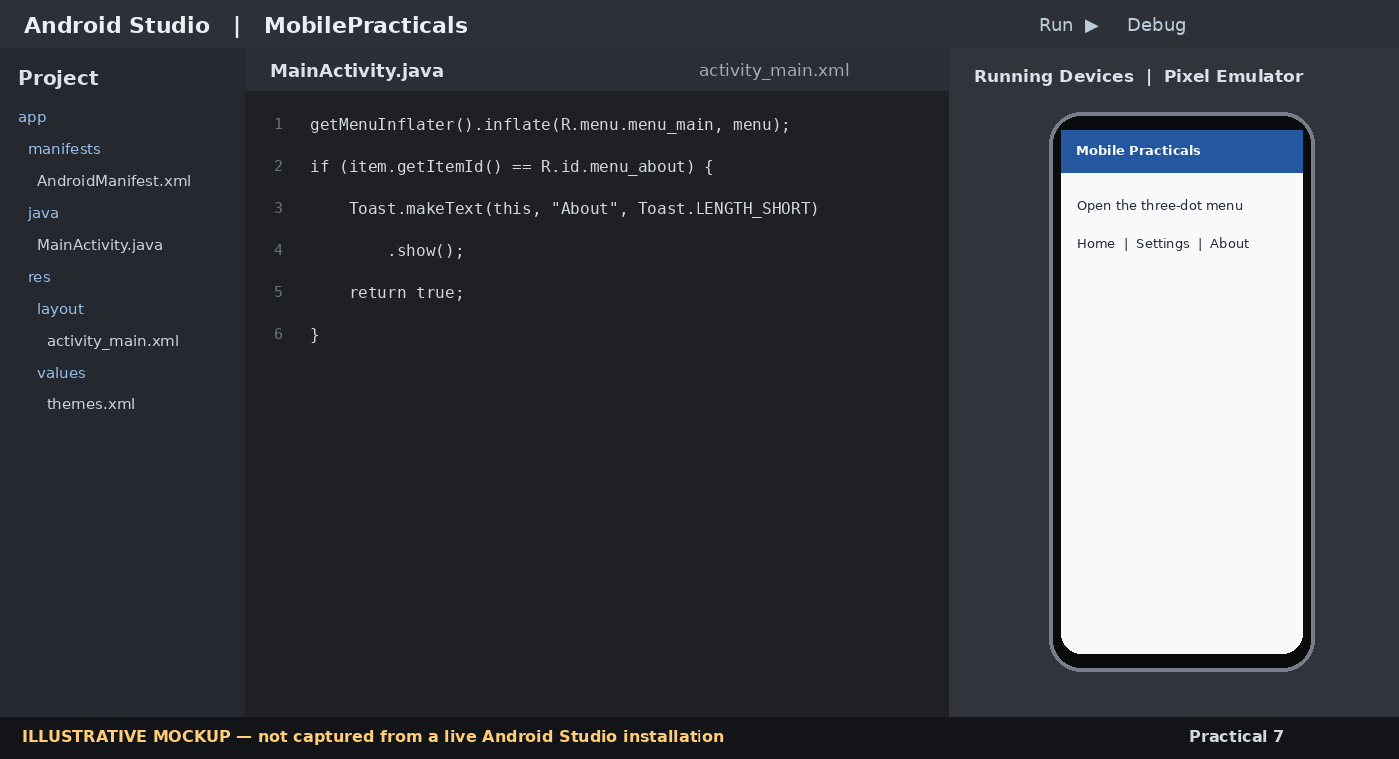
Figure 7: Illustrative Android Studio editor and emulator view for Practical 7.

Code

res/menu/menu_main.xml
<?xml version="1.0" encoding="utf-8"?>
<menu xmlns:android="http://schemas.android.com/apk/res/android">
<item android:id="@+id/menu_home" android:title="Home"
android:showAsAction="never"/>
<item android:id="@+id/menu_settings" android:title="Settings"
android:showAsAction="never"/>
<item android:id="@+id/menu_about" android:title="About"
android:showAsAction="never"/>
</menu>

MainActivity.java
package com.example.mobilepracticals;

import android.os.Bundle;
import android.view.Menu;
import android.view.MenuItem;
import android.widget.Toast;
import androidx.annotation.NonNull;
import androidx.appcompat.app.AppCompatActivity;

public class MainActivity extends AppCompatActivity {
@Override
protected void onCreate(Bundle savedInstanceState) {
super.onCreate(savedInstanceState);
setContentView(R.layout.activity_main);
}

@Override
public boolean onCreateOptionsMenu(Menu menu) {
getMenuInflater().inflate(R.menu.menu_main, menu);
return true;
}

@Override
public boolean onOptionsItemSelected(@NonNull MenuItem item) {
int id = item.getItemId();
if (id == R.id.menu_home) {
Toast.makeText(this, "Home selected", Toast.LENGTH_SHORT).show();
return true;
} else if (id == R.id.menu_settings) {
Toast.makeText(this, "Settings selected", Toast.LENGTH_SHORT).show();
return true;
} else if (id == R.id.menu_about) {
Toast.makeText(this, "Android Practical Application", Toast.LENGTH_SHORT).show();
return true;
}
return super.onOptionsItemSelected(item);
}
}

res/layout/activity_main.xml
<?xml version="1.0" encoding="utf-8"?>
<LinearLayout xmlns:android="http://schemas.android.com/apk/res/android"
android:gravity="center" android:orientation="vertical"
android:layout_width="match_parent" android:layout_height="match_parent">
<TextView android:text="Open the three-dot menu to view options"
android:textSize="18sp" android:layout_width="wrap_content"
android:layout_height="wrap_content"/>
</LinearLayout>

Expected Output
The app bar overflow menu displays Home, Settings and About. Selecting an item displays a Toast.

Practical 8: Storing Local Data Using User Preferences
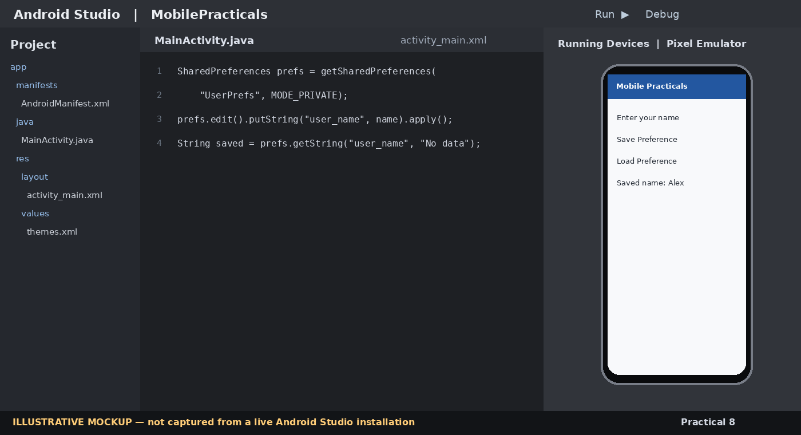
Figure 8: Illustrative Android Studio editor and emulator view for Practical 8.

Code

MainActivity.java
package com.example.mobilepracticals;

import android.content.SharedPreferences;
import android.os.Bundle;
import android.widget.Button;
import android.widget.EditText;
import android.widget.TextView;
import androidx.appcompat.app.AppCompatActivity;

public class MainActivity extends AppCompatActivity {
private static final String PREFS = "UserPrefs";
private static final String KEY_NAME = "user_name";

@Override
protected void onCreate(Bundle savedInstanceState) {
super.onCreate(savedInstanceState);
setContentView(R.layout.activity_main);

EditText nameInput = findViewById(R.id.editName);
TextView result = findViewById(R.id.txtResult);
Button save = findViewById(R.id.btnSave);
Button load = findViewById(R.id.btnLoad);

SharedPreferences preferences = getSharedPreferences(PREFS, MODE_PRIVATE);

save.setOnClickListener(v -> {
String name = nameInput.getText().toString().trim();
preferences.edit().putString(KEY_NAME, name).apply();
result.setText("Saved successfully");
});

load.setOnClickListener(v -> {
String savedName = preferences.getString(KEY_NAME, "No data saved");
result.setText("Saved name: " + savedName);
});
}
}

res/layout/activity_main.xml
<?xml version="1.0" encoding="utf-8"?>
<LinearLayout xmlns:android="http://schemas.android.com/apk/res/android"
android:orientation="vertical" android:padding="20dp"
android:layout_width="match_parent" android:layout_height="match_parent">
<EditText android:id="@+id/editName" android:hint="Enter your name"
android:inputType="textPersonName"
android:layout_width="match_parent" android:layout_height="wrap_content"/>
<Button android:id="@+id/btnSave" android:text="Save Preference"
android:layout_width="match_parent" android:layout_height="wrap_content"/>
<Button android:id="@+id/btnLoad" android:text="Load Preference"
android:layout_width="match_parent" android:layout_height="wrap_content"/>
<TextView android:id="@+id/txtResult" android:textSize="18sp"
android:padding="12dp" android:layout_width="match_parent"
android:layout_height="wrap_content"/>
</LinearLayout>

Expected Output
After saving a name, pressing Load displays the stored name even after restarting the app.

Practical 9: Creating, Reading and Writing Data Using SQLite
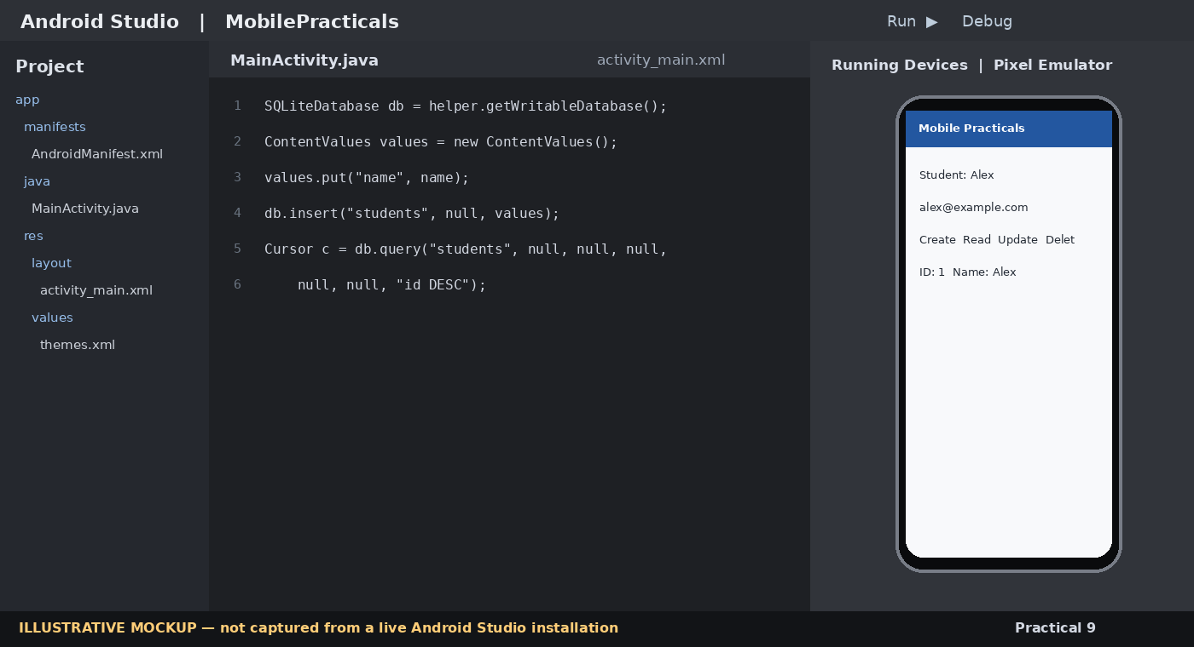
Figure 9: Illustrative Android Studio editor and emulator view for Practical 9.

Code

DatabaseHelper.java
package com.example.mobilepracticals;

import android.content.ContentValues;
import android.content.Context;
import android.database.Cursor;
import android.database.sqlite.SQLiteDatabase;
import android.database.sqlite.SQLiteOpenHelper;

public class DatabaseHelper extends SQLiteOpenHelper {
private static final String DB_NAME = "Students.db";
private static final int DB_VERSION = 1;
public static final String TABLE = "students";

public DatabaseHelper(Context context) {
super(context, DB_NAME, null, DB_VERSION);
}

@Override
public void onCreate(SQLiteDatabase db) {
db.execSQL("CREATE TABLE " + TABLE +
" (id INTEGER PRIMARY KEY AUTOINCREMENT, name TEXT NOT NULL, email TEXT)");
}

@Override
public void onUpgrade(SQLiteDatabase db, int oldVersion, int newVersion) {
db.execSQL("DROP TABLE IF EXISTS " + TABLE);
onCreate(db);
}

public long insertStudent(String name, String email) {
SQLiteDatabase db = getWritableDatabase();
ContentValues values = new ContentValues();
values.put("name", name);
values.put("email", email);
return db.insert(TABLE, null, values);
}

public Cursor getAllStudents() {
SQLiteDatabase db = getReadableDatabase();
return db.query(TABLE, null, null, null, null, null, "id DESC");
}

public int updateStudent(int id, String name, String email) {
ContentValues values = new ContentValues();
values.put("name", name);
values.put("email", email);
return getWritableDatabase().update(TABLE, values, "id=?",
new String[]{String.valueOf(id)});
}

public int deleteStudent(int id) {
return getWritableDatabase().delete(TABLE, "id=?",
new String[]{String.valueOf(id)});
}
}

MainActivity.java
package com.example.mobilepracticals;

import android.database.Cursor;
import android.os.Bundle;
import android.widget.Button;
import android.widget.EditText;
import android.widget.TextView;
import android.widget.Toast;
import androidx.appcompat.app.AppCompatActivity;

public class MainActivity extends AppCompatActivity {
private DatabaseHelper db;
private EditText idInput, nameInput, emailInput;
private TextView output;

@Override
protected void onCreate(Bundle savedInstanceState) {
super.onCreate(savedInstanceState);
setContentView(R.layout.activity_main);
db = new DatabaseHelper(this);

idInput = findViewById(R.id.editId);
nameInput = findViewById(R.id.editName);
emailInput = findViewById(R.id.editEmail);
output = findViewById(R.id.txtOutput);

findViewById(R.id.btnInsert).setOnClickListener(v -> {
long id = db.insertStudent(nameInput.getText().toString().trim(),
emailInput.getText().toString().trim());
Toast.makeText(this, id == -1 ? "Insert failed" : "Inserted. ID: " + id,
Toast.LENGTH_SHORT).show();
});

findViewById(R.id.btnRead).setOnClickListener(v -> readRecords());

findViewById(R.id.btnUpdate).setOnClickListener(v -> {
int id = readId();
if (id < 0) return;
int count = db.updateStudent(id, nameInput.getText().toString().trim(),
emailInput.getText().toString().trim());
Toast.makeText(this, count > 0 ? "Updated" : "ID not found",
Toast.LENGTH_SHORT).show();
});

findViewById(R.id.btnDelete).setOnClickListener(v -> {
int id = readId();
if (id < 0) return;
int count = db.deleteStudent(id);
Toast.makeText(this, count > 0 ? "Deleted" : "ID not found",
Toast.LENGTH_SHORT).show();
});
}

private int readId() {
try {
return Integer.parseInt(idInput.getText().toString().trim());
} catch (NumberFormatException e) {
Toast.makeText(this, "Enter a valid record ID", Toast.LENGTH_SHORT).show();
return -1;
}
}

private void readRecords() {
StringBuilder data = new StringBuilder();
try (Cursor cursor = db.getAllStudents()) {
while (cursor.moveToNext()) {
data.append("ID: ").append(cursor.getInt(cursor.getColumnIndexOrThrow("id")))
.append("\nName: ").append(cursor.getString(cursor.getColumnIndexOrThrow("name")))
.append("\nEmail: ").append(cursor.getString(cursor.getColumnIndexOrThrow("email")))
.append("\n\n");
}
}
output.setText(data.length() == 0 ? "No records found" : data.toString());
}

@Override
protected void onDestroy() {
db.close();
super.onDestroy();
}
}

res/layout/activity_main.xml
<?xml version="1.0" encoding="utf-8"?>
<ScrollView xmlns:android="http://schemas.android.com/apk/res/android"
android:layout_width="match_parent" android:layout_height="match_parent">
<LinearLayout android:orientation="vertical" android:padding="16dp"
android:layout_width="match_parent" android:layout_height="wrap_content">
<EditText android:id="@+id/editId" android:hint="Record ID (for update/delete)"
android:inputType="number" android:layout_width="match_parent"
android:layout_height="wrap_content"/>
<EditText android:id="@+id/editName" android:hint="Student name"
android:layout_width="match_parent" android:layout_height="wrap_content"/>
<EditText android:id="@+id/editEmail" android:hint="Email"
android:inputType="textEmailAddress" android:layout_width="match_parent"
android:layout_height="wrap_content"/>
<Button android:id="@+id/btnInsert" android:text="Create / Insert"
android:layout_width="match_parent" android:layout_height="wrap_content"/>
<Button android:id="@+id/btnRead" android:text="Read All"
android:layout_width="match_parent" android:layout_height="wrap_content"/>
<Button android:id="@+id/btnUpdate" android:text="Update by ID"
android:layout_width="match_parent" android:layout_height="wrap_content"/>
<Button android:id="@+id/btnDelete" android:text="Delete by ID"
android:layout_width="match_parent" android:layout_height="wrap_content"/>
<TextView android:id="@+id/txtOutput" android:textSize="16sp"
android:padding="8dp" android:layout_width="match_parent"
android:layout_height="wrap_content"/>
</LinearLayout>
</ScrollView>

Expected Output
Insert displays a saved-record message; Read displays stored records; Update changes the matching record; Delete removes it.

Practical 10: Creating an Application to Send SMS
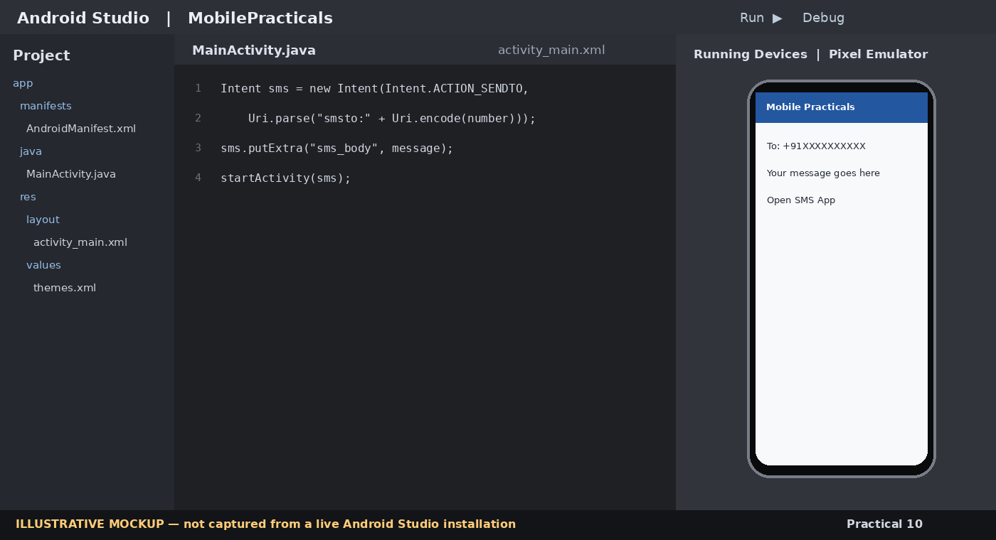
Figure 10: Illustrative Android Studio editor and emulator view for Practical 10.

Code

MainActivity.java
package com.example.mobilepracticals;

import android.content.ActivityNotFoundException;
import android.content.Intent;
import android.net.Uri;
import android.os.Bundle;
import android.widget.EditText;
import android.widget.Toast;
import androidx.appcompat.app.AppCompatActivity;

public class MainActivity extends AppCompatActivity {
@Override
protected void onCreate(Bundle savedInstanceState) {
super.onCreate(savedInstanceState);
setContentView(R.layout.activity_main);

EditText phone = findViewById(R.id.editPhone);
EditText message = findViewById(R.id.editMessage);

findViewById(R.id.btnSend).setOnClickListener(v -> {
String number = phone.getText().toString().trim();
String body = message.getText().toString().trim();

if (number.isEmpty() || body.isEmpty()) {
Toast.makeText(this, "Enter phone number and message",
Toast.LENGTH_SHORT).show();
return;
}

Intent intent = new Intent(Intent.ACTION_SENDTO,
Uri.parse("smsto:" + Uri.encode(number)));
intent.putExtra("sms_body", body);

try {
startActivity(intent);
} catch (ActivityNotFoundException e) {
Toast.makeText(this, "No messaging app found",
Toast.LENGTH_LONG).show();
}
});
}
}

res/layout/activity_main.xml
<?xml version="1.0" encoding="utf-8"?>
<LinearLayout xmlns:android="http://schemas.android.com/apk/res/android"
android:orientation="vertical" android:padding="20dp"
android:layout_width="match_parent" android:layout_height="match_parent">
<EditText android:id="@+id/editPhone" android:hint="Phone number"
android:inputType="phone" android:layout_width="match_parent"
android:layout_height="wrap_content"/>
<EditText android:id="@+id/editMessage" android:hint="Enter SMS message"
android:gravity="top" android:minLines="4"
android:inputType="textMultiLine" android:layout_width="match_parent"
android:layout_height="wrap_content"/>
<Button android:id="@+id/btnSend" android:text="Open SMS App"
android:layout_width="match_parent" android:layout_height="wrap_content"/>
</LinearLayout>

Expected Output
The default SMS app opens with the recipient number and message pre-filled. The user sends it manually.

Practical 11: Creating an Application to Send an E-mail
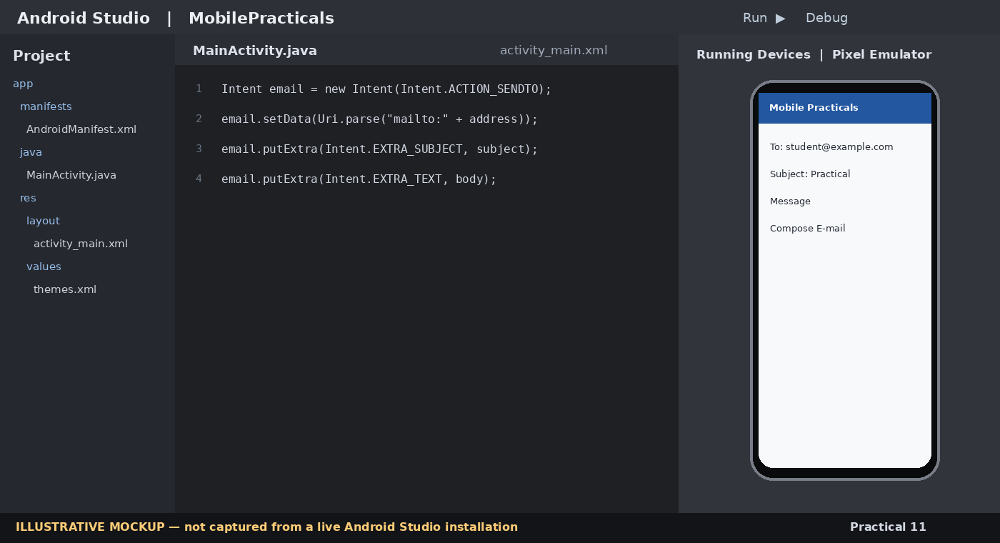
Figure 11: Illustrative Android Studio editor and emulator view for Practical 11.

Code

MainActivity.java
package com.example.mobilepracticals;

import android.content.Intent;
import android.net.Uri;
import android.os.Bundle;
import android.widget.EditText;
import android.widget.Toast;
import androidx.appcompat.app.AppCompatActivity;

public class MainActivity extends AppCompatActivity {
@Override
protected void onCreate(Bundle savedInstanceState) {
super.onCreate(savedInstanceState);
setContentView(R.layout.activity_main);

EditText to = findViewById(R.id.editTo);
EditText subject = findViewById(R.id.editSubject);
EditText body = findViewById(R.id.editBody);

findViewById(R.id.btnEmail).setOnClickListener(v -> {
String address = to.getText().toString().trim();
if (address.isEmpty()) {
Toast.makeText(this, "Enter recipient email",
Toast.LENGTH_SHORT).show();
return;
}

Intent intent = new Intent(Intent.ACTION_SENDTO);
intent.setData(Uri.parse("mailto:" + Uri.encode(address)));
intent.putExtra(Intent.EXTRA_SUBJECT, subject.getText().toString());
intent.putExtra(Intent.EXTRA_TEXT, body.getText().toString());

try {
startActivity(Intent.createChooser(intent, "Send email"));
} catch (Exception e) {
Toast.makeText(this, "No email application found",
Toast.LENGTH_LONG).show();
}
});
}
}

res/layout/activity_main.xml
<?xml version="1.0" encoding="utf-8"?>
<ScrollView xmlns:android="http://schemas.android.com/apk/res/android"
android:layout_width="match_parent" android:layout_height="match_parent">
<LinearLayout android:orientation="vertical" android:padding="20dp"
android:layout_width="match_parent" android:layout_height="wrap_content">
<EditText android:id="@+id/editTo" android:hint="Recipient email"
android:inputType="textEmailAddress" android:layout_width="match_parent"
android:layout_height="wrap_content"/>
<EditText android:id="@+id/editSubject" android:hint="Subject"
android:layout_width="match_parent" android:layout_height="wrap_content"/>
<EditText android:id="@+id/editBody" android:hint="Message"
android:minLines="5" android:gravity="top" android:inputType="textMultiLine"
android:layout_width="match_parent" android:layout_height="wrap_content"/>
<Button android:id="@+id/btnEmail" android:text="Compose E-mail"
android:layout_width="match_parent" android:layout_height="wrap_content"/>
</LinearLayout>
</ScrollView>

Expected Output
An email application opens with the recipient, subject and message pre-filled.

Practical 12: Displaying a Map Based on Current or Given Location
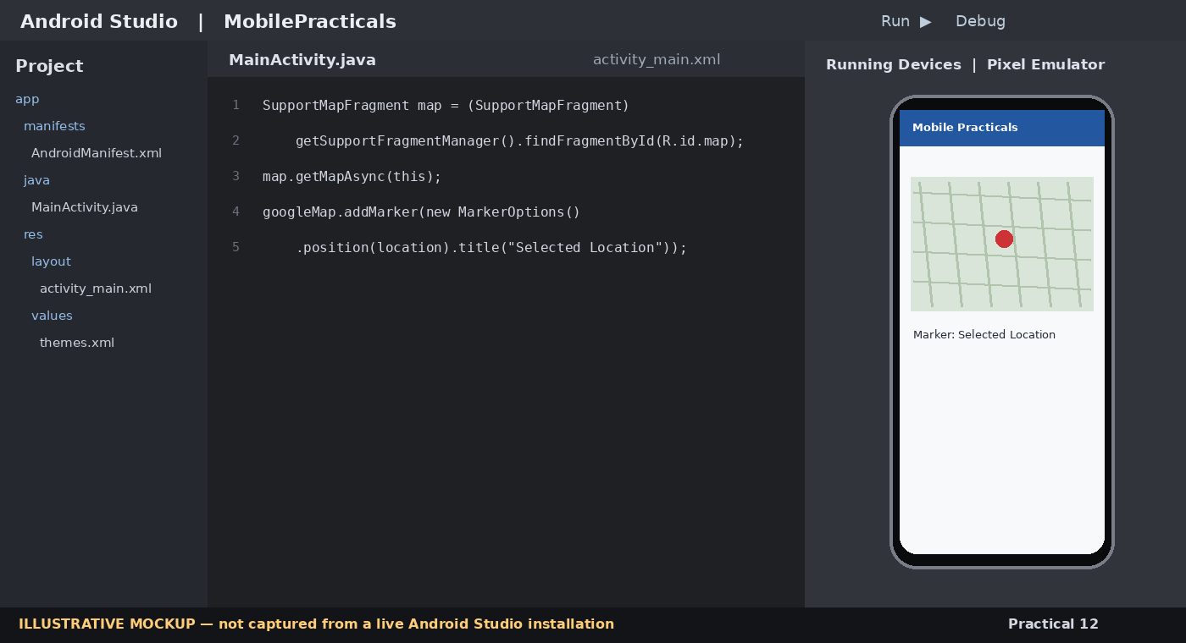
Figure 12: Illustrative Android Studio editor and emulator view for Practical 12.

Code

app/build.gradle – add dependency (use a current compatible version from Google's Maps documentation)
dependencies {
implementation 'com.google.android.gms:play-services-maps:19.2.0'
}

AndroidManifest.xml – permissions and API key metadata
<manifest xmlns:android="http://schemas.android.com/apk/res/android">
<uses-permission android:name="android.permission.INTERNET" />
<application ...>
<meta-data
android:name="com.google.android.geo.API_KEY"
android:value="YOUR_GOOGLE_MAPS_API_KEY" />
<activity android:name=".MapsActivity" android:exported="false" />
</application>
</manifest>

res/layout/activity_maps.xml
<?xml version="1.0" encoding="utf-8"?>
<fragment xmlns:android="http://schemas.android.com/apk/res/android"
android:id="@+id/map"
android:name="com.google.android.gms.maps.SupportMapFragment"
android:layout_width="match_parent"
android:layout_height="match_parent" />

MapsActivity.java
package com.example.mobilepracticals;

import android.os.Bundle;
import androidx.annotation.NonNull;
import androidx.fragment.app.FragmentActivity;
import com.google.android.gms.maps.CameraUpdateFactory;
import com.google.android.gms.maps.GoogleMap;
import com.google.android.gms.maps.OnMapReadyCallback;
import com.google.android.gms.maps.SupportMapFragment;
import com.google.android.gms.maps.model.LatLng;
import com.google.android.gms.maps.model.MarkerOptions;

public class MapsActivity extends FragmentActivity implements OnMapReadyCallback {
@Override
protected void onCreate(Bundle savedInstanceState) {
super.onCreate(savedInstanceState);
setContentView(R.layout.activity_maps);

SupportMapFragment mapFragment = (SupportMapFragment)
getSupportFragmentManager().findFragmentById(R.id.map);

if (mapFragment != null) {
mapFragment.getMapAsync(this);
}
}

@Override
public void onMapReady(@NonNull GoogleMap googleMap) {
// Example coordinates: Golden Temple, Amritsar
LatLng location = new LatLng(31.6200, 74.8765);
googleMap.addMarker(new MarkerOptions()
.position(location)
.title("Golden Temple, Amritsar"));
googleMap.moveCamera(CameraUpdateFactory.newLatLngZoom(location, 15f));
}
}

Expected Output
Google Maps opens centred on the selected coordinates and displays a marker with a title.

Practical 13: Deploying Android Applications
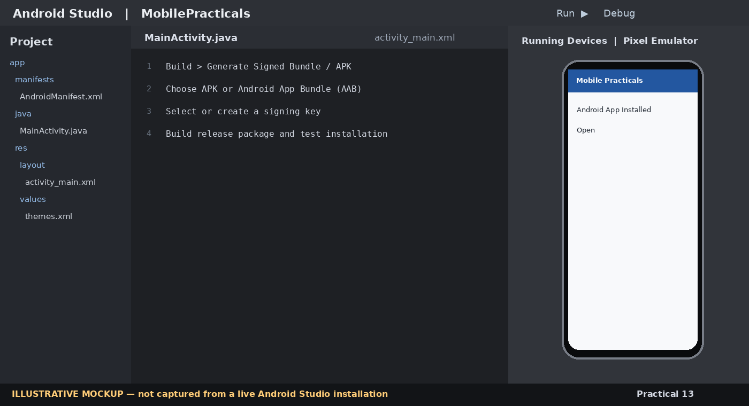
Figure 13: Illustrative Android Studio editor and emulator view for Practical 13.

Code

Optional: install a generated APK using Android Debug Bridge (ADB)
adb devices
adb install -r app-debug.apk

Expected Output
A debug APK or signed release package is generated. After installation, the app appears in the device app launcher.

