Vitoria City of Quebec

População: 240.000 530.000

Região: 1.950.000 800.00

# Crime Comparison Between [Vitoria](https://www.numbeo.com/crime/in/Vitoria) and [Quebec City](https://www.numbeo.com/crime/in/Quebec-City)

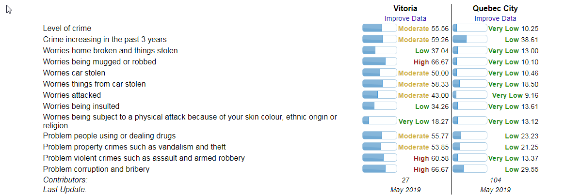

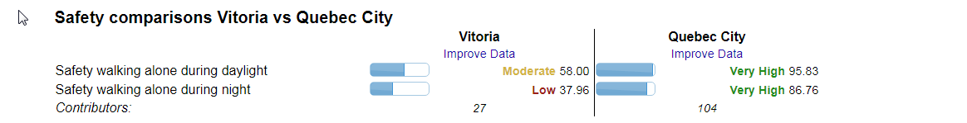

Média Salarial: R$ 3.529,00 $3239(CAD) / R$ 12.632,00

Custos Aluguel: 759 $ à 939 $

