|  |  |  |  |
| --- | --- | --- | --- |
|  |  | |  |
|  | P:\Q-Matic\Miscellaneous\Q Matic LH.Master.jpg | |  |
|  |  | Orchestra Component Description and Deployment Guide |  |
|  |  | Button Schedule and SMS widget |  |

Revision history

|  |  |  |  |
| --- | --- | --- | --- |
| Version | Date | Author | Remarks |
| 1.0 | 2015-05-29 | Bouwdewijn van Duijn | First version |
| 2.0 | 2018-06-01 | Bouwdewijn van Duijn | Updated to Schedulebutton version 7.0.2.x |
|  |  |  |  |

Contents

1. Main attributes of this Component 3

1.1. *Components included for the full solution* 3

2. Installation and configuration 4

2.1.1. Uploading Widgets 4

3. Setting up the Surface Application 5

3.1.1. Supperted flows 5

3.1.2. The surface application 7

3.1.3. Widget Parameters 11

# Main attributes of this Component

## *Components included for the full solution*

| Name | Description |
| --- | --- |
| buttonschedulesms.wgt | Widget for arriving appointments by keyboard or scanner |

# Installation and configuration

### Uploading Widgets

Go to System Administration and upload the file “**buttonschedulesms.wgt**" in the widget admin and map it to the surface type.

The function of this widget is to give the customer the possibility to a phonenumber her/himself on a touch device.

This can be any touch device (TP/Intro8, Vision or Intro 17).

This widget contains a keyboard and several functions to update standard elements on the surface.

Further will this widget enable/disable buttons based on a schedule.

Note:

* For the sms function, the sms_email_sender.utt or notification.utt is needed
* For the max ticket functionality, the buttonschedule.utt is needed

# Setting up the Surface Application

### Supperted flows

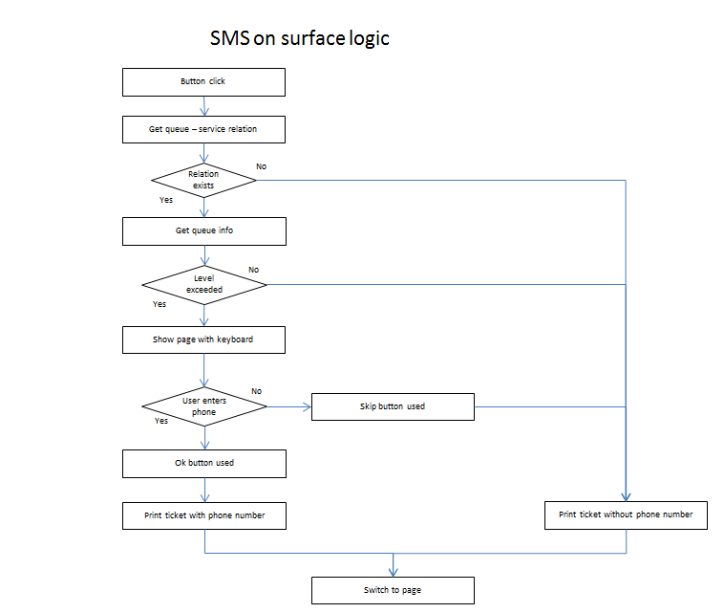

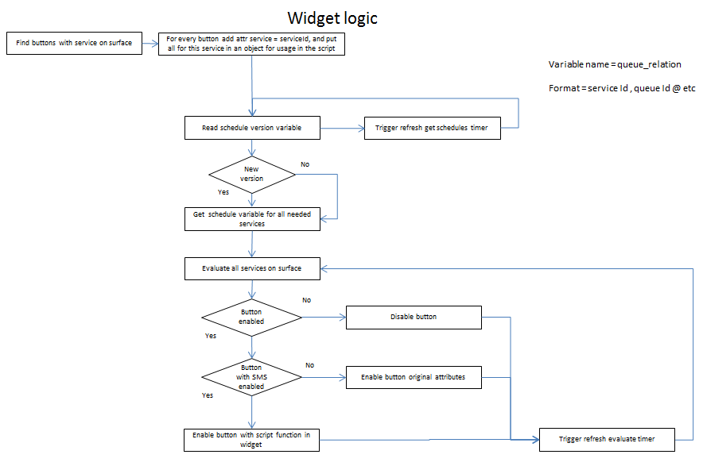

### The surface application

Make sure the return to start page time is set to 0 for the application. The return time need to be set on each page individual.

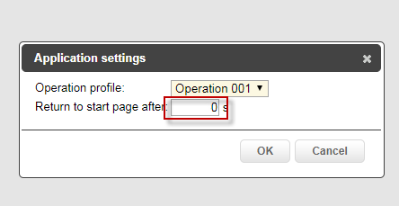

Needed pages:

- Start page with services

- Page with yes/no question (optional)

- Page to show when ticket is printed

- Phone Input page with buttonschedulesms control widget

**Startpage:**

Every button that represents a service must have a service connected.

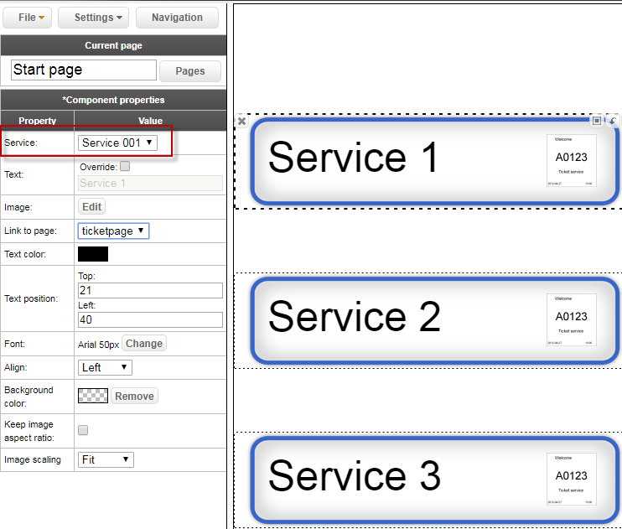

**Yes/No page:**

On the yes and no page add two buttons.

The yes button needs a link to the PhoneInputpage and may not have a service selected

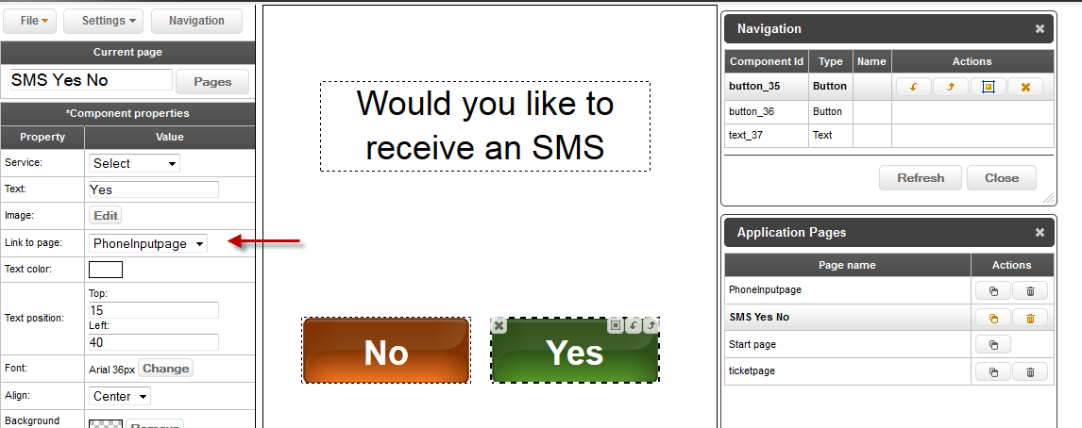

The No button doesnot need any link nor service.

Remember the component id of the No button (can be found when you open the Naviagation Window

. 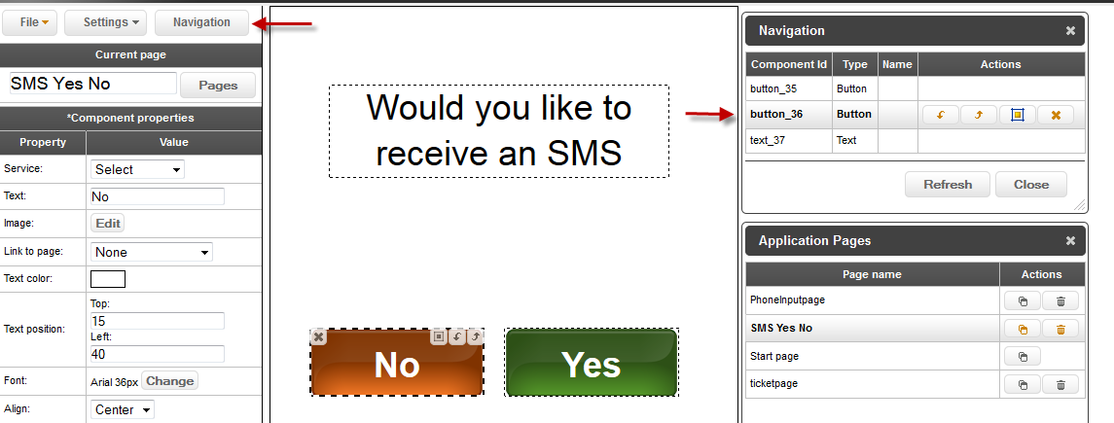

Make sure to set a “Return to start page time” for this page:

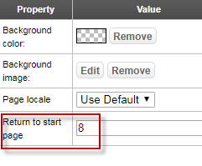

**Ticket printed page:**

Create a page which is shown when a ticket is printed

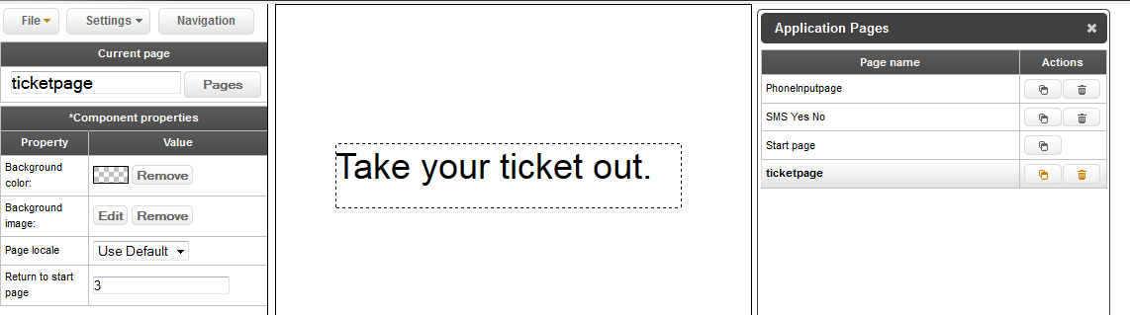

Make sure to set a “Return to start page time” for this page:

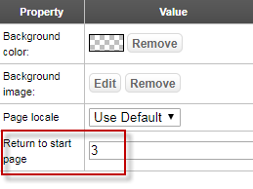

**Phone number input page:**

Create a page with the ButtonSchedule and SMS logic widget, this is the phone input page.

Next to the widget this page must the following elements

* a text component which will show the number the customer puts in
* a button component the customer clicks after entering his phone number.
* a button component the customer clicks if he doesnot want to enter a phone number.

Again the component id must be remembered.

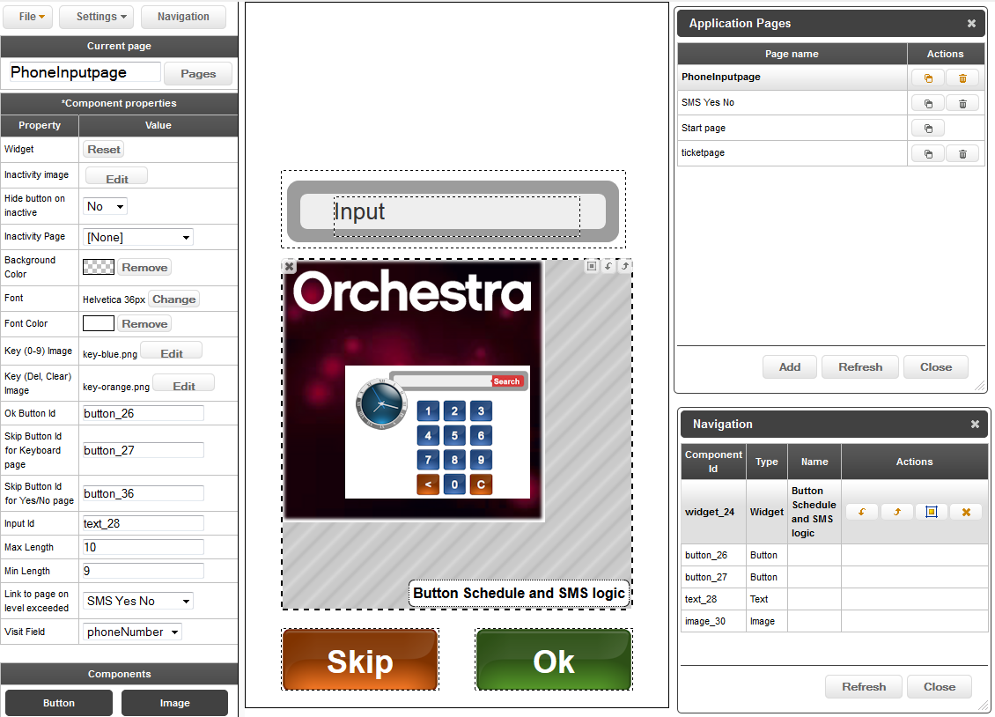

Make sure to set a “Return to start page time” for this page:

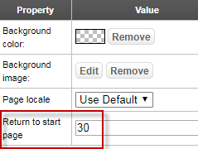

### Widget Parameters



Image to be shown when the button is disabled

Determine if a button should be hidden when disabled

Page to switch to when a button is disabled

Page to switch to when the max tickets has received

Background color for the widget (must be set on a TP/Intro8)

Font used for the text on the keyboard keys

Font color for the text on the keyboard keys

Optional Image to be used for key 0 – 9

Optional Image to be used for the Del and Clear key

Component id of the component which will add the phone number

Component id of the component which will skip the input

Compenent id of the component which skip the input page

Component id of the text component showing the input value

Max length the input can be

Min length of the input before the ok button becomes active

Page shown on button pressed and the level set for sms is exceeded

Visit field used to store the phone number