|  |  |  |  |
| --- | --- | --- | --- |
|  |  | |  |
|  | P:\Q-Matic\Miscellaneous\Q Matic LH.Master.jpg | |  |
|  |  | Orchestra Component Description and Deployment Guide |  |
|  |  | Services Schedule Admin |  |

Revision history

|  |  |  |  |
| --- | --- | --- | --- |
| Version | Date | Author | Remarks |
| 1.0 | 2014-07-07 | Bouwdewijn van Duijn | First version |
| 1.1 | 2015-05-29 | Bouwdewijn van Duijn | New version with SMS option |
| 7.0.2.02 | 2018-22-26 | Bouwdewijn van Duijn | Release of Buttonschedule version 2 |

Contents

1. Main attributes of this Component 3

1.1. *Components included for the full solution* 3

2. Installation and configuration 4

2.1. Installation on Central 4

2.1.1. Copy files 4

2.1.2. Database changes 4

2.2. Installation on distributed 5

2.2.1. Creating a new profile zip for upload. 5

3. Configuration 6

3.1.1. Adding user roles for the Schedule Admin 6

3.1.2. Asign users to the new Roles 7

4. Service Schedule application 8

4.1.1. Introduction 8

4.1.2. Setting open times for a service/template 9

4.1.3. Closed Dates 10

4.1.4. Copy templates 10

4.1.5. Link templates 10

4.1.6. Warning if service is linked to a template 11

4.1.7. Widget 11

4.1.8. Utt 12

5. Backup of settings 13

# Main attributes of this Component

## *Components included for the full solution*

| Name | Description |
| --- | --- |
| buttonschedule.war | Admin for the schedules |
| EntryPoint_BP_Schedule.utt | Utt for the BP to disable the buttons accordingly |
| EntryPoint_Intro5_Schedule.utt | Utt for the Intro5 to disable the buttons accordingly |
| schedulebuttoncontrol.wgt | Widget to be placed on the surface to disable the buttons |

# Installation and configuration

## Installation on Central

### Copy files

Copy the folder "**buttonschedule.war** into the "**custdeploy**" folder of Orchestra Central.

Add the content from the file "**add_to_commonMessages.txt**" to the file "**commonMessages.properties**" which is located in the folder "**conf/lang**" on Central.

### Database changes

Some changes are needed to the qp_central database  
  
 *This can be done by using the update_central.sql from the sql folder.*

At this point a restart of Orchestra Central is required.

## Installation on distributed

Installation on distributed is done by deploying a new profile through the Queue Agents feature under System Administration

### Creating a new profile zip for upload.

Note: Make sure to use the correct profile when deploying to a branchhub

The base for the zip file is a default profile which you find in the folder media\agentProfiles.

Copy the subfolder you want to use to a save location.

Add the content from the file "**add_to_commonMessages.txt**" to the file "**commonMessages.properties**" which is located in the folder "**conf/lang**".

In the folder webapp create the following subfolders:

buttonschedule

Copy the folder "**buttonschedule.war** " into the folder "**webapp\buttonschedule**"

Note: For version 5.3.x also create a folder called images and copy "images.war" into the folder "webapp\images", this should not be done for 5.4 or later

# Configuration

### Adding user roles for the Schedule Admin

click on "**New Role**"

Give the new role the name "**Service Schedule Admin**" and select the modules "**Schedule Services**" and make sure to also included "**Connector EntryPoint**".

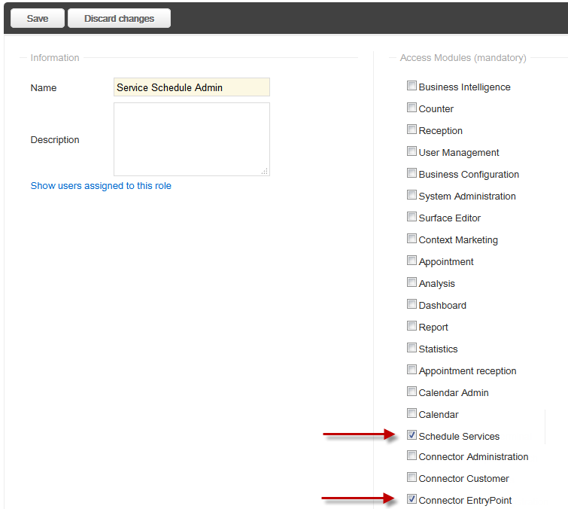

### Asign users to the new Roles

Select the menu item "**User Management**"

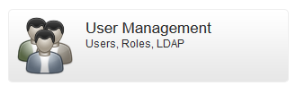

Create a new user or select an excisting one.

On the right side you find the "**Roles**" from which you can now select the new one.

When this user now logs on to Orchestra she/he will see a new menu item which gives her/him access to the new application.

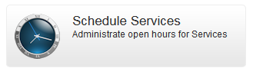

# Service Schedule application

### Introduction

In version 2 the following functionality is added to the Schedule application:

1 – settings are now saved both in Central and Branch, the branch settings are leading

2 – Automatic sync of the Central settings is branch settings are not found

3 – Support for schedule templates per branch

4 – Templates can be copied to multiple Services

5 – Services can be linked to a template, in this case one can no longer edit the service directly but must edit the linked template

6 – Each day will have only 1 schedule time by default but more schedule times can be added from the UI. In 5.4 the maximum is 3, in 6.0 and up the maximum is 4.

7 – New option to overwrite the default page which is shown when a service is closed

8 – Option to have the SMS page appear always

9 – Max number of tickets per service and day (requires buttonschedule unit type)

10 – Option to overwrite the default page which is shown when a service has reached the max number of tickets.

### Setting open times for a service/template

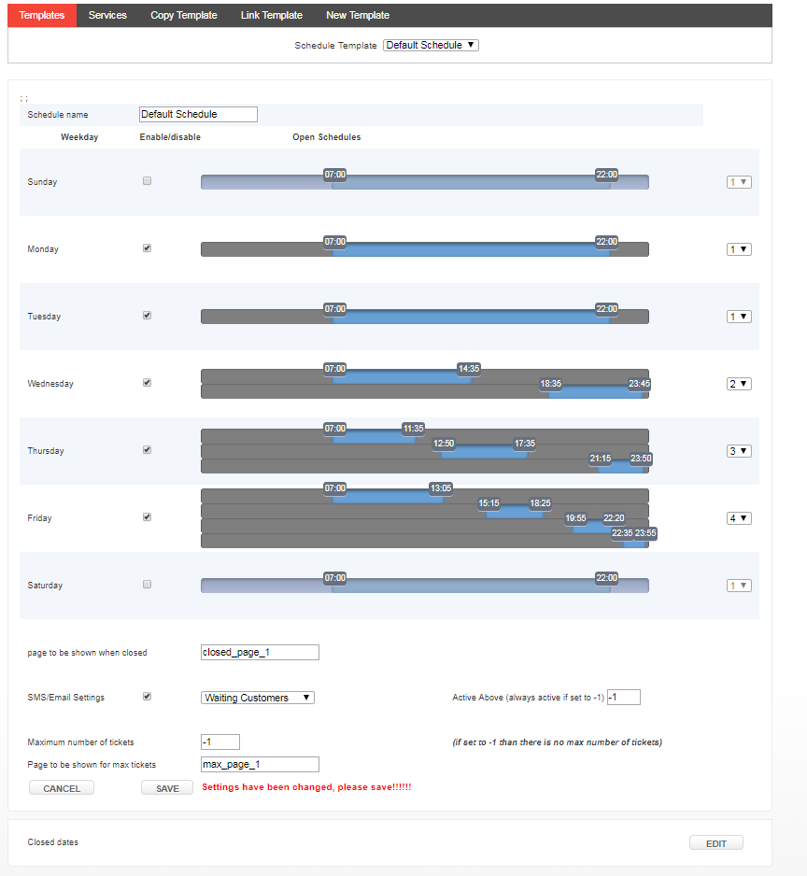

Each day can be enabled or disabled, when disabled the widget and/or utt will work as if the Service is closed and will not longer issue any tickets. When enabled one can use the sliders to set two different periods. During those periods the Service will be available and print tickets

Option to enable SMS function for the selected service. This requires the buttonschedulesms widget, sms_email_sender.utt and the SMS/Email application. Install instruction for the buttonschedulesms widget is included separately.

### Closed Dates

This setting will allow you the select dates on which the schedule will be ignored and the Service is closed during the whole day.

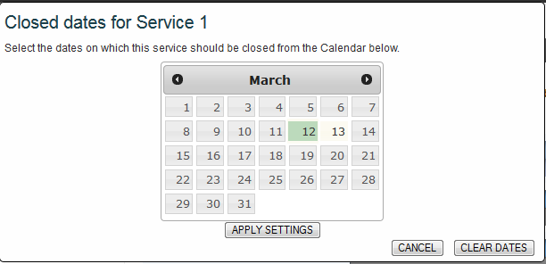

### Copy templates

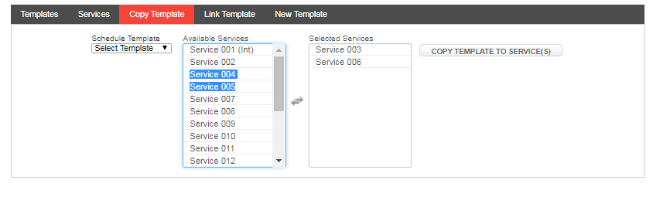

### Link templates

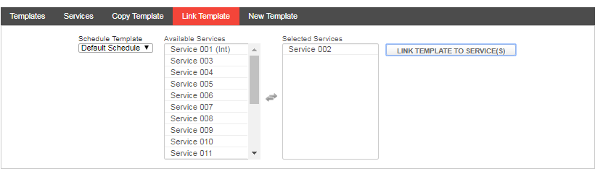

### Warning if service is linked to a template

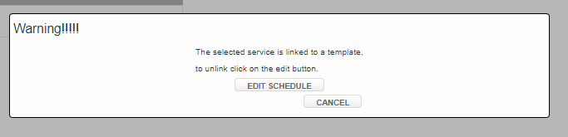

### Widget

The widget is placed once on page on the surface application. When using an Intro8 or TP Touch it should be placed on a page which is never show. The widget will control all the button components which are connected to a service.

Depending when a Service is supposed to be closed it will change the behaviour of the button.

How the behaviour is changed is depending on the settings in the widget.

One can set an alternative image to be shown, show an alternative page when clicked or hide the button completely.

See configuration_guide_buttonschedulesms_widget for explaination on how to configure the buttonschedulesms widget.

The buttonschedulesms widget requires the notification unit to be present in the equipment profile.

In case of the sharebox SMS solution the alert unit is required.

If the max tickets per day option is used, then the buttonschedule unit type will be required.

Note: buttonschedulecontrol widget will not work with schedulebutton version 2

### Utt

For the Intro 5 and BP printers a new utt needs to be uploaded.

In the utt one can enable the schedules to be used. For the Intro 5 there is also an option to set an alterniative ticket to be printed when the Service is closed

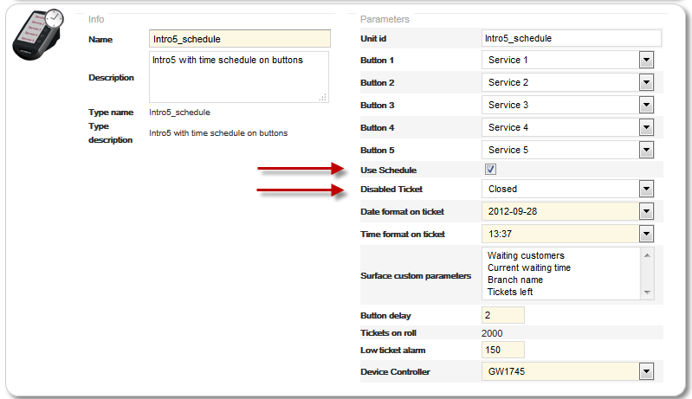

# Backup of settings

The settings for each service are stored in a branch variable. Branch variable are saved in the qp_agent database. The qp_agent database is wiped when the agent is updated/upgraded or when new agent profil is received.

To avoid the lost of previously made schedule, one should backup the settings to Central before upgrading an agent. This can be done through the Service Schedule UI.

Click on the maintenance icon on the right side.

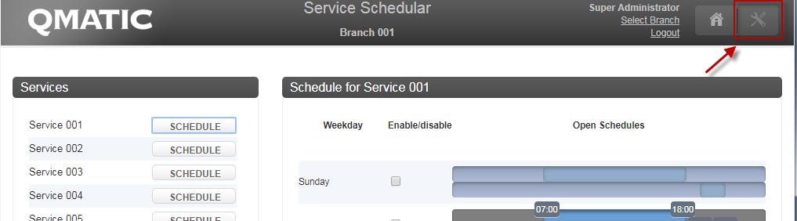

This will open a window which can be used to copy the variables for either a branch or all branches to Central.

One should do this before every update of the Agent.

