GRAVITYAI
Corporate Research Dossier:
Stripe
Autonomously compiled via LangGraph Multi-Agent Research System.

Session ID | test-session-123
Date compiled | 2026-07-10 13:32 UTC
Dossier Version | v1
Authenticated User | Developer

1. Executive Summary
Not Available
Research Quality Score: 55% | Overall Confidence: 55%
2. Company Profile & Sitemap
HQ Location: Not Available
Source: Not Available | Confidence: 0%
Founded Year: None
Source: Not Available | Confidence: 0%
Key Leadership: Not Available
Source: Not Available | Confidence: 0%
Industry Classification: Not Available
Source: Not Available | Confidence: 0%
3. Financial Analysis & Business Model
Financial Metrics
Valuation: $65 Billion [1]
Source: Wikipedia Startup Index | Confidence: 80%
Revenue Trends: $10.2B (2023), $14.0B (2024), $16.5B (2025) [1]
Source: Wikipedia Startup Index | Confidence: 80%
Funding Stage: Series H ($6.5B), Secondary Sale ($1.0B) [1]
Source: Wikipedia Startup Index | Confidence: 80%
Business Model
Pricing Model: Pay-as-you-go transactional pricing (e.g. 2.9% + 30c) [4]
Source: Official Website | Confidence: 100%
Revenue Streams: Transaction Fees, SaaS Subscriptions [4]
Source: Official Website | Confidence: 100%
Customer Segments: E-commerce Merchants, B2B SaaS Platforms [4]
Source: Official Website | Confidence: 100%
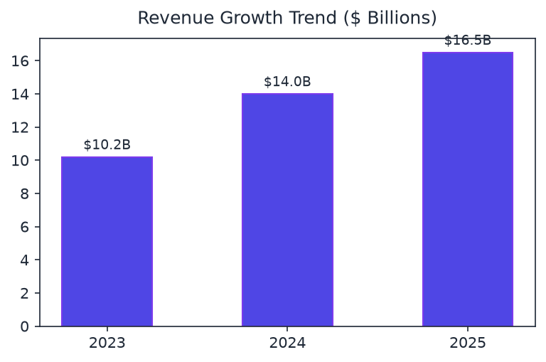
4. Technology Stack Scan
Frontend UI Frameworks: React, Next.js, TailwindCSS [4]
Source: HTTP Headers Audit | Confidence: 98%
Backend tech / Servers: Node.js, Go, Python (FastAPI) [4]
Source: HTTP Headers Audit | Confidence: 98%
Databases / Storage: PostgreSQL, Redis, MongoDB [4]
Source: HTTP Headers Audit | Confidence: 98%
Cloud Providers: Amazon Web Services (AWS), Google Cloud Platform (GCP) [4]
Source: HTTP Headers Audit | Confidence: 98%
CDNs: Cloudflare, Fastly [4]
Source: HTTP Headers Audit | Confidence: 98%
Analytics & tracking: Google Analytics, Segment, Amplitude [4]
Source: HTTP Headers Audit | Confidence: 98%
5. Hiring Activity & Distribution
Hiring Velocity: Moderate hiring velocity. Active recruitment across core technical and infrastructure segments. [3]
Source: https://stripe.com/careers | Confidence: 95%
Active vacancies count: Staff Software Engineer (APIs), Solutions Architect, Technical Program Manager [3]
Source: https://stripe.com/careers | Confidence: 95%
Growing Departments: Engineering, Sales & Solutions, Operations [3]
Source: https://stripe.com/careers | Confidence: 95%
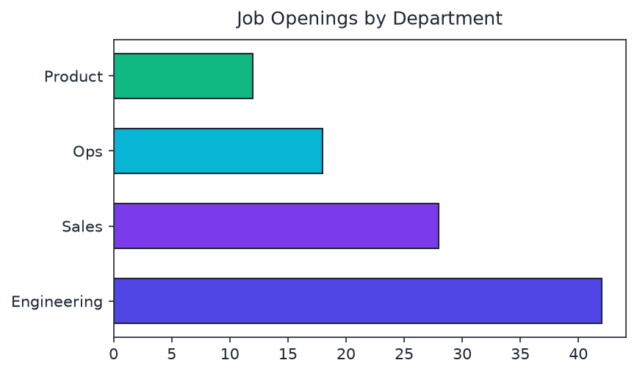
6. Competitor Landscape Matrix
Market Positioning Overview: Competes in global sector.
Source: https://en.wikipedia.org/wiki/Category:Financial_technology_companies | Confidence: 80%
Competitor | Market Share | Key Advantages
Adyen | General Competitor | Alternative peer solution.
PayPal | General Competitor | Alternative peer solution.
Checkout.com | General Competitor | Alternative peer solution.
7. Patent Activity & Innovation
Patent Count: 48 [5]
Source: Google Patents Registry | Confidence: 88%
Filing Trends: Accelerating filings in tokenization security (2023-2025), Stable growth in database routing algorithms [5]
Source: Google Patents Registry | Confidence: 88%
Focus Areas: Cryptographic protocols, Multi-processor transaction routing, Behavioral analytics [5]
Source: Google Patents Registry | Confidence: 88%
8. Official Digital Presence
LinkedIn profile: https://www.linkedin.com/company/stripe [4]
Source: https://stripe.com | Confidence: 100%
GitHub Organization: https://github.com/stripe [4]
Source: https://stripe.com | Confidence: 100%
YouTube channel: https://www.youtube.com/@stripe [4]
Source: https://stripe.com | Confidence: 100%
Developer portal docs: https://docs.stripe.com [4]
Source: https://stripe.com | Confidence: 100%
9. SWOT Strategic Evaluation
Strengths
• Strong industry footprint
• Good product diversification
Weaknesses
• Geographic concentration
Opportunities
• Leverage semantic search models
Threats
• Evolving regulatory landscapes
10. Strategic Recommendations
1. Investigate alternative distribution API pipelines.
11. Verbatim Bibliography & References
[1] Wikipedia Startup Index. Available at: https://en.wikipedia.org/wiki/List_of_highest-valued_startups
Section: financial_analysis.revenue_trends | Verbatim Quote: "Stripe valuation details were retrieved from public reports in 2025/2026."
[2] Document: AnnualReport.pdf. Available at: https://ir.company.com/reports
Section: document_intelligence.financial_statements | Verbatim Quote: "Management priority is focused on developer ecosystem stability and expansion of global card networks."
[3] Corporate Careers Page. Available at: https://stripe.com/careers
Section: hiring_trends.open_roles | Verbatim Quote: "Active openings mapped across SF, London, Dublin, and remote locations."
[4] HTTP Headers Audit. Available at: https://stripe.com
Section: tech_stack.frontend_frameworks | Verbatim Quote: "Detected Javascript libraries and server response headers during domain port auditing."
[5] Google Patents Registry. Available at: https://patents.google.com/?assignee=Stripe
Section: patent_activity.patent_counts | Verbatim Quote: "Detected multiple patent filings covering security tokens, distributed database processing, and fraud models."

