**Laboratory of Natural Information Processing**

DA-IICT Gandhinagar

**3DNA PRINTER**

**User Manual**

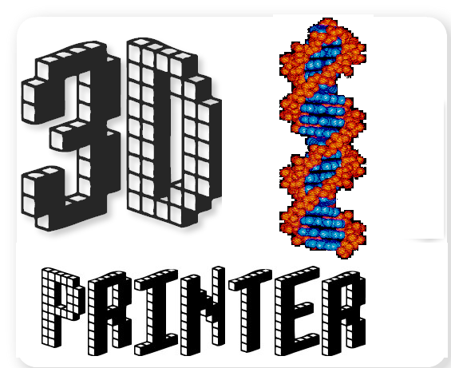

3DNA PRINTER

**User Manual**

**© 2017 Manish K Gupta,**

**Laboratory of Natural Information Processing**

**DA-IICT, Gandhinagar, Gujarat 382007**

[**http://www.guptalab.org/3dna**](http://www.guptalab.org/3dna)**printer**

**The software described in this book is furnished under an open source license agreement and may be used only in accordance with the terms of the agreement. Any selling or distribution of the program or its parts, original or modified, is prohibited without a written permission from**

**Manish K Gupta.**

Documentation version 1.0

**Credits & Team**

***Principle Investigator:*** Dr.Manish K. Gupta

***Graduate Mentor:*** Dixita Limbachiya

***Developers:*** Amay Agrawal, Birva Patel

***Software Logo:*** Birva Patel

**Acknowledgements**

The author would like to thank Bruno Lowagie (<http://itexpdf.com>) whose free open source libraries have been used for generating bar codes and PDF. We thank GLYPHICONS free for providing us with icons. (http://glyphicons.com)

**General Information**

Introduction

3DNA Printer is a software that can be used to generate any arbitrary 3D DNA structures using structured algorithmic self-assembly. In this software user have to just import any 3d .obj file which can easily be obtained from any software like Autocad, Maya etc. In this we have default used M_13 scaffold for the structures but the user can use any of the random sequence in place of it. Using this software we have successfully modeled various complex structures like tetrahedron ,octahedron etc.

This manual assumes that the user is familiar with the basics of DNA base pairing. The reader should refer to [Designer nanoscale DNA assemblies programmed from the top-down approach](http://science.sciencemag.org/content/352/6293/1534.long) for further technical details on the language semantics.

Installing 3DNA

The software can be installed from the website [**http://www.guptalab.org/3dnaprinter**](http://www.guptalab.org/3dnaprinter)

**Getting Started**

Once you have successfully installed the software, open 3DNA Printer by double clicking on the application, you will be prompted with a welcome screen with different options on the menu bar.

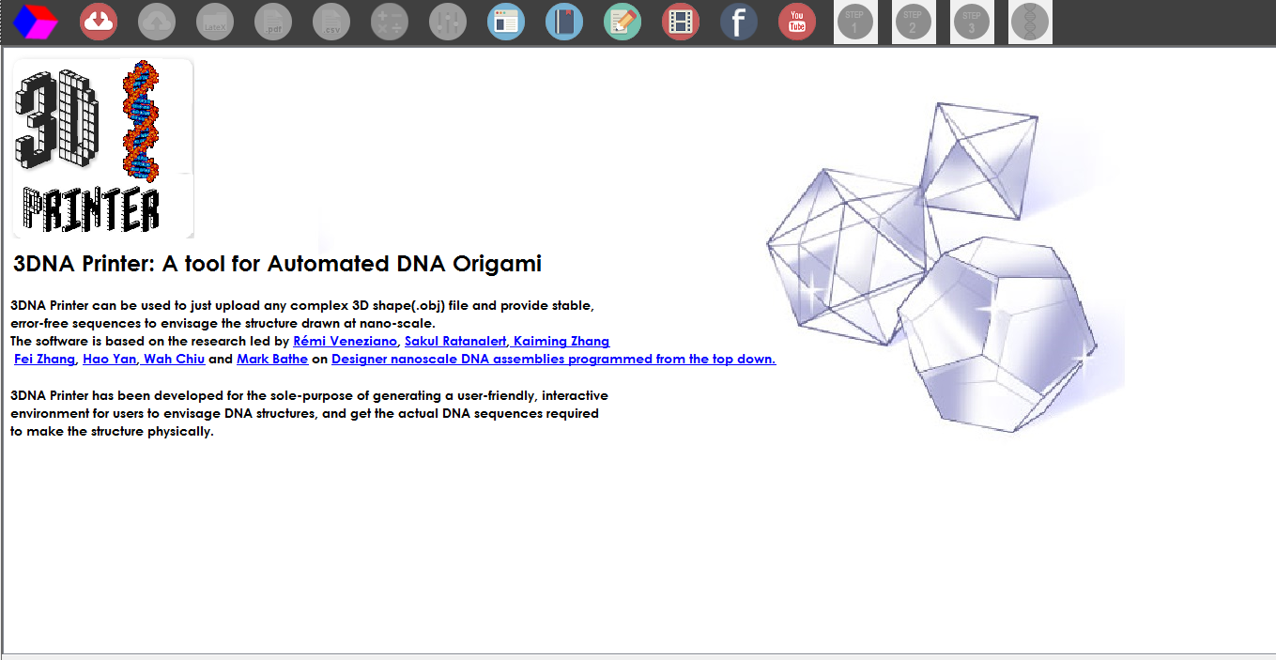

Figure 1: 3DNA Printer Welcome Screen

The main features that the software provides the user with and which are spanned across these four options on the menu bar are:-

* Polyhedra mesh generation.
* Step 1 (Spanning tree generation of the Polyhedra mesh)
* Step 2 (Eulerian Circuit Generation)
* Step 3 (Generate DNA Sequences)
* Generate Sequences Directly
* Fare Estimator
* Social Media Options

Polyhedra Mesh Generation

This option can be selected by clicking on the “Import File” button on the top left side of menubar which can be seen in figure below. After selecting the proper (.obj) extension file of any 3d object, we can see the corresponding 3D object on the screen and also can rotate it as shown in figure below.

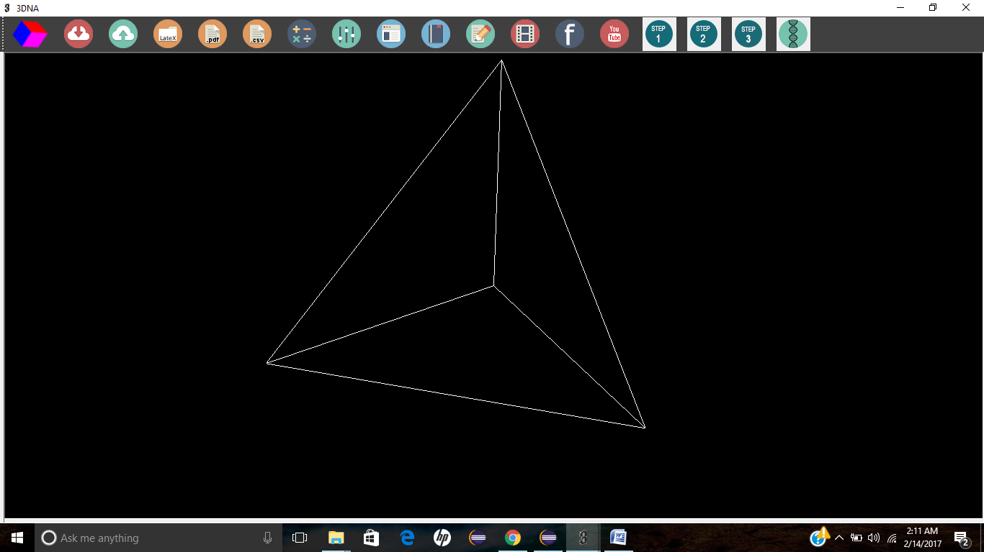

Figure 2: Importing file and generating polyhedral mesh

Spanning tree generation of the Polyhedra Mesh

This option can be used by clicking the “Step 1” option as shown in the figure below. Below we can see the spanning tree generated for tetrahedron. The edges which are colored green are part of the spanning tree.

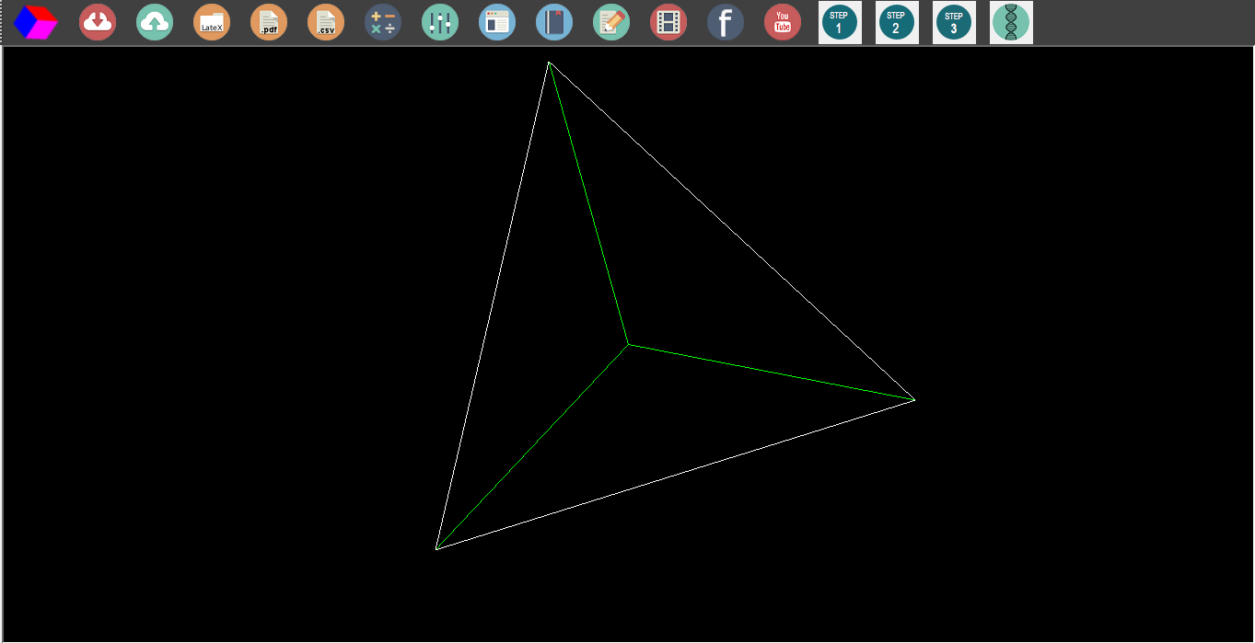

Figure 3: Green Edges in the figure are the spanning tree edges

**Eulerian Circuit Generation**

This option can be used by clicking the “Step 2” option as shown in the figure below. The edges that were part of the spanning tree remains as it is but the remaining edges are cutted into half to form a Eulerian circuit which can be seen in figure below. Also pseudo nodes are added at each vertex.

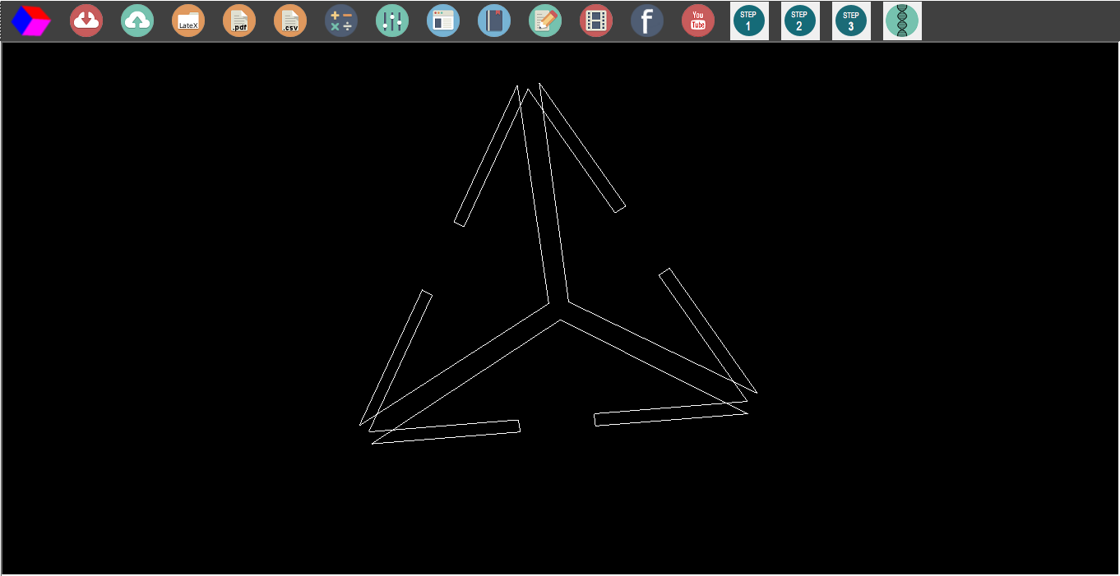

Figure 4: Eulerian Circuit Formation

**Generate DNA Sequences**

This option can be used by clicking the “Step 3” option as shown in the figure below. By default we have taken M_13 scaffold here but the user can enter any scaffold of his choice. The M_13 scaffold is scaffolded across the Eulerian circuit with starting edge shown in red and the next edge shown in green which can be seen in fig below. After this step the DNA Sequences corresponding to the given 3D steucture can be found in Output_Sequences.xls file present at _____________(Location to decide).

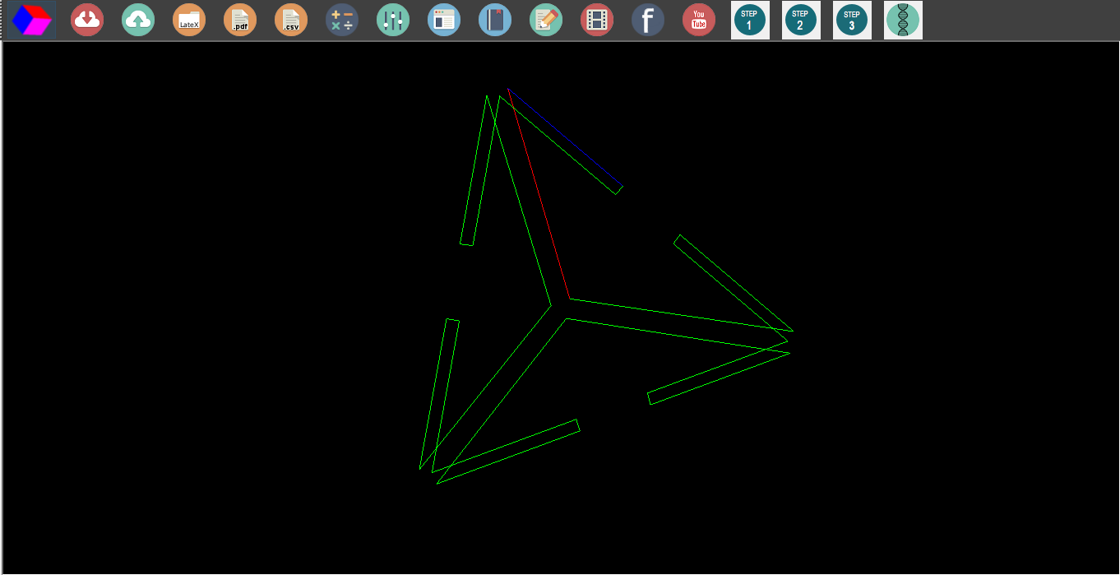

Figure 5: Red edge shows from where to start scaffold routing and blue shows the second one

**Generate Sequence Directly**

This option can be used by selecting the rightmost option in the menubar which can be seen in fig above. What it does is similar to the above “Step 3” button. This can be used if the user does not want to see all the above steps after **importing the file** and generate DNA Sequences directly.

**Fare Estimator**

By clicking this button, you will be asked to enter the cost/bp. After entering this you can get the total cost resembling to the total no of bp used in the structure formation.

**Support and Feedback**

Users are requested to contact team at the feedback page on the website [www.guptalab.org/3dnaprinter](http://www.guptalab.org/3dnaprinter) for any issue with the software. Only one platform specific installers (Windows) is available on the project home page .