**PRACTIACL NO 1**

**AIM:** Google and Whois Reconnaissance

Use Google search technique to gather information about a specific target or organization

Utilize advanced search operators to refine search results and access hidden information

Perform whois lookups to retrieve domain registration information and gather details about the target’s infrastructure

**SOLUTION:**

**Step 1 :** Seach prestashop on google and take a screenshot of the result displayed

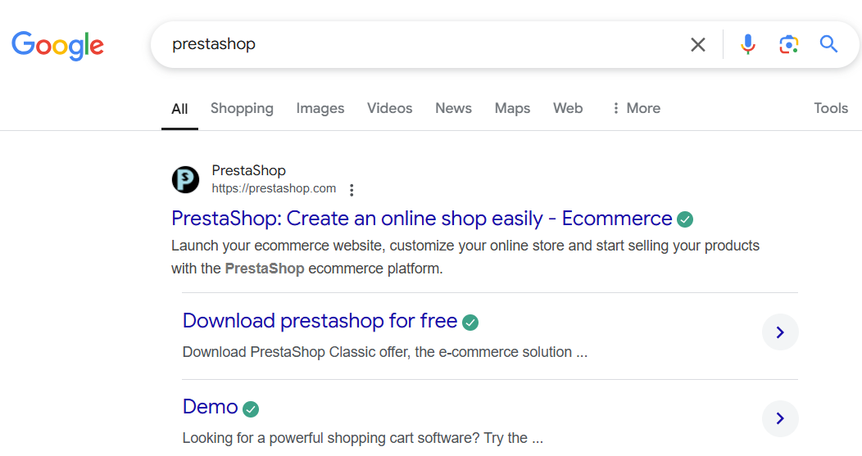

**Step 2 :** Take a screenshot of the side panel containing information prestashop information

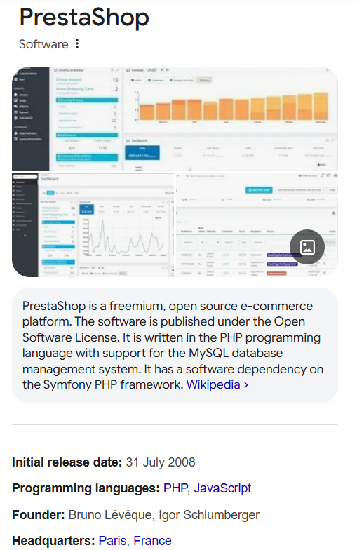

**Step 3 :** Go to the browser and search for <https://whois.is/>

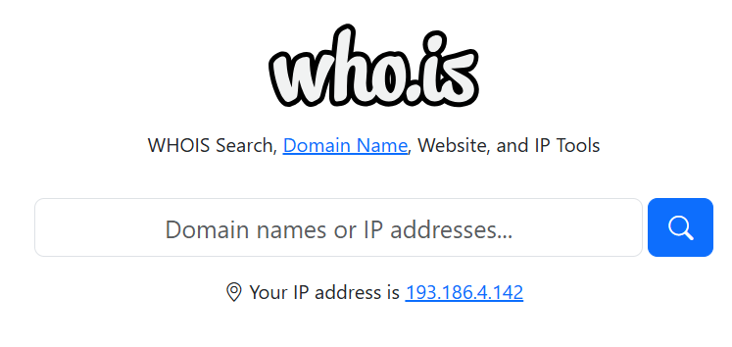

**Step 4 :** Search for <https://prestashop.com/>

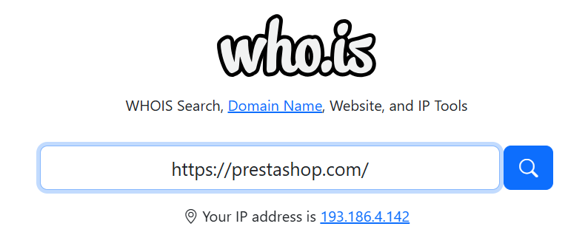

**Step 5 :** Scroll down and study the information given below

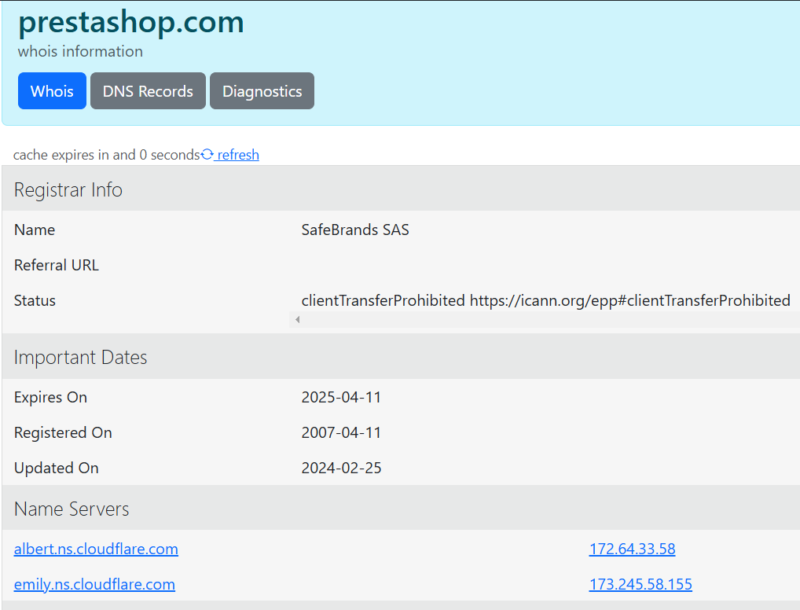

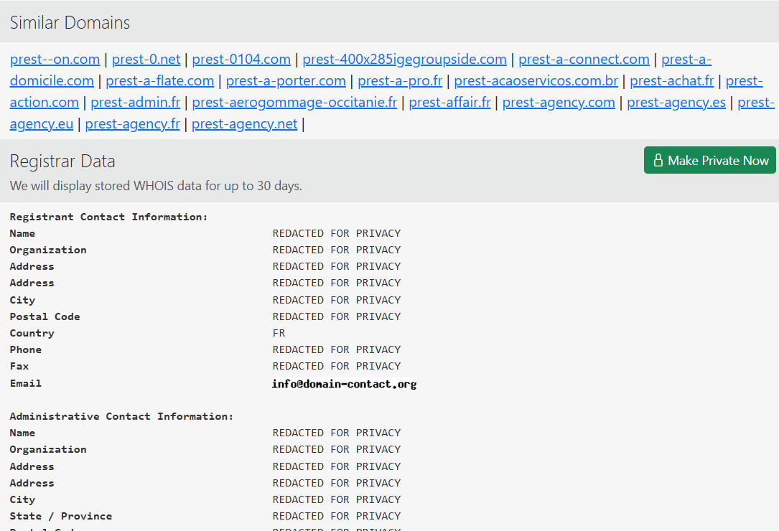

**Step 6 :** Click on DNS Record

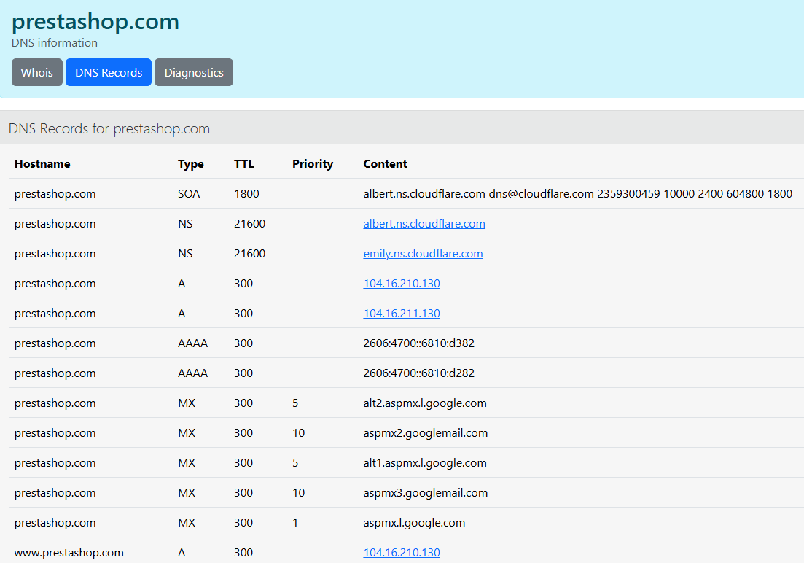

**Step 7 :** Click on Diagnostics

