**PRACTICAL NO 2**

**AIM:** Password Encryption and Cracking with CrypTool and Cain and Abel

Password Encryption and Decryption:

* Use CrypTool to encrypt passwords using the RC4 algorithm.
* Decrypt the encrypted passwords and verify the original values.

Password Cracking and Wireless Network Password Decoding:

* Use Cain and Abel to perform a dictionary attack on Windows account passwords.
* Decode wireless network passwords using Cain and Abel's capabilities.

**SOLUTION:**

1. Password Encryption and Decryption:

* Use CrypTool to encrypt passwords using the RC4 algorithm.
* Decrypt the encrypted passwords and verify the original values.

**Step 1 :** Download Cryptool1 from the website : https://www.cryptool.org/en/ct1/downloads/

**Step 2 :** Create a new text file

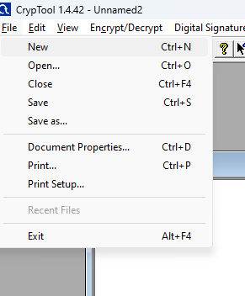

**Step 3 :** Write anything you want to encrypt

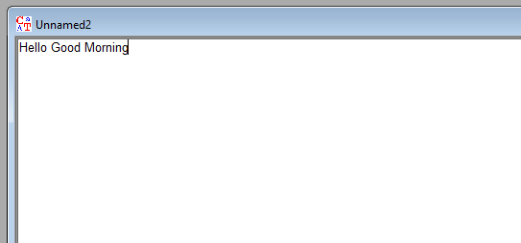

**Step 4 :** Click on Encrypt/Decrypt < Symmetric (Modern) < RC4

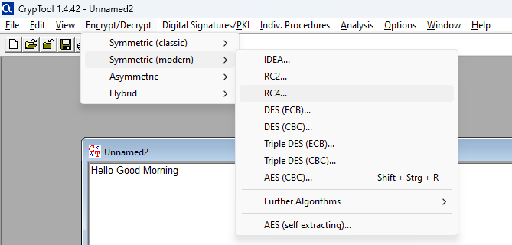

**Step 5 :** Click on Encrypt

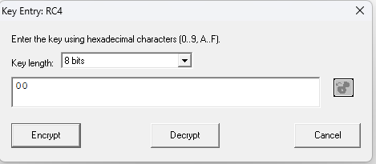

**Step 6 :** A window will appear where you will get the encrypted text

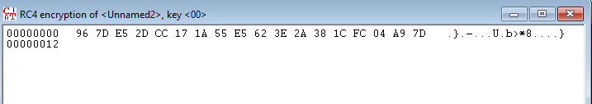

**Step 7 :** Now for decryption Click on Decrypt



**Step 8 :** A window will appear where you will get the original text of the encrypted text

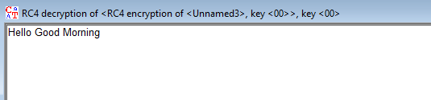

2) Password Cracking and Wireless Network Password Decoding:

* Use Cain and Abel to perform a dictionary attack on Windows account passwords.
* Decode wireless network passwords using Cain and Abel's capabilities.

**Step 1 :** Download Install and then open the Cain & Abel Tool

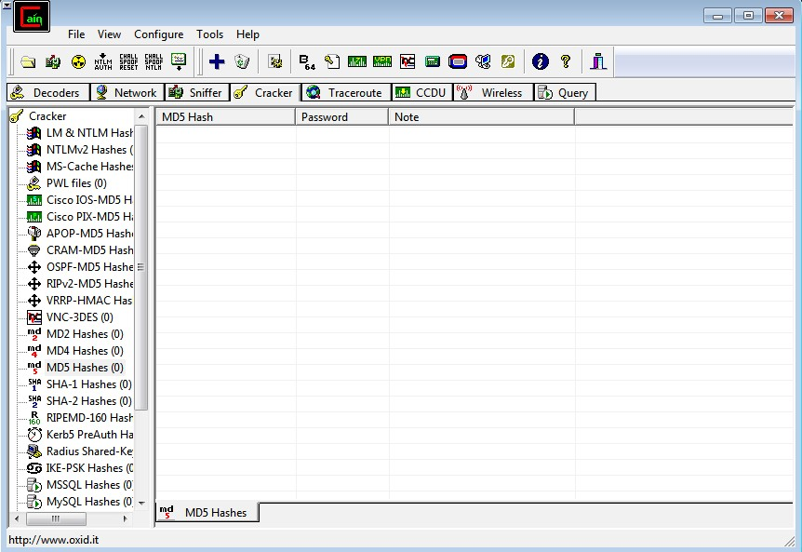

**Step 2 :** first go to sniffer and then click on configure , select the appropraite wireless adapter. Click on apply and then click on the ok button

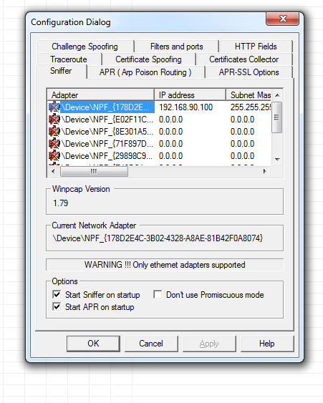

**Step 3 :** activate sniffer

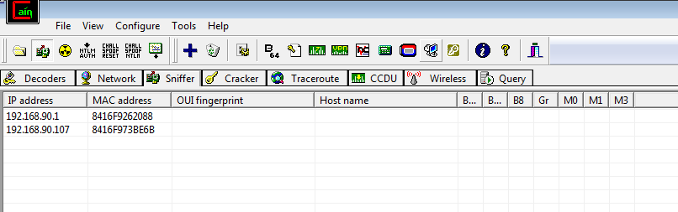

**Step 4 :** Click on + icon . check all tests checkbox and then click on OK

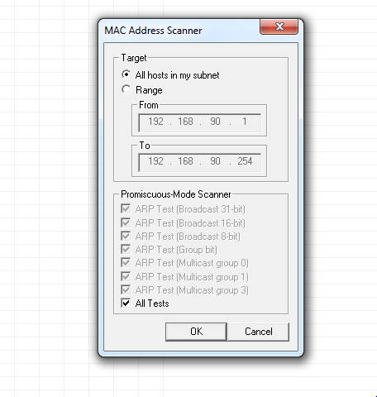

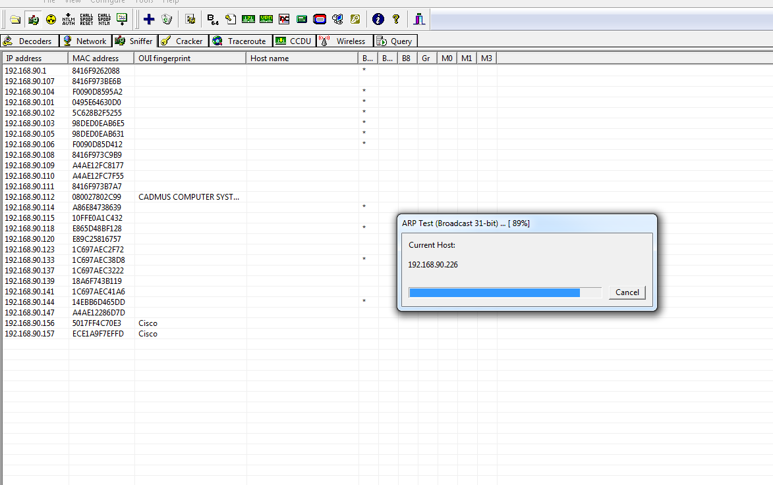

**Step 5 :**  click on APR then click on the blank screen and then on the + icon. select any ip address ( ipv4 address) form the left side and select all ip address and mac address from right side and then click on ok

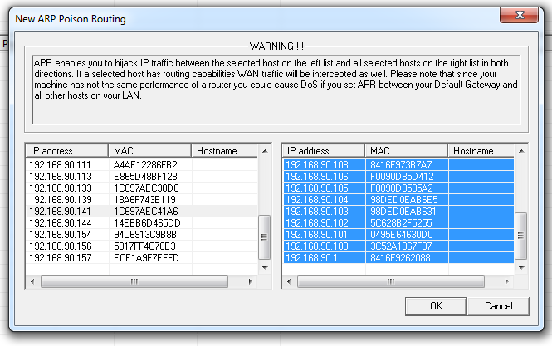

**Step 6 :** Apply sniffer by click on the start /stop sniffer on the top. It gives the status of all the devices connected to wifi

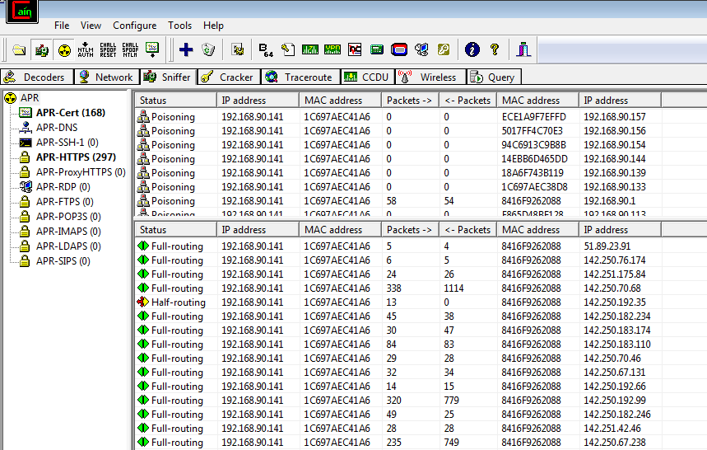

**Step 7 :** Then go the passwords tab it will display the passwords presents

