**PRACTICAL NO 7**

**AIM:** Session Impersonation with Firefox and Tamper Data

* Install and configure the Tamper Data add-on in Firefox.
* Intercept and modify HTTP requests to impersonate a user's session.
* Understand the impact of session impersonation and the importance of session management.

**SOLUTION:**

**Step 1 :** Open Firefox and click on Setting

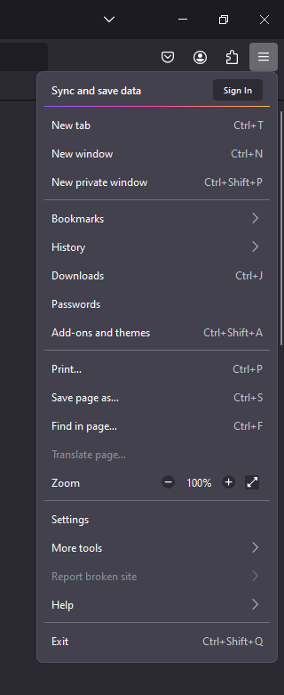

**Step 2 :** Click on Extension and Themes at the bottom

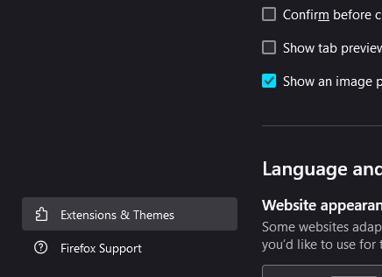

**Step 3 :** In the search bar type tamper data and click on enter

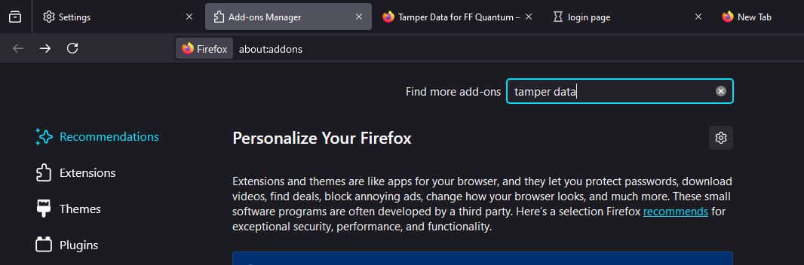

**Step 4 :** Click on ‘Tamper Data for FF Quantum’ and download it

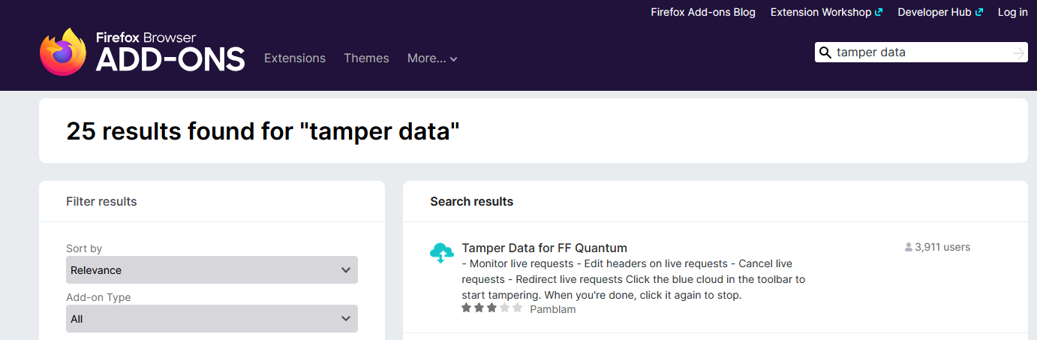

**Step 5 :** Click on Extension button and select the Tamper Data option

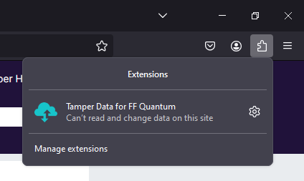

**Step 6 :** A window will appear and click on Yes to enable the extension

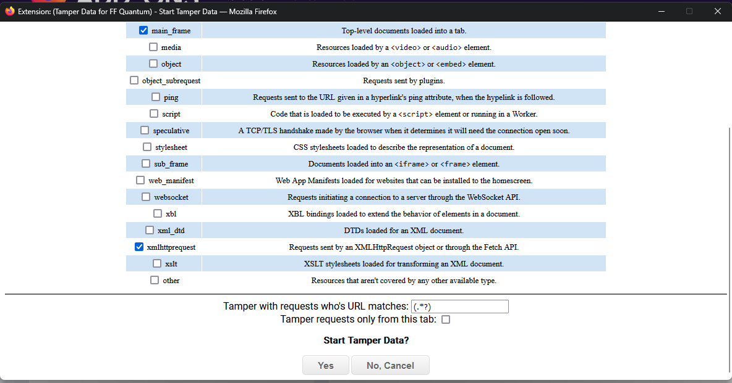

**Step 7 :** Visit the following website : <http://testphp.vulnweb.com/login.php>

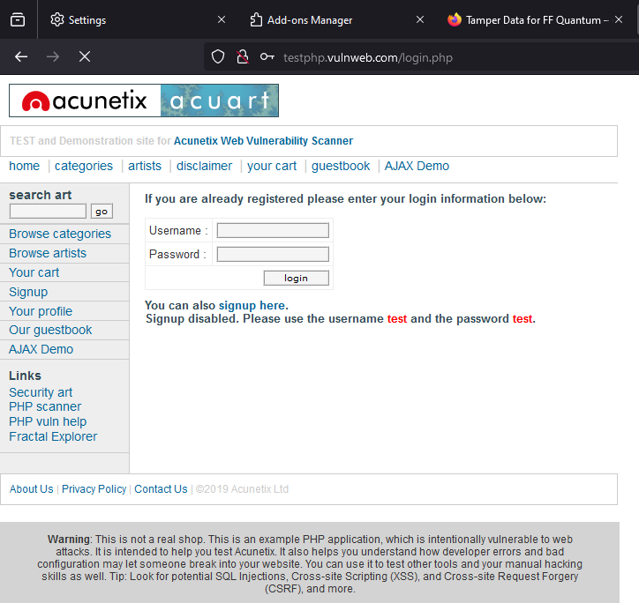

**Step 8 :** Enter the username and password and your choice and click on login

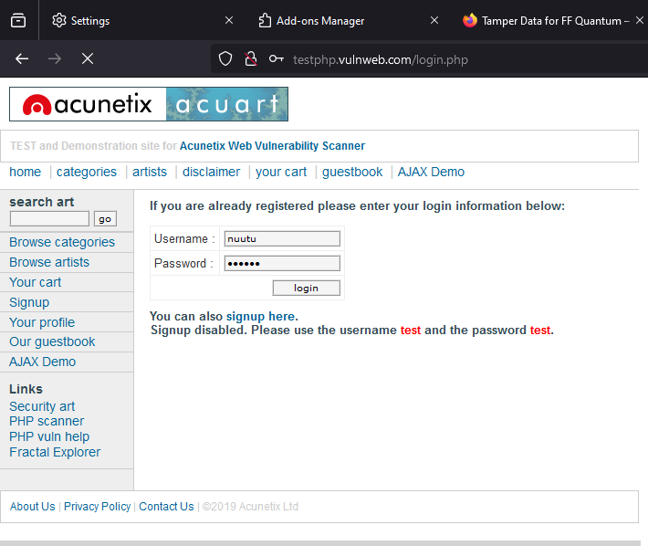

**Step 9 :** A window will appear where you will see the username and password

