**PRACTICAL NO 1**

**AIM:** Document Indexing and Retrieval

1. Implement an inverted index construction algorithm.

2**.** Build a simple document retrieval system using the constructed index.

**SOLUTION:**

1. Implement an inverted index construction algorithm.

**INPUT:**

document1 = "The quick brown fox jumped over the lazy dog"

document2 = "The lazy dog slept in the sun"

import nltk

from nltk.corpus import stopwords

stop_words = set(stopwords.words('english'))

# Tokenize and filter stopwords

tokens1 = [word for word in document1.lower().split() if word not in stop_words]

tokens2 = [word for word in document2.lower().split() if word not in stop_words]

# Build inverted index and occurrence counts

inverted_index = {}

occurrences = {"Document 1": {}, "Document 2": {}}

for term in set(tokens1 + tokens2):

inverted_index[term] = []

if term in tokens1:

inverted_index[term].append("Document 1")

occurrences["Document 1"][term] = tokens1.count(term)

if term in tokens2:

inverted_index[term].append("Document 2")

occurrences["Document 2"][term] = tokens2.count(term)

# Print results

print("Inverted Index:", inverted_index)

print("Occurrences in Document 1:", occurrences["Document 1"])

print("Occurrences in Document 2:", occurrences["Document 2"])

# Print inverted index with occurrences

for term, docs in inverted_index.items():

print(f"{term} ->", end="")

print(", ".join(f"{doc}({occurrences[doc].get(term, 0)})" for doc in docs))

print("Performed by 740_Pallavi & 743_Deepak")

**OUTPUT:**

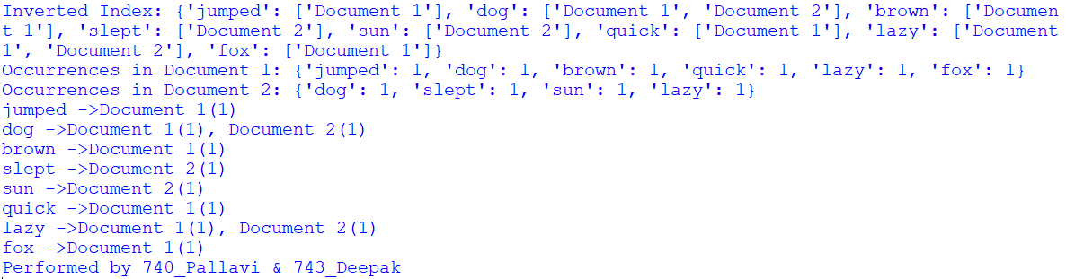

2. Build a simple document retrieval system using the constructed index.

**INPUT:**

import re

from collections import defaultdict

class DocumentRetrievalSystem:

def __init__(self):

self.index = defaultdict(list)

self.documents = []

def add_documents(self, documents):

for doc_id, document in enumerate(documents):

self.documents.append(document)

for term in self.tokenize(document):

self.index[term].append(doc_id)

def search(self, query):

query_terms = self.tokenize(query)

result_docs = set(self.index[query_terms[0]]) if query_terms and query_terms[0] in self.index else set()

for term in query_terms[1:]:

result_docs &= set(self.index[term])

return [self.documents[doc_id] for doc_id in result_docs]

@staticmethod

def tokenize(text):

return re.findall(r'\b\w+\b', text.lower())

if __name__ == "__main__":

retrieval_system = DocumentRetrievalSystem()

retrieval_system.add_documents([

"This is the first document",

"Python is a popular programming language",

"Document retrieval systems are important"

])

query = "is"

results = retrieval_system.search(query)

if results:

print(f"Search results for '{query}':")

for result in results:

print("-", result)

else:

print(f"No results found for '{query}'.")

**OUTPUT:**

