**PRACTICAL NO 5**

**AIM :** Text Categorization

* Implement a text classification algorithm (e.g., Naive Bayes or Support Vector Machines).
* Train the classifier on a labelled dataset and evaluate its performance.

**SOLUTION :**

Dataset.csv file

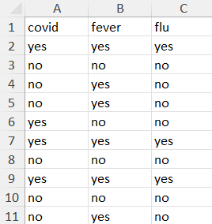

Test.csv file

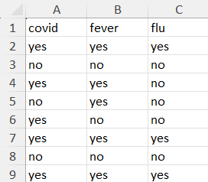

**INPUT:**

import pandas as pd

from sklearn.model_selection import train_test_split

from sklearn.feature_extraction.text import CountVectorizer

from sklearn.naive_bayes import MultinomialNB

from sklearn.metrics import accuracy_score, classification_report

df=pd.read_csv(r"C:\Users\nupur\sem 6 journals\IR\Dataset.csv")

data= df["covid"]+" "+df["fever"]

X=data.astype(str)

y=df['flu']

X_train, X_test, y_train, y_test=train_test_split(X,y,test_size=0.2, random_state=42)

vectorizer=CountVectorizer()

X_train_counts=vectorizer.fit_transform(X_train)

X_test_counts = vectorizer.transform(X_test)

classifier=MultinomialNB()

classifier.fit(X_train_counts, y_train)

data1=pd.read_csv(r"C:\Users\nupur\sem 6 journals\IR\Test.csv")

new_data=data1["covid"]+" "+data1["fever"]

new_data_counts=vectorizer.transform(new_data.astype(str))

predictions=classifier.predict(new_data_counts)

new_data=predictions

print(new_data)

accuracy=accuracy_score(y_test, classifier.predict(X_test_counts))

print(f"\nAccuracy : {accuracy:.2f}")

print("Classification Report :")

print(classification_report(y_test,classifier.predict(X_test_counts)))

predictions_df=pd.DataFrame(predictions,columns=['flu_prediction'])

data1=pd.concat([data1,predictions_df],axis=1)

data1.to_csv(r"C:\Users\nupur\sem 6 journals\IR\test1.csv",index=False)

**OUTPUT:**

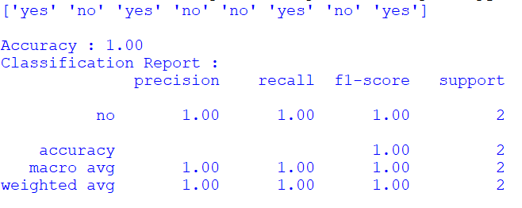

test1.csv

