**PRACTICAL NO 7**

**AIM :** Web Crawling and Indexing

* Develop a web crawler to fetch and index web pages.
* Handle challenges such as robots.txt, dynamic content, and crawling delays.

**SOLUTION:**

Install the following modules using pip: pip install requests beautifulsoap4

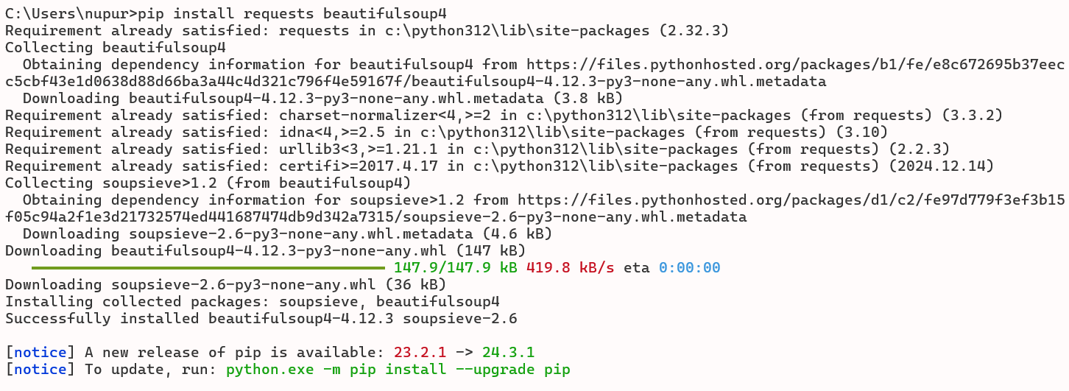

**INPUT:**

import requests

from bs4 import BeautifulSoup

import time

from urllib.parse import urljoin, urlparse

from urllib.robotparser import RobotFileParser

def get_html(url):

headers = {'User-Agent': 'Mozilla/5.0 (Windows NT 10.0; Win64; x64) AppleWebKit/537.36 (KHTML, like Gecko) Chrome/58.0.3029.110 Safari/537.3'}

try:

response=requests.get(url,headers=headers)

response.raise_for_status()

return response.text

except requests.exceptions.HTTPError as errh:

print(f"HTTP Error:{errh}")

except requests.exceptions.RequestException as err:

print(f"Request Error:{err}")

return None

def save_robots_txt(url):

try:

robots_url=urljoin(url,'/robots.txt')

robots_content= get_html(robots_url)

if robots_content:

with open('robots.txt','wb') as file:

file.write(robots_content.encode('utf-8-sig'))

except Exception as e:

print(f"Error saving robots.txt: {e}")

def load_robots_txt():

try:

with open('robots.txt', 'rb') as file:

return file.read().decode('utf-8-sig')

except FileNotFoundError:

return None

def extract_links(html,base_url):

soup=BeautifulSoup(html,'html.parser')

links=[]

for link in soup.find_all('a',href=True):

absolute_url=urljoin(base_url,link['href'])

links.append(absolute_url)

return links

def is_allowed_by_robots(url,robots_content):

parser=RobotFileParser()

parser.parse(robots_content.split('\n'))

return parser.can_fetch('*',url)

def crawl(start_url,max_depth=3, delay=1):

print("Hello")

visited_urls=set()

def recursive_crawl(url,depth, robots_content):

if depth>max_depth or url in visited_urls or not is_allowed_by_robots(url,robots_content):

return

visited_urls.add(url)

time.sleep(delay)

html=get_html(url)

if html:

print(f"Crawling {url}")

links=extract_links(html,url)

for link in links:

recursive_crawl(link,depth+1,robots_content)

save_robots_txt(start_url)

robots_content=load_robots_txt()

if not robots_content:

print("Unable to retrieve robots.txt. Crawling without restrictions.")

else:

print("Using robots.txt for crawling restrictions.")

recursive_crawl(start_url,1,robots_content)

print("Performed by Nupur Karpe")

crawl('https://', max_depth=2, delay=2)

**OUTPUT:**

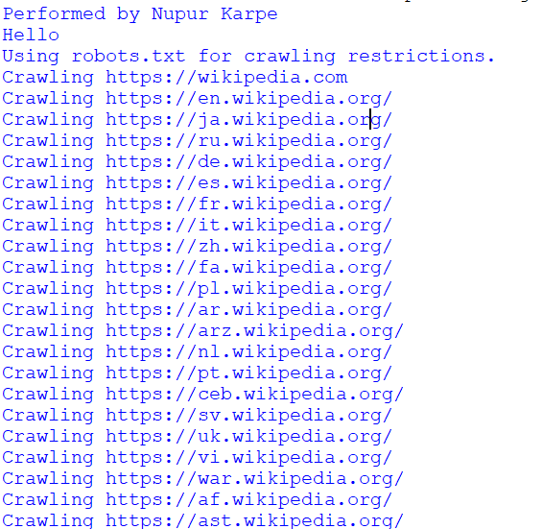

Robot.txt file

