**Appendix A**

**EVALUATION INSTRUMENT**

Technological University of the Philippines

College of Science

Mathematics Department

**Name (Optional): Student Professional**

**Instruction:** Please check the appropriate column that corresponds to your evaluation in the system using the scale below

|  |  |  |  |  |  |
| --- | --- | --- | --- | --- | --- |
| **Numerical Rating** | **Qualitative Interpretation** | | | | |
| 4 | Highly Acceptable | | | | |
| 3 | Very Acceptable | | | | |
| 2 | Acceptable | | | | |
| 1 | Not Acceptable | | | | |
| **DESIGN CRITERIA** | | **4** | **3** | **2** | **1** | |
| **A. FUNCTIONALITY** | |  | | | | |
| 1. **Functional completeness.** Degree to which the set of functions covers all the specified tasks and user objectives. | |  |  |  |  | |
| 1. **Functional correctness.** Degree to which a product or system provides the correct results with the needed degree of precision. | |  |  |  |  | |
| 1. **Functional appropriateness.** Degree to which the functions facilitate the accomplishment of specified tasks and objectives. | |  |  |  |  | |
| **B. PERFORMANCE EFFICIENCY** | |  |  |  |  | |
| 1. **Time behaviour.** Degree to which the response and processing times and throughput rates of a product or system, when performing its functions, meet requirements. | |  |  |  |  | |
| 1. **Resource utilization.** Degree to which the amounts and types of resources used by a product or system, when performing its functions, meet requirements | |  |  |  |  | |
| 1. **Capacity.** Degree to which the maximum limits of a product or system parameter meet requirements. | |  |  |  |  | |
| **C. COMPATIBILITY** | |  |  |  |  | |
| 1. **Co-existence.**Degree to which a product can perform its required functions efficiently while sharing a common environment and resources with other products, without detrimental impact on any other product. | |  |  |  |  | |
| 1. **Interoperability.** Degree to which two or more systems, products or components can exchange information and use the information that has been exchanged. | |  |  |  |  | |
| **D. USABILITY** | |  |  |  |  | |
| 1. **Appropriateness recognizability.** Degree to which users can recognize whether a product or system is appropriate for their needs. | |  |  |  |  | |
| 1. **Learnability.** Degree to which a product or system can be used by specified users to achieve specified goals of learning to use the product or system with effectiveness, efficiency, freedom from risk and satisfaction in a specified context of use. | |  |  |  |  | |
| 1. **Operability.** Degree to which a product or system has attributes that make it easy to operate and control. | |  |  |  |  | |
| 1. **User error protection.** Degree to which a system protects users against making errors. | |  |  |  |  | |
| 1. **User interface aesthetics.** Degree to which a user interface enables pleasing and satisfying interaction for the user. | |  |  |  |  | |
| 1. **Accessibility.** Degree to which a product or system can be used by people with the widest range of characteristics and capabilities to achieve a specified goal in a specified context of use. | |  |  |  |  | |
| **E. RELIABILITY** | |  |  |  |  | |
| 1. **Maturity.** Degree to which a system, product or components meets needs for reliability under normal operation. | |  |  |  |  | |
| 1. **Availability.** Degree to which a system, product or component is operational and accessible when required for use. | |  |  |  |  | |
| 1. **Fault tolerance.** Degree to which a system, product or component operates as intended despite the presence of hardware or software faults. | |  |  |  |  | |
| 1. **Recoverability.** Degree to which, in the event of an interruption or a failure, a product or system can recover the data directly affected and re-establish the desired state of the system. | |  |  |  |  | |
| **F. SECURITY** | |  |  |  |  | |
| 1. **Confidentiality.** Degree to which a product or system ensures that data are accessible only to those authorized to have access. | |  |  |  |  | |
| 1. **Integrity.** Degree to which a system, product or component prevents unauthorized access to, or modification of, computer programs or data. | |  |  |  |  | |
| 1. **Non-repudiation.** degree to which actions or events can be proven to have taken place, so that the events or actions cannot be repudiated later. | |  |  |  |  | |
| 1. **Accountability.** Degree to which the actions of an entity can be traced uniquely to the entity. | |  |  |  |  | |
| 1. **Authenticity.** Degree to which the identity of a subject or resource can be proved to be the one claimed. | |  |  |  |  | |
| **G. MAINTAINABILITY** | |  |  |  |  | |
| 1. **Modularity.** Degree to which a system or computer program is composed of discrete components such that a change to one component has minimal impact on other components. | |  |  |  |  | |
| 1. **Reusability.** Degree to which an asset can be used in more than one system, or in building other assets | |  |  |  |  | |
| 1. **Analysability.** Degree of effectiveness and efficiency with which it is possible to assess the impact on a product or system of an intended change to one or more of its parts, or to diagnose a product for deficiencies or causes of failures, or to identify parts to be modified. | |  |  |  |  | |
| 1. **Modifiability.** Degree to which a product or system can be effectively and efficiently modified without introducing defects or degrading existing product quality. | |  |  |  |  | |
| 1. **Testability.** Degree of effectiveness and efficiency with which test criteria can be established for a system, product or component and tests can be performed to determine whether those criteria have been met. | |  |  |  |  | |
| **H. PORTABILITY** | |  |  |  |  | |
| 1. **Adaptability.** Degree to which a product or system can effectively and efficiently be adapted for different or evolving hardware, software or other operational or usage environments. | |  |  |  |  | |
| 1. **Installability.** Degree of effectiveness and efficiency with which a product or system can be successfully installed and/or uninstalled in a specified environment. | |  |  |  |  | |
| 1. **Replaceability.** Degree to which a product can replace another specified software product for the same purpose in the same environment. | |  |  |  |  | |

**Comments and Suggestions:**

Appendix B

**SAMPLE OF ANSWERED EVALUATION SHEET**

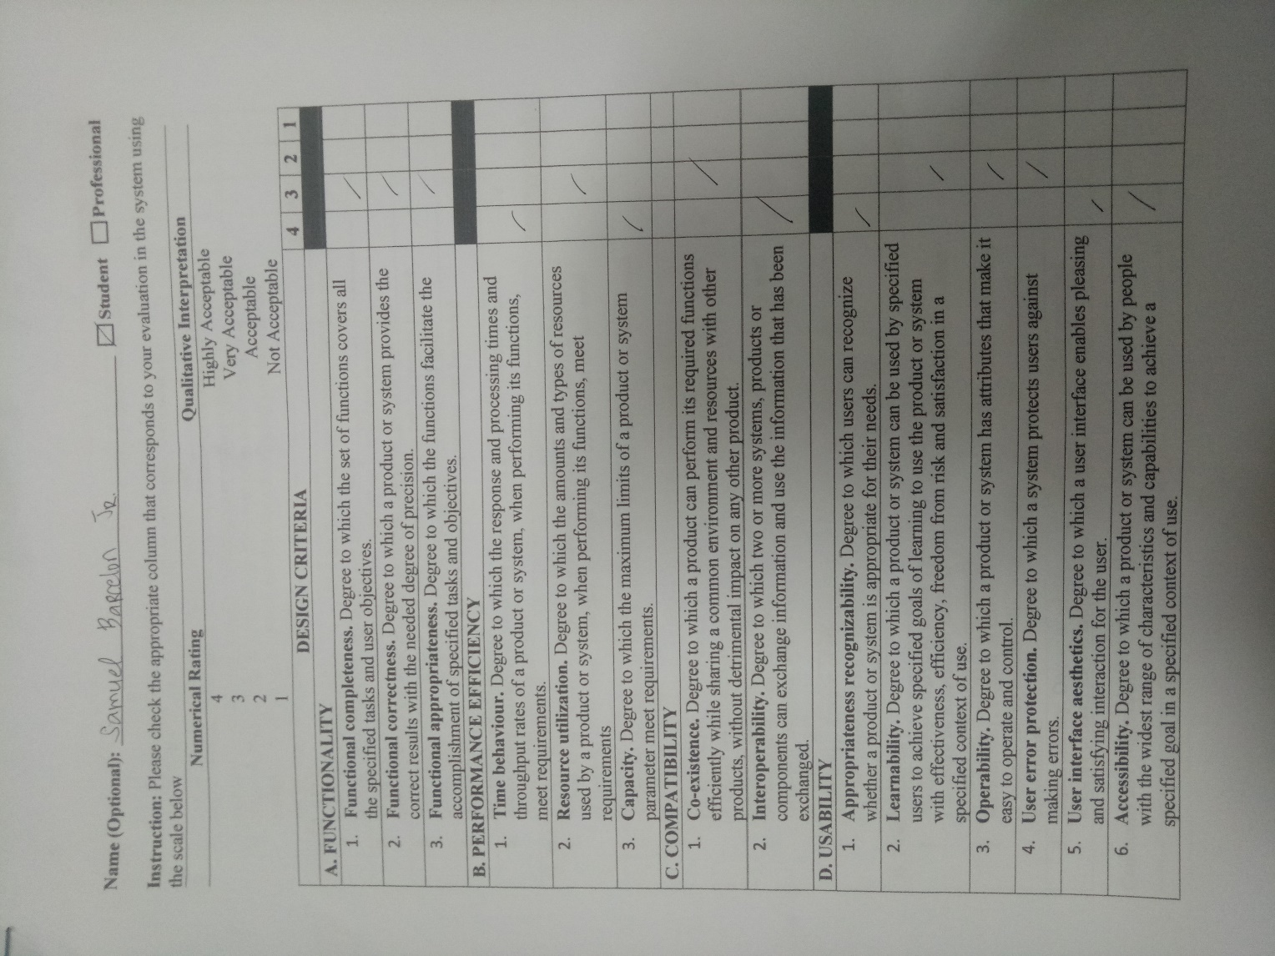

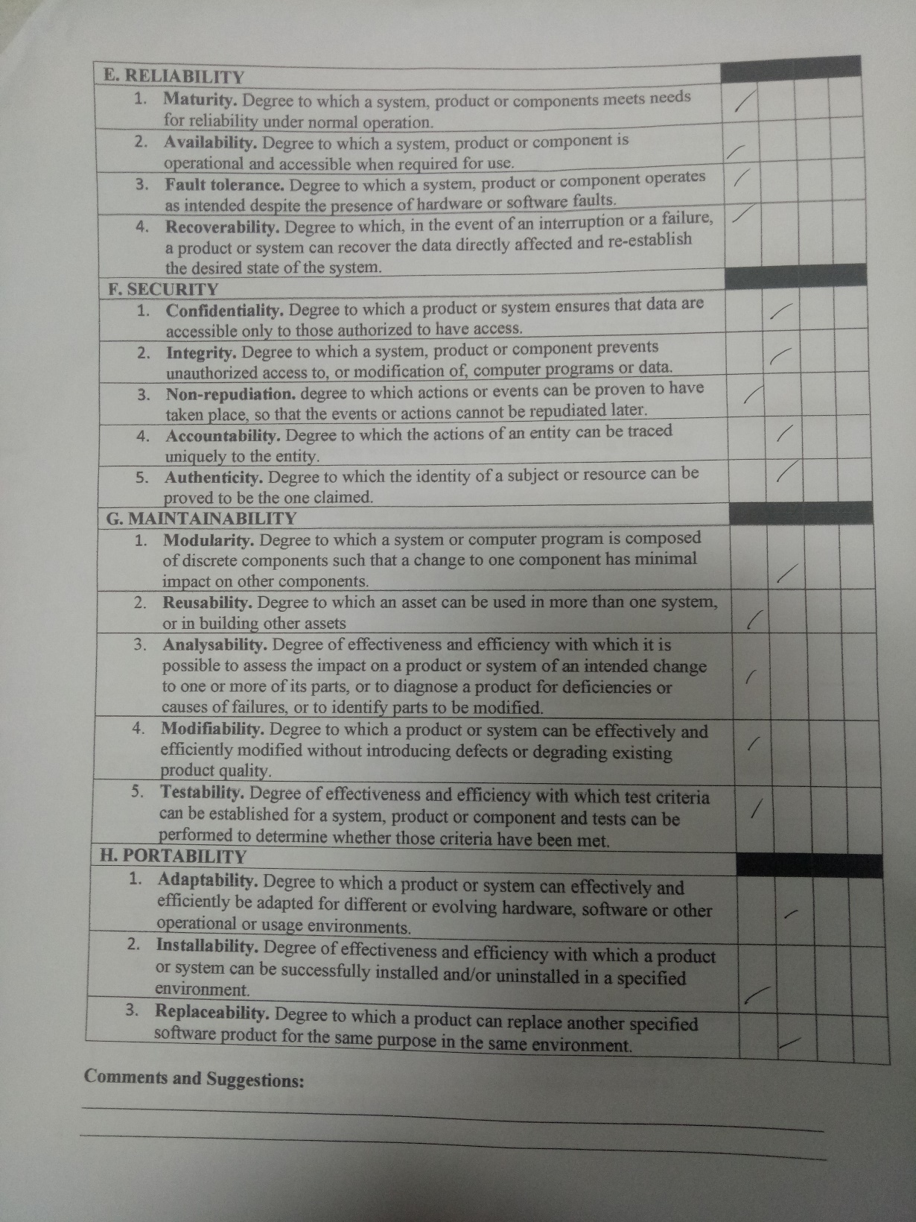

Appendix C

**SUMMARY OF RESPONDENTS EVALUATION**

|  |  |  |  |  |
| --- | --- | --- | --- | --- |
| **Criteria** | **4** | **3** | **2** | **1** |
| **Functionality** | | | | |
| Completeness | 33 | 17 | 0 | 0 |
| Correctness | 35 | 15 | 0 | 0 |
| Appropriateness | 35 | 15 | 0 | 0 |
| **Performance Efficiency** | | | | |
| Time behaviour | 31 | 19 | 0 | 0 |
| Resource utilization | 37 | 13 | 0 | 0 |
| Capacity | 31 | 19 | 0 | 0 |
| **Compatibility** | | | | |
| Co-existence | 29 | 21 | 0 | 0 |
| Interoperability | 35 | 15 | 0 | 0 |
| **Usability** |  |  |  |  |
| Appropriateness | 34 | 16 | 0 | 0 |
| Learnability | 31 | 19 | 0 | 0 |
| Operability | 34 | 15 | 1 | 0 |
| User Error Protection | 29 | 21 | 0 | 0 |
| User Interface Aesthetics | 33 | 16 | 1 | 0 |
| Accessibility | 30 | 20 | 0 | 0 |
| **Reliability** | | | | |
| Maturity | 32 | 18 | 0 | 0 |
| Availability | 35 | 15 | 0 | 0 |
| Fault tolerance | 29 | 21 | 0 | 0 |
| Recoverability | 37 | 13 | 0 | 0 |
| **Security** | | | | |
| Confidentiality | 29 | 21 | 0 | 0 |
| Integrity | 36 | 14 | 0 | 0 |
| Non-repudiation | 31 | 19 | 0 | 0 |
| Accountability | 38 | 12 | 0 | 0 |
| Authenticity | 39 | 11 | 0 | 0 |
| **Maintainability** | | | | |
| Modularity | 35 | 15 | 0 | 0 |
| Reusability | 36 | 14 | 0 | 0 |
| Analyzability | 34 | 16 | 0 | 0 |
| Modifiability | 40 | 10 | 0 | 0 |
| Testability | 37 | 13 | 0 | 0 |
| **Portability** | | | | |
| Adaptability | 34 | 15 | 1 | 0 |
| Installability | 36 | 13 | 1 | 0 |
| Replaceability | 30 | 19 | 1 | 0 |

Appendix D

**GANTT CHART**

|  |  |  |  |  |  |  |  |  |  |  |  |  |  |  |  |  |  |  |  |  |  |  |  |  |
| --- | --- | --- | --- | --- | --- | --- | --- | --- | --- | --- | --- | --- | --- | --- | --- | --- | --- | --- | --- | --- | --- | --- | --- | --- |
| **Activities** |  | | | | | | | | | | | | | | | | | | | | | | | |
| Documentation 1-3 |  |  |  |  |  |  |  |  |  |  |  |  |  |  |  |  |  |  |  |  |  |  |  |  |
| Plan and Design |  |  |  |  |  |  |  |  |  |  |  |  |  |  |  |  |  |  |  |  |  |  |  |  |
| Coding |  |  |  |  |  |  |  |  |  |  |  |  |  |  |  |  |  |  |  |  |  |  |  |  |
| Testing |  |  |  |  |  |  |  |  |  |  |  |  |  |  |  |  |  |  |  |  |  |  |  |  |
| Debugging |  |  |  |  |  |  |  |  |  |  |  |  |  |  |  |  |  |  |  |  |  |  |  |  |
| Project Evaluation |  |  |  |  |  |  |  |  |  |  |  |  |  |  |  |  |  |  |  |  |  |  |  |  |
| Documentation 4-5 |  |  |  |  |  |  |  |  |  |  |  |  |  |  |  |  |  |  |  |  |  |  |  |  |
| Final Defense |  |  |  |  |  |  |  |  |  |  |  |  |  |  |  |  |  |  |  |  |  |  |  |  |
| **Weak** | **1** | **2** | **3** | **4** | **1** | **2** | **3** | **4** | **1** | **2** | **3** | **4** | **1** | **2** | **3** | **4** | **1** | **2** | **3** | **4** | **1** | **2** | **3** | **4** |
| **Month** | **Sep** | | | | **Oct** | | | | **Nov** | | | | **Dec** | | | | **Jan** | | | | **Feb** | | | |

Appendix E

**USER’S MANUAL**

**WEBSITE**

1. **Sign up**
   1. Click the Sign up button on the homepage
   2. Fill up the required fields on the form then click Register
2. **Sign in**
   1. Click the Sign in button on the homepage
   2. Enter your username and password then click the Sign in button
3. **Logout**
   1. Click the Logout button on the header

**Company**

1. **Add transaction type**
   1. Choose Transaction on the sidebar menu
   2. Click the Add button below the table
2. **Add transaction account**
   1. Choose Account on the sidebar menu
   2. Click the Add button below the table
   3. Fill up the required fields on the form then click Add
3. **View Mobile Users**
   1. Choose Mobile Users on the sidebar menu
4. **Account Setting**
   1. Choose Setting on the sidebar menu
   2. Click the Edit Account button
   3. Click Save
5. **Change Password**
   1. Choose Setting on the sidebar menu
   2. Click the Change Password button
   3. Enter your current password and your new password
   4. Click Save

**Window**

1. **Start Transaction**
   1. Hover to the big orange box
   2. Scan QR Code using QR Scanner
   3. Click Done button after transaction
2. **View Mobile Users**
   1. Choose Mobile Users on the sidebar menu
3. **Notify User**
   1. Choose Mobile Users on the sidebar menu
   2. Click Notify
4. **Expire Transaction**
   1. Choose Mobile Users on the sidebar menu
   2. Click Expire Transaction
5. **Close All Transaction**
   1. Choose Mobile Users on the sidebar menu
   2. Click Close All Transaction

**ANDROID APPLICATION**

**Customer**

1. **Sign in**
   1. Enter your username and password
   2. Click Log in button
2. **Sign up**
   1. Click Register Now button on the Login page
   2. Fill up the required fields on the form
   3. Click Register button
3. **Account Setting**
   1. Click the menu bar on the right top of the application
   2. Click Settings
   3. Click Edit Info
   4. Click Save
4. **Change Password**
   1. Click the menu bar on the right top of the application
   2. Click Settings
   3. Click Edit Password
   4. Enter your current password and new password
   5. Click Save
5. **Make transaction**
   1. On your profile page, click the Make Transaction button
   2. Choose company from the list
   3. Choose transaction from the list
   4. Choose time from the list
   5. Click Confirm
6. **Manage transaction**
   1. On your profile page, click the Make Transaction button
   2. Click Pending Transaction to see pending transactions
   3. Click Past Transactions to see past transactions
7. **View QR Code**
   1. On your profile page, click the Make Transaction button
   2. Click Pending Transaction to see pending transactions
   3. Click Past Transactions to see past transactions
   4. Choose from the list of your transactions
8. **Logout**
   1. Click the menu bar on the right top of the application
   2. Click Log Out