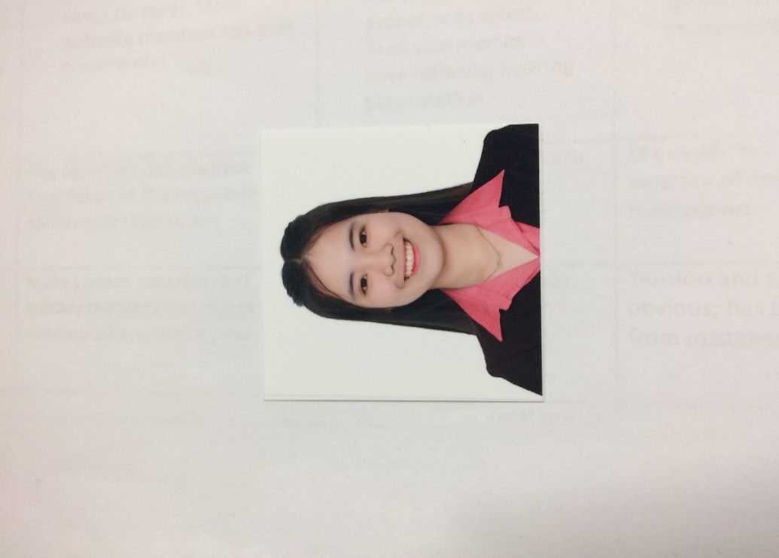

**Elisha R. Evangelista**

09361904384

****elishaevangelistaa@gmail.com

125 Astorga St., Brgy 37,2nd Ave., Caloocan City

**PERSONAL INFORMATION**

**SKILLS AND ABILITIES**

**Place of Birth** : Makati City

**Date of Birth** : December 31, 1998

**Gender** : Female

**Height** : 4’11

**Weight** : 43kg

**Nationality** : Filipino

**Civil Status** : Single

**Religion** :Born Again

Proficient in oral and written communication

**Programming Languages:**

C/C++

HTML

Java

CSS

**Database:**

MySQL

**Tools:**

Turbo C

Visual Basic

NetBeans

Adobe Photoshop

Adobe Illustrator

Adobe Animate

**EDUCATION**

**Technological University of the Philippines – Manila**

***Bachelor of Science in Computer Science***

2015 – Current

**Florentino Torres High School**

***High School***

2011 – 2015

**Barrio Obrero Elementary School**

***Elementary***

2005 – 2011

**WORK EXPERIENCE**

**Travelbook**

***OJT***

April 2018 – May 2018

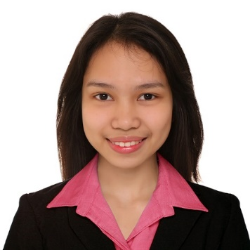

**Candy Amaya C. Lelis**

09771273912

lelisamaya02@yahoo.com

Blk 19 Lot 21 Anahaw 1 Silang Cavite

**PERSONAL INFORMATION**

**SKILLS AND ABILITIES**

**Place of Birth** : Silang Cavite

**Date of Birth** : Feb. 2, 1999

**Gender** : Female

**Height** : 4’11

**Weight** : 39kg

**Nationality** : Filipino

**Civil Status** : Single

**Religion** :Roman Catholic

### **Programming Languages:** C, C++, HTML, Java, Assembly Language, Python, PHP, JavaScript, CSS

### **Databases:** MySQL, Apache Derby

### **Tools:** Turbo C, Visual Basic, NetBeans, Eclipse, FoxPro, PyCharm, Adobe Photoshop, Adobe Illustrator, Adobe Animate, text editors

### Self-motivated, has initiative and high level energy;

### Good verbal and leadership skills;

### Tolerant and flexible to different situations;

### Adaptable and has ability to work under pressure;

Efficient in time management, a good listener, and quick

**EDUCATION**

**Technological University of the Philippines – Manila**

***Bachelor of Science in Computer Science***

2015 – Current

**Philippine Christian University – Dasmariñas**

***High School***

2011 – 2015

**Bulihan Sites and Services Project Elementary School**

***Elementary***

2005 – 2011

**WORK EXPERIENCE**

**Sytian IT Solutions**

***OJT***

April 2018 – May 2018

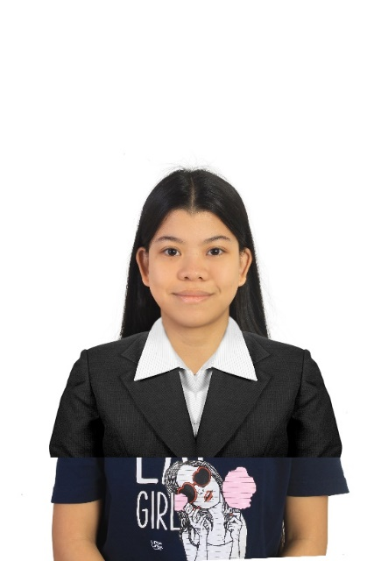

**Kathlyn R. Teves**

09957953644

****[teveskathlyn@yahoo.com](mailto:teveskathlyn@yahoo.com)

2504 P. Villanueva St. Pasay City

**PERSONAL INFORMATION**

**COMPUTER**

**SKILLS**

**Place of Birth** : Sipocot, Camarines Sur

**Date of Birth** : January 6, 1999

**Gender** : Female

**Height** : 154cm

**Weight** : 46kg

**Nationality** : Filipino

**Civil Status** : Single

**Religion** :Roman Catholic

**Operating Systems:** Windows, Linux (Ubuntu)

**Programming Languages:** Java, C/C++, PHP, HTML, CSS, JavaScript

**Database:** MySQL

**Tools:** NetBeans, Turbo C,Text Editors, Adobe Photoshop, Adobe Animate, MS Office (Word, PowerPoint).

**EDUCATION**

**Technological University of the Philippines – Manila**

***Bachelor of Science in Computer Science***

2015 – Current

**Sta. Clara Parish School**

***High School***

2011 – 2015

**Jose Rizal Elementary School**

***Elementary***

2005 – 2011

**WORK EXPERIENCE**

**Federal Land**

***OJT***

April 2018 – June 2018