**CERTIFICATE OF PROOFREADING**

This is to certify that the paper with the provisional title **Android-based Queuing System Using QR Code,** to be submitted by **Evangelista, Elisha R., Lelis, Candy Amaya C. and Teves, Kathlyn R.** of **Technological University of the Philippines**, has been proofread.

Signed this 25th of February in Silang Cavite.

Signed:

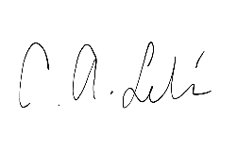

**Ciela Aunica C. Lelis**

English Teacher