COS10029 Fundamentals of Programming

Assignment 1 report

Name: Amaya Ekanayake
Student ID:104358635
Lab class: Wednesday/ 12.00-16.00/Edison Hall
Teacher: Nuwan Jayasekara
Due Date: Thursday 10th August 2023 at 11:59 pm
Date Submitted: Thursday 10th August 2023 at 8.10pm

Question 1

Program description

This program enables the generation of drawings upon button clicks. By selecting button number 1, a specific drawing is displayed, and choosing button number 2 reveals a different drawing. Each drawing is rendered on a fresh canvas, clearing any previous content.

Source code:

#include <iostream>
#include "splashkit.h"

int main()
{
open_window("Button drawing", 800, 800);
clear_screen(COLOR_WHITE);

while (not quit_requested())
{
process_events();

//button 1
fill_rectangle(COLOR_RED, 0, 0, 50, 50);
draw_text("B1", COLOR_WHITE, 20, 20);

//button 2
fill_rectangle(COLOR_BLUE, 750, 0, 50, 50);
draw_text("B2", COLOR_WHITE, 770, 20);

if (mouse_clicked(LEFT_BUTTON) && mouse_x() <= 50 && mouse_y() <= 50)

{clear_screen(COLOR_LIGHT_BLUE);
//darwing

fill_rectangle(COLOR_BROWN, 0,425,800,50);

//Bird legs
fill_rectangle(COLOR_BLACK, 400, 390, 10, 40);
fill_rectangle(COLOR_BLACK, 450, 390, 10, 40);
fill_rectangle(COLOR_BLACK, 395, 430, 25, 10);
fill_rectangle(COLOR_BLACK, 445, 430, 25, 10);

//Bird face
fill_circle(COLOR_ORANGE,250,300,50);

//Bird beak
fill_triangle(COLOR_RED, 150, 300,200,285, 200, 315);

// Bird eye
fill_circle(COLOR_BLACK,225,285,10);

//Body
fill_ellipse(COLOR_ORANGE, 300, 200, 250, 200);

refresh_screen(60);
}

else if (mouse_clicked(LEFT_BUTTON) && mouse_x() >= 750 && mouse_y() <= 50)
{
clear_screen(COLOR_LIGHT_BLUE);
// Drawing

// Draw ground
fill_rectangle(COLOR_GREEN, 0, 450, 800, 150);

// Draw walls
fill_rectangle(COLOR_BROWN, 200, 350, 400, 100);

// Draw walls
fill_rectangle(COLOR_BROWN, 350, 250, 100, 50);

// Draw factory chimney
fill_rectangle(COLOR_BLACK, 440, 200, 20, 50);

// Draw ellipse as a cloud
fill_ellipse(COLOR_WHITE, 400, 100, 200, 90);

// Draw windows
fill_circle(COLOR_WHITE, 280, 380, 20);
fill_circle(COLOR_WHITE, 400, 380, 20);
fill_circle(COLOR_WHITE, 520, 380, 20);

// Draw triangular roof
fill_triangle(COLOR_GRAY, 200, 350, 600, 350, 400, 200);

refresh_screen(60);

}
refresh_screen(60);
}

return 0;
}

Screenshots showing working program (Show all possible outcome):

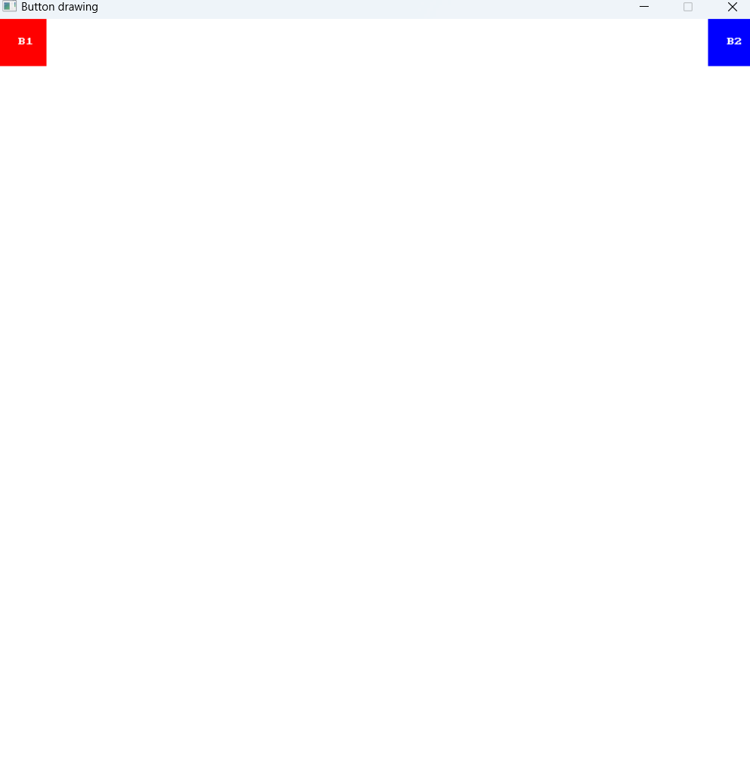
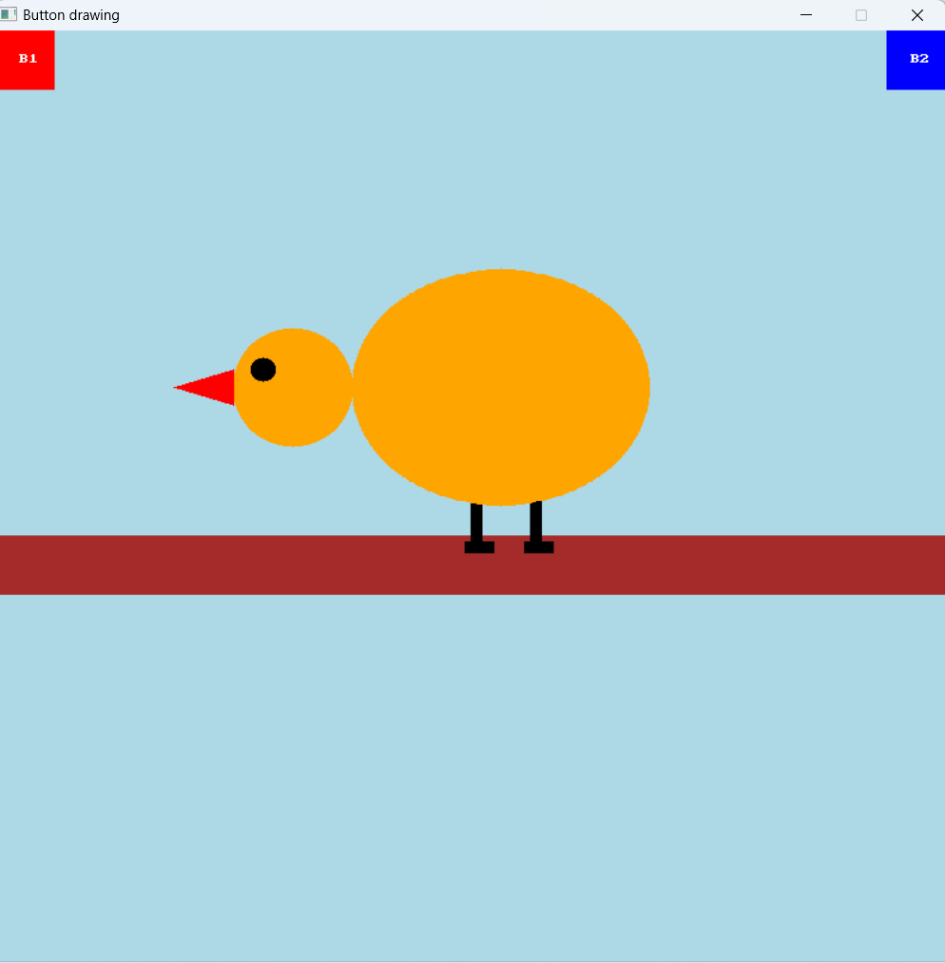

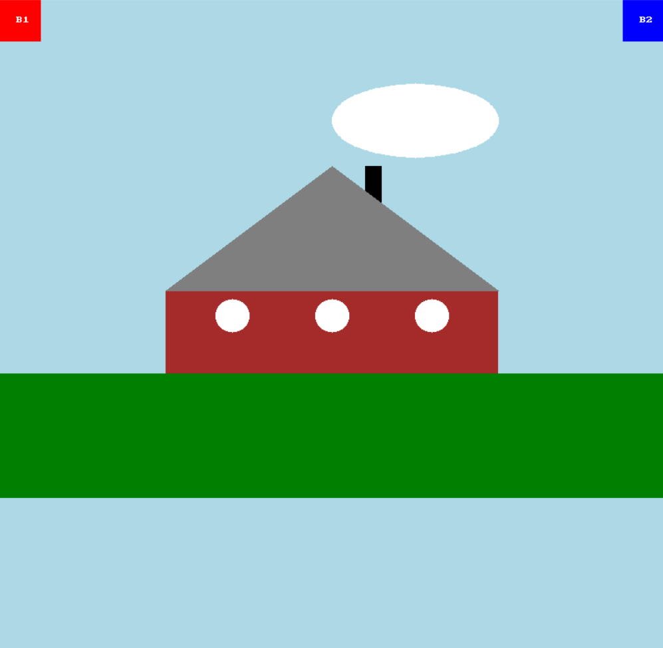

Question 2

Program description
This program is designed to calculate the weekly pay for each employee and the total payroll for a two-week period (fortnight). It caters to four distinct types of employees, each with their own unique wage calculation:

1. **Team Leaders**: Team leaders receive a fixed salary for every fortnight.

2. **Sales Workers**: Sales workers earn a base amount of $500 plus an additional 6.5% of their gross fortnightly sales.

3. **Pieceworkers**: Pieceworkers are compensated based on the quantity of items they produce. They receive a set amount of money per item, with each pieceworker specializing in a specific type of item.

4. **Hourly Workers**: Hourly workers are paid based on their hours worked. They earn a predetermined hourly wage for the first 60 hours worked and then receive "time-and-a-half" (1.5 times their hourly wage) for any overtime hours worked beyond the initial 60 hours.

This application streamlines the process of calculating various employee wages, considering the unique compensation structures for each employee type. It facilitates accurate and efficient payroll management, ensuring employees are fairly compensated in accordance with their respective roles and work arrangements.

Source code:

#include <iostream>

using namespace std;

int main()
{
int code;
double PRate;//pay rate
double fpay;//fortnightly pay
double total; //total play roll

do
{
cout<<"Enter employee's number code (-1 to end): ";
cin>>code;
if (code >=1 && code<=4 && code != -1)
{
switch (code){
case 1: // Team Leader: Calculate and display team leader's pay

cout<<"Enter the Team leaders's pay rate: ";
cin>>fpay;
cout<<"fortnightly pay is: "<<fpay<<endl;
cout<<" \n"<<endl;
break;

case 2:// Sales Worker: Calculate and display sales worker's pay

double gross;//employee's gross weekly sales

cout<<"Enter Sales employee's gross weekly sales: ";
cin>>gross;

fpay=500+(gross/6.5*100);//(to calculate fortnightly pay salary )
cout<<"fortnightly pay is: "<<fpay<<endl;
cout<<"\n "<<endl;
break;

case 3:// Pieceworker: Calculate and display piece worker's pay

int pieces;
double pppayrate;//employee's per piece pay rate

cout<<"Enter the number of pieces completed: ";
cin>>pieces;

cout<<"Enter the employee's per piece pay rate: ";
cin>>pppayrate;

fpay= pppayrate*pieces;//(to calculate fortnightly pay salry)
cout<<"fortnightly pay is:"<<fpay<<endl;
cout<<" \n"<<endl;
break;

case 4:// Hourly Worker: Calculate and display hourly worker's pay

double hours;

cout<<"Enter hourly worker's pay rate: ";
cin>>PRate;
cout<<"Enter the number of hours worked: ";
cin>>hours;

// Calculate pay considering overtime hours
if(hours>60)
{
fpay = (PRate*60) + ((hours-60)*(PRate*1.5)); //(this is for first 60 hours calculation)

cout<<"fortnightly pay is: "<<fpay<<endl;
cout<<" "<<endl;
}
else
{
fpay=(PRate*hours);//(this is overtime worked)
cout<<"fortnightly pay is: "<<fpay<<endl;;
cout<<" \n"<<endl;
}
break;
}
total =total + fpay; // Add the calculated pay to total payroll
}
else if (code != -1)
{
cout<<"You have entered an invalid code."<<endl;
cout<<" \n"<<endl;
}

}while(code != -1);

cout<<"The total payroll for the fortnight is: "<<total;
return 0;
}

Screenshots showing working program (Show all possible outcome):
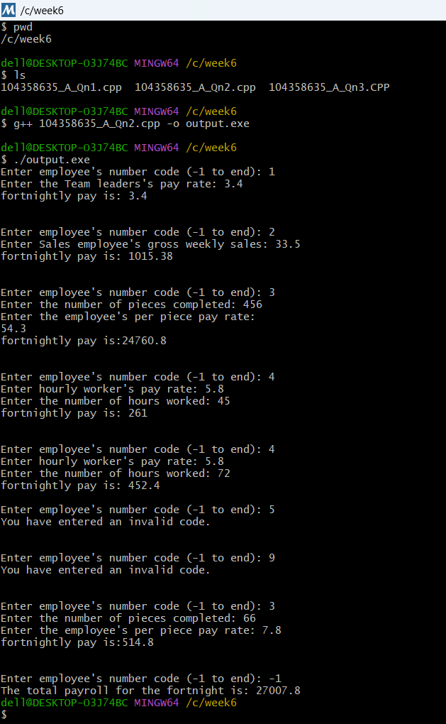

Question 3

Program description
Remove the grey text and insert your content.

This program brings a dice game where a participant rolls three six-sided dice, totalling the numbers on the upward faces after they settle. Winning occurs if the sum is 13 or higher on the first roll, while losing happens with a total of 6 or lower. If the sum falls between 7 and 12 in the initial roll, that number becomes the player's "point," and they continue rolling until they match it. Yet, if the player's total reaches 15 or more at any point during this process, they lose. This program determines game outcomes, declaring players as winners or losers based on these criteria.

Source code:

#include <iostream>
#include <cstdlib>
#include <ctime>

using namespace std;

int main()
{
// Define the range of dice values
int lower =1;
int upper =7;
int point;

srand(time(NULL)); //generate a unique seed

// Initialize variables to store dice rolls and sums
int rand1;
int rand2;
int rand3;
int sum =0;
int sum1=0;

// Simulate the first set of dice rolls and calculate sum
rand1=(rand() % (upper-lower)+ lower);
rand2=(rand() % (upper-lower)+ lower);
rand3=(rand() % (upper-lower)+ lower);
sum= rand1+rand2+rand3;
cout<<"Player rolled "<<rand1<<" + "<<rand2<<" + "<<rand3<<" = "<<sum<<endl;

// Determine outcome based on the sum of the first set of rolls
if(sum >=13)
{
cout<<"Player wins";
}
else
{
if (sum >6 && sum<13)
{

// Establish a point for the player
cout<<"Point is "<<sum<<endl;
point=sum;
do
{
// Simulate additional dice rolls for the player
sum1 = 0;
rand1=(rand() % (upper-lower)+ lower);
rand2=(rand() % (upper-lower)+ lower);
rand3=(rand() % (upper-lower)+ lower);
sum1= rand1+rand2+rand3;
cout<<"Player rolled "<<rand1<<" + "<<rand2<<" + "<<rand3<<" = "<<sum1<<endl;

// Determine outcomes within the point-establishing loop
if (sum1==point)
{
cout<<"Player wins";
break;
}
else if (sum1 >=15)
{
cout<<"Player loses";
break;
}

}while(sum1 != -1);// Loop until a specific condition is met

}
else
{
cout<<"Player loses";
}
}
// End of the game
return 0;
}

Screenshots showing working program (Show all possible outcome):

