

Indian Institute of Technology Guwahati

Department of Mechanical Engineering

MTP Phase 1

Optimization of 3d printing of ceramic components

Submitted by

Amay B. Gholpe (214103205)

Under the Supervision

of

Prof. P.S.Robi & Prof. Sukhomay Pal

**Abstract**:

Along with extensive research on the three-dimensional (3D) printing of polymers and metals, 3D printing of ceramics is now the latest trend to come under the spotlight. The ability to fabricate ceramic components of arbitrarily complex shapes has been extremely challenging without 3D printing. This review focuses on the latest advances in the 3D printing of ceramics and presents the historical origins and evolution of each related technique. The main technical aspects, including feedstock properties, process control, post-treatments and energy source–material interactions, are also discussed. The technical challenges and advice about how to address these are presented. Comparisons are made between the techniques to facilitate the selection of the best ones in practical use. In addition, representative applications of the 3D printing of various types of ceramics are surveyed. Future directions are pointed out on the advancement on materials and forming mechanism for the fabrication of high-performance ceramic components.

List of Figure

1. Schematics of stereolithography
2. Schematics of SLS
3. Schematics of SLM
4. Schematics of FDM
5. Schematics of LOM
6. Slurry Preparation
7. Methodology

List of Tables

1. Overview of Slurry
2. Overview of process

|  |  |
| --- | --- |
| Content | |
| List of figures | 3 |
| List of Tables | 3 |
| Chapter 1: Introduction | 5-14 |
| 1.1 Introduction | 5 |
| 1.2 Ceramic 3D Printing   1. Sterolithography 2. Selective Laser Sintering 3. Selective Laser Melting 4. Fused Deposition Modelling 5. Laminated Object Manufacturing 6. Direct Ink Writing   1.2.6.1. Slurry  1.2.6.2. Debinding and sintering | 6  7  8  9  10  11  12  12  13 |
| Chapter 2: Literature Review   1. Direct Ink Writing of Alumina Ceramics 2. Direct Ink Writing of Other Ceramics 3. Research Gap 4. Proposed Objective | 15-18  15  16  17  18 |
| Chapter 3. Methodology | 19 |
| References | 20 |

Introduction:

Manufacturing is the important part of engineering especially mechanical engineering. And manufacturing is the part of achiving the desired shape for the components with the desired properties and in during the manufacturing there are several types of manufacturing technique each having its own advantages and limitations over a last few centuries manufacturing was carried out by casting Technique and machining technique or by material removal method. In the recent few decades additive manufacturing has been introduced which have a lot of advantange achiving the desired shape and leading to reduction in the loss of material compared to machining techniques. We can have the shape with precision and it is the faster method production specially for Prototyping. The techniques is easy to get complex shape.

Coming to additive manufacturing. This technique is based on adding layer by layer and building up the particular shape. There are several methods of additive manufacturing such as STL, Selective laser sintering (SLS), Selective laser Melting (SLM), digital light processing DLP,ink jet printing (IJP),Fused deposition modelling (FDM), Laminated object manufacturing (LOM) and Direct Ink writing (DIW).the extensive use of additive manufacturing so far is confined to 3d printing which is generally polymer material composite material are also madebut when it comes to manufacture costly material or advance material including metallic alloys and ceramics it at the stage of development some of the techniques for metals are SLM, SLS, Powder Bed Fusion, Electron Beam Melting. **In metallic material draw back high cost involved** fully or partially melted is required and it is extremely costly. And now recent attention has been to the engineering ceramics. Additive manufacturing (AM) techniques of ceramics bring opportunities for rapid fabrication of complex shaped ceramic components in a range of structures from macroscale - e.g., in thermal protection systems - to microscale - e.g., photocatalysts, sensors. The high melting point and of the ceramics material are impediments of manufacturing of ceramics material however in some cases it can be it can be very effectively uthilizefor manufacturing ceramic naterials by 3d printing. This is basically beposting a slurry the developments of additive manufacturing. With the increasing demand for complex ceramic structures, several additive manufacturing techniques have been successfully developed, such as selective laser melting (SLM), stereolithography (SLA), selective laser sintering (SLS) and binder jetting (BJ). However, most of these techniques are powder-based and often involve time-consuming binder removal process. The following consolidation into a dense part is generally rather difficult due to the burn-out of large amounts of organic additives, leading to unavoidable residual pores and the sacrifice of the printing resolution. Ceramic components with highly complex structures that are extremely difficult to be fabricated using conventional manufacturing methods can now be processed via 3D printing techniques. The high melting points of ceramics impose a greater demand on the fabrication process. The coarse surface finish, undesirable porosity and large shrinkage of ceramic parts after processing also limit their areas of application.

Tabel 1. Overview of Slurry

|  |  |  |
| --- | --- | --- |
| **Slurry Based** | **Powder based** | **Bulk solid technologies** |
| Stereolithography (STL) | 3d printing(3DP) | Laminated object printing (LOM) |
| Direct Ink Writing (DIW) | Selective Laser Melting (SLM) | Fused deposition modelling (FDM) |
| Digital light processing (DLP) | Selective Laser Sintering (SLS) |  |
| Ink jet printing (IJP) |  |  |

3D Printing of Ceramics:

Ceramics are agile and adaptable materials because of their exceptional qualities, including great mechanical strength and hardness, high oxidation resistance, and strong chemical and thermal stability with or without binders and other additives, ceramic goods are often shaped into the necessary forms using traditional processes including injection molding, die pressing, tape casting, gel casting, etc. However, these methods are always constrained by their high duration, high expense and limited accuracy. Moreover, because molding and pricey tooling are required, it is difficult to make complicated shaped geometries such pieces with interior holes or curved surfaces. The net shape 3D ceramic components may be manufactured using AM as a substitute to the traditional formative technique without the use of expensive tooling. The development of 3D printing in the production of ceramic components opens up new avenues for tackling the difficulties and constraints. 3D printing is a competitive manufacturing technology, which has opened up new possibilities for the fabrication of complex ceramic structures and customized parts. **There is major 4 ceramics widely used in the 3d printing 1: Al2O3 2: SiO2 3: ZrO2 4: SiC.** As compared to metal the ceramics have relative characteristics, high strength, brittleness hardness, high young’s modulus; low toughness, density, thermal expansion, electric conductivity.

Slurry based Ceramic 3D printing technology allow green bodies to be fabricated at high packing densities. It involves liquid systems dispersed with fine ceramic particles as feedstock either in the form of inks or pastes, depending on the solid content. In this section, photo polymerization-based techniques such as Stereolithography along with Inkjet printing and extrusion based Direct Ink Writing (DIW) is discussed.

1. Stereolithography:

SLA is a special [3D printing](https://www.sciencedirect.com/topics/engineering/3d-printing) manufacturing process. When scanned through a noncuring resin, a programmed UV laser beam allows for [photopolymerization](https://www.sciencedirect.com/topics/engineering/photopolymerisation) of the first layer, followed by the creation of subsequent layers by moving the polymer reservoir down or up. This light-based 3D printing approach has been studied to create different biomedical [microdevices](https://www.sciencedirect.com/topics/materials-science/microdevices), including tissue scaffolds because of its unique characteristics of high-resolution and precise construction compared to other 3D printing methods, achieved by controlling the different aspects of the photons applied. Sometimes a single initiation is used for in situ polymerization, but due to its enhanced controllability two photon processes are gaining interest. Due to primary initiation, a higher-resolution SLA printer (100 nm) was developed for the development of intricate structures. As a dust-free mounting device, SLA can be used to cope with difficulties with dust accumulation that specially occur during printing. However, through processing time, permitted [resin materials](https://www.sciencedirect.com/topics/engineering/resin-material), complexity, and thermomechanical efficiency affect SLA.

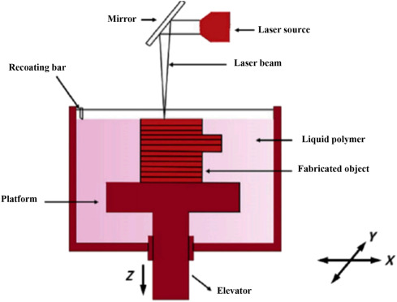

Fig.1 Schematics of Stereolithography.

Advantages:

* Flexibility in choosing different light sources such as lasers, lamps or LEDs.
* Precision parts can be printed in minutes by exploiting high output speed and high resolution.
* It can print light sensitive hydrogels layer by layer rather than in straps or droplets.
* The total printing time depends only on the thickness of the structure. Printing time for each layer is same no matter how complex or large the layer is.

Disadvantages:

* Post processing of part is required to remove excessive resin due to the stickiness of resin.
* The current stereolithography parts do not possess impact strength and durability as compared to injection molded thermoplastics.
* Support structures are required to firmly attach the part to the print bed and prevent warpage.

Applications:

* High elastic silicones for usage in soft robotics
* It has been explored in the field of microfluidics where small fluid volumes need to be precisely controlled through micro sized channels.

1. Selective laser sintering:

As suggested by the method name, an SLS involves selectively irradiating the target powder bed's surface with a high-power laser beam. The powder is then heated, causing interparticle fusing, or sintering, to occur for bulk joining. The prior surface is then covered with a fresh coating of powder for the subsequent heating and joining cycle. In this manner, the procedure is carried out repeatedly until the specified 3D item is manufactured. During an SLS process, overhanging regions don't require any additional support structures because the loose powder in the bed surrounds them at all times. 2001. In an SLS process, as its name implies, a high-power laser beam is used to selectively irradiate the surface of the target powder bed. The powder then heats up and sintering (i.e. interparticle fusion) takes place for bulk joining. After this, a new layer of powder is spread onto the previous surface for the next run of heating and joining. In this way, the process is repeated layer by layer until the designed 3D part is fabricated. No extra support structures have to be intentionally prepared for overhanging regions during an SLS process, as they are surrounded by the loose powder in the bed at all times. A schematic diagram of the SLS process is shown in fig.2. The original intention of SLS was to make wax models for invest-ment casting of metallic prototypes (e.g. aluminium). SLS has been extensively studied to process a broad range of powdered materials, starting with plastic and polymer powders of lower melting/softening points [193–196], such as acrylonitrile butadiene styrene (ABS), poly-vinyl chloride (PVC), polyether ether ketone (PEEK), polycarbonate (PC), polyamide (PA) and other composites, and later extended to metals (e.g. aluminium, iron and copper) and composite powders with relatively higher melting point.

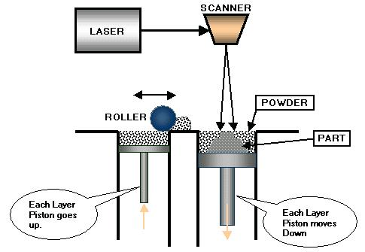

Fig. 2 Schematics of SLS.

1. Selective laser melting:

SLM is one of the 3D printing technologies that is expanding the fastest, especially in the metal forming industry. This is mostly due to its capacity to produce sturdy metal components in a single step, allowing for the simultaneous acquisition of the parts final shape and qualities. When SLM is used on ceramic powder, full melting of the powder creates a solid component via layer-by-layer, high-energy density laser scanning, which eliminates the need for binders or post-sintering because the powder is fully melted and fused. As a result, it is anticipated that complicated components with greater purity, density, and strength would be manufactured in less time. SLM is thought to be the only 3D printing technique that permits the production of fully dense, highly durable, and intricately shaped ceramic objects from ceramic powders in a single step. Many factors, including feedstock characteristics, fabrication parameters, fabrication position and orientation, post-processing, and the physical and chemical properties of the interaction in the fabrication process, including the interaction of the energy source and the materials, affect the overall quality of an SLM-produced ceramic part. The slice thickness, which may affect the part's manufacturing time and surface roughness, is one of the most crucial fabrication factors.

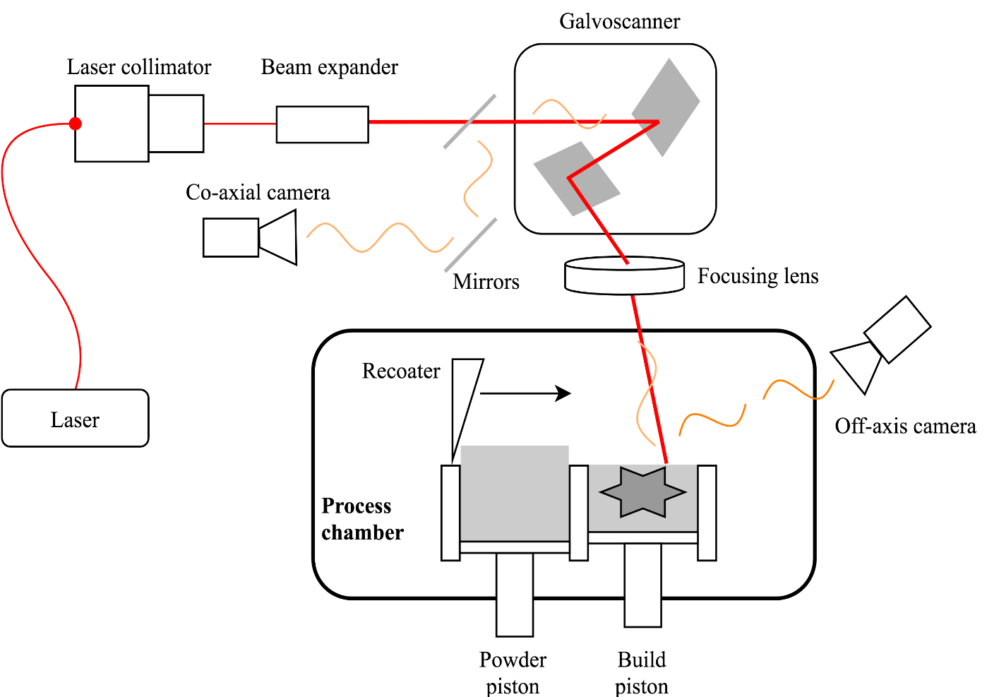

Fig.3 Schematics of SLM.

1. Fused deposition modelling (FDM):

FDM machines are projected to have the biggest unit shipments out of all the many types of 3D printers Due to its many benefits, including ease of use, flexibility in unit size, ease of DIY usage, and, most crucially, their low cost. The most popular materials for FDM 3D printing are thermoplastic polymers in filament form, such as ABS, PC, PA, and polylactic acid (PLA). In the FDM method, the material filament is continually fed into and heated within a moving nozzle to a temperature slightly over its melting point, allowing it to be readily extruded through the nozzle to create layers. The substance quickly hardens over the previously printed layer after extrusion. The platform then descends, similar to some other 3D printing techniques, to allow for the extrusion of the subsequent layer. When the part is finished, supports can be constructed and then removed. The layer thickness, which in turn depends on the nozzle size, determines the part's vertical dimensional resolution. A schematic representation of the FDM procedure is shown fig.4.

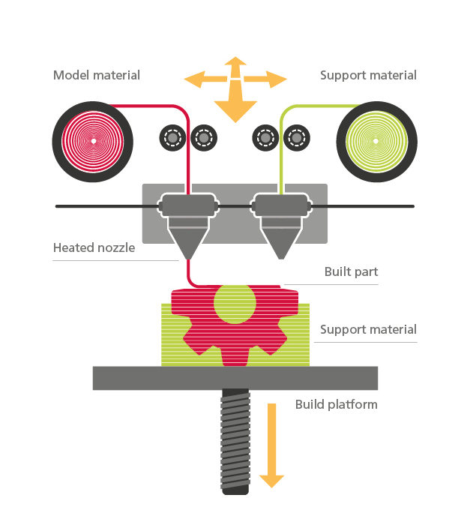

Fig. 4 Schematics of FDM.

1. Laminated Object Manufacturing (LOM):

LOM was initially designed to produce components made of paper, plastic, and metal. The technique typically entails layer-wise adhesion of one cut sheet on top of another, pre-coated with adhesive chemicals, to create 3D components. Thin sheets of material are produced and computer-controlled laser cut into cross sections according to sliced digital CAD models. Real-time heating and mechanical compression can be used to bond and laminate neighboring layers. Due to the minimal thermal stresses created during manufacture, this approach has the benefit of preventing distortion and deformation. However, as delamination, interfacial porosities, and anisotropic characteristics in the planar directions and the building direction are the typical difficulties associated with weak interfacial bonding behaviors between layer, the primary drawbacks are also directly related to such a procedure.

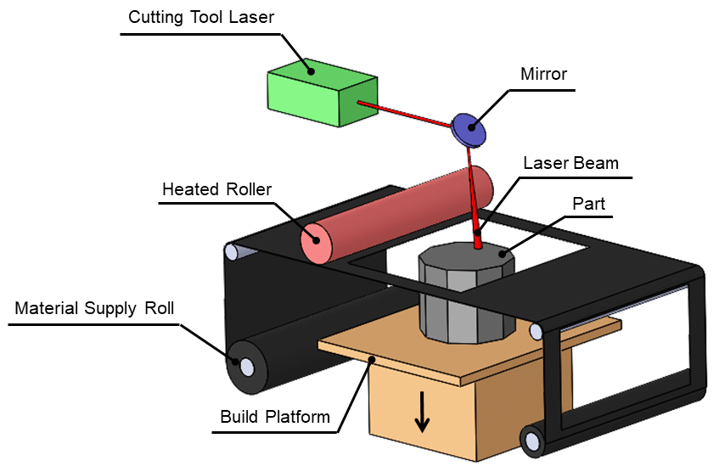

Fig. 5 Schematics of LOM.

1. Direct Ink Writing (DIW):

Possibility for the additive production of ceramic objects by extrusion is direct ink writing (DIW), a process in which a highly viscous raw material is extruded in layers at room temperature. This method, also called robocasting (RC), for processing ceramic masses with a low organic content was developed in 1997. The spectrum of applications ranges from the production of ceramic composite components to filter and battery technology to medical or artistic applications. Robocasting is also a promising method for the production of ceramic parts for construction applications. The process is characterized by its ability to produce complex shapes cheaply and quickly. The high solid content in the raw material ensures that the blank retains its shape in the finishing process.

1. Slurry Preparation:

The slurry needs to exhibit the appropriate rheological behavior. In order to produce continuous filaments, it must, on the one hand, have a viscosity that is low enough to pass through nozzles at low pressure without clogging. On the other hand, it must be able to maintain the form of the nozzle and have enough yield strength and stiffness to sustain layer stacking. The colloidal suspension of ceramic particles (40–50 vol% or 60–80 wt%), binder materials, deionized water, and appropriate additives make up the slurries for DIW. To disperse the particle clumps and guarantee thorough mixing, the suspension is next ball milled in a planetary mixer. Degassing is then performed on the resultant slurry to release any retained air. In general, any agglomeration or air bubble must be eliminated before printing and the slurry must be homogeneous. The amount of solids in the slurry is of utmost significance. Fig.6 displays the comprehensive schematic for the creation of the ceramic slurry. High solid loading is generally incorporated into the suspension designs since it raises the yield stress needed to preserve structural integrity. Additionally, high solid loading raises the density of the green body to maximise densification and minimise dimensional error in the finished component. The compatibility of the organic binders, additives, dispersants, and plasticizers must be carefully adjusted as it relies on the ceramic material.

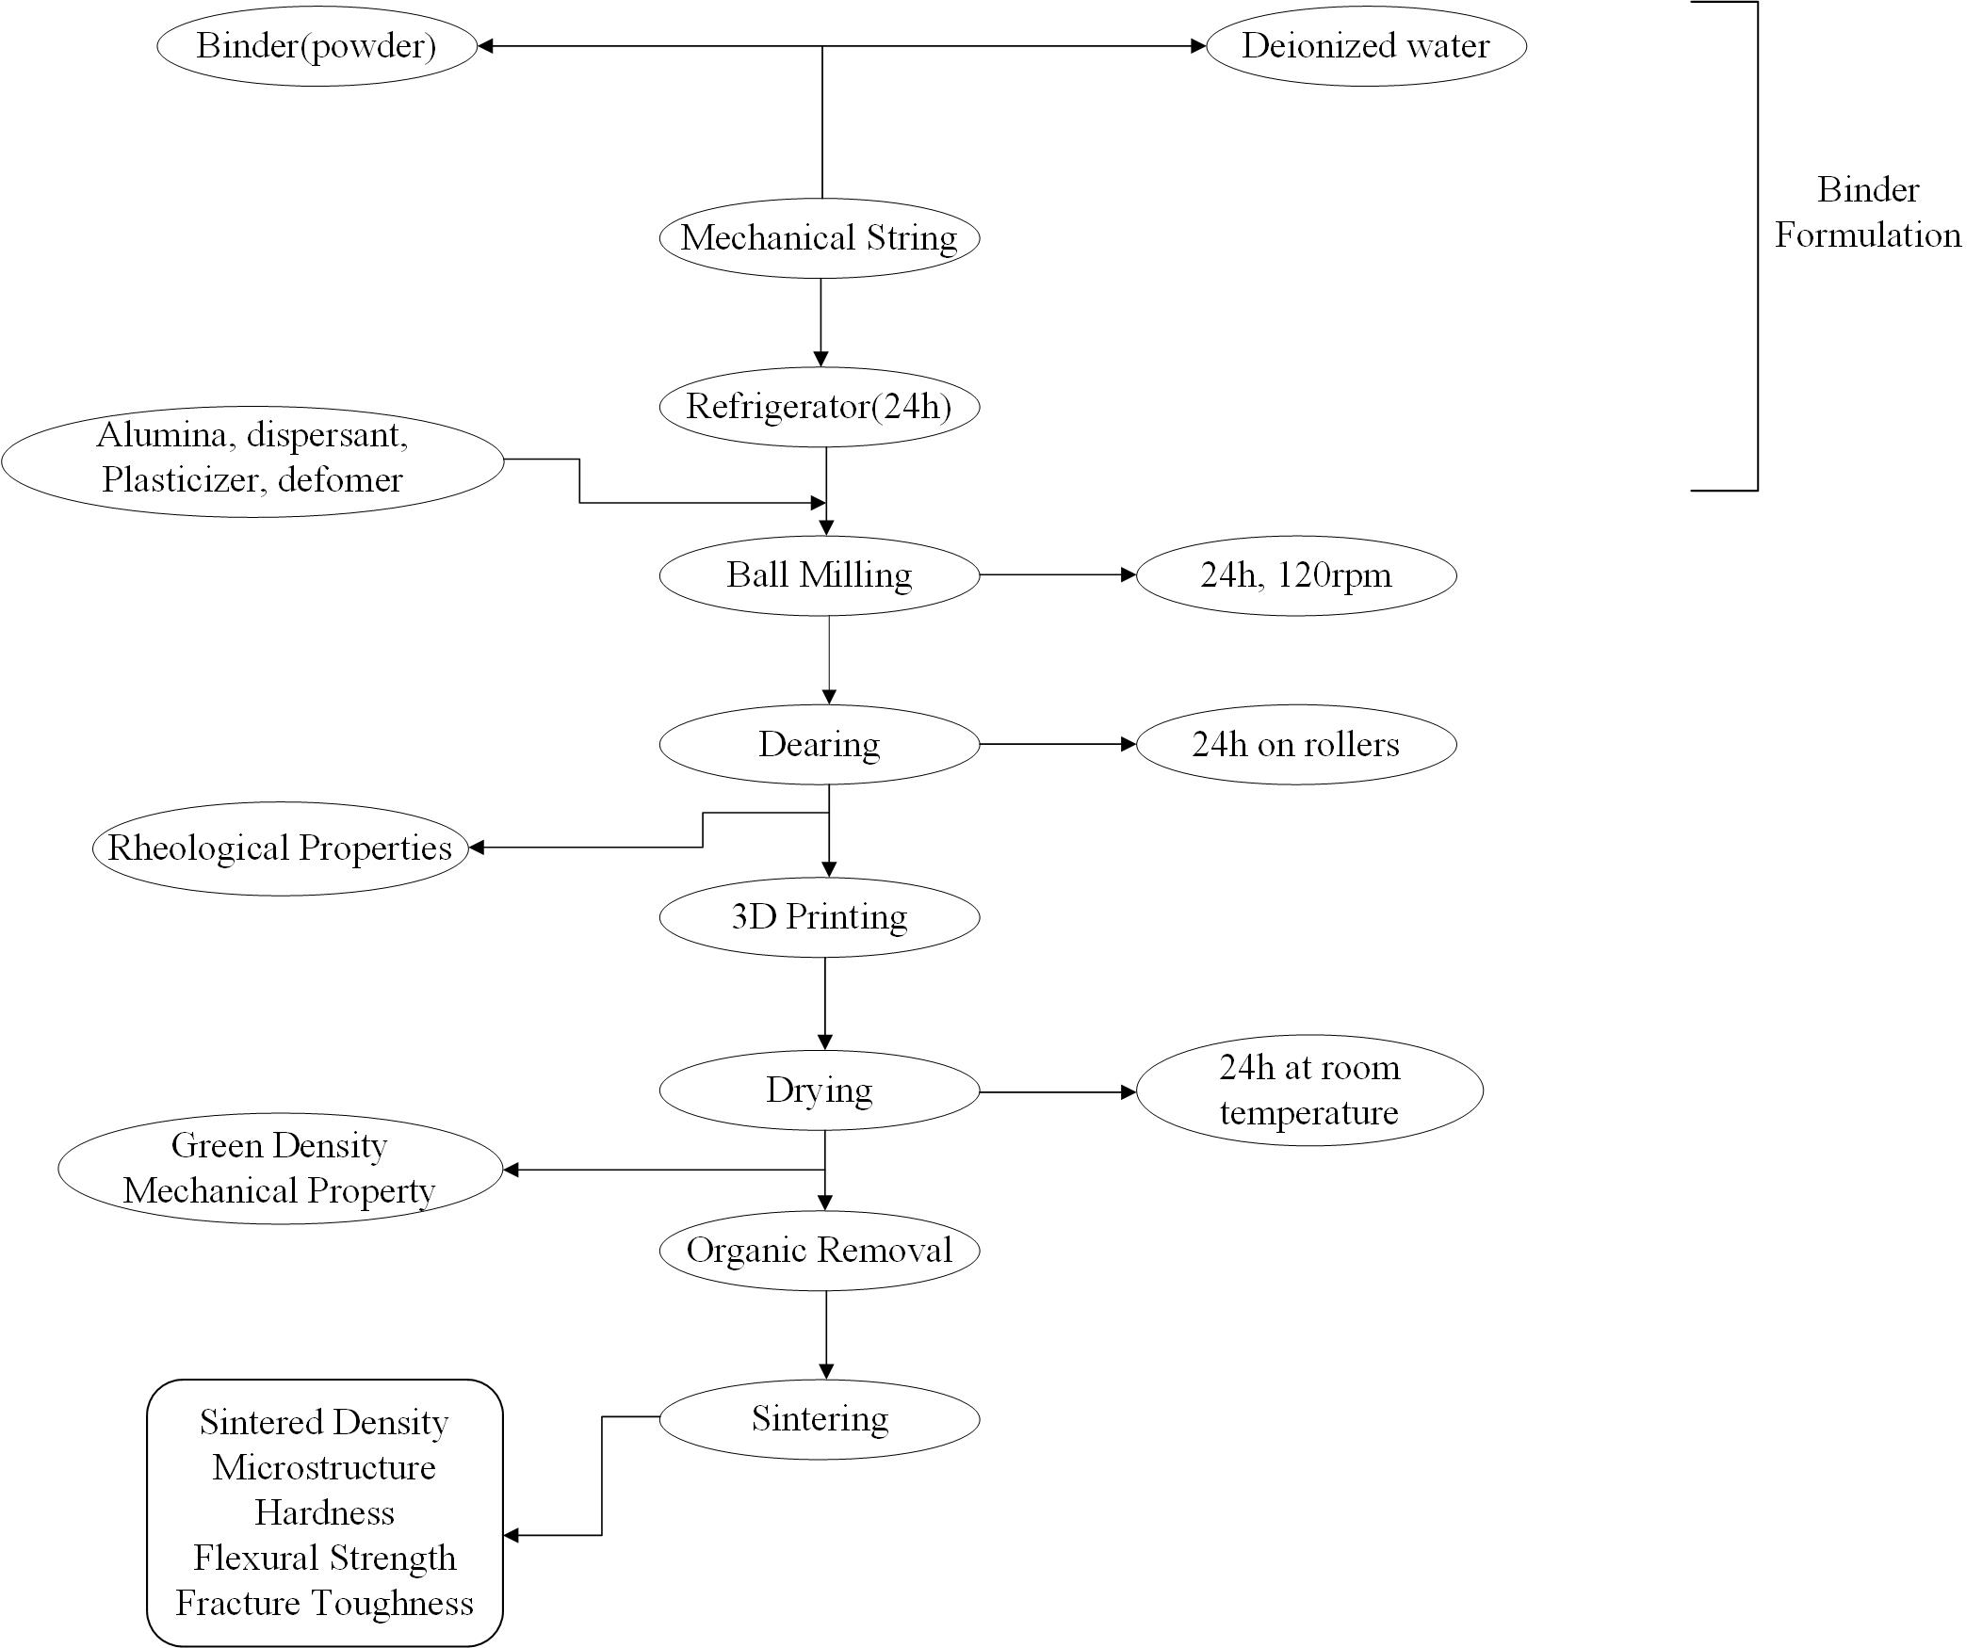

Fig.6 Slurry Preparation method

1. Debinding And sintering:

Before sintering, the organic additives and other processing aids must be taken out of the green body. Debinding is the process of removing the binder. If the binder content is significant, debinding might be a crucial step in the production of ceramics. Solvent and thermal debinding are the two phases in the binder removal process. The green component is submerged in a suitable solvent at various temperatures and immersion times to perform solvent debinding. The melting temperature of the binders is used to calculate the temperature for solvent debinding. Thermal debinding is the process of removing the binder as a vapour by heating it at room temperature in an oxidising or non-oxidizing atmosphere, or even partially under vacuum. Both chemical and physical factors have an impact on it. After debinding, and sintering process is completed in a sintering furnace that offers a controlled atmosphere and temperature. One of the most crucial processes and a special phenomenon in the creation of ceramic parts is sintering. Volumetric shrinkage, densification, reduction of pore volume and size, significantly increased mechanical strength, and grain coarsening are important outcomes of the sintering process.

Chapter 2: Literature Review

1. Direct ink writing of Alumina Ceramics:

* **(Barki 2017)** expect to be an accurate predictor of printability for other DIW inks because it links physical parameters that are not related with the chemical properties of the inks. Thus, while it is not evident that all starting materials can result in inks with the rheological properties necessary for printability, those with a near one should be capable of producing low deformation, high density and high strength materials like those demonstrated.
* **(David 2021)** It has been shown that near full-density (greater than 99% relative density) transparent ceramics of different shapes and sizes can be produced with optical quality comparable to that attained by more traditional processing techniques for transparent ceramics, such as CIP, using an extrusion-based 3D printer and post-processing steps like debinding, vacuum sintering, and polishing. The utilization of improved slurry and printing process parameters, as well as a two-step sintering profile, resulted in the highest grade 3D printed transparent ceramics. By using standard techniques, it would be more expensive and time-consuming to create transparent ceramics of different sizes and shapes. processes.
* **(Alvarez. 2022)** To create new DIW α-Al2O3 catalysts with various shapes and infill to increase the catalytic efficiency, a proper scientific study has been carried out to optimise both ceramic ink formulation and heat treatment. Due to the fact that printed architectures allow for longer residence periods to be attained for the same volume, DIW structures exhibit greater catalytic performance than commercially available materials.
* **(Sindi 2020)** By applying this method, dense objects can be machined into complex shapes at a lower cost and in less time. The preparation of the gelcasting fluid has a significant impact on the characteristics of the alumina components that are formed. The final relative density and mechanical characteristics of the pieces produced were significantly influenced by the de-airing procedure and the solids loading. The manufactured pieces' density and mechanical characteristics are on par with those of parts made using conventional methods. The solids loading, sintering temperature, and deairing all have an impact on the relative densities that are achieved.
* **(Savio 2002)** has studied the suitability to fabricate MoSi2 using slip casting technique. The slurry was prepared starting from 45% solid loading (MoSi2 powder) to 75 wt% in the 10.7 pH aqueous solution which consisted of hydrochloric acid and ammonium hydroxide solution. It was observed that densities of sintered sample increases with solid content and reached maximum at 50 wt%, then decreased further with increasing solid loading. They successfully casted and sintered MoSi2 cylinders (i.d. = 11 mm, o.d. = 20 mm and height = 15 mm) and seals (length = 40 mm, width = 6 mm and thickness = 2 mm).
* **(Chan et al. 2020)** on the other hand, investigate the interaction between the solid content and the rheological properties of the extrusion compound as well as the printing parameters. A formula is also proposed to determine favourable pressure properties for the ceramic blends.
* **(Shi and Wang 2020)** using carrageenan as a thermocuring binder for printing alumina ceramic in three dimensions. He set the paste's solid loading at 50% by volume. At 65oC, a significant rise in viscosity of the paste containing 0.4 wt% carrageenan was seen. The team created pore-free thin-walled alumina ceramic pieces with effective fabrication. **(Rane et al. 2021)** looked at how the printing parameters affected the physical and mechanical characteristics of 3D printed alumina and zirconia items. In his investigation, flexural strength, microhardness, and toughness were associated with printing parameters like part orientation and extrusion velocity. The most important factor for microhardness and flexural strength, it is discovered, is part orientation. Alumina and zirconia produced by 3D printing have fracture toughness that increases with elastic modulus and flexural strength while decreasing with hardness and sintered density.
* **(Liu et al. 2017)** reported the use of low-temperature DIW for the preparation of LiFePO4 (lithium iron phosphate) electrodes. Their results showed improvements in the performance of printed electrodes due to their highly porous structures as a result of low-temperature printing.

1. Direct ink writing of other ceramics:

* **(Zhu et al. 2020)** investigated the influence of printing parameters and effect of slurry composition on the performance of Al2O3 refractory products. They prepared the slurry which composed of Alumina powder (with a purity of 90%, and particle size of 75 μm) as the raw materials, silica fume (with a purity of 96% and D50 = 0.2 μm) as the binders, and water as the solvent. The amount of silica fume was 7 wt%. The solid content of slurries was prepared as 57, 60, 63, 66 vol%. They found that the slurry with solid content of 63 vol% was optimum for Direct Ink Writing based on the rheological study. They reported that as the layer height decreases, the void area also decreases and the layer height has significant effect on the inter space area. They observed that as the nozzle travel speed increases, a large dimensional deviation was observed. It was reported that the flexural strength was enhanced from 45 MPa to 61 MPa when the layer height decreased from 1.8 mm to 0.8 mm. It was concluded that the samples prepared with a layer height of 0.8 mm showed superior slag resistance and a flexural strength of 61 MPa after sintering at 1600 °C for 3 h.
* **(Schwarz et al. 1992)** In an effort to create oxygen-free MoSi2 and maintain tight control over second phase additions, high energy mechanical alloying was used to manufacture MoSi2 and MoSi2 based alloys beginning from pure elements. Researchers looked into the compositions of: Starting with elemental powders, MoSi2, MoSi2 -27 mol% Mo5Si3, MoSi2-50 mol% Mo5Si3, and MoSi2-50 mol% WSi2. Molybdenum powder that was 99.9% pure and had a mesh size of 325 and silicon powder that was 99.9999% pure made up the beginning powder. By using Energy Dispersive X-Ray Spectroscopy, they discovered that tungsten could not be detected in any of the alloys, but it could be found in the (Mo, W) Si2 alloy. They claimed that moderate hot-pressing temperatures could nevertheless produce high densities.
* **(Shao et al. 2017)** developed a new printing technique called 3D Gel Printing to create complex-shaped Zirconia Ceramic parts using a 2-hydroxyethyl methacrylate (HEMA) gelation system. As a dispersion, the researchers utilised ammonium citrate. According to a report, when the shear rate is greater than 1000 s1, the viscosity of the slurry with solid loading greater than 50 vol% cannot be measured. The results of a visual inspection revealed no flaws. The fracture morphology of the printed samples showed several short cracks, indicating that the bonding between the layers has to be further strengthened. In contrast, the fracture morphology of the sintered samples showed no defects or holes.
* **(Shi and Wang 2020)** successfully printed Zirconia ceramic teeth using 3D inkjet printing method and characterized the properties of ceramic ink and mechanical performance of sintered samples. They used 3wt% ammonium citrate as dispersants to produce the suspension. They observed that higher solid loading suspensions such as 56 vol% settled quickly within few minutes and was not suitable for printing. They reported that when the extrusion pressure exceeded 0.4 MPa, the extrusion material does not increase which is due to the friction between 32 the high viscosity ink and the nozzle tube. It was reported that with the printing speed of 15 mm/s, the zirconia ceramic teeth were fabricated in less than 5 min.

1. Research Gap

* The impact of particle size on the sintering properties of 3D printed alumina components has not yet been thoroughly analysed.
* It has not yet been thoroughly investigated how particle size, particle size distribution, and particle shape affect the microstructural and mechanical characteristics of 3D printed alumina components.
* Very few research has been published about the choice of suitable binders for Molybdenum Disilicide components.
* The use of additive manufacturing for Molybdenum Disilicide components has not yet been thoroughly investigated.
* It has not yet been published on thorough investigation of the impact of binders on the rheological behavior and the structure-property correlation of ceramic components.

1. Proposed Objectives:

Based on the literature survey and research gap analysis, the following research objectives has been proposed:

* Analyzing how additives affect the rheological behavior of alumina suspensions and comparing those results to the mechanical and microstructural characteristics of 3D-printed objects using direct ink writing.
* Optimizing the process parameters and creating a correlation between structure and property for the alumina parts produced using the direct ink writing technique.
* Effect of particle size on the sintering behavior and mechanical properties of Alumina components fabricated by Material extrusion based 3D printing process.

Chapter 3: Methodology:

The methodology of these objectives consists of following steps:

* Preprocessing of Powder
* Rheological analysis
* 3D printing
* Post processing

1. Drying
2. Sintering

* Characterization and testing

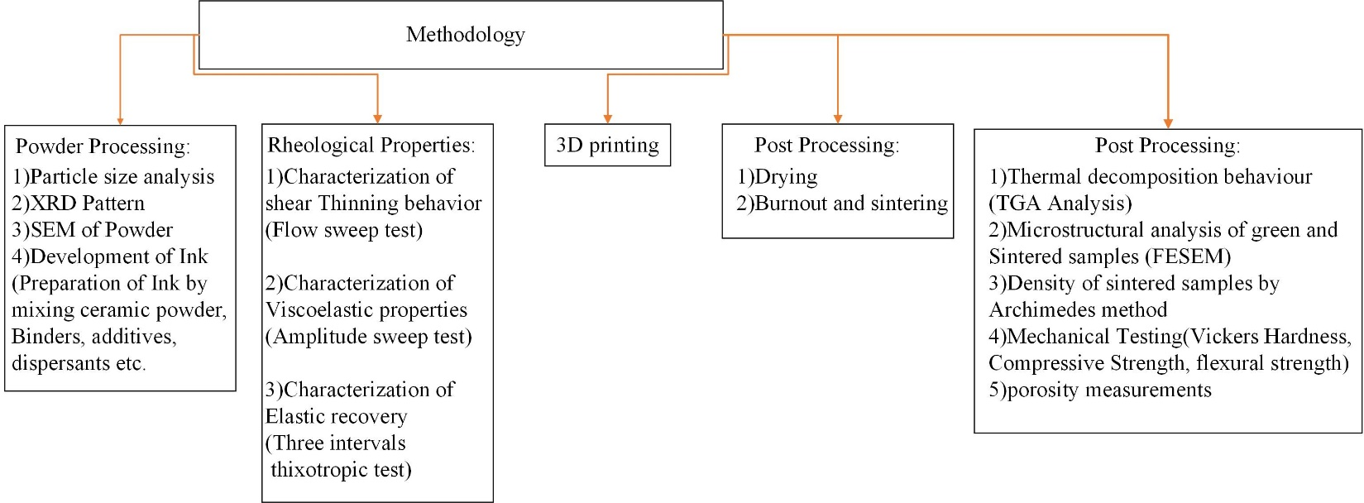

Fig.7 Methodology

References:

Alvarez., F. 2022. “Optimization of the Sintering Thermal Treatment and the Ceramic Ink Used in Direct Ink Writing of α-Al2O3: Characterization and Catalytic Application.” *Journal of the European Ceramic Society* 42 (6): 2921–30. https://doi.org/10.1016/j.jeurceramsoc.2022.01.032.

Barki, Amin. 2017. “Linking Rheology and Printability for Dense and Strong Ceramics by Direct Ink Writing.” *Scientific Reports* 7 (1): 1–10. https://doi.org/10.1038/s41598-017-06115-0.

Chan, Shareen S.L., Ryan M. Pennings, Lewis Edwards, and George V. Franks. 2020. “3D Printing of Clay for Decorative Architectural Applications: Effect of Solids Volume Fraction on Rheology and Printability.” *Additive Manufacturing* 35 (December 2019): 101335. https://doi.org/10.1016/j.addma.2020.101335.

David. 2021. “Transparent Alumina Ceramics Fabricated by 3D Printing and Vacuum Sintering.” *Journal of the European Ceramic Society* 41 (1): 781–91. https://doi.org/10.1016/j.jeurceramsoc.2020.07.051.

Liu, Changyong, Xingxing Cheng, Bohan Li, Zhangwei Chen, Shengli Mi, and Changshi Lao. 2017. “Fabrication and Characterization of 3D-Printed Highly-Porous 3D LiFePO4 Electrodes by Low Temperature Direct Writing Process.” *Materials* 10 (8). https://doi.org/10.3390/ma10080934.

Rane, Kedarnath, Muhammad Asad Farid, Waqar Hassan, and Matteo Strano. 2021. “Effect of Printing Parameters on Mechanical Properties of Extrusion-Based Additively Manufactured Ceramic Parts.” *Ceramics International* 47 (9): 12189–98. https://doi.org/10.1016/j.ceramint.2021.01.066.

Savio, S.et al. 2002. “Fabrication of Molybdenum Disilicide Components by Slip Casting.” *Materials Letters* 57 (1): 43–47. https://doi.org/10.1016/S0167-577X(02)00696-1.

Schwarz, R. B., S. R. Srinivasan, J. J. Petrovic, and C. J. Maggiore. 1992. “Synthesis of Molybdenum Disilicide by Mechanical Alloying.” *Materials Science and Engineering A* 155 (1–2): 75–83. https://doi.org/10.1016/0921-5093(92)90314-Q.

Shao, Huiping, Dechao Zhao, Tao Lin, Jianzhuang He, and Ji Wu. 2017. “3D Gel-Printing of Zirconia Ceramic Parts.” *Ceramics International* 43 (16): 13938–42. https://doi.org/10.1016/j.ceramint.2017.07.124.

Shi, Yongliang, and Wenqin Wang. 2020. “3D Inkjet Printing of the Zirconia Ceramic Implanted Teeth.” *Materials Letters* 261: 127131. https://doi.org/10.1016/j.matlet.2019.127131.

Sindi. 2020. “Fabrication of Complex Shaped Alumina Parts by Gelcasting on 3D Printed Moulds.” *Ceramics International* 46 (3): 3177–82. https://doi.org/10.1016/j.ceramint.2019.10.021.

Zhu, Kai, Daoyuan Yang, Zhenfei Yu, Yachao Ma, Sheng Zhang, Ruichao Liu, Jie Li, Junyan Cui, and Huiyu Yuan. 2020. “Additive Manufacturing of SiO2–Al2O3 Refractory Products via Direct Ink Writing.” *Ceramics International* 46 (17): 27254–61. https://doi.org/10.1016/j.ceramint.2020.07.210.