**Memo to:** Randy Larimer

**From:** Johnny Gaddis

**Date:** 1/18/17

**Regarding:** EELE 465, Lab 0 – Heartbeat LED

**Summary:**

The purpose of lab 0 was to use the HCS908QG to flash an LED at 0.5 Hz to indicate that the microprocessor is running. This task was accomplished multiple ways: using loops with counters, using the TPM module, and a mixture of the two with the MTIM module. This lab led to a way to see if the HCS908QG was active.

**Setup:**

The lab code was setup with the following steps in the following order: disable the watchdog, initialize the output LED port, setup a register for a timer, give the counter a value, and enable interrupts. In terms of physical setup, due to not having any jumper cables the lab was setup on just the in lab board.

**Counter Loop Solution:**

The first solution using the counter loops was achieved through three loops. The first loop looped through 15 times. The inner two loops counted through 256 loops each. Then after the loops were completed the LED was flashed. This code lead to a very accurate 0.5 Hz blink on the LED.

**Interrupt Solution:**

The interrupt solution required the TPM register. With a 16 bit value of $78D1 set to TPMMODH:L and the TPM status control register pre-scaled to 128 with interrupts enabled, a 0.5 Hz blink on the LED was achieved with an empty main loop and an interrupt routine that toggled the led.

**Mix of Solutions:**

In order to use the MTIM register a counter loop was needed. With the bus clock pre-scaled by 256 and a modulo value of 256, a counter loop value of 61 was required. When the counter completed after 62 interrupts, the LED state would toggle and the count was reset and the microcontroller returned from interrupt. This solution is very clean and takes only one byte of RAM to run!

**Final Thoughts:**

This lab went according to plan. The research required to complete these solutions has familiarized us students to the controller behavior once again. The only problem encountered was that you could not set the MTIM to a low enough speed to achieve a 0.5 Hz flash rate without an accompanied counter loop.

**Appendix A Flowcharts:**

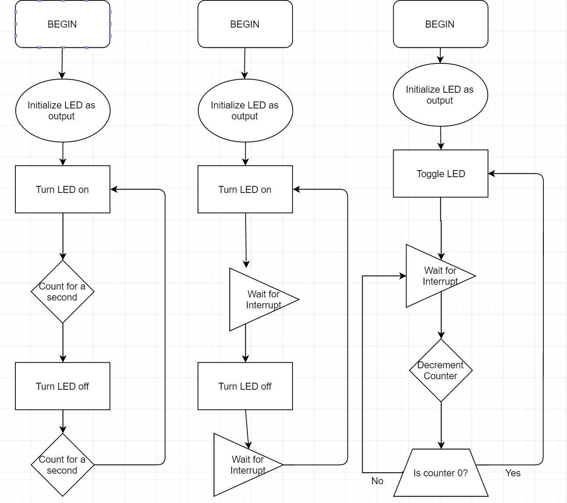

Figure 3: Third solution with MTIM and counter

Figure 2: Second solution with interrupt from TPM

Figure 1: First solution with counter