**Memo to:** Randy Larimer

**From:** Johnny Gaddis

**Date:** 4/28/17

**Regarding:** EELE 465, Lab 3

**Summary:**

The purpose of lab 3 was to use the HCS908QG8 to read in data from the temperature sensors and display them on the LCD screen. This was accomplished by math routines and writing to LCD routines. This lab led to a greater understanding of the HCS908QG8 while showing students practical uses of math in assembly combined with LCD knowledge. The program 1861 bytes of read only memory and 94 bytes of read/write memory.

**Setup:**

The setup required was rather minimal. We needed to put an external temperature sensor input to PTAD 2. The code was setup to read data from the internal and external temperatures and store the data.

**Solution:**

The solution for this lab required lots of time. The first thing was to get the LCD menus working. Then I moved onto getting the math routines working. The coded solution was tested it with known values. Once this was working I changed the values to the LM19 value. Now that the math worked I sent the value to the LCD. First I converted the hex result to a decimal number. This required using a series of loops and counters to increment a tens place and a ones place and then writing each place to the LCD as an individual character. To write the ASCII one should add hex 30 to each digit. A similar process for getting the internal temperature sensor to work was followed. The last portion of the solution was to have the number keys on the keypad calculate an average temp. I added all of the temperatures up then divided by the keypad number and then displayed it.

**Final Thoughts:**

This lab taught me how difficult math can be in assembly. There was a ton of time required for this lab. The work required to set up the lab was minimal. This lab taught me how to do math in assembly, a great tool for the future.

**Appendix A Flowcharts:**

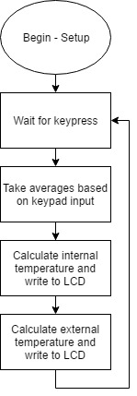

Figure 1: Program Flow