**Memo to:** Randy Larimer

**From:** Johnny Gaddis

**Date:** 4/28/17

**Regarding:** EELE 465, Lab 5

**Summary:**

The purpose of lab 5 was to use the HCS908QG8 to communicate with an RTC (real-time clock) using I2C communications. The idea was to set the time and date and then read it back to the LCD.

**Setup:**

The setup required was wiring up the RTC to the microcontroller and a crystal. Once the RTC was set up with the crystal and a good square wave was being produced by the crystal, I hooked up the clock and data lines. The code setup was an adaptation of EELE 371 code for bit banging I2C.

**Solution:**

The solution for this lab was to wait until 12 keypresses happen and then send that data via I2C. This was accomplished by storing keypresses to an array and incrementing the X register each time a button was pressed. Once the data was sent, I then read from it constantly while storing the values and writing them to the LCD every second. This was accomplished with a read and LCD flash every second using delay loops.

**Final Thoughts:**

This lab taught me how to better use I2C to communicate with devices. I had problems reading from the device and didn’t want to stop to try to fix it so I took a hit on this lab. Overall, this lab helped me learn more about I2C and crystal oscillators.

**Appendix A Flowcharts:**

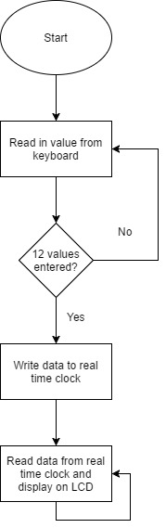

Figure 1: Program Flow