**Memo to:** Randy Larimer

**From:** Johnny Gaddis

**Date:** 4/28/17

**Regarding:** EELE 465, Lab 6

**Summary:**

The purpose of lab 6 was to use the HCS908QG8 to read from a temperature sensor and an RTC while heating or cooling an aluminum block. I used an I2C bus for the temperature sensor and RTC while using the LED’s to toggle the heat and cool states.

**Setup:**

First I set up my own LM92 to make sure I could read from this device using I2C. This was a straight forward process. Then I had to set up the MOS FET transistors to power the cool and heat states of the device.

**Solution:**

Firstly, I setup the LM92 provided in the lab kit. Once this was working and displaying temperature I moved on to the LM92 on the TE cooler. Then, I got the different states working by setting the LED values accordingly. Once I had all of this displaying I reset the counter from the RTC every time a state was switched.

**Final Thoughts:**

This lab felt rather straightforward in terms of optimizing what we have learned so far. This lab led to a greater understanding of multi element systems working together. I also learned how to write in assembly better.

**Appendix A Flowcharts:**

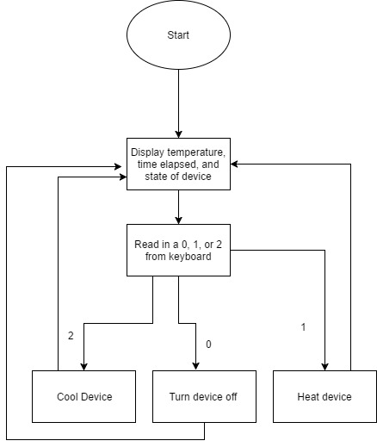

Figure 1: Program Flow