**Memo to:** Randy Larimer

**From:** Johnny Gaddis

**Date:** 4/28/17

**Regarding:** EELE 465, Lab 7

**Summary:**

The purpose of lab 7 was to use the HCS908QG8 control a menu to control the heating and cooling of a TE cooler. The option I chose to go for this lab was setting the device to heat or cool for a set time. The program used 1861 bytes of read only memory and 94 bytes of read/write memory.

**Setup:**

There was no extra physical setup for this lab.

**Solution:**

The solution for this lab required lots of time. The first thing was to get the LCD menus working. I presented the user with an option for heat or cool initially then saved the result. Then I prompted the user for a time amount and stored the result. Once the value was entered for time the program started a count to the value entered while saying if its heating or cooling. Once the time ran up to its set time the program went “off” until a * was pressed.

**Final Thoughts:**

This lab taught me how complex microcontroller systems can be at the assembly level. My program, built up over all labs, is now extraordinarily long to fit all the assembly code needed to accomplish this last labs goals. This entire course showed me how to have a greater understanding of assembly and microcontrollers. I feel so much more confident in my computer knowledge after this class!

**Appendix A Flowcharts:**

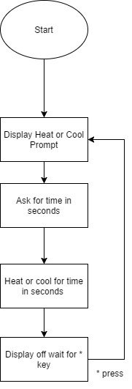

Figure 1: Program Flow