Game Design Document

Fill up the following document

1. Write the title of your project.

Classic Bowling

1. What is the goal of the game?

Ans: To win the bowling game

1. Write a brief story of your game.

Two friends are playing bowling and they go for a competition there is limited time and one of them is going to emerge as the winner.

1. Which are the playing characters of this game?

* Playing characters are the ones who respond to the user based on the input from the user.
* Cars, monkeys, dinos, wizards, etc., are the playing characters in the game.

|  |  |  |
| --- | --- | --- |
| Number | Character Name | What can this character do? |
| 1 | John(1st friend) | Protangonist -1 |
| 2 | Tommy(2nd friend) | Protangonist -2 |
| 3 | - | - |
| 4 | - | - |
| 5 | - | - |
| 6 | - | - |
| 7 | - | - |
| 8 | - | - |

1. Which are the Non-Playing Characters of this game?

* Non-Playing characters are the ones that don't have an action or behavior when the user interacts with the game.
* Hurdles, stones, bananas, coins, etc., are non-playing characters in the game.

|  |  |  |
| --- | --- | --- |
| Number | Character Name | What can this character do? |
| 1 | The bowling pins | The more the pins fall the kore points the player gets. |
| 2 |  |  |
| 3 |  |  |
| 4 |  |  |
| 5 |  |  |
| 6 |  |  |
| 7 |  |  |
| 8 |  |  |

Draw your imagination of this game. What does this game look like?

* Draw the game either on your computer or on paper.
* Add images of the game scenes to show each of the playing and non-playing characters at least once.

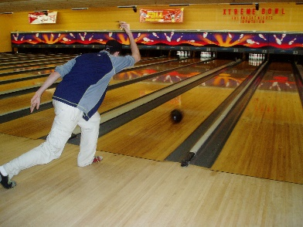 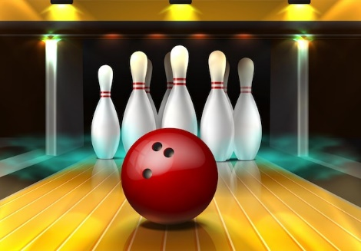

How do you plan to make your game engaging?

Ans: I can my game engaging by adding more designs to it so that it looks attractive and increasing the difficulity of the game.