Doom-style World Renderer
The goal of this project is to design and implement a simplified but robust Doom-style renderer that the user can navigate and interact with the environment. While I chose “Doom” in the title, the actual renderer will be closer to Wolfenstein 3D, but I figured that “Doom” is far more recognizable. To contextualize this idea further, I included a screenshot below from Wolfenstein 3D as a reference. This image conveys the type of grid-based, corridor-style environment that I would like to emulate.
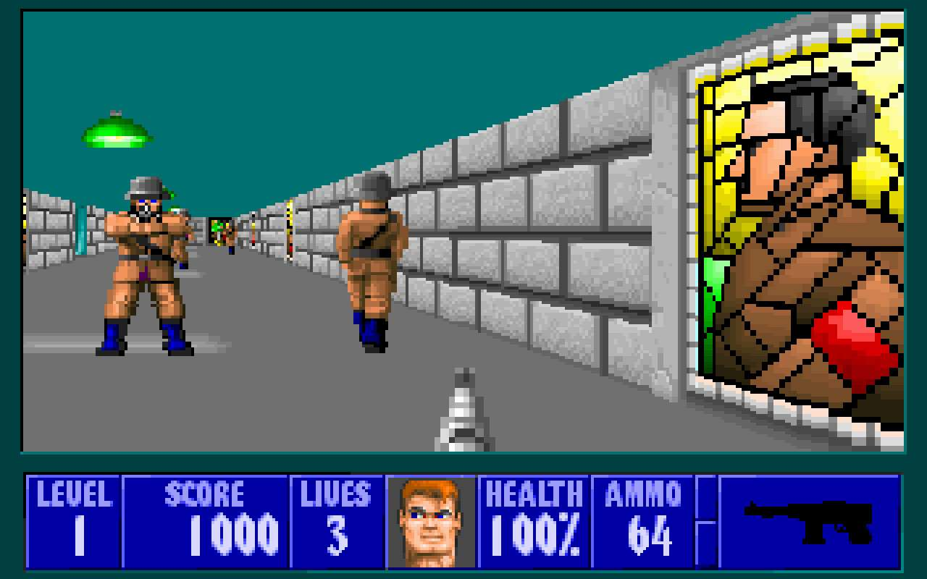
It is important to note that this project focuses primarily on the rendering instead of the violent gameplay associated with these titles. Any interactive elements will be more casual in nature and be more suited to demonstrate movement, collision, and interaction with the environment. One possible idea is to navigate a pyramid-like structure where the player tries to reach the exit at the highest level, but the exact theme is flexible and not integral to the goals of this project.

Below are some important references for this project.
- Wolfenstein 3D (1992)
This game is used to inspire the look and feel of the end result of this project. Like the screenshot shows, the simple 2.5D environment is closely related to the goals of this project.
- Doom (1993)
This game is another reference. This project has non-rectangular surfaces. While I do not plan to emulate this, I might investigate this if time allows.
- WebGL Documentation
The official WebGL Documentation page should be a useful resource to implement all the essential parts of this project including but not limited to perspective projection, light shading, buffers, textures, etc.
- Course Notes/Lectures
These materials form the basis for the project’s technical approach, so I will probably refer to this stuff heavily while implementing my project.

Below is a step-by-step description of the potential challenges that could arise while implementing this into a fully navigable, textured environment. The main ones are as follows:
- World Representation
I have to determine a reliable way to represent the world. A cell can encode information, but the question of how to store this information is still up in the air. I will probably use a grid so that layouts are easy to modify
- Rendering Pipeline in WebGL
I would like a deeper understanding of this, and this project is the perfect way to do this. I can learn all about the vertex buffer, frame buffers, etc while applying to a real-world project.
- Camera and Perspective Projection
A first-person camera will be implemented. I plan to implement perspective projection so that the world looks relatively realistic and pay homage to the look and feel of these classic games.
- Collision Detection and Movement
I would like to ensure the player cannot just clip through walls, so basic collision detection will probably be required. I also want to enable the player to look and change the direction of the camera at will.
- Texture Mapping
The floor and the walls will more than likely be loaded from an image or even procedurally generated textures. I cannot wait to learn more about this and then apply it in a real-world setting.

Below is a general timeline that I plan to stick to as the semester progresses.
