|  |
| --- |
|  |
| Dokumentation - ScanPark |
| Des Prototypen ScanPark |
|  |
| **[Arthur Böhm] [Julian Hügel] [Michael Keller]** |
| **3/12/2017** |

Ein potenzieller Kunde registriert sich mit unserer Webanwendung und hinterlegt seine Persönliche Daten wie Vor- und Nachname, Adresse, E-Mail, Bankverbindung und Kennzeichen. In der Parkanlage sind beim Herausfahren Kameras und Sensoren angebracht, welche das Kennzeichen des Kunden abscannen. Die Kennzeichen werden in einer Datei gespeichert und mehrmals am Tag automatisch an unsere Datenbank gesendet. Die Datenbank gleicht anhand des Nummernschildes das angelegte Profil und die Bankverbindung ab. Je nach Parkdauer wird der entsprechende Betrag per Lastschriftverfahren automatisch eingezogen. Der Kunde erhält daraufhin eine Rechnung per E-Mail.

1. Pages
   1. Page Tree

Login  
 Register  
 Login_guest  
Home_eingeloggt  
Home_profil  
Home_invoice  
Home_vehicles  
Home_gps

* 1. Login

OnPageLoad:  
 Beim Start der Seite:  
 Set Focus on EMail_Text

* + 1. User Interface

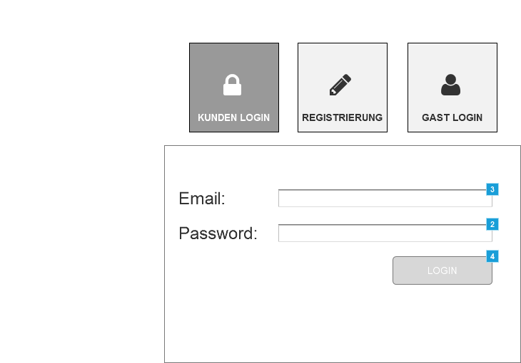

* + 1. Widget Table

|  |  |  |
| --- | --- | --- |
| Footnote | Name | Interactions |
| 1 | Passwort | OnFocus:  Case 1:  Hide Warn_Password |
| 2 | PW_Text | OnTextChange:  Login aktivieren  (If text on PW_Text does not equal "" and text on EMail_Text does not equal ""):  Enable Login_Button OnFocus:  Case 1:  Hide Warn_Password OnLostFocus:  Case 1  (If text on This equals ""):  Show Warn_Password  Disable Login_Button |
| 3 | EMail_Text | OnTextChange:  Login aktivieren  (If text on PW_Text does not equal "" and text on EMail_Text does not equal ""):  Enable Login_Button OnFocus:  Case 1:  Hide Warn_Username OnLostFocus:  Keine Eingabe  (If text on This equals ""):  Show Warn_Username  Disable Login_Button |
| 4 | Login_Button | OnClick:  einloggen:  Open Home_eingeloggt in Current Window |

* + 1. Unnamed
       1. State1
       2. User Interface

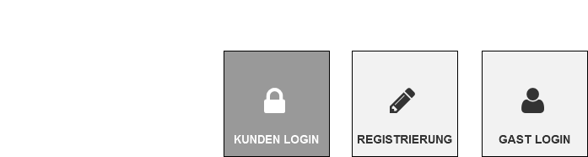

* 1. Register

OnPageLoad:  
 Beim Start der Seite:  
 Set Focus on EMail_Text

* + 1. User Interface

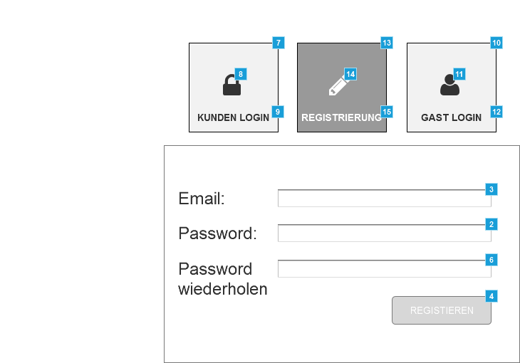

* + 1. Widget Table

|  |  |  |
| --- | --- | --- |
| Footnote | Name | Interactions |
| 1 | Passwort | OnFocus:  Case 1:  Hide Warn_Password |
| 2 | PW_Text | OnTextChange:  Login aktivieren  (If text on PW_Text does not equal "" and text on EMail_Text does not equal ""):  Enable Login_Button OnFocus:  Case 1:  Hide Warn_Password OnLostFocus:  Case 1  (If text on This equals ""):  Show Warn_Password  Disable Login_Button |
| 3 | EMail_Text | OnTextChange:  Login aktivieren  (If text on PW_Text does not equal "" and text on EMail_Text does not equal ""):  Enable Login_Button OnFocus:  Case 1:  Hide Warn_Username OnLostFocus:  Keine Eingabe  (If text on This equals ""):  Show Warn_Username  Disable Login_Button |
| 4 | Login_Button | OnClick:  einloggen:  Open Home_eingeloggt in Current Window |
| 5 | Passwort | OnFocus:  Case 1:  Hide Warn_Password |
| 6 | PW_Text | OnTextChange:  Login aktivieren  (If text on PW_Text does not equal "" and text on EMail_Text does not equal ""):  Enable Login_Button OnFocus:  Case 1:  Hide Warn_Password OnLostFocus:  Case 1  (If text on This equals ""):  Show Warn_Password  Disable Login_Button |
| 7 | Kunden_Login | OnClick:  Case 1:  Open Login in Current Window |
| 8 |  | OnClick:  Case 1:  Open Login in Current Window |
| 9 |  | OnClick:  Case 1:  Open Login in Current Window |
| 10 | Gast_Login | OnClick:  Case 1:  Open Login_guest in Current Window |
| 11 |  | OnClick:  Case 1:  Open Login_guest in Current Window |
| 12 |  | OnClick:  Case 1:  Open Login_guest in Current Window |
| 13 | Registrierung | OnClick:  Case 1:  Open Register in Current Window |
| 14 |  | OnClick:  Case 1:  Open Register in Current Window |
| 15 |  | OnClick:  Case 1:  Open Register in Current Window |

* 1. Login_guest

OnPageLoad:  
 Case 1:  
 Set Focus on Kennzeichen_Text

* + 1. User Interface

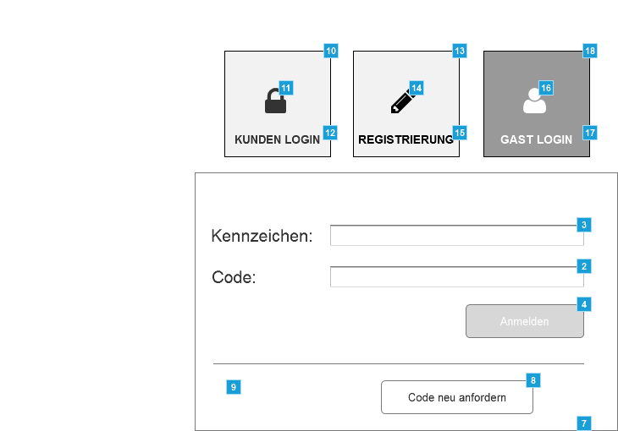

* + 1. Widget Table

|  |  |  |
| --- | --- | --- |
| Footnote | Name | Interactions |
| 1 | Code_Text | OnFocus:  Case 1:  Hide Warn_Password |
| 2 | PW_Text | OnTextChange:  Login aktivieren  (If text on PW_Text does not equal "" and text on Kennzeichen_Text does not equal ""):  Enable Login_Button OnFocus:  Case 1:  Hide Warn_Password OnLostFocus:  Case 1  (If text on This equals ""):  Show Warn_Password  Disable Login_Button |
| 3 | Kennzeichen_Text | OnTextChange:  Login aktivieren  (If text on PW_Text does not equal "" and text on Kennzeichen_Text does not equal ""):  Enable Login_Button OnFocus:  Case 1:  Hide Warn_Username OnLostFocus:  Keine Eingabe  (If text on This equals ""):  Show Warn_Username  Disable Login_Button |
| 4 | Login_Button | OnClick:  einloggen:  Open Home_eingeloggt in Current Window |
| 5 | Code_Text | OnFocus:  Case 1:  Hide Warn_Password |
| 6 | PW_Text | OnFocus:  Case 1:  Hide Warn_Password OnLostFocus:  Case 1  (If text on This equals ""):  Show Warn_Password |
| 7 | Kennzeichen_Text | OnFocus:  Case 1:  Hide Warn_Username OnLostFocus:  Keine Eingabe  (If text on This equals ""):  Show Warn_Username |
| 8 | Guest_Button | OnClick:  Panel_ausfahren:  Show Code_anfordern slide down 500 ms bring to front |
| 9 |  | OnClick:  Panel zuklappen:  Hide Code_anfordern flip up 500 ms |
| 10 | Kunden_Login | OnClick:  Case 1:  Open Login in Current Window |
| 11 |  | OnClick:  Case 1:  Open Login in Current Window |
| 12 |  | OnClick:  Case 1:  Open Link in Current Window |
| 13 | Registrierung | OnClick:  Case 1:  Open Register in Current Window |
| 14 |  | OnClick:  Case 1:  Open Register in Current Window |
| 15 |  | OnClick:  Case 1:  Open Register in Current Window |
| 16 |  | OnClick:  Case 1:  Open Login_guest in Current Window |
| 17 |  | OnClick:  Case 1:  Open Link in Current Window |
| 18 | Gast_Login | OnClick:  Case 1:  Open Login_guest in Current Window |

* 1. Home_eingeloggt
     1. User Interface

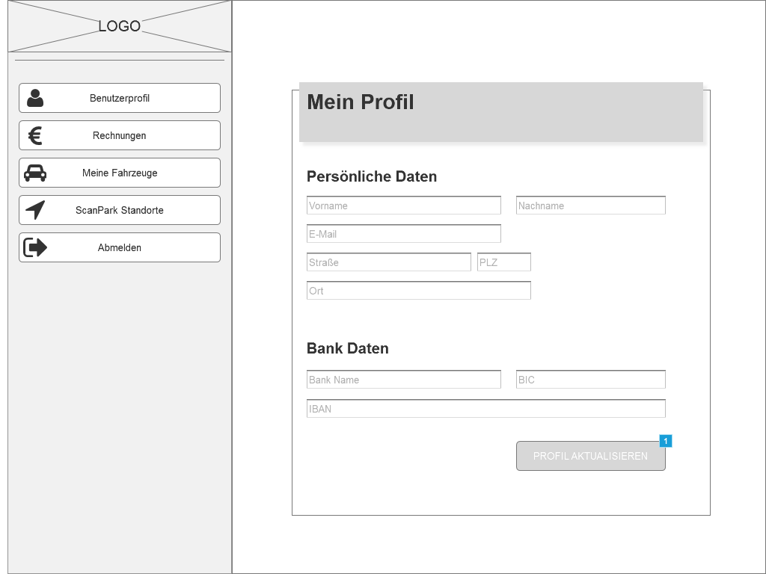

* + 1. Widget Table

|  |  |  |
| --- | --- | --- |
| Footnote | Name | Interactions |
| 1 | Login_Button | OnClick:  einloggen:  Open Home_eingeloggt in Current Window |

* 1. Home_profil
     1. User Interface



* + 1. Widget Table

|  |  |  |
| --- | --- | --- |
| Footnote | Name | Interactions |
| 1 | Login_Button | OnClick:  einloggen:  Open Home_profil in Current Window |

* 1. Home_invoice
     1. User Interface

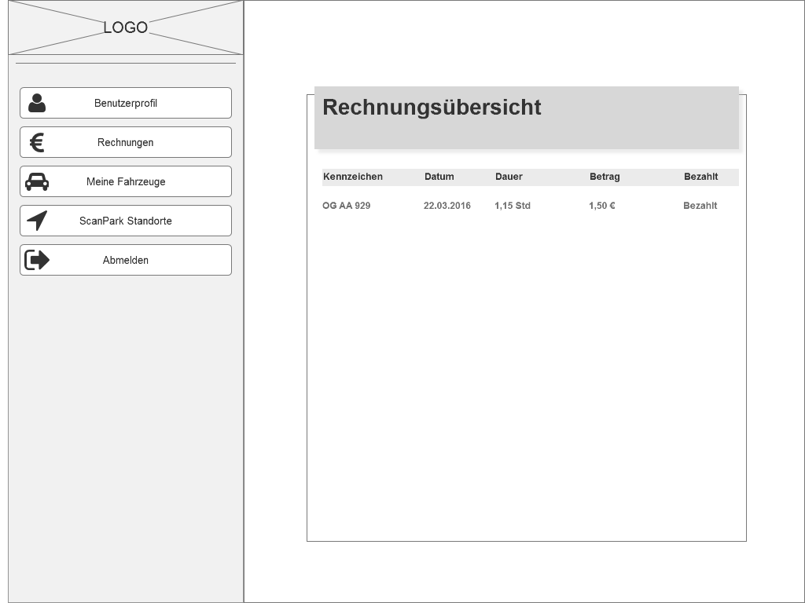

* 1. Home_vehicles
     1. User Interface

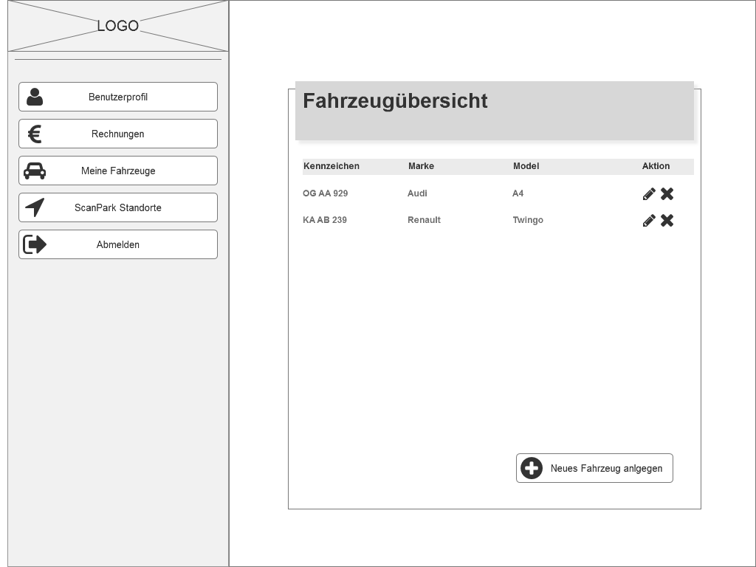

* 1. Home_gps
     1. User Interface

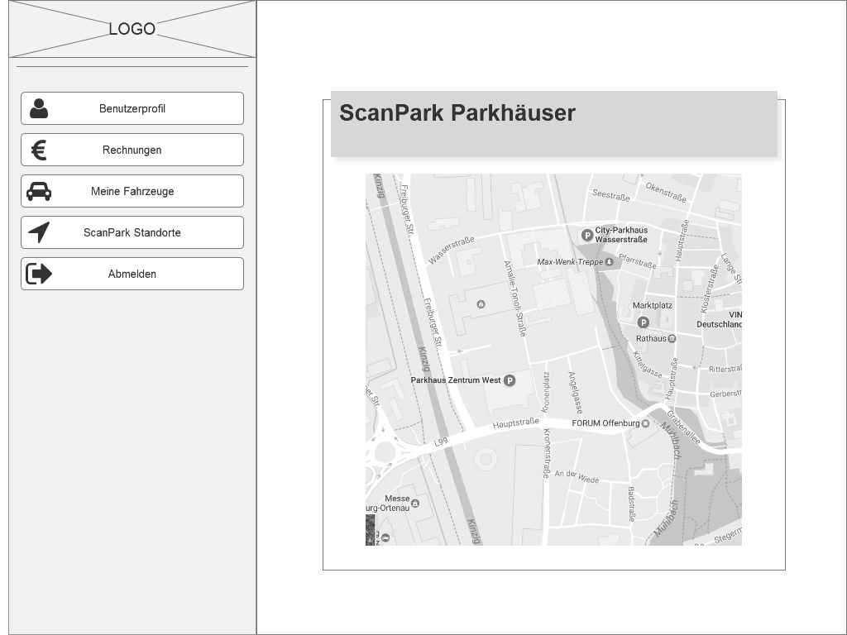

1. Masters
   1. Master List

Sidebar  
Header  
Footer  
Login

* 1. Sidebar
     1. User Interface

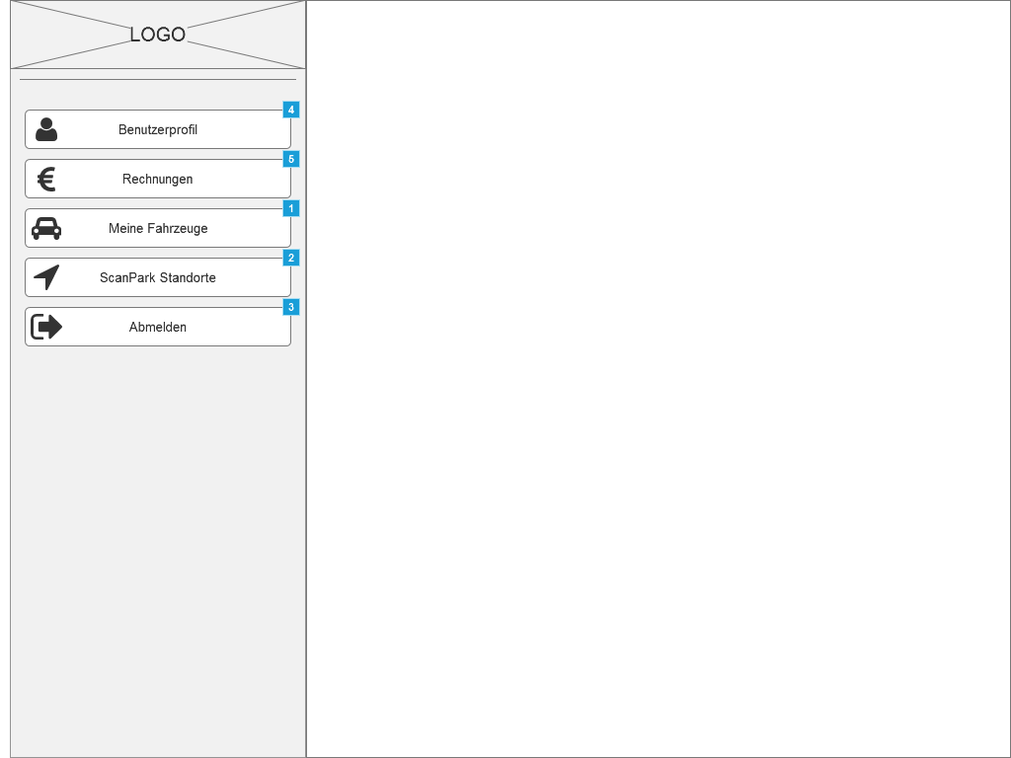

* + 1. Widget Table

|  |  |  |
| --- | --- | --- |
| Footnote | Name | Interactions |
| 1 | invoice_button | OnClick:  Case 1:  Open Home_vehicles in Current Window |
| 2 | vehicles_button | OnClick:  Case 1:  Open Home_gps in Current Window |
| 3 | places_button | OnClick:  Case 1:  Open Login in Current Window |
| 4 | invoice_button | OnClick:  Case 1:  Open Home_profil in Current Window |
| 5 | vehicles_button | OnClick:  Case 1:  Open Home_invoice in Current Window |

Login

* + 1. User Interface

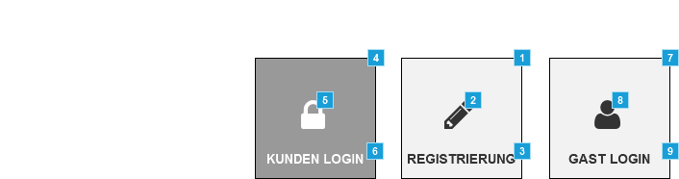

* + 1. Widget Table

|  |  |  |
| --- | --- | --- |
| Footnote | Name | Interactions |
| 1 | Registrierung | OnClick:  Case 1:  Open Register in Current Window |
| 2 |  | OnClick:  Case 1:  Open Register in Current Window |
| 3 |  | OnClick:  Case 1:  Open Register in Current Window |
| 4 | Kunden_Login | OnClick:  Case 1:  Open Login in Current Window |
| 5 |  | OnClick:  Case 1:  Open Login in Current Window |
| 6 |  | OnClick:  Case 1:  Open Login in Current Window |
| 7 | Gast_Login | OnClick:  Case 1:  Open Login_guest in Current Window |
| 8 |  | OnClick:  Case 1:  Open Login_guest in Current Window |
| 9 |  | OnClick:  Case 1:  Open Link in Current Window |