**Impasse**

**Time Limit: 3000/1000 MS (Java/Others) Memory Limit: 65536/32768 K (Java/Others)**

**Problem Description**

Impasse is a very interesting web game. In this game, you are in a 3*n maze and you should avoid obstacles and reach the destination.

You can move to four directions (north, south, east and west). And you should notice that the maze is connected north and south, by other words you can go from (1, 1) to (3, 1) by only one step to north.

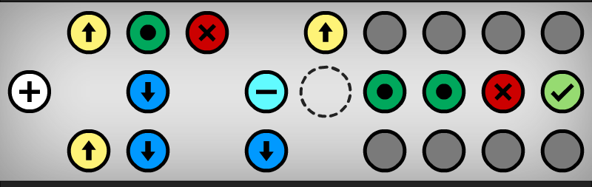

Then there are some different kinds of blocks in that maze:

‘O’: Immovable obstacle.

‘A’: It will move to a north position when you move north or south.

‘V’: It will move to a south position when you move north or south.

‘M’: It will move to a north position when you move east or west.

‘W’: It will move to a south position when you move east or west.

You can never stand on the positions described above. And for ‘-’, ‘=’ and ‘X’, you can step on it when it’s off. Details:

‘-’: It will change its status when you move north or south. (Default on)

‘=’: It will change its status when you move north or south. (Default off)

‘X’: You can’t stand on it when the switch is on.

‘S’: The switch status will changed when you step on it. And this switch will disappear forever. (Default on)

And then:

‘.’: Empty position.

‘+’: The position you start with. (Only one)

‘Y’: Destination. (Only one)

All these blocks may stay in a same position, and they would not affect each other.

You should know that these blocks change as soon as you make a move. You just need to check the status after each step.

**Input**

First line is an integer t (t<=20), indicating the number of test cases.

For each case, there is an integer n (n<=100) first.

Then three lines, each line has n characters described the maze.

**Output**

For each case in the input, print one line: "Case X: Y", where X is the test case number (starting with 1) and Y is the minimal steps to solve this case.

**Sample Input**

2

4

.V.O

+VAY

..AO

10

.MSX.MOOOO

+.W.-=SSXY

.MW.W.OOOO

**Sample Output**

Case 1: 5

Case 2: 43

Hint:

For the first case, you can solve it by “NESEE”, five steps.