
IGS
Model 117
6-Pulse Converter

Developed by

Professors A. P. Meliopoulos
& G. J. Cokkinides
Georgia Institute of Technology
School of Electrical and Computer Engineering
Atlanta, Georgia 30332

July 2002

Table of Contents

Scope 3
Model Description 4
Overview of State Space Model 5
Single Valve Model 5
Smoothing Capacitor Model 7
Converter Algebraic Companion Form 9
Fixed Time Step Model vs. Multi-Rate Time Step Model 11
Multi-Rate Converter Model 11
Converter Control 13
Converter Equi-Distant Control 13
Converter PWM Control 14
Model Validation 15
Model Applications 15
References 15

Scope

A converter is a device that converts electric power from one form to another, for example AC to DC or DC to AC. Converters may be unidirectional or bi-directional. A six-valve converter is a bi-directional converter.

The objective of this work is to develop a six-valve converter model to be integrated in the WinIGS program. The model will be used to study control strategies for this device. The control method is to be used can be: (a) equi-distant control, (b) PWM, or (c) harmonic suppression control.

The six-valve model utilizes the multi-rate modeling approach to simulate the switching times accurately. The Algebraic Companion Form can naturally accommodate this approach.

Model Description

The overall model of a six-valve converter is shown in Figure 1. The converter consists of six valves. Each valve consists of two back-to-back thyristor valves with a parasitic capacitor, a snubber circuit, and a current rate limiting circuit. They are interconnected to yield the six-pulse converter topology.

The circuit parameters of the six-valve converter of Figure 1 are:

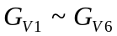 : thyristor conductance of each valve
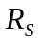 : snubber circuit resistance
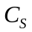 : snubber circuit capacitance
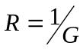 : resistance in parallel with reactor
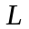 : current rate limiting inductance
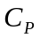 : thyristor parasitic capacitance
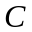 : DC side smoothing capacitance
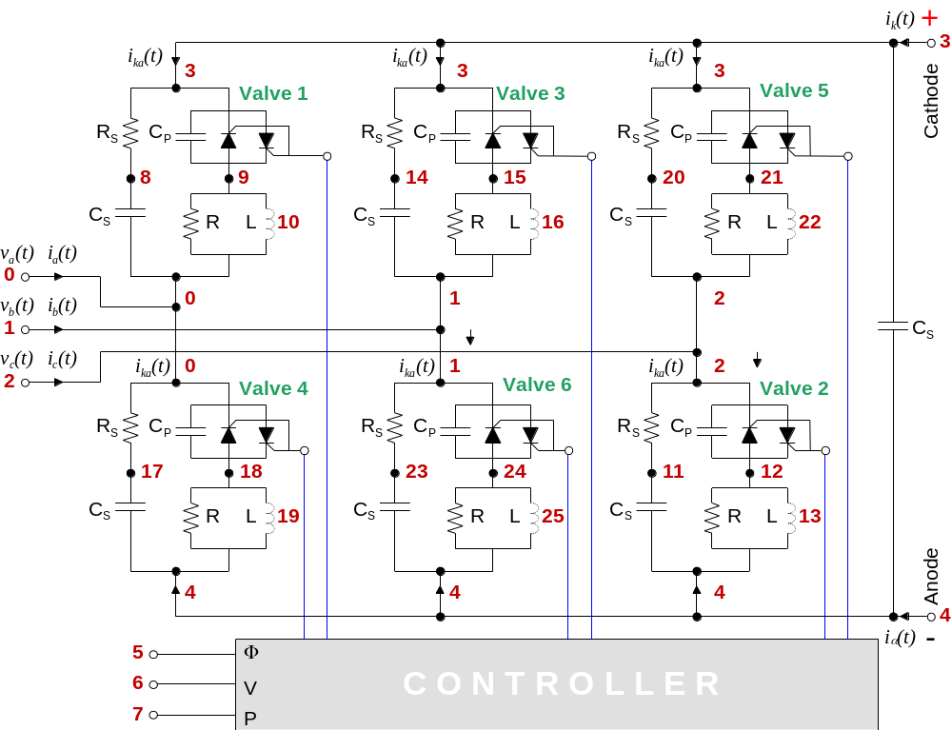

Figure 1. Three Phase, Six-Valve Bridge Model with Controller
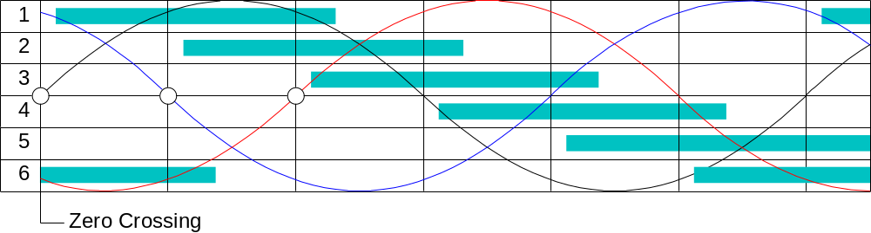

Figure 2. Firing Angle Sequence

Overview of State Space Model

Here we develop the discrete state space model of the converter. For this purpose, we consider the converter as the interconnection of six valves and smoothing capacitor. The model equations of the converter are developed. Specifically, the differential equations describing the converter model are written in state space form. There are two sets of equations, external equations and internal equations. The external equations consist of the node currents of the converter and the internal equations are derived with internal states. The state space model is given by

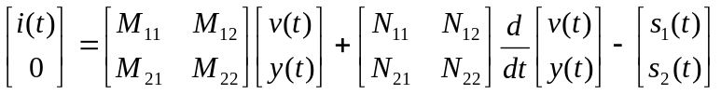 (2.1)

where 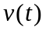 is the vector of external states, 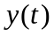 is the vector of internal states, and 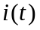 is the vector of terminal currents. From above model we can derive the algebraic companion form model in the following form:

(2.2)

Our objective is to derive the model of the converter in the form of equation (2.1). The steps of this derivation are: First, we write the equations for each of the six valves and the smoothing capacitor. Then we apply the connectivity construction of the six valves to obtain the equations for the overall converter model.

Single Valve Model

The model of a single valve of a six-valve converter is shown in Figure 2. Note that the valve may reside in one of three states. We derive the state space equations for a single valve.

The model has two external state variables, 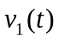 and 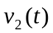, and three internal state variables, 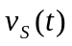, 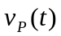, and 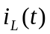. Figure 2 illustrates the three topologies of the thyristor, i.e., valve on, valve off, and valve in transition.

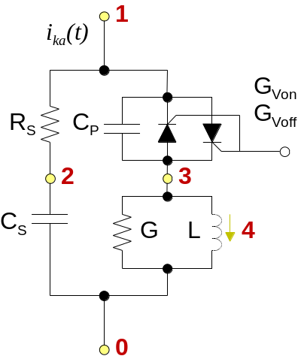

Figure 2. Single Valve Model
(Valve Conductance is a Function of Valve Status)

The state space model of the valve of Figure 2 is:

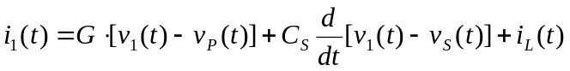
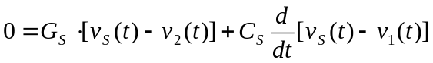
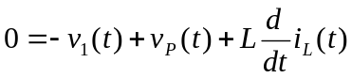

Note that the electronic switch model is represented with the conductance G_{V}. This conductance value is changed according to the three states. For compactness, the above equations are written in matrix notations as follows:

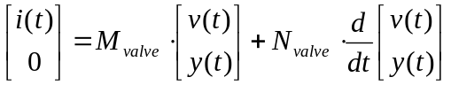 (2.3)

where

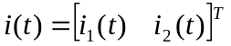,
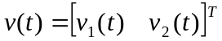,

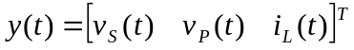,

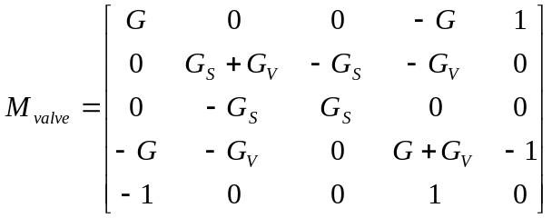

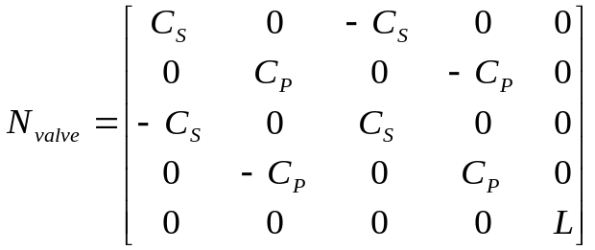

Each valve is connected to specific nodes of the converter. The connectivity of each valve is defined in terms of the order of the corresponding states. Table 1 provides the connectivity pointers ofr the six valves.

Table 1: Valve Pointers

Valve # | States
1 | 0 | 3 | 8 | 9 | 10
2 | 4 | 2 | 11 | 12 | 13
3 | 1 | 3 | 14 | 15 | 16
4 | 4 | 0 | 17 | 18 | 19
5 | 2 | 3 | 20 | 21 | 22
6 | 4 | 1 | 23 | 24 | 25

Smoothing Capacitor Model

We also derive the equations for the smoothing capacitor illustrated in Figure 1. For capacitor C, the dynamic equations can be cast in the same form as (2.4) as follows:

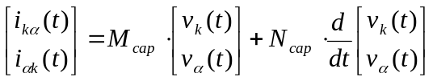 (2.4)

where: 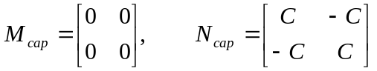

Each smoothing capacitor is connected to specific nodes of the converter. The connectivity of each capacitor is defined in terms of the order of the corresponding states. Table 2 provides the connectivity pointers of the smoothing capacitor.

Table 2: Smoothing Capacitor

Cap # | States
1 |  | 3 | 4

Converter Algebraic Companion Form

In previous sections, we have shown the dynamic equations for single valve and smoothing capacitor. Now we need to construct the whole converter’s model. There are two ways to construct the converter model. One is to use the ACF for each component and apply connectivity constrain to form the converter’s ACF; The second method is to use the dynamic equations of each component and apply the connectivity constrain to form the whole converter’s dynamic equations and then integrate the converter dynamic equations to obtain its ACF. The first method seems straightforward and will work well when time step is fixed. But as we will discuss later, we need to use the second method in order to implement variable time step computation, which is more accurate than fixed time step computation. Therefore, we will use the second method here.

The five external equations, which describe the terminal currents of the converter, are given by (see Figure 1)

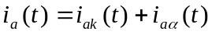
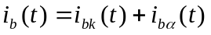
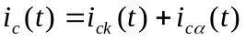

Upon substitution of the indicated currents and appending the internal equations, the overall converter equations are derived. We say that we apply the conbnectivity equations to obtain the converter model.

The resulting converter state space model is:

(2.5)

The indicated variables are:

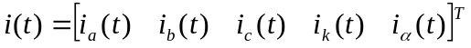,

,

,

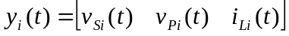, where i = 1, 2, 3,…6.

The ACF is obtained by direct application of trapezoidal integration of above equation.

(2.6)

where

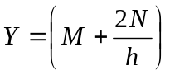

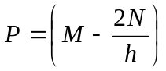

Fixed Time Step Model vs. Multi-Rate Time Step Model

In the above sections, we have discussed how to generate ACF model for each component and the whole converter. However, the so generated ACF model is valid only if there is no topology change or parameter change in the device during the [t-h, t] period. This condition is assumed true when we integrate equation (2.5) to obtain (2.6) where we treat M and N matrices as constant matrices. However, the switching sequence control is totally independent of the integration time step. It could happen any time and most likely the switching will occur within the fixed time step as illustrated in following figure. To accurately model the thyristor during time domain simulation, a variable time step approach must be used.

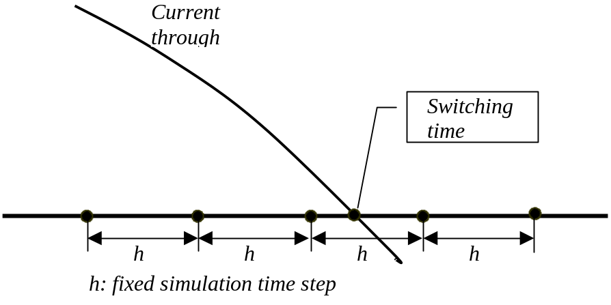

Multi-Rate Converter Model

Refer to figure below. Assume that we have computed the ACF for the time interval [ t-h, t₁ ]. The goal is to compute the ACF for the time interval [ t-h, t₂ ]..

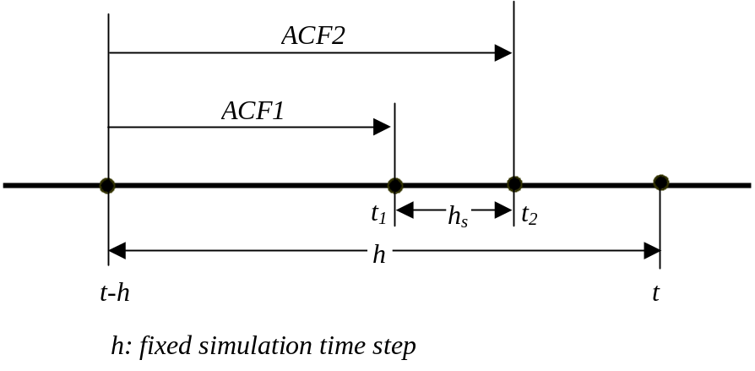

At time t₁, the ACF₁ is expressed with the following equations.

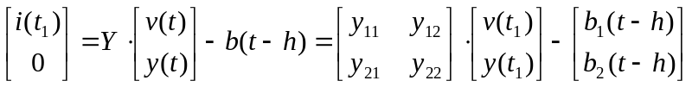 (3.1)

Solve above equation for y(t₁) as a function of v(t₁), we obtain

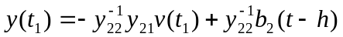 (3.2)

Also from (2.7), we can express 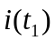 as follows

(3.3)

In addition, we can interpolate 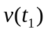between [ t-h, t2 ] as below

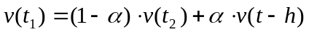 (3.4)

where 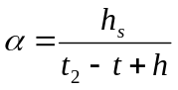

On the other hand, upon integration of the dynamic equation (2.5) for the interval [ t_{1 ,} t₂ ], we get

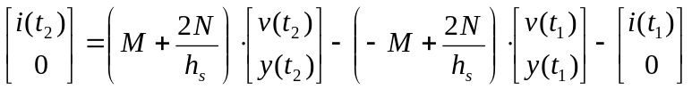 (3.5)

Now, let’s plug equations (2.8), (2.9) and (2.10) into (2.11). Upon manipulation, we can obtain ACF in terms of variables at time t₂ and t-h as follows.

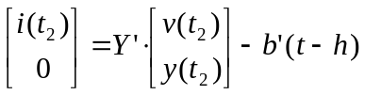 (3.6)

where 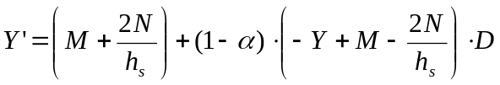 (3.7)

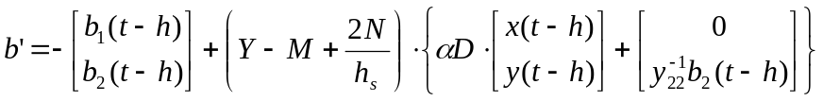 (3.8)

(3.9)
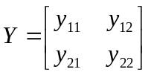 (3.10)

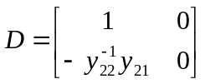 (3.11)

Converter Control

The converter controller can be a very complex system depending on the sophistication of the control scheme. Here we implement the basic scheme for the converter control, which consists of two steps. In the first step, an estimation method is applied to determine the control reference. The second step is the control action, which determines the firing angle of each valve with delay relative to the control reference.

Converter Equi-Distant Control

The control action is taken based on the zero crossing (from negative to positive) of voltage 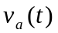. First, we compute the next zero crossing of this voltage.
The algorithm for this task is as follows:

Step 1: Compute the first cycle zero crossing. This is given by
the equation:

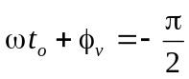

Solving for t_{o}

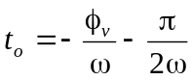

Step 2: Compute the next zero crossing from the present time with
the following algorithm

DO WHILE (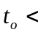 PRESENT TIME)
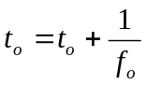
END DO

Step 3: Compute the last zero crossing time

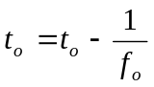

Once the zero crossing time has been computed, the closing of the thyristor valves will be computed as the following time steps:

Valve 1: 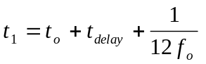
Valve 2: 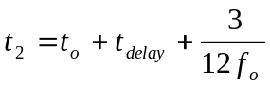
Valve 3: 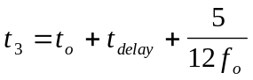
Valve 4: 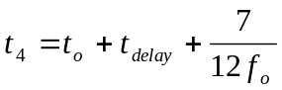
Valve 5: 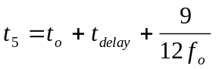
Valve 6: 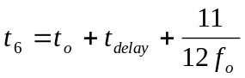

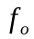 is the fundamental frequency at which the device is operating. The valve 1’s firing time is not the zero crossing time but the time delayed by 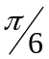 because the thyristor valve 1 is turned on when the voltage 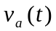 is greater than the voltages of the valve 3 and 5, and the rest of valves are also delayed by . The value 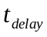 has to be defined by the user of the PST program and the constant is the fundamental frequency of the system.

Converter PWM Control

The control action is taken based on the zero crossing (from negative to positive) of voltage . First, we compute the next zero crossing of this voltage. The algorithm for this task is as follows:

Model Validation

Circuit icon of the model;
examples of applications of the model;
validity range and limitations of the model, etc.

Model Applications

Circuit icon of the model;
examples of applications of the model;
validity range and limitations of the model, etc.

References

