Virtual Test Bed

Six-Pulse Converter with Equidistant Control

Model 117

Developed by

Professor: A. P. Meliopoulos

GRA: Xi Zhu

School of Electrical Engineering
Georgia Institute of Technology
Atlanta, GA 30332

Scope

A converter is a device that converts electric power from one form to another, for example AC to DC or DC to AC. Converters may be unidirectional or bi-directional. A six-pulse converter is a bi-directional converter.
The objective of this work is to develop a six-pulse converter model to be integrated in the VTB program. The model will be used to study control strategies for this device. The control method is to use equi-distant control with feedback from the AC side.
The main objective of this work is to demonstrate the use of variable time step in the development of this Algebraic Companion Form.

Model Description

The model of a six-pulse converter is shown in Figure 1. The converter consists of six valves. Each valve consists of a thyristor valve with a parasitic capacitor, a snubber circuit, and a current rate limiting circuit. They are interconnected to yield the six-pulse converter topology.

The circuit parameters of the six-pulse converter of Figure 1 are:

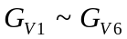 : thyristor conductance of each valve
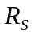 : snubber circuit resistance
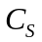 : snubber circuit capacitance
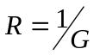 : resistance in parallel with reactor
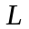 : current rate limiting inductance
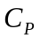 : thyristor parasitic capacitance
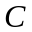 : DC side smoothing capacitance

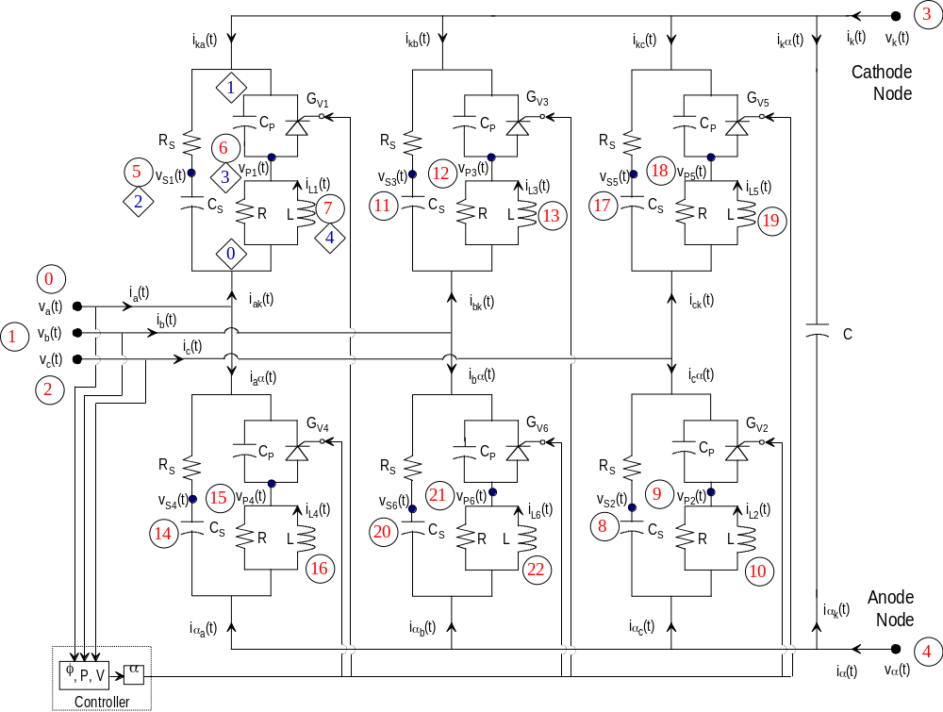
Figure 1. Three Phase, Six-pulse Bridge Model with Equidistant Control

State Space Model - Discrete
Here we develop the discrete state space model of the converter. For this purpose, we consider the converter as the interconnection of six valves and smoothing capacitor. The model equations of the converter are developed. Specifically, the differential equations describing the converter model are written in state space form. There are two sets of equations, external equations and internal equations. The external equations consist of the node currents of the converter and the internal equations are derived with internal states. The state space model is given by

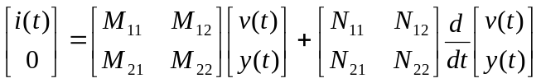 (2.1)

where 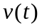 is the vector of external states, 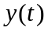 is the vector of internal states, and 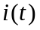 is the vector of terminal currents. From above model we can derive the algebraic companion form model in the following form:

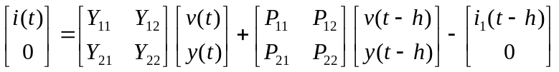 (2.2)

Our object is to get to above form. Above equation (2.2) is derived as follows. First, we write the equations for each of the six valves and the smoothing capacitor. Then we apply the connectivity construction of the six valves to obtain the equations for the overall converter model.

Model of Single Valve
The model of a single valve of a six-pulse converter is shown in Figure 2. Note that the valve may reside in one of three states. We derive the state space equations for a single valve.

The model has two external state variables, 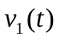 and 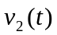, and three internal state variables, 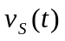, 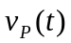, and 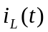. Figure 2 illustrates the three topologies of the thyristor, i.e., valve on, valve off, and valve in transition.

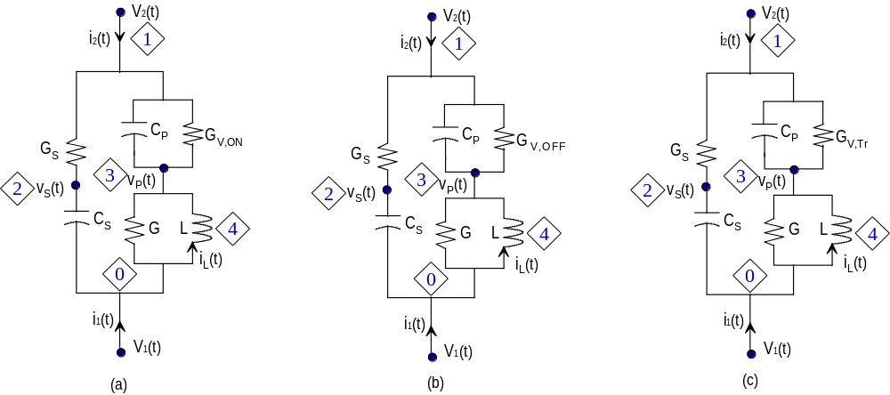

Figure 2. Single Valve Model of a Six-pulse Converter
- Valve in On Position
- Valve in Off Position
- Valve in Transition

State space model of the valve of Figure 2 is:
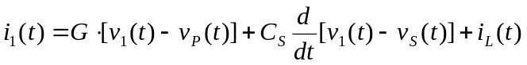
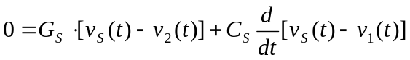
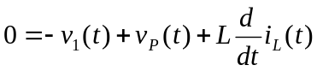

Note that the electronic switch model is represented with the conductance G_{V}. This conductance value is changed according to the three states. For simplification of computation for the single valve, above equations are rewritten in matrix notations as follows:

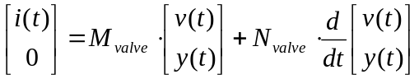 (2.3)

where

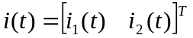,

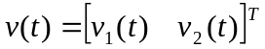,

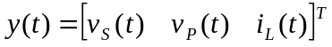,

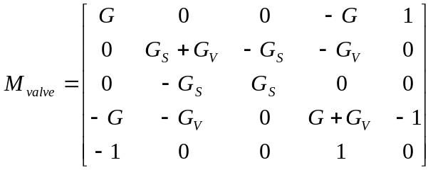

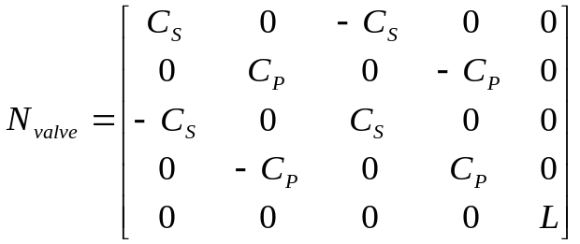

Model of Smoothing Capacitor
We also derive the equations for the smoothing capacitor illustrated in Figure 1.

For capacitor C, the dynamic equations can be cast in the same form as (2.4) as follows:

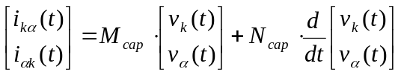 (2.4)

where 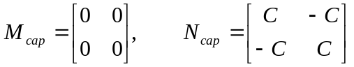

Algebraic Companion Form of Converter
In previous sections, we have shown the dynamic equations for single valve and smoothing capacitor. Now we need to construct the whole converter’s model. There are two ways to construct the converter model. One is to use the ACF for each component and apply connectivity constrain to form the converter’s ACF; The second method is to use the dynamic equations of each component and apply the connectivity constrain to form the whole converter’s dynamic equations and then integrate the converter dynamic equations to obtain its ACF. The first method seems straightforward and will work well when time step is fixed. But as we will discuss later, we need to use the second method in order to implement variable time step computation, which is more accurate than fixed time step computation. Therefore, we will use the second method here.

The five external equations, which describe the terminal currents of the converter, are given by (see Figure 1)

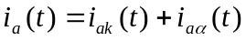
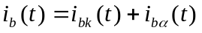
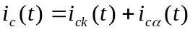

Upon substitution of the internal equations, which are equations for each valve, into above external equations, we can derive overall equations for the converter model. This is done simply by using the connectivity constraint, which are the pointer elements shown in Table 1.

Table 1. Pointer elements for each valve
Valve | Pointer Elements (POINTER_{KEY})
KEY = 1 | 0, 3, 5, 6, 7
KEY = 2 | 4, 2, 8, 9, 10
KEY = 3 | 1, 3, 11, 12, 13
KEY = 4 | 4, 0, 14, 15, 16
KEY = 5 | 2, 3, 17, 18, 19
KEY = 6 | 4, 1, 20, 21, 22
Smoothing Capacitor | 3, 4

The converter’s state equation can be expressed as following:
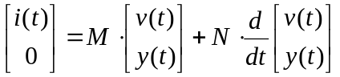 (2.5)

where M and N are formed by using the connectivity constrains and M_{valve}, N_{valve}, N_{cap} matrices. Other variables are as follows.

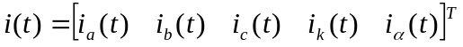,

,

,

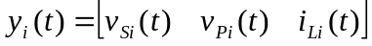, where i = 1, 2, 3,…6.

Then, the ACF for the whole converter can be expressed as
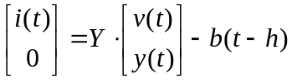 (2.6)
where
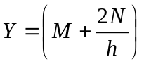
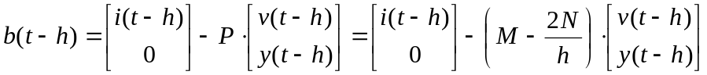
Fixed Time Step Model vs. Variable Time Step Model

In above sections, we have discussed how to generate ACF model for each component and the whole converter. However, the so generated ACF model is valid only if there is no topology change or parameter change in the device during the [t-h, t] period. This condition is assumed true when we integrate equation (2.5) to obtain (2.6) where we treat M and N matrices as constant matrices. However, the switching sequence control is totally independent of the integration time step. It could happen any time and most likely the switching will occur within the fixed time step as illustrated in following figure. To accurately model the thyristor during time domain simulation, a variable time step approach must be used.
h
h
h
h
Current through thyristor
Switching time
h: fixed simulation time step

Model of Converter with Variable Time Step
Refer to figure below. Assume that we have computed the ACF for the time interval [ t-h, t₁ ]. The goal is to compute the ACF for the time interval [ t-h, t₂ ]..
h
ACF1
h: fixed simulation time step
t-h
t
ACF2
t₁
t₂₁
h_{s}

At time t₁, the ACF₁ is expressed with the following equations.
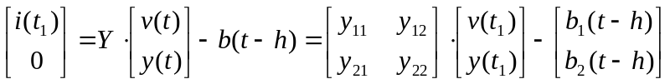 (2.7)
Solve above equation for y(t₁) as a function of v(t₁), we obtain
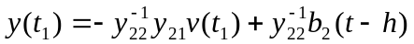 (2.8)
Also from (2.7), we can express 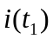 as follows
(2.9)
In addition, we can interpolate 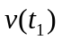between [ t-h, t2 ] as below
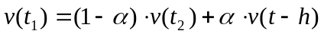 (2.10)
where 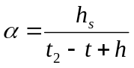
On the other hand, upon integration of the dynamic equation (2.5) for the interval [ t_{1 ,} t₂ ], we get
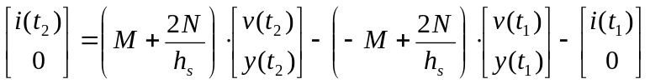 (2.11)
Now, let’s plug equations (2.8), (2.9) and (2.10) into (2.11). Upon manipulation, we can obtain ACF in terms of variables at time t₂ and t-h as follows.
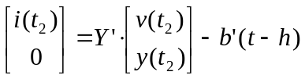 (2.12)
where 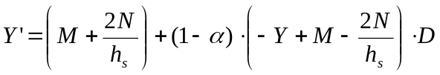
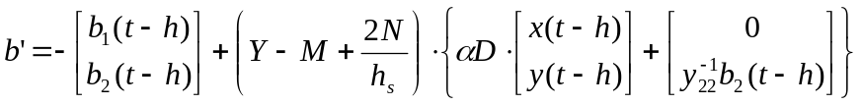
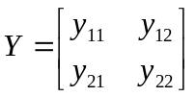
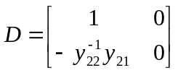

Converter Control

The converter controller can be a very complex system depending on the sophistication of the control scheme. Here we implement the basic scheme for the converter control, which consists of two steps. In the first step, an estimation method is applied to determine the control reference. The second step is the control action, which determines the firing angle of each valve with delay relative to the control reference.

Since the converter has electronic switches, which generate harmonics, and the voltage across each valve is not sinusoidal, we cannot estimate the zero crossing time of the voltage exactly. Thus, we must compute the zero crossing time of the fundamental voltage.

Estimation of Control Reference

Suppose that for a three-phase system, line to line voltages 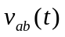, 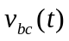, and 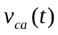 in Figure 1 have Fourier Series representation

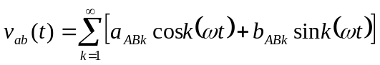 (4.1)

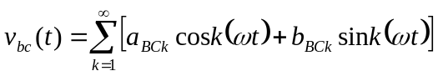 (4.2)

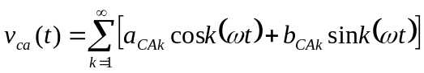 (4.3)

To compute the Fourier coefficient, 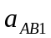, of the fundamental component of the voltage , multiply Equation (4.1) by 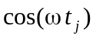, which is described by the fundamental frequency, and then integrate the both sides over one period T numerically.

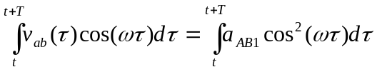

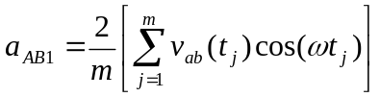 (5.1)

where 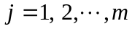, which is equivalent to one period, and the period is the reciprocal of the fundamental frequency.
And also multiplying Equation (4.1) by 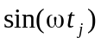 and integrating it, we have

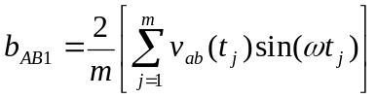 (5.2)

Application of the same procedure to the voltage and yields,
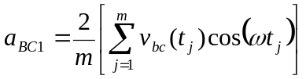 (5.3)

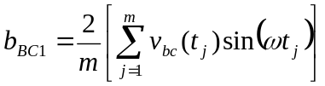 (5.4)

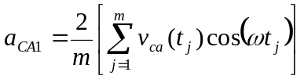 (5.5)

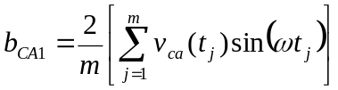 (5.6)

Note that at each time step, the quantities , 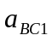, 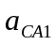, 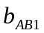, 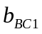, and 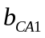 can be computed. The fundamental frequency components of all three phase voltages in polar coordinates can be expressed as follows:
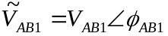, where 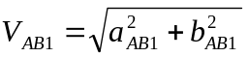, 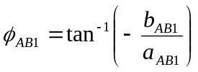
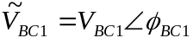, where 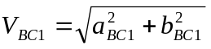, 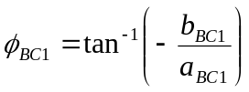
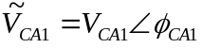, where 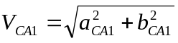, 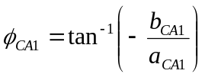

Therefore, the fundamental frequency component of 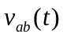can be written as follows:

Similar expression can be written for other two phases.

Above three phase phasors may be unbalanced and contain negative and zero sequence components. To use the positive sequence fundamental component as reference voltage, we need to perform modal decomposition to extract the positive sequence component from the three unbalanced phasors. The transformation is expressed in the following relation.

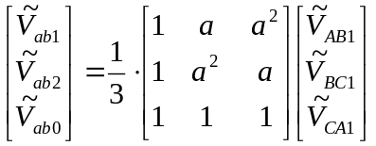 where 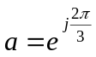 (5.7)

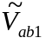,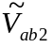 and 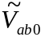 are the positive, negative and zero sequence components of 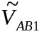 respectively.

Therefore, the positive sequence component of the fundamental components of line to line voltage 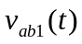obtained from the Fourier analysis, can be expressed as follows:

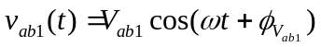 (5.8)

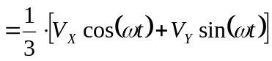

where
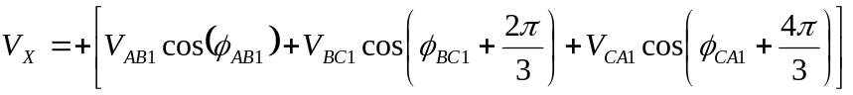 (5.9)

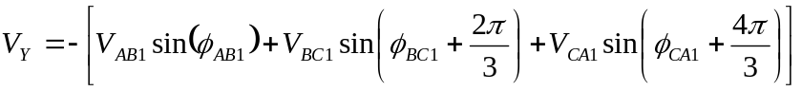 (5.10)

Therefore, the peak value and phase angle of the line voltage 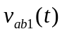can be calculated as below.

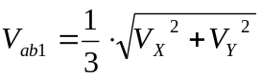 is the peak line voltage (5.11)
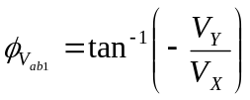 is the phase angle of line voltage (5.12)

The phase voltage can easily be computed from the line voltage for the positive sequence due to symmetry. The magnitude of phase voltage is the product of line voltage and 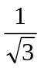. The phase angle lags the line voltage by 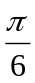. For example, the positive sequence of the fundamental component of phase A voltage can be compute as follows.

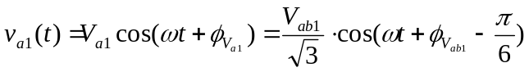 (5.13)

In case there is a need to control the real power of the tri-level converter, it is necessary to compute the real power of the converter. For this purpose, we compute the fundamental real power of the converter. This computation needs positive sequence fundamental currents, which are computed with the same procedure as voltages. Specifically, consider the currents 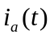, 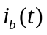, and 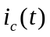 in Figure 1 which can be expressed as

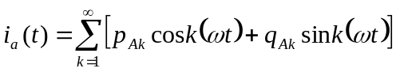 (6.1)

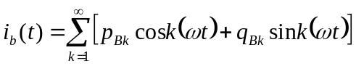 (6.2)

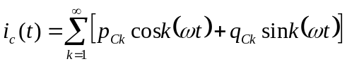 (6.3)

After computing the phasors magnitudes and angles of all the three phases, we can compute the following quantities,

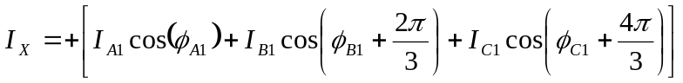 (6.4)

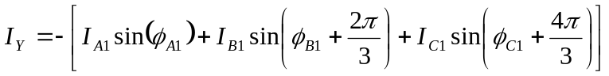 (6.5)

Then the fundament current of positive sequence can be described as follows:

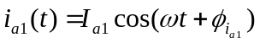 (6.6)

where 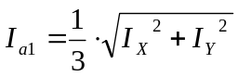 is the peak current (6.7)
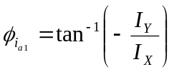 is the phase angle (6.8)

In summary, the phasors of the positive sequence of the Fourier Series fundamental voltage and current are 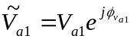and 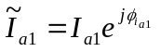 from Equations (5.13) and (6.6). Here, the estimated real power of the converter is computed as follows:

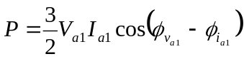

Control Action

The control action is taken based on the zero crossing (from negative to positive) of voltage 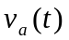. First, we compute the next zero crossing of this voltage.
The algorithm for this task is as follows:

Step 1: Compute the first cycle zero crossing. This is given by
the equation:

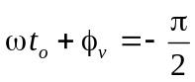

Solving for t_{o}

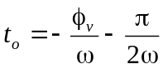

Step 2: Compute the next zero crossing from the present time with
the following algorithm

DO WHILE (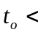 PRESENT TIME)
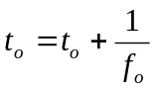
END DO

Step 3: Compute the last zero crossing time

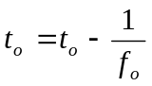

Once the zero crossing time has been computed, the closing of the thyristor valves will be computed as the following time steps:

Valve 1: 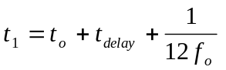
Valve 2: 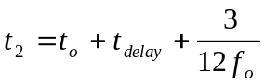
Valve 3: 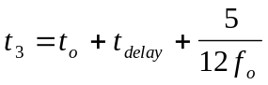
Valve 4: 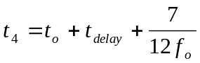
Valve 5: 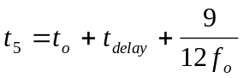
Valve 6: 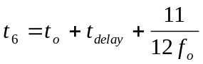

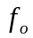 is the fundamental frequency at which the device is operating. The valve 1’s firing time is not the zero crossing time but the time delayed by 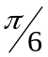 because the thyristor valve 1 is turned on when the voltage 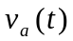 is greater than the voltages of the valve 3 and 5, and the rest of valves are also delayed by . The value 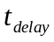 has to be defined by the user of the PST program and the constant is the fundamental frequency of the system.

Algebraic Companion Form

The converter ACF derived in Section 2 is summarized here.
Refer to figure below. Assume that we have computed the ACF for the time interval [ t-h, t₁ ] and the ACF is expressed as below.
h
ACF1
h: fixed simulation time step
t-h
t
ACF2
t₁
t₂₁
h_{s}

Then, the ACF for time interval [ t₁, t₂ ] can be expressed in terms of variables at time t₂ and t-h as follows.
where
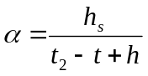, ,

Time Domain Algorithm in VTB

To implement the six-pulse converter in the VTB program, the integrated general companion form, Equation (2.2), is illustrated with a matrix form. In the VTB program, the general algebraic companion form is expressed as follows:
(4.1)
where
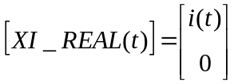
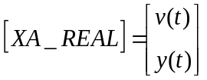
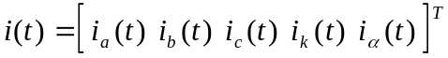

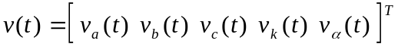

Summary of Discrete State Space Model
We derive the discrete state space model for the six-pulse converter. This model is used for small signal stability analysis in the VTB program.
Using equation (3.1), (3.2) and the algorithm we have used to build the matrix Y and P in equation (4.1), we construct the discrete model of equation (3.1) as follows:
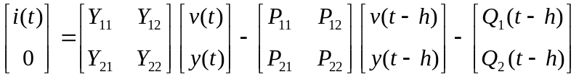 (4.2)

Equation (4.2) represents the Norton equivalent model, which is the algebraic companion form. By applying Kirchhoff’s current law on the terminal to which the converter is connected we can have the discrete state space model:
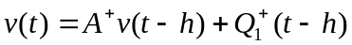

where 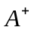 and 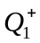are the matrices for all the system where the converter is connected. Thus, the model of equation (4.2) is called the discrete state space model of the six-pulse converter model.

Model Validation and Applications

Circuit icon of the model;
examples of applications of the model;
validity range and limitations of the model, etc.
References

