**Exploratory Data Analysis on credit card churn**

**Data Source:**The data set was collected from Kaggle, a popular platform for Data Science and Machine learning.

**Dataset name :** Credit Card Churn Prediction

**Dataset link :** <https://www.kaggle.com/code/swetanishad/credit-carn-churn-prediction>

**Data Description :**

There are 20 input feature s and target class label in the dataset.

**Univariate Analysis :**

* Numerical columns

**. Box plot**

* Categorical columns

**. Bar plot**

**Bi-variate Analysis :**

* Nmuerical columns

**. Scatter plot**

**. box plot**

* Categorical columns

**. Stacked bar plot**

**Multi variate analysis :**

* **Pair plot**
* **Heat map**

**Obesrvations:**

With respect to my target variable Credit_Limit, Total_Trans_Amt, Months_on_book as these columns are very crucial to the dataset I did not remove the outliers.

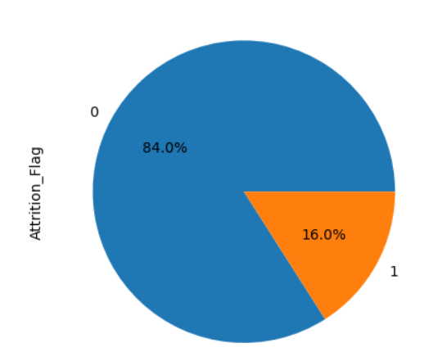**Insights:**

* This graph shows about the statistics of piechart that Existing customers are more than the Attrited Customer.
* 0 indicates Existing customers
* 1 indicates Attrited Customers.

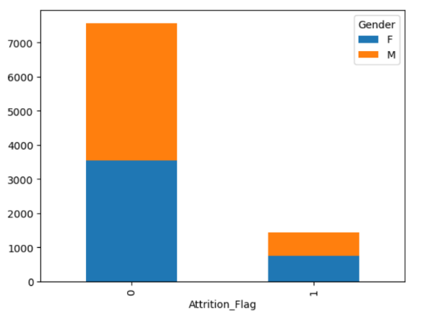

* This graph shows about the statistics of stacked bar plot With respect to the target variable female’s customers existing compare to male.
* Attrited Customers are very less in both male and female.

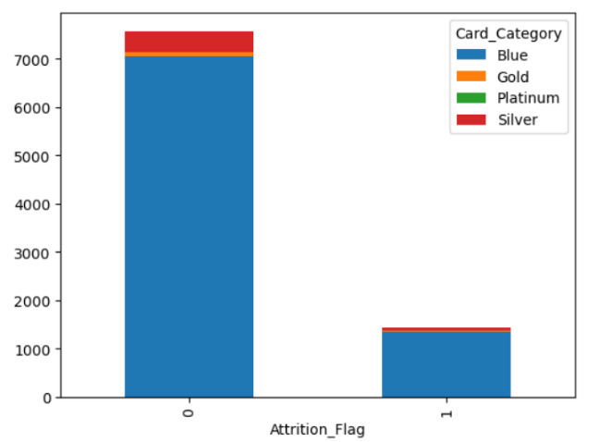

* This graph shows about the statistics of card_categorey that blue card users are more compare to others cards.

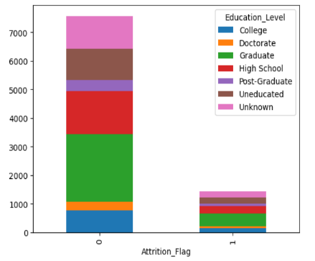

* This graph shows about the statistics of stacked bar plot tells that Graduate students are high in using credit cards compare to all other students.
* This graph shows about the statistics of stacked bar plot tells 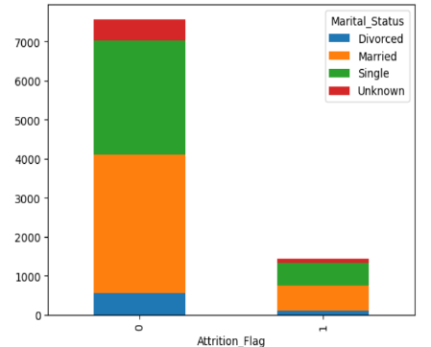that married people are high in using credit cards and existing customers.
* females own more credit card than male
* Married people takes the more credit card
* mostly people are graduate
* most people have salary less than 40k
* 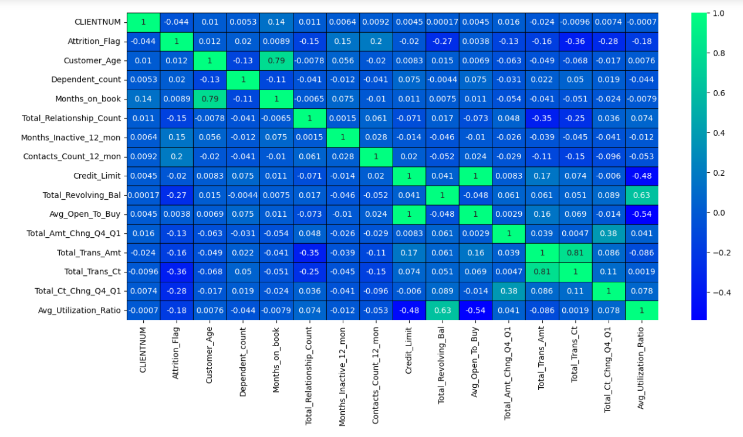almost 90% people have Blue Card
* This heat map shows about the statistics of relation between the columns we can observe that Months_on_book, Credit_Limit, Customer_Age, Avg_Open_To_Buy, Total_Trans_Amt, Total_Trans_C these columns are highly correlated.
* according to heat map we consider highly co related columns because the relation ship is strong .I have dropped the columns which are less correlated less than 0.63.