**Assignment 1**

GitHub Link: https://github.com/Vedanshi15/DailySpecial-Page

URL of the Page: <https://dailyspecial.netlify.app/>

Requirements:

* Link Validation
* Validation through W3C
* Lighthouse auditing
* Axe auditing

Links on the Page:

https://www.liquor.com/recipes/pimms-cup/

https://www.gimmesomeoven.com/margarita-recipe/

https://www.liquor.com/recipes/cosmopolitan/

https://www.liquor.com/recipes/negroni/

https://www.allrecipes.com/recipe/147363/the-real-mojito/

https://www.bonappetit.com/recipe/whiskey-sour

https://cookieandkate.com/classic-aperol-spritz-recipe/

Screenshot:

Desktop:

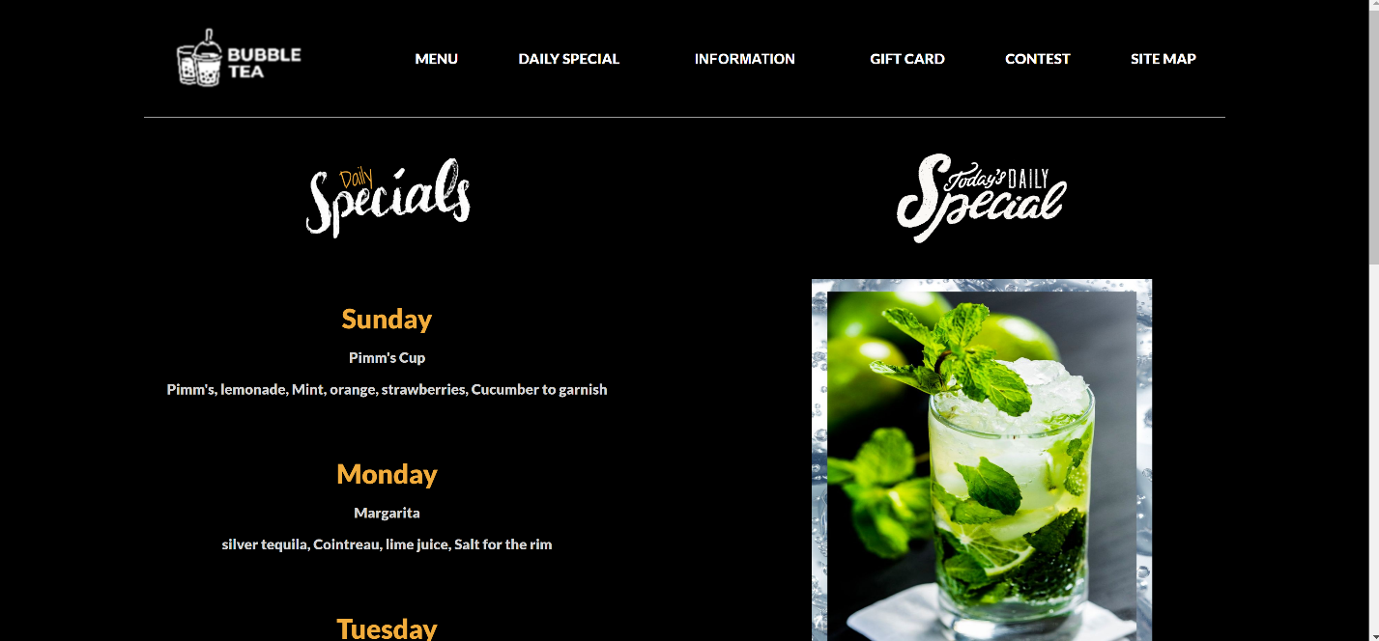

Tablet:

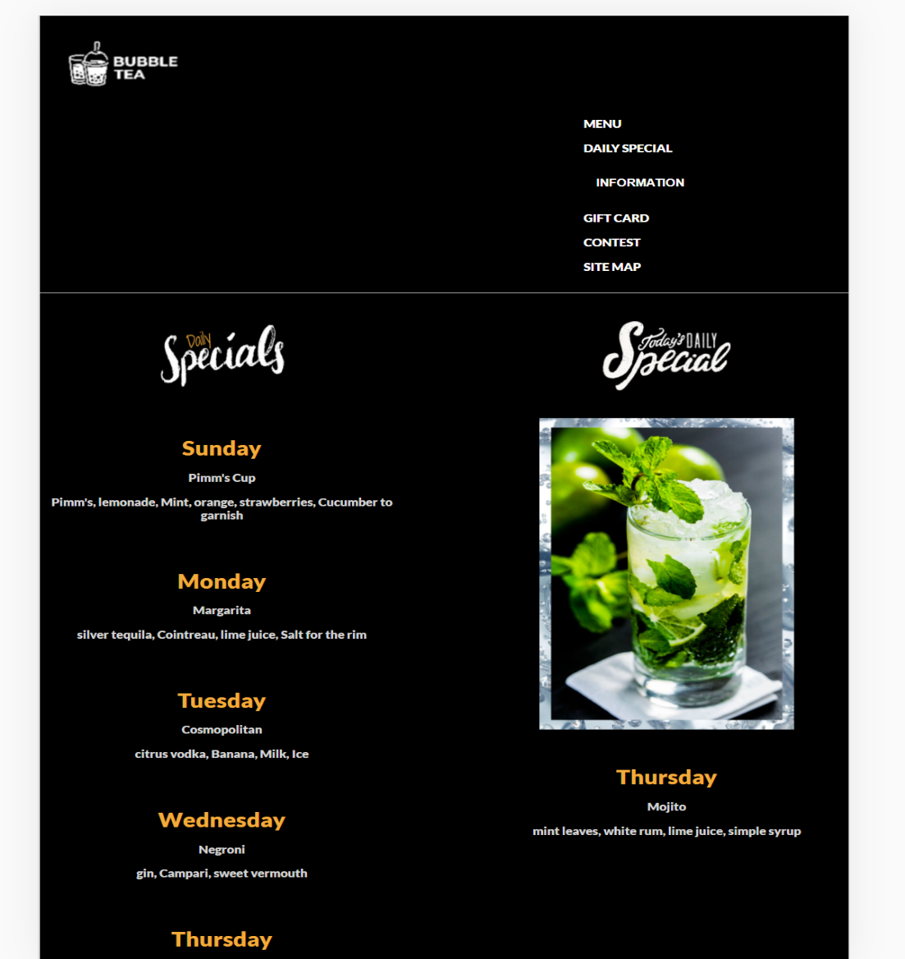

Phone:

