**A**

**Detailed report**

**On**

**“Tic Tac Toe”**

**Prepared and Presented by**

**Raghu Naluvala**

**Mounika Nagabhyru**

**Ambarish Kesavaram**

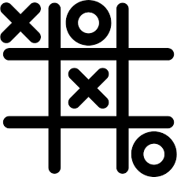

Contents

Chapter 1 3

Tic Tac Toe 3

Chapter 2 4

Game Overview 4

Chapter 3 6

Levels 6

Chapter 4 7

Technical 7

Figure 1 game won example diagram 3

Figure 2 game flow diagram 5

# Chapter 1

# Tic Tac Toe

Tic-tac-toe ([American English](https://en.wikipedia.org/wiki/American_English)), noughts and crosses ([British English](https://en.wikipedia.org/wiki/British_English)), or Xs and Os is a [paper-and-pencil game](https://en.wikipedia.org/wiki/Paper-and-pencil_game) for two players, X and O, who take turns marking the spaces in a 3×3 grid. The player who succeeds in placing three of their marks in a horizontal, vertical, or diagonal row wins the game.

The following example game is won by the first player, X:

game

[Game of Tic-tac-toe, won by X](https://en.wikipedia.org/wiki/File:Tic-tac-toe-game-1.svg)

Figure 1 game won example diagram

* 1. **Tic Tac Toe – Computer Ai based tic tac toe**

This game is developed using JavaScript, html and css with bootstrap. Tic Tac Toe is designed with simple Ui where first User starts Game by placing X on 3*3 grid and then computer will place O and then user will place X and this will continue till someone succeeds in placing three of their marks in a horizontal, vertical, or diagonal row.

# Chapter 2

# Game Overview

**2.1** **Game Concept**

The game can be generalized to an [m,n,k-game](https://en.wikipedia.org/wiki/M,n,k-game" \o "M,n,k-game) in which two players alternate placing stones of their own color on an m×n board, with the goal of getting k of their own color in a row. Tic-tac-toe is the (3,3,3)-game. [Harary's generalized tic-tac-toe](https://en.wikipedia.org/wiki/Harary%27s_generalized_tic-tac-toe" \o "Harary's generalized tic-tac-toe) is an even broader generalization of tic-tac-toe. It can also be generalized as a [nd game](https://en.wikipedia.org/wiki/Nd_game" \o "Nd game). Tic-tac-toe is the game where n equals 3 and d equals 2 If played properly, the game will end in a draw, making tic-tac-toe a [futile game](https://en.wikipedia.org/wiki/Futile_game).

**2.2 Target Audience**

Because of the simplicity of tic-tac-toe, it is often used as a [pedagogical](https://en.wikipedia.org/wiki/Pedagogical) tool for teaching the concepts of good [sportsmanship](https://en.wikipedia.org/wiki/Sportsmanship) and the branch of [artificial intelligence](https://en.wikipedia.org/wiki/Artificial_intelligence) that deals with the searching of [game trees](https://en.wikipedia.org/wiki/Game_tree). It is straightforward to write a [computer program](https://en.wikipedia.org/wiki/Computer_program) to play tic-tac-toe perfectly or to enumerate the 765 essentially different positions (the [state space complexity](https://en.wikipedia.org/wiki/State_space_complexity)) or the 26,830 possible games [up to](https://en.wikipedia.org/wiki/Up_to) rotations and reflections (the [game tree complexity](https://en.wikipedia.org/wiki/Game_tree_complexity)) on this space.

**2.3 Game Flow Summary**

User will start the game by placing X on the board, now AI will check if the game is won or draw, if not won or draw then system will make move, now again AI will check if the

game is won or draw, if not won or draw then User will make move, this will continue until the game is one or draw.

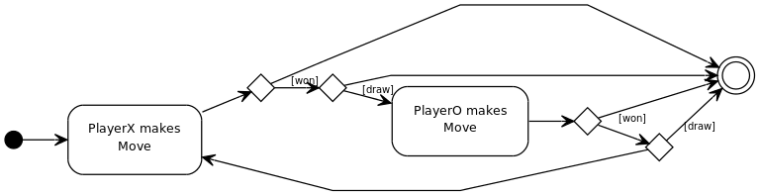

Figure 2 game flow diagram

# Chapter 3

# Levels

**3.1 Easy**

In Easy mode the player have maximum chance of winning the game. Here the algorithm is created to place the O’s by system in empty places from first row. Hence user have 80% of chance to win the game.

**3.2 Standard**

In Standard Mode Player have only 50% of chance in winning the game. After the player make a move, system will place O’s in random places making the game a bit competitive.

**3.3 Hard**

In Hard mode the Player don’t have any chance of winning the game, it will be always draw or the system will win the game. The algorithm is created in such a way that system know all the possible moves that can be possible and thus make it difficult for the player to win the game.

# Chapter 4

# Technical

**4.1 System Requirements**

Any working operating system.

1. Windows, linux, Ubuntu, chrome os, macbook.
2. Any Browser.
3. Mouse.

**4.2 Languages used**

**JavaScript-** JavaScript is used to write the main game logic.

**Css with Bootstrap-** css with bootstrap is used to design the game UI.

**HTML-** Html is used to write the login and registration page.

**Index DB-** JavaScript API to store client side data.

Git hub location: https://github.com/AmbarishKesavaram/TicTacToe.git

References

<https://en.wikipedia.org/wiki/Tic-tac-toe-> Wikipedia