1. To validate for user model business validations:

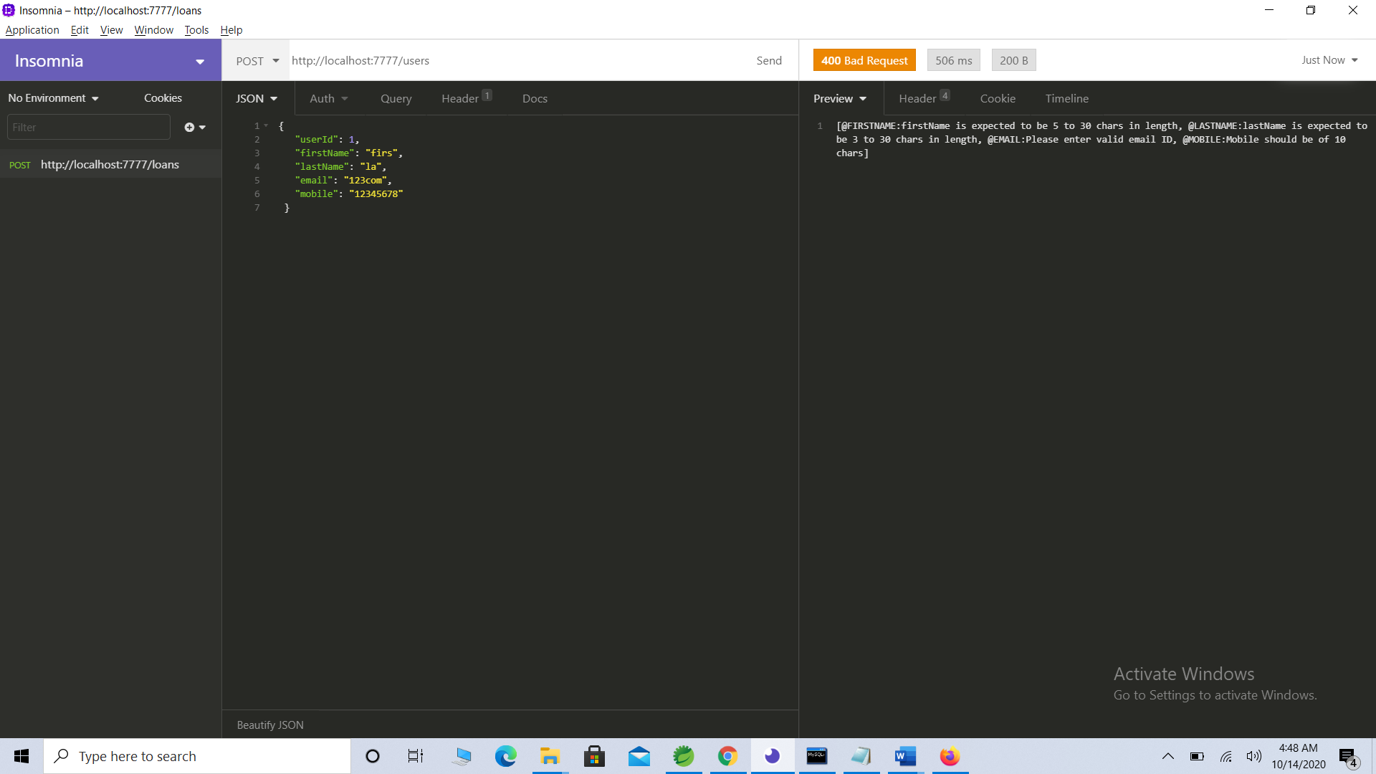

1. To add a user:

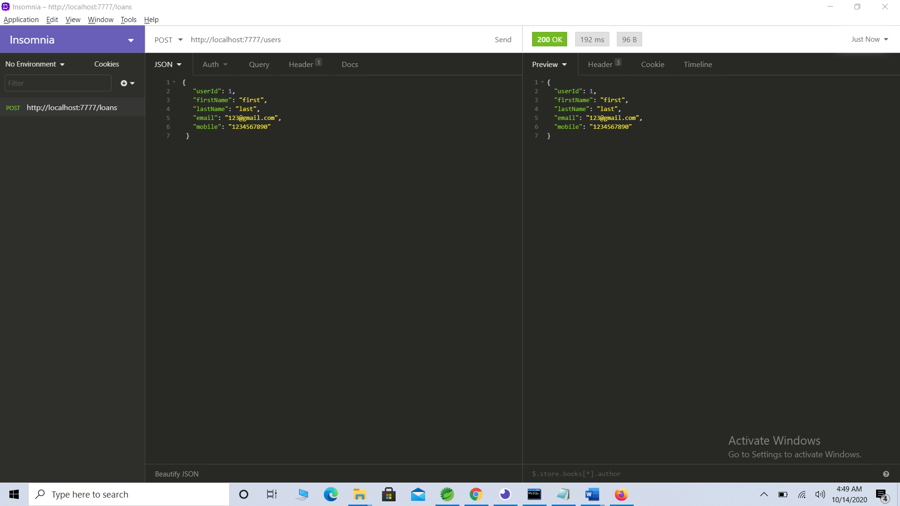

1. If user already exists - to validate for user exception:

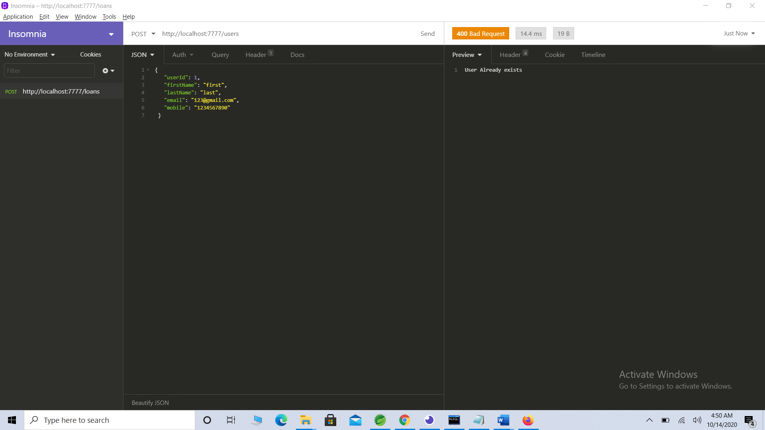

1. To display all users:

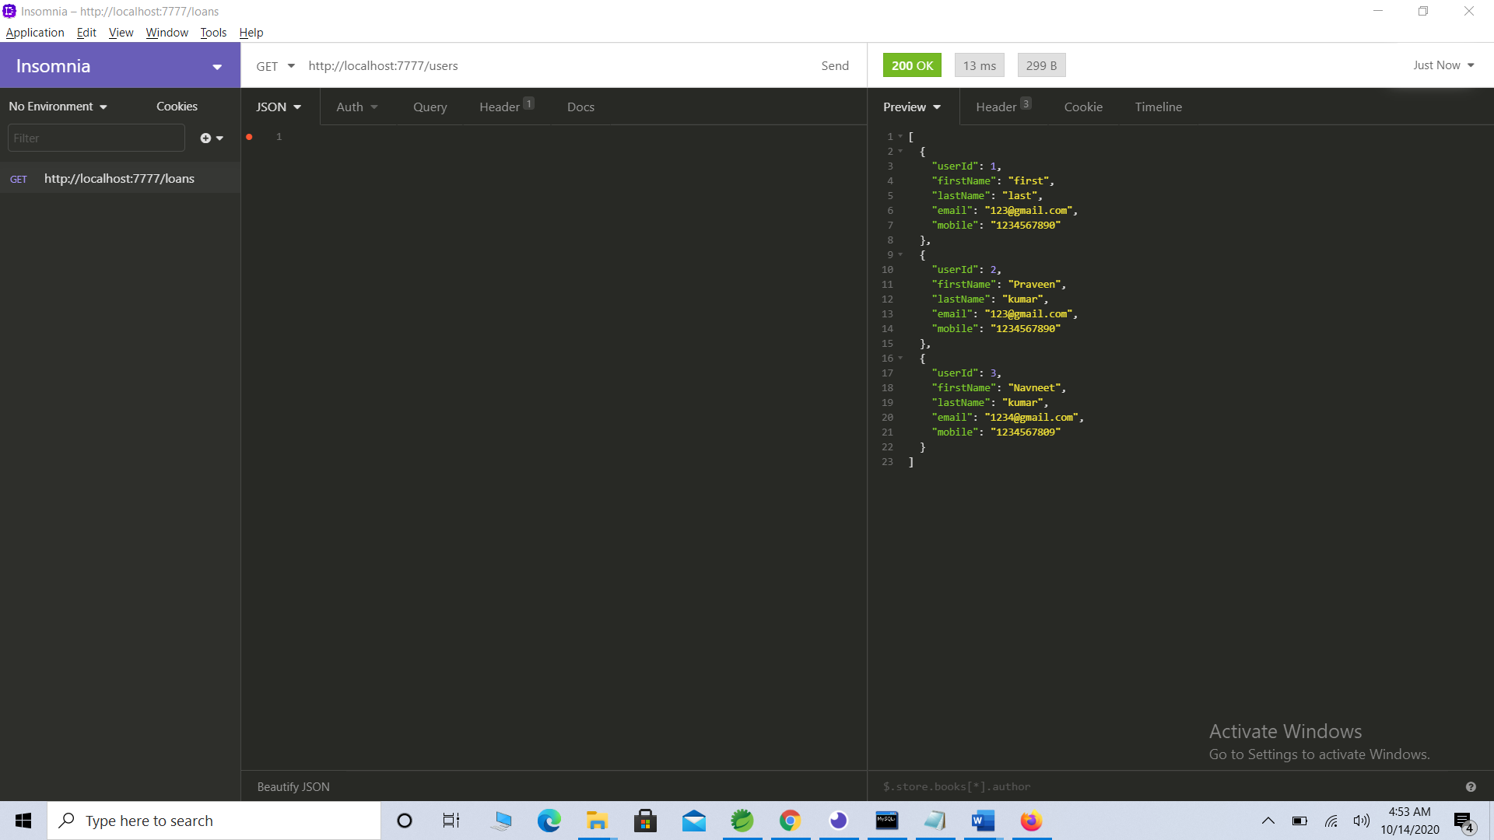

1. To delete a user:

User id:4

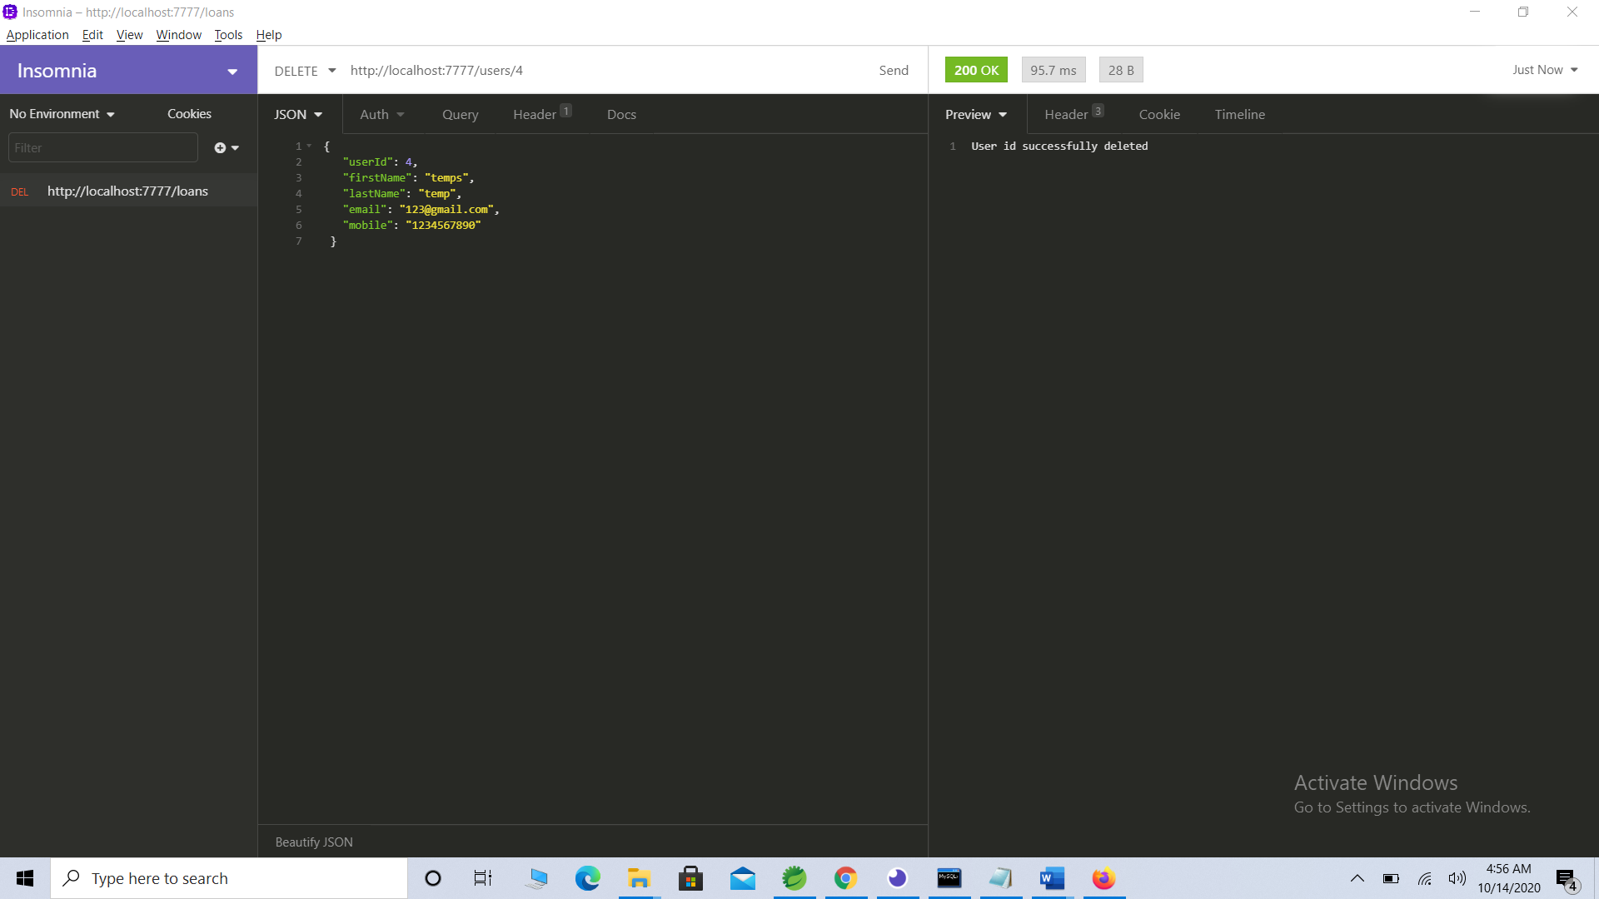

Get all records post deletion:

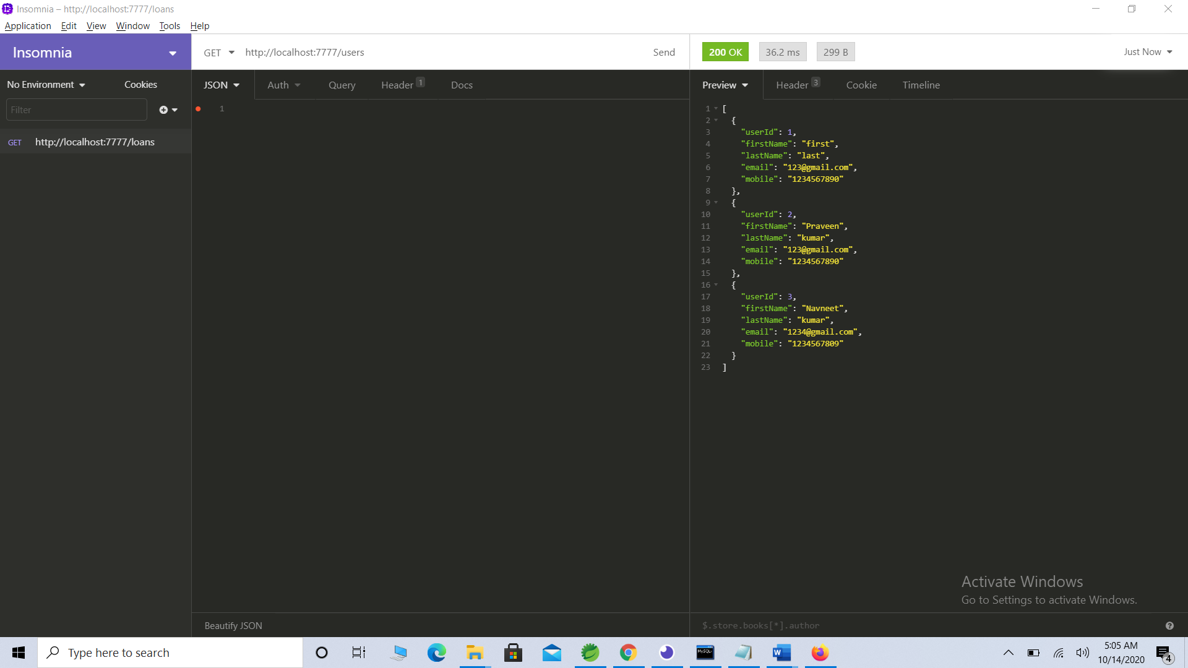

1. To add a interview:

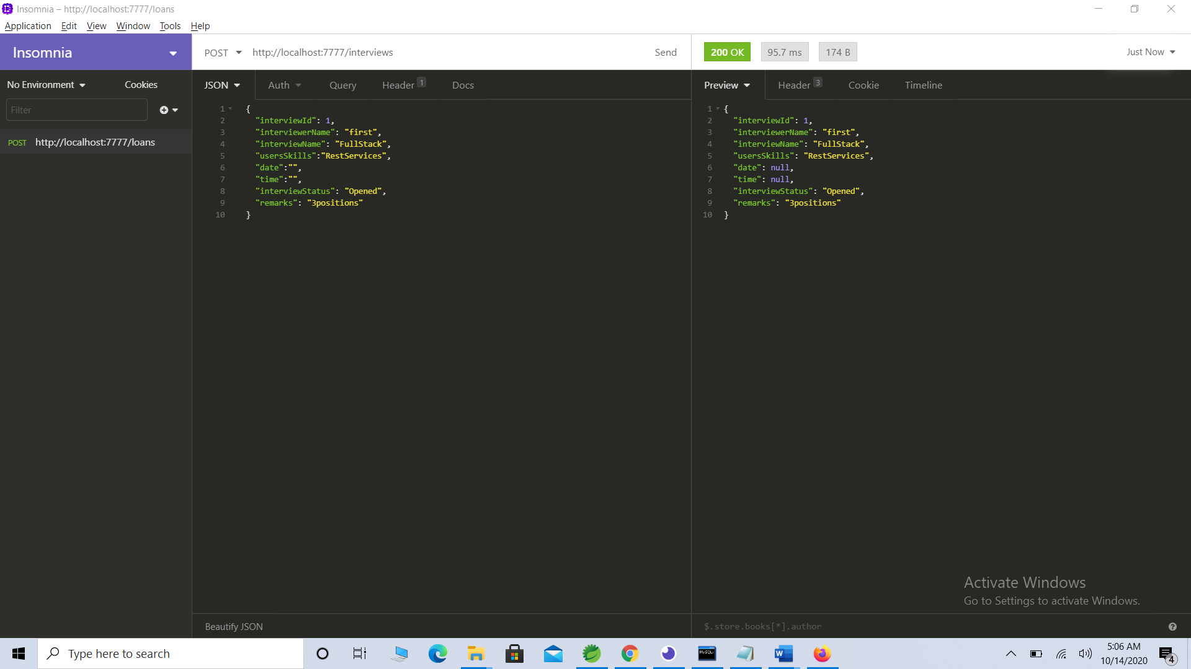

1. To validate for Interview Model business validations

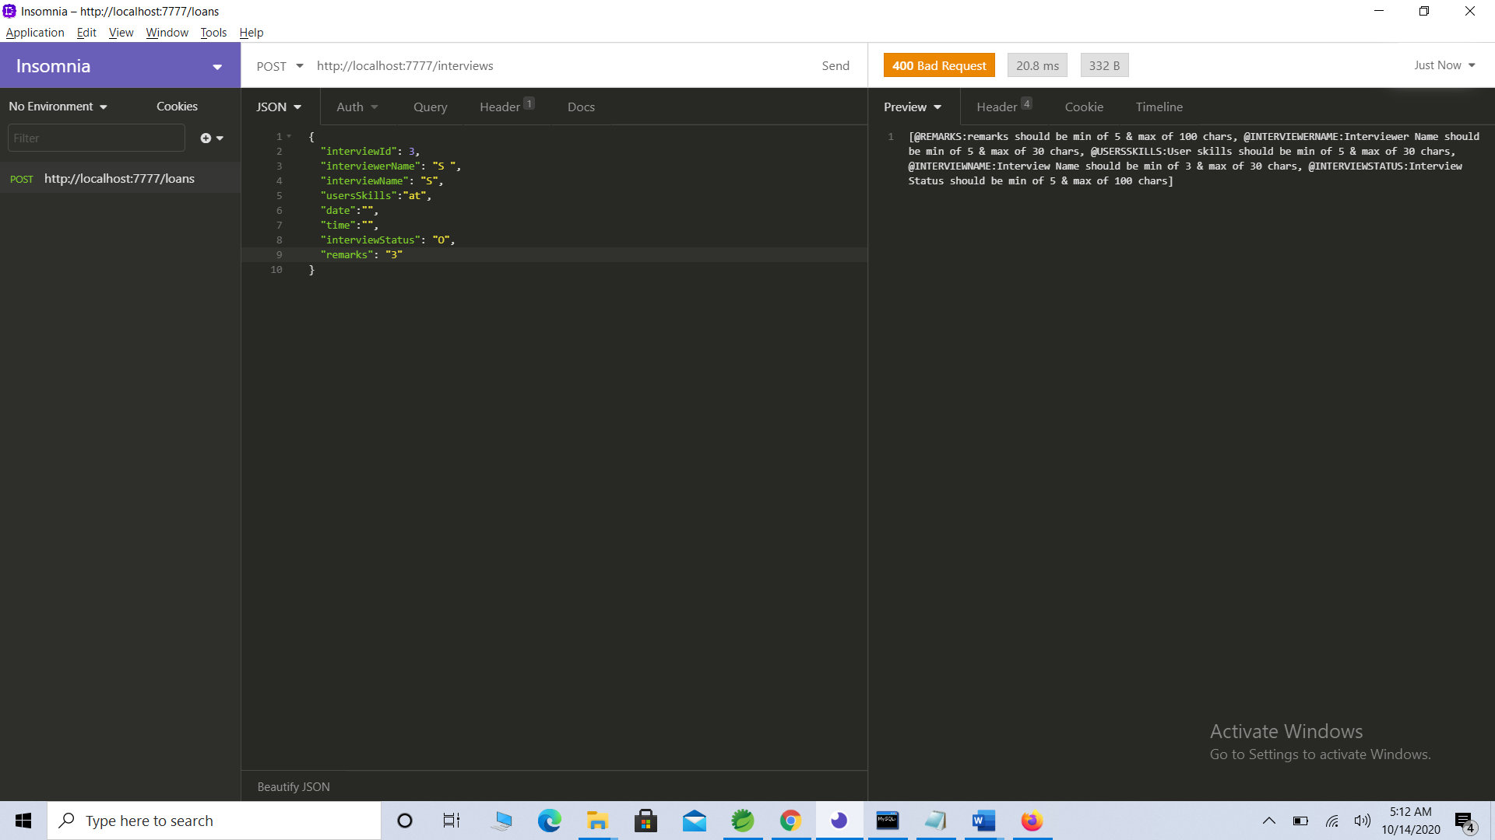

1. To validate for Interview Exception – if interview already exists.

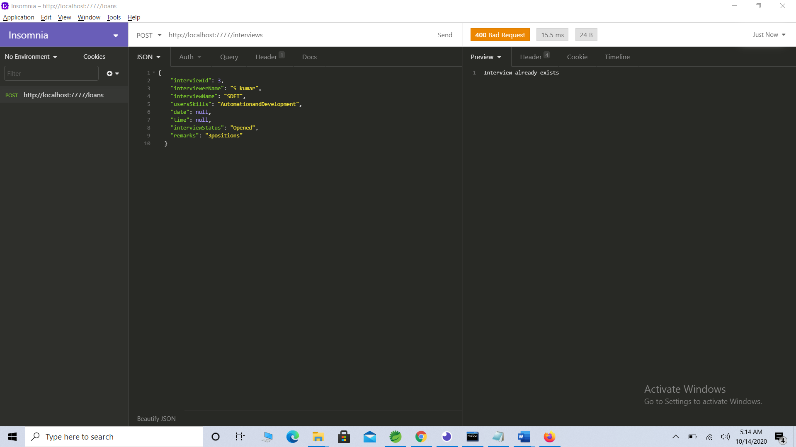

1. Update interview status:

Opened -> HiringInprogress

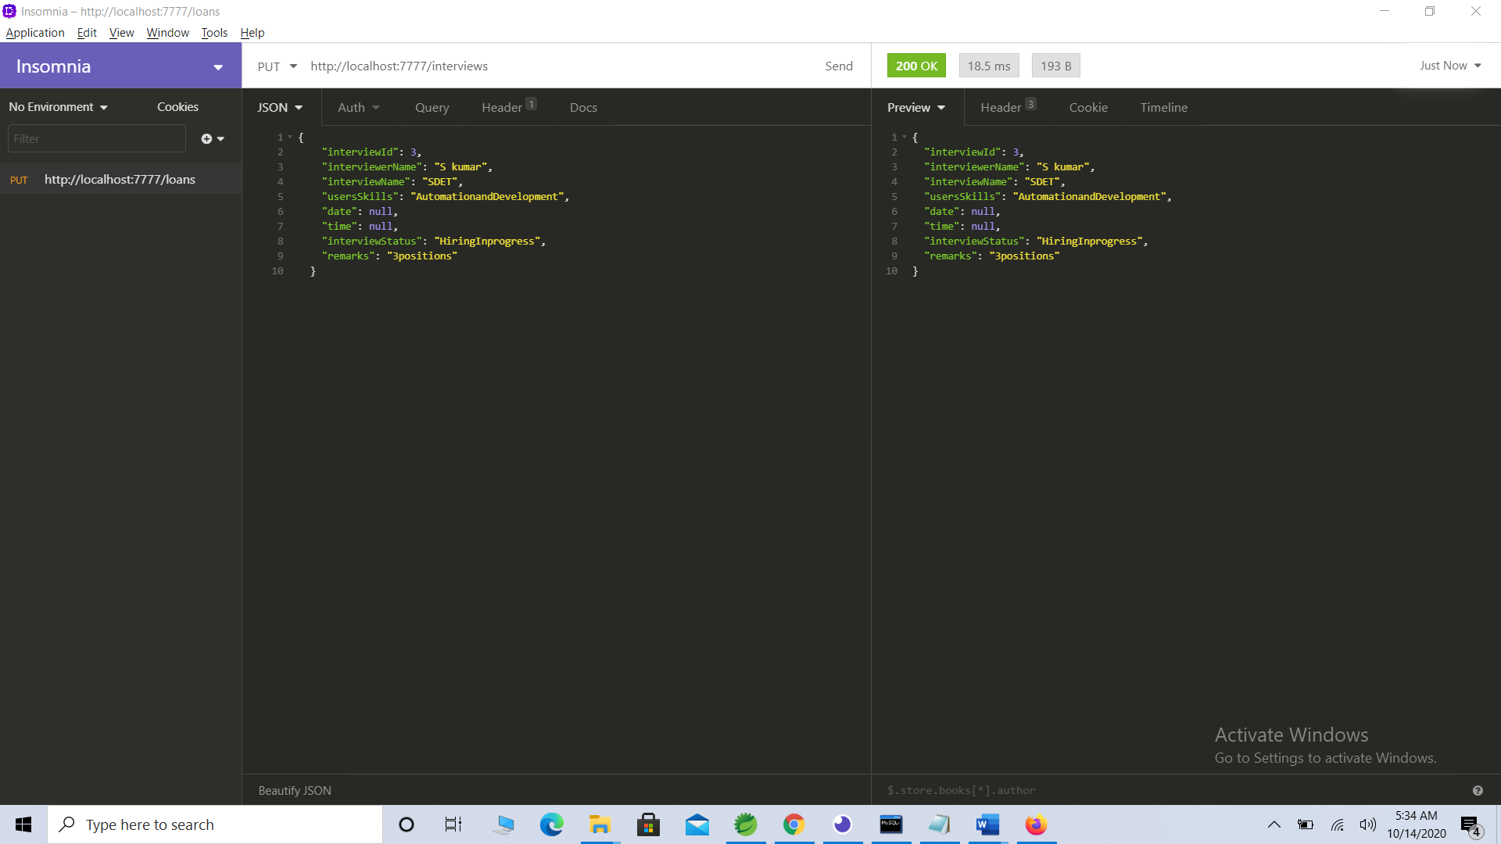

1. Search by interview name:

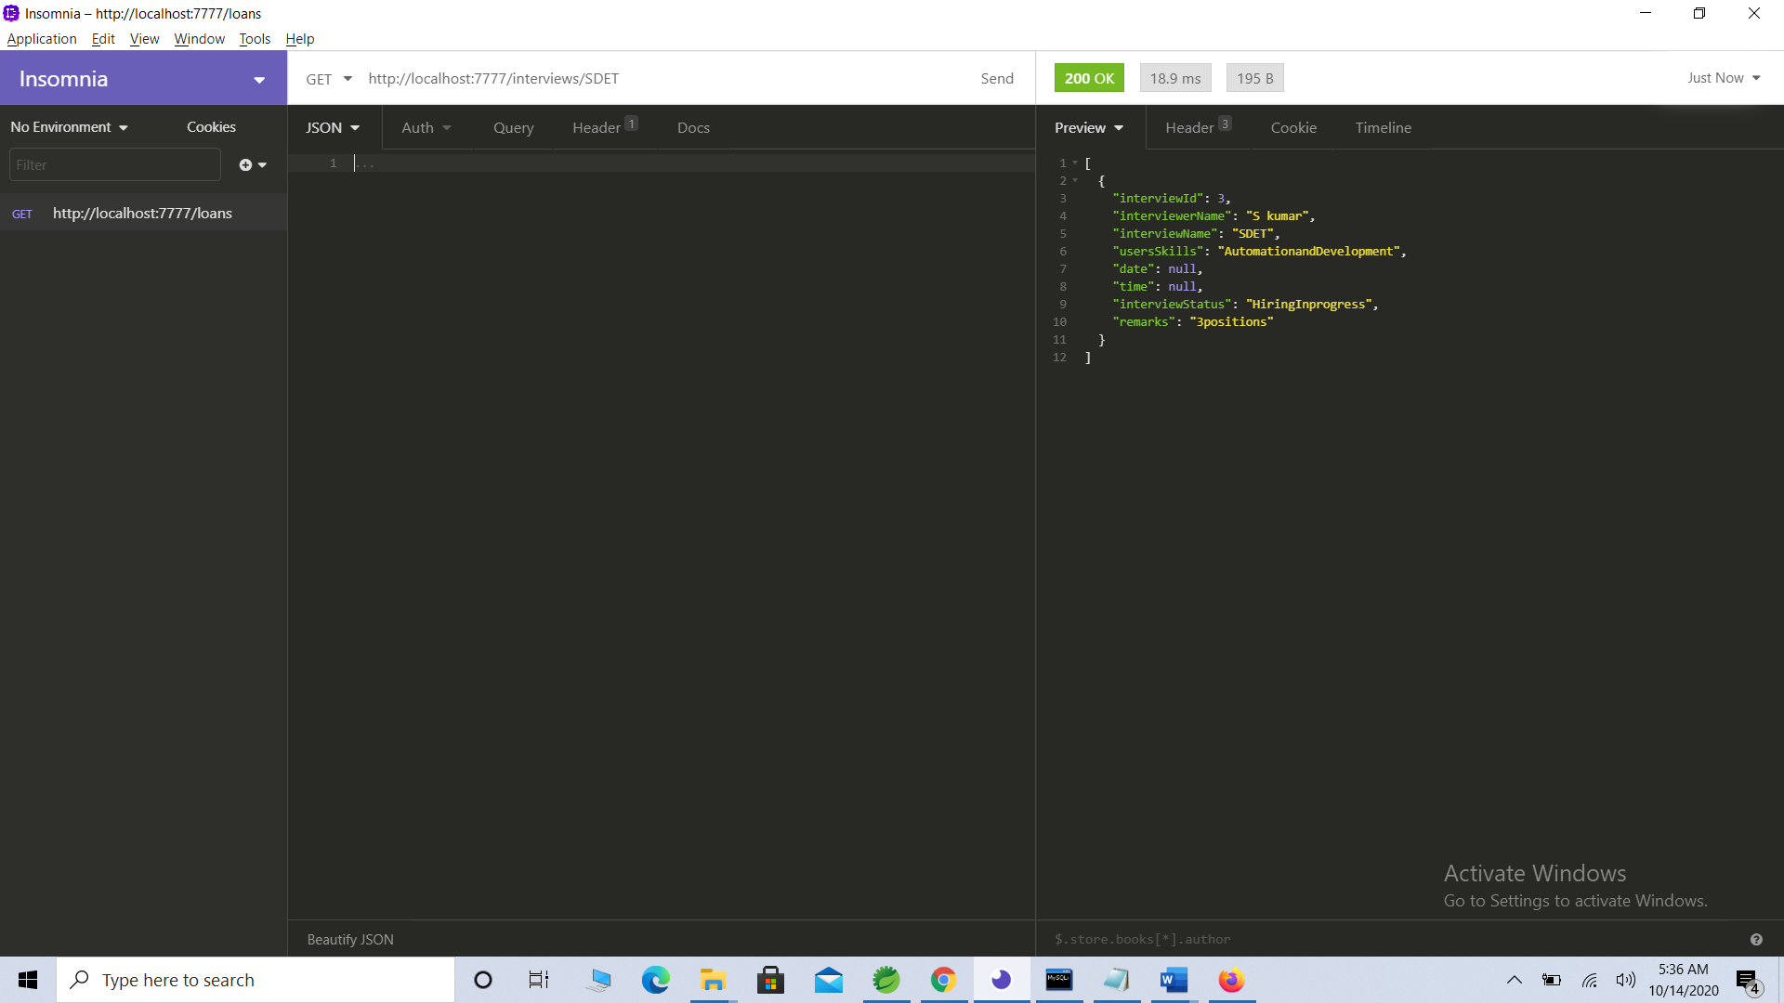

1. Search by interviewer name:

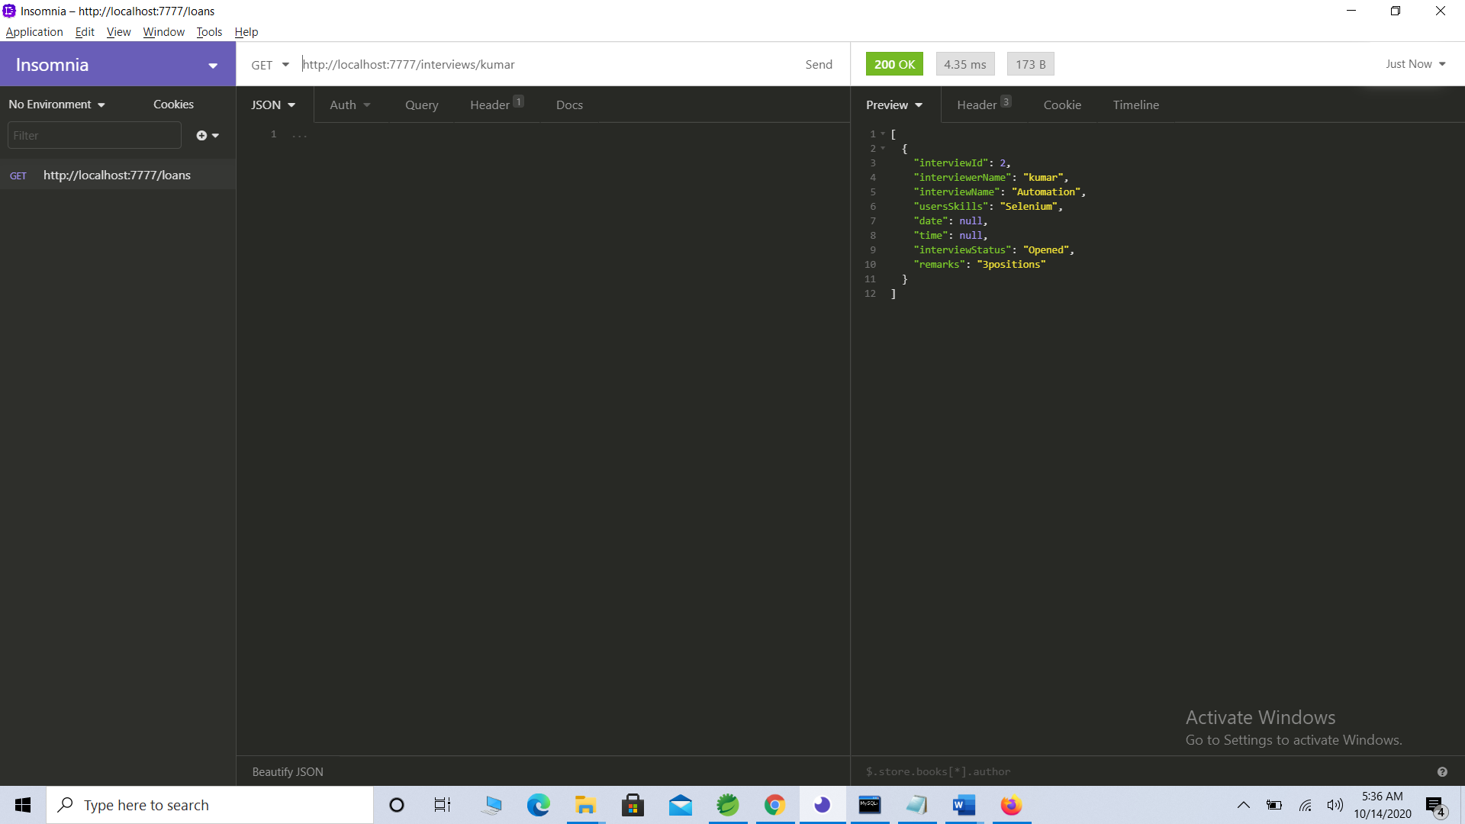

1. To get count of total interviews:

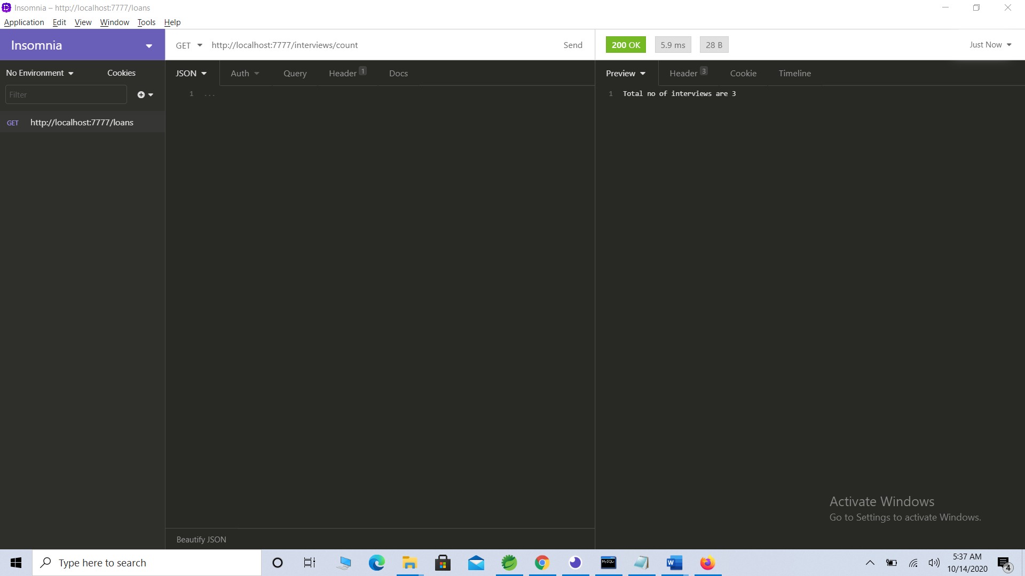

1. To delete an interview with id 4:

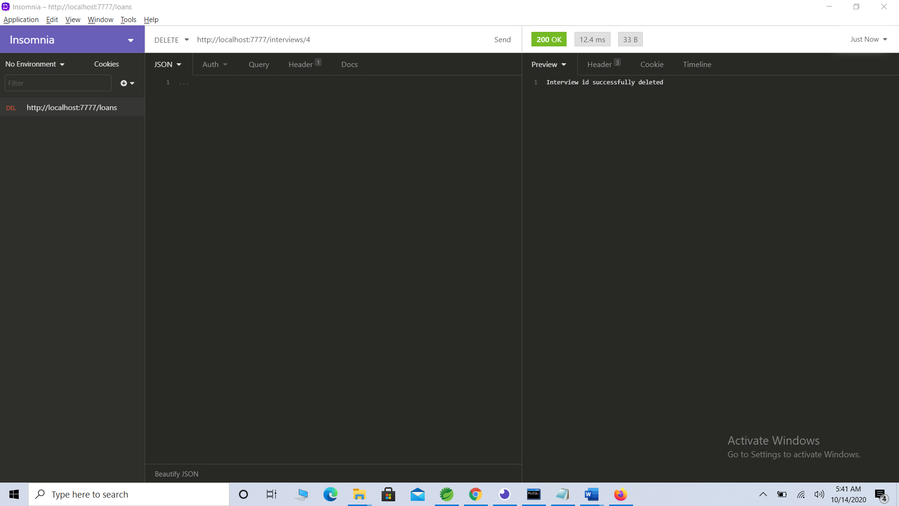

1. To add Attendee to interview:

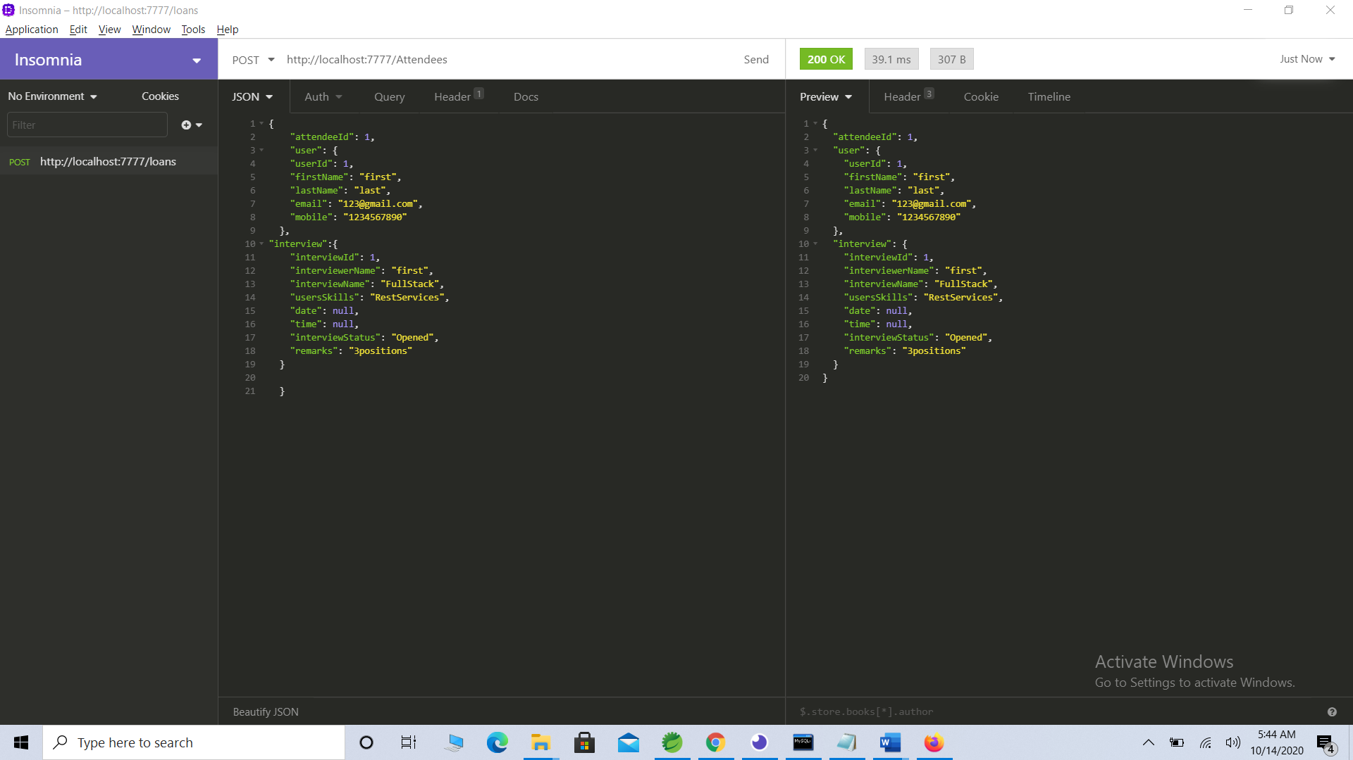

1. To validate for Attendee Exception when provided duplicate Attendee id:

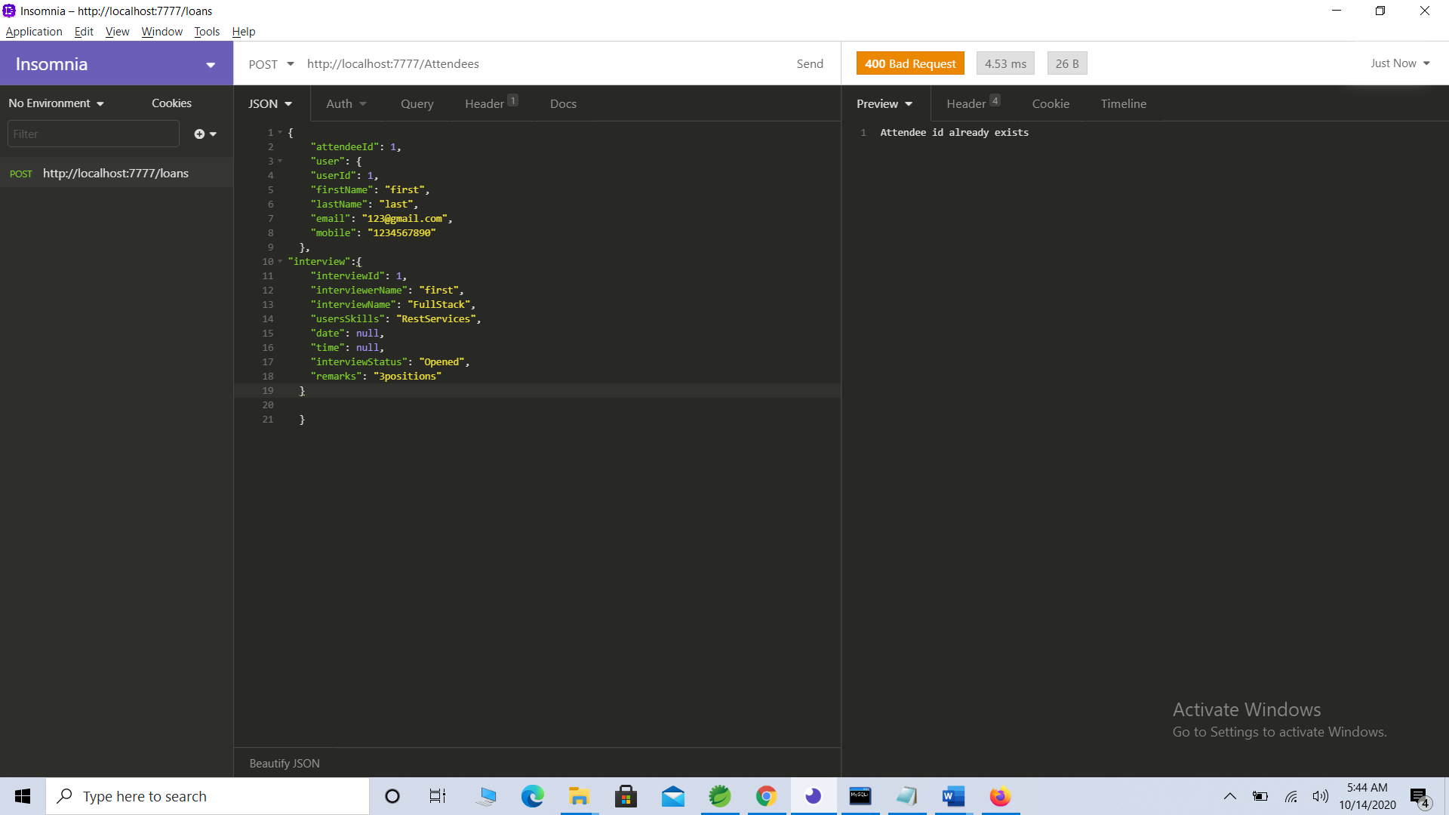

1. To validate for exception if provided user id doesn’t exists:

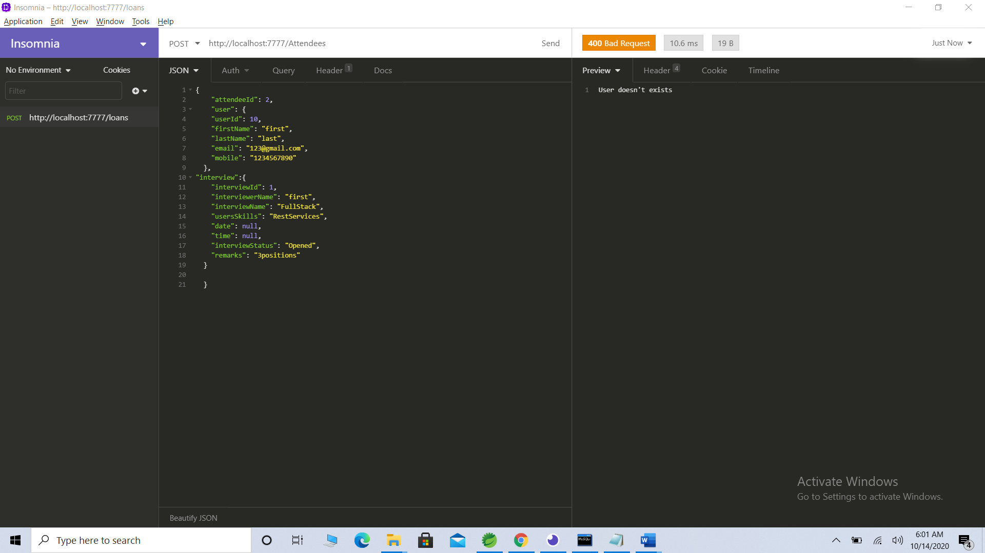

1. To validate for exception if provided interview id doesn’t exists:

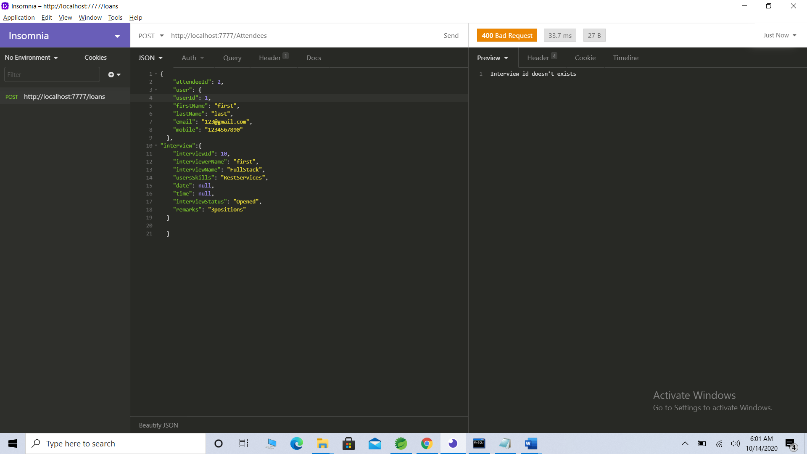

1. To validate for exception if provided user has already applied to given interview:

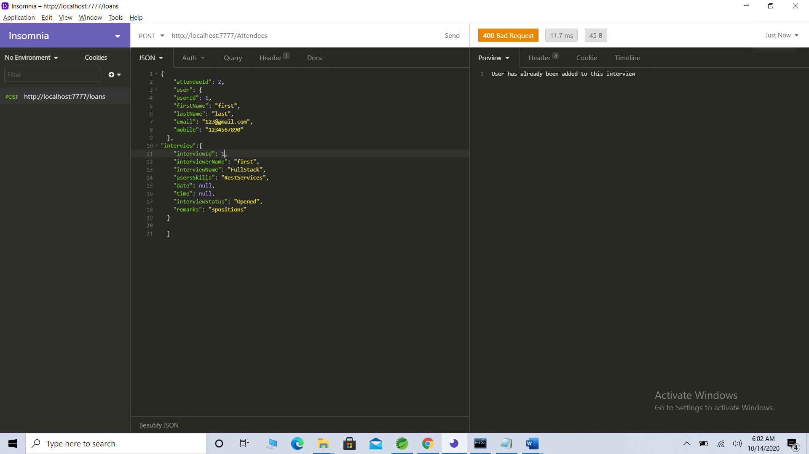

1. To get all attendees of a given interview id 3

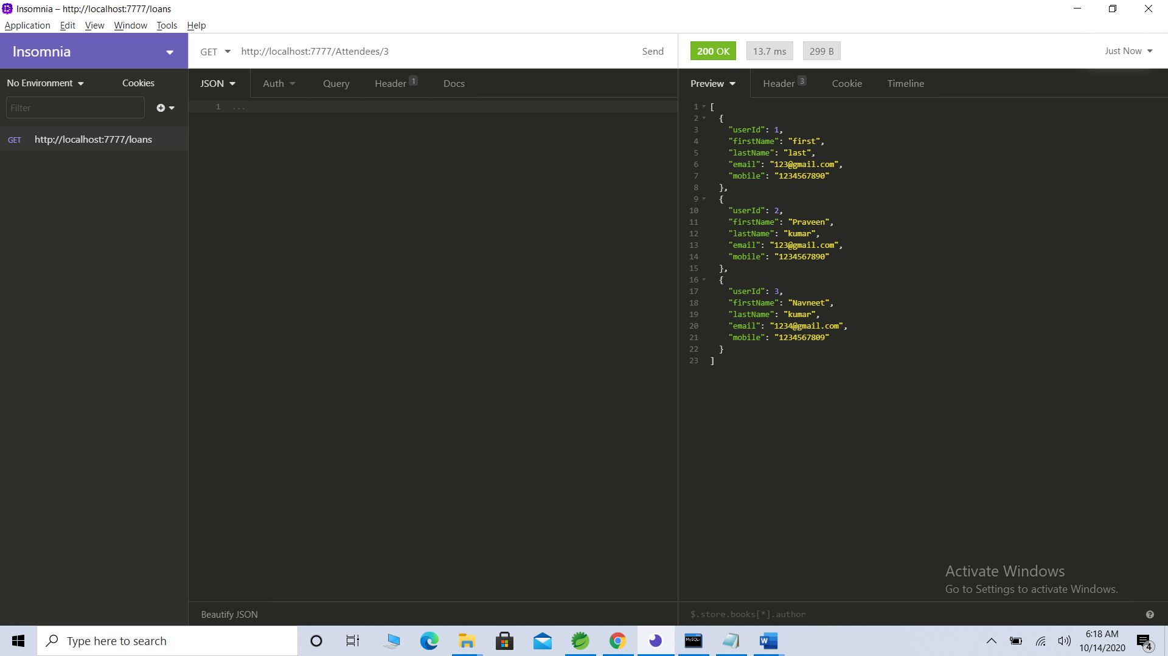

1. Delete a user to see if corresponding users are getting deleted or not in attendee table:

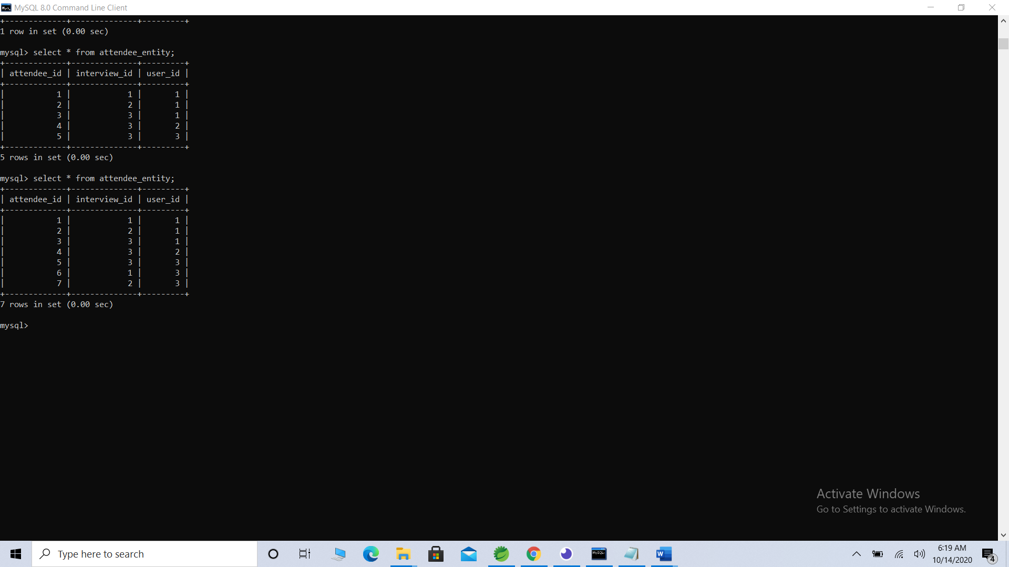

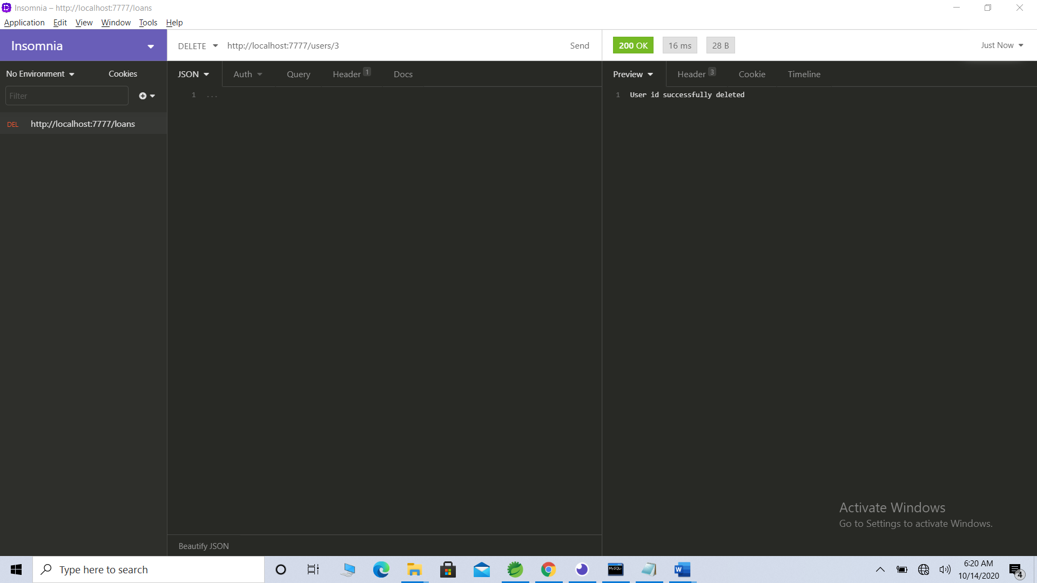

Corresponding entries got deleted in attendee table.

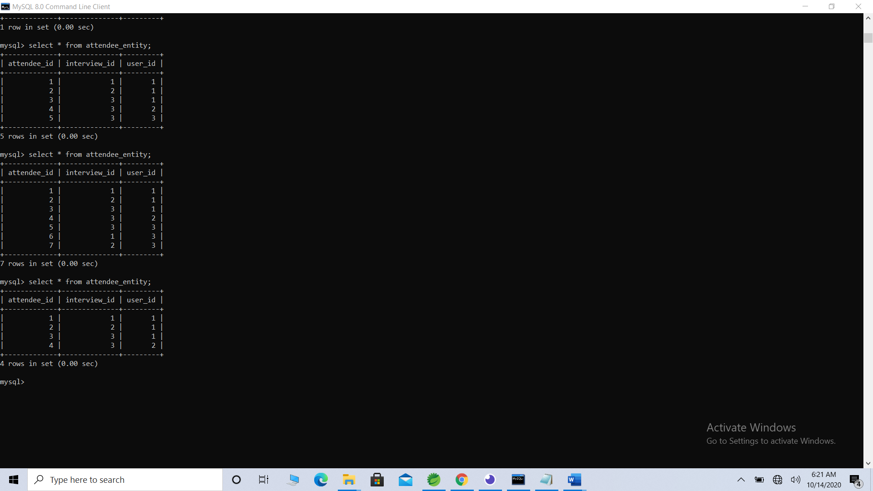

1. Delete an interview to see if corresponding entries are getting deleted or not in attendee table:

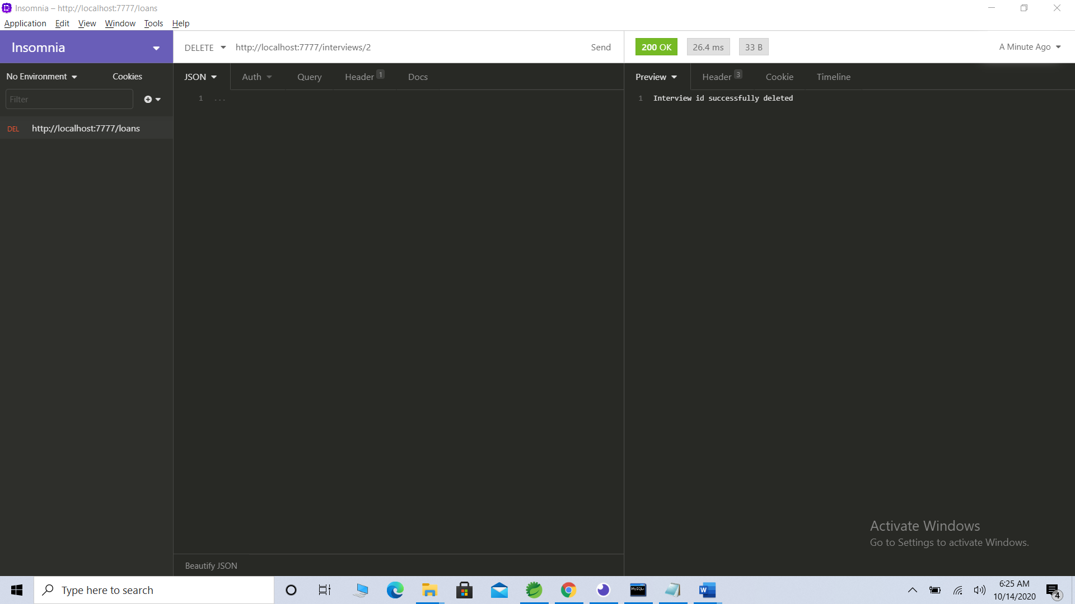

Corresponding entries got deleted in attendee table

