A PROJECT REPORT ON

“REFERRAL E-COMMERCE SYSTEM”



Session (2023-2026)
SUBMITTED IN PARTIAL FULFILLMENT OF THE REQUIREMENT FOR THE AWARD OF THE DEGREE BACHELOR OF COMPUTER APPLICATION

Project Guide Name : Mr. Harish Dhiman Submitted By
External Guide (if any): N/A Amber bisht
Internal Guide: Mr. Harish Dhiman Enrollment No
(BCA Faculty) Roll No
Study College Code : 80efrr fake ha

Submitted to
Hemvati Nandan Bahuguna Garhwal University (HNBGU), Srinagar

Sai group of institutions
Project Certificate
This is to certify that the project report entitled “Referral E-Commerce System” submitted to Hemvati Nandan Bahuguna Garhwal University, Srinagar in partial fulfillment of the requirement for the award of the degree of Bachelor of Computer Applications (BCA), is an original work carried out by Mr. Amber Bisht with enrollment no. ____________ under the supervision of Mr. Harish Dhiman.

The matter embodied in this project report is genuine work carried out by the student and has not been submitted previously to this University or any other University/Institute for the fulfillment of the requirement of any course of study.

Date: _______________

Name & Signature of the Student
Amber Bisht

Email: bishtamber0@gmail.com
Phone: +91 7617623010
Address: Chandan Vihar, Rajpur Road, Dehradun

Verified by the Supervisor

Name & Signature of the Supervisor
Mr. Harish Dhiman

Date: _______________

Acknowledgement

This Major Project is the result of contribution of many mind. I would like to acknowledge and thank my project guide.................................. (Faculty Name) for his/her valuable support and guidance. He/she guided me through the process from conception and till the completion of this project. I would also like to thanks my class teacher/institute director .............................and my all my faculties................... I thank to lab staff members......................and other non-teaching members.
I am very thankful for the open-handed support extended by many people. While no list would be complete, it is my pleasure to acknowledge the assistance of my friends who provided encouragement, knowledge and constructive suggestions.

Signature of Student
(Name of student)
(Roll No ------------)
(Enrollment No --------)

Self-Certificate

This is to certify that the Major Project report entitled “-----------------------------------------------------------” is done by me, and it is authentic work carried out for the partial fulfillment of the requirements for the award of the degree of Bachelor of Computer Application (BCA) under the guidance of.................... (Faculty name). The matter and software embodies in this project has notbeen submitted earlier for award of any degree or diploma to the best of my knowledge and believes.

Signature of Student
(Name of student)
(Roll No ------------)
(Enrollment No --------)

Certificate from Project Guide

This is certify that this Major Project entitled "------------------------------------" submitted in partial fulfillment of the requirements for the award of the degree of Bachelor of Computer Application (BCA) in session (years 20—to 20---) to the HemvatiNandanBahuguna Garhwal University, Srinagar, done by ____________(student name ) is an authentic work carried out by them at “... ........................................ ”(study Centre name /departmentname) (Place) under my guidance. The matter and software embodied in this project work has not been submitted earlier for the award of any degree or diploma to the best of my knowledge and belief.

Signature of BCA Teacher

(Project Guide)

CHAPTER – 1 : INTRODUCTION
1.1 Background of the Project
In today's digital world, shopping online has become a regular part of our daily lives. With easy access to high-speed internet, smartphones, and secure online payment methods, more and more people prefer buying products online rather than visiting physical shops. This growth of electronic commerce (e-commerce) has created great opportunities for businesses, but it has also made the online marketplace very competitive. Today, thousands of online shops are competing for the same customers. To attract buyers, companies spend a huge amount of money on digital advertisements, such as Google ads, social media posts, and banners.
However, traditional digital marketing is becoming more expensive and less effective. Most internet users now ignore advertisements (a problem known as "banner blindness") or use ad-blocking software to hide them. In addition, recent privacy settings on mobile phones make it harder for businesses to target the right audience. As a result, the cost of acquiring new customers is rising, which reduces the profits of e-commerce startups. To solve this problem, online businesses are going back to the most basic and trusted form of marketing: Word-of-Mouth (WoM). People are much more likely to trust a product recommendation if it comes from a friend, classmate, or family member rather than a corporate advertisement on the internet. Referral marketing uses this social trust by rewarding existing customers for bringing in new buyers.
Standard referral programs are simple: a user refers a friend and receives a one-time discount code. While this works well for a short time, it does not encourage long-term growth. To create a self-running viral marketing chain, a multi-tier referral system is much more effective. In a two-level referral system, a user gets rewarded not just for their direct referrals, but also when those referrals bring in new customers. For example, if User A refers User B, and User B refers User C, User A gets a primary "direct" commission when User B buys something, and a secondary "indirect" commission when User C buys something. This creates a network of active promoters who want to share the website to earn passive rewards.
To build such a system, we need a strong, fast, and modern web application framework. The MERN stack—which stands for MongoDB, Express.js, React.js, and Node.js—is the most popular and efficient choice for web development students today. This project, "Referral E-Commerce System", is an e-commerce platform built using the MERN stack that integrates a full online shopping experience with an automated two-level referral program. By combining a shopping cart, dynamic product catalog, safe checkout through the Razorpay payment gateway, and an automated wallet ledger, this project demonstrates how a business can reduce marketing costs and drive growth through technology.

1.2 Objective of the Project
The main objective of this project is to develop and implement a functional, secure e-commerce web application that features an automated, two-tier referral commission system. The application allows users to browse and buy products online while earning rewards by building their own network of buyers.
To complete the main objective, the following specific secondary objectives must be achieved:
- To Design a Responsive Frontend Interface: Build a user-friendly and highly responsive website using React.js and Tailwind CSS. The interface should allow customers to view the product catalog, read product specifications, manage their shopping carts, and add shipping addresses smoothly.
- To Build a Secure Backend API: Create a backend server using Node.js and Express.js to handle user authentication, shopping cart details, order creation, and wallet calculations.
- To Implement Automated Referral Ledger Calculations: Develop backend database logic that automatically calculates and distributes commissions. When a user buys a product, the system must immediately identify their referrers, calculate Level 1 (direct) and Level 2 (indirect) earnings based on the product’s commission settings, and update the wallets without database errors.
- To Integrate Razorpay Payment Gateway: Incorporate the Razorpay payment API to process real-time mock transactions in Indian Rupees (INR) using credit cards, UPI, and internet banking, using cryptographic verification to ensure all transactions are genuine.
- To Create a Dual-Purpose Digital Wallet: Build a virtual wallet system that displays a user's total earnings, withdrawals, and net balance. The wallet should allow users to redeem their rewards either by converting them into digital gift coupons or by purchasing products directly from the shop.
- To Develop an Admin Control Panel: Create a separate dashboard for administrators to upload new products, manage inventory stock, set product commission rates, update promotional banners, and monitor platform statistics like total users and completed orders.
- To Apply System Constraints: Implement safety features, such as limiting the maximum number of direct referrals per user to 8, to ensure the network tree remains balanced and the database performs efficiently.

1.3 Scope of the Project
The scope of this project defines the technical boundaries, target functionalities, user roles, and rules of the referral system. This application is designed as a complete web prototype, showcasing both modern frontend design and backend database management.
Technical Scope
The application is built using standard JavaScript frameworks. The frontend uses React.js alongside Vite for fast development and rendering. Tailwind CSS is used for creating a modern, clean layout that works on desktop computers, tablets, and smartphones. The backend runs on Node.js and Express.js, providing RESTful API routes. MongoDB serves as the database, using Mongoose schemas for managing data structures.
Functional Scope
The system has two main user categories with different access levels:
- User Features:
- Authentication: Users can sign up, log in, and manage their sessions securely using JSON Web Tokens (JWT). During signup, users can enter a valid referral code.
- Store Operations: Users can search for items, filter by categories, add items to a cart, check stock availability, and manage their shipping addresses.
- Payment & Orders: Users can check out using the Razorpay gateway or pay using their wallet balance.
- Dashboard: A personal profile displaying wallet details, withdrawal history, and a list of referred users at Level 1 and Level 2.
- Withdrawals: A portal to simulate redeeming wallet balances for store vouchers.
- Admin Features:
- Product & Category Management: Dynamic CRUD controls to add, edit, or delete products, categorizations, and homepage banner images.
- System Logs: Visibility into total users, total sales, user wallets, and completed orders.
System Boundaries
The referral network is limited to a depth of two levels (Level 1 and Level 2). To prevent spam signups and ensure the database handles request queues efficiently, a strict rule is applied: a single user cannot have more than 8 direct (Level 1) referred accounts.

1.4 Features of the System
The "Referral E-Commerce System" web application includes several key technical features designed to ensure system security, accuracy, and ease of use:
- Secure Authentication & Onboarding: The portal uses a secure login and registration setup. User passwords are encrypted on the database using the bcryptjs hashing tool. The backend issues JSON Web Tokens (JWT) for keeping users logged in safely. The registration form is built to detect invitation links: when a user clicks a referral link, the site automatically fills in the referral code, saving time.
- Shopping Cart & Saved Address Manager: Users can add multiple products to their cart, change quantities, and check out in one transaction. The cart interacts with the server to check active product inventory stock, preventing users from buying out-of-stock items. Users can also save multiple delivery addresses in their profiles and select a default shipping address.
- Integrated Razorpay Payments: The payment workflow is fully automated. When checking out, the server creates a unique Razorpay order ID. The React client displays the checkout interface. Upon payment, the server verifies the payment signature using a SHA256 HMAC hash. Verified payments instantly create order entries and deduct items from inventory.
- Automated Commission Engine: When a product is successfully purchased, the system checks if the buyer has referrers.
- Level 1 Referrer gets the direct commission: Product Price * (Commission % / 100).
- Level 2 Referrer gets the indirect commission: Level 1 Commission * 10%.
To ensure these database modifications are safe, they are wrapped in MongoDB Session Transactions. If one step fails, the entire update is canceled, preventing incorrect wallet balances.
- Dual Wallet Utility: The personal wallet tracks all earnings in real-time. Users can choose to withdraw their balance by generating unique, random voucher codes for top brands (like GIFT-AMZ-XXXXX) or purchase items directly using their wallet balance as a payment method, which also distributes commissions.
- Interactive Downline Visualizer: The system provides users with a clean, clear visual list of all their referrals grouped into Level 1 and Level 2. This allows promoters to easily track their network's purchasing activity.
- Admin Dashboard Hub: A clean administrative center showing real-time statistics (total earnings, total orders, active users) alongside tables to add or modify products, inventory numbers, and promotional banners.

1.5 Limitations of the Project
Although the system represents a highly functional e-commerce and referral platform, it has certain limitations in its current prototype stage:
- Simulated Financial Withdrawals: The withdrawal process generates mock store voucher codes instead of transferring real money to a user's physical bank account. Implementing real payouts requires corporate merchant accounts and complex banking APIs, which were omitted due to legal and financial registration requirements.
- Fixed referral Capping: The limit of 8 direct referrals per user helps prevent spam and ensures the database performs well, but it might restrict large promoters who have thousands of followers and want unlimited direct referrals.
- Sandbox Database Setup: The application uses a local sandbox database environment for development testing. It does not include complex database clustering, replication, or memory caching systems (like Redis) required to handle millions of simultaneous users.
- Local Notifications: Commission credits and order updates are displayed inside the web application's dashboard. The system does not send real-time alerts via external email servers or SMS networks, which would require commercial API subscriptions.

1.6 Selection Method of Data Collection
To design and develop a reliable system, a systematic data collection process was followed. This involved both primary and secondary data collection methods, which provided the necessary information to build the database models, user interfaces, and business calculations.
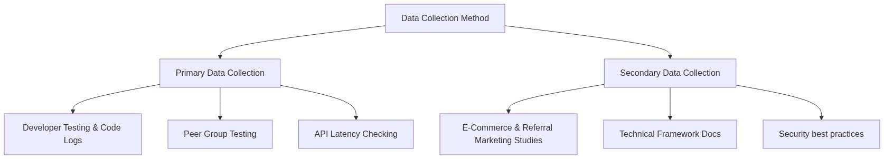
Figure: 2.1 selection method of data collection
Primary Data Collection
Primary data was gathered first-hand during the coding and testing phases of the application:
- Developer Testing and Code Logs: Technical data was collected directly from the server runtime logs. Mongoose transaction records, Express API logs, and console debug traces were monitored to check database response times and verify if the commission distributions were mathematically correct.
- Peer Group Testing: A small testing group of 10 classmates was set up to evaluate the system. They registered using referral links, browsed products, added items to the cart, completed checkout using mock payment details, and redeemed gift coupons. Their feedback was used to fix bugs and improve the layout of the user dashboard.
- API Latency Checking: Data regarding the time taken to verify payments and load database collections was analyzed using web browser developer tools to ensure fast page loads.

Secondary Data Collection
Secondary data consists of information collected from existing publications, official guides, and documentation:
- Referral Marketing Studies: Academic articles and online business guides about referral networks and multi-level commissions were analyzed to set up realistic reward percentages.
- Technical Framework Documentation: The official documentation for the MERN stack—including React.js guides, Express.js API references, Mongoose transaction manuals, and Razorpay SDK documentation—was thoroughly studied to ensure standard coding practices were followed.
- Security Best Practices: Online guides on hashing passwords using bcryptjs, managing sessions with JSON Web Tokens, and avoiding common database injection flaws were researched to secure the application.

CHAPTER – 2: METHODOLOGY
2.1 Background
In software engineering, a development methodology represents the structured framework of processes, models, and guidelines used to design, build, test, and maintain a software application. Without a well-planned methodology, developing complex web systems can become highly chaotic, leading to database errors, security flaws, and poor user experiences. This is especially true for systems that involve financial transactions and multi-level data tracking, such as the Referral E-Commerce System. Building an application that handles user shopping carts, online payment gateways, and a two-tier referral commission calculation requires a highly disciplined design and coding methodology to ensure that data remains consistent and transactions are executed securely.
For this project, an Agile/Incremental Development Methodology was selected. In a student project environment, building a large web application all at once can be overwhelming. The incremental model breaks the software development lifecycle into small, manageable stages or sprints. Each increment focus on building, testing, and integrating a specific module before moving on to the next one. This iterative approach is highly beneficial because it allows for continuous testing and debugging, ensuring that errors in basic functions are fixed before complex systems are built on top of them.
Figure: 2:1 agile development
The development was divided into six key incremental stages:
- Requirements & Setup: Setting up the project architecture, establishing Git repositories, and defining folders for the client and server.
- User Authentication Module: Building the secure registration and login routes, implementing bcryptjs encryption, and setting up JSON Web Token (JWT) session generation on the server.
- Core Storefront & Cart: Developing product database models, listing components, quantity selector logic, dynamic shopping carts, and address management.
- Razorpay Integration: Integrating Razorpay payment interface and backend payment verification.
- Referral Wallet & Commission Engine: Developing the mathematical referral calculation logic, handling level 1 and level 2 commissions, and wrapping them in atomic database transaction sessions.
- Admin Dashboard and Wallet Redemptions: Implementing the administrative CRUD systems, platform transaction reports, and simulated voucher code generators for withdrawals.
This methodical, step-by-step approach ensured that every feature was validated and verified before adding subsequent modules, leading to a highly stable final system.

2.2 Project Description
The "Referral E-Commerce System" is a MERN-stack web application designed to demonstrate a modern online storefront integrated with a two-level referral marketing system. The application serves two main purposes: it provides a smooth, modern shopping experience for regular customers, and it operates an automated digital sales ledger that calculates, records, and distributes commissions to promoters in real-time.
At a high level, the system is composed of three interconnected architectural modules:
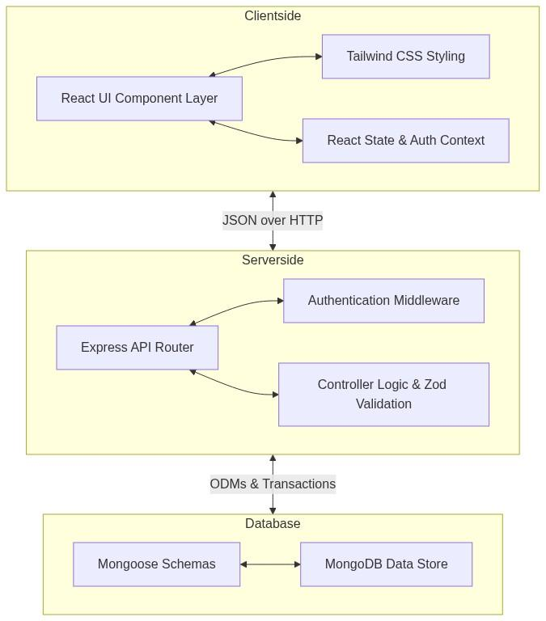
Figure: 2.2 project description
1. The Client-side React Interface
The frontend provides a rich, responsive interface where users can interact with the system. Users can browse the catalog of products, search for items, and filter them by category. They can add items to their shopping cart, select delivery addresses from their profile, and make secure purchases. Promoters have a private dashboard where they can see their unique referral code, copy an invitation link, view a list of their Level 1 and Level 2 referrals, track their wallet balance, and redeem their earnings for mock gift cards or buy products directly using wallet funds.
2. The Server-side Express API
The backend acts as the brains of the system, processing all API requests from the React client. It exposes endpoints for creating accounts, managing logins, executing shopping cart checkouts, and verifying payments. The backend ensures security by authenticating requests using JWT tokens and validating input data using Zod schema validators before executing any database queries. It also interfaces directly with the Razorpay API to create payment orders.
3. The MongoDB Database
MongoDB stores all system data in flexible document structures. Mongoose acts as the Object Data Modeling (ODM) layer on the server, defining clean schemas for users, addresses, products, orders, categories, and banners. The database handles complex relational data—such as user downline paths and earning history ledgers—efficiently, and utilizes database transactions to ensure that commission distributions are executed atomically and safely.
2.3 System Architecture
The overall system architecture is built on the MERN (MongoDB, Express, React, Node.js) framework. This framework is popular because it uses JavaScript across the entire stack, from frontend rendering to database scripting. This unified language structure makes it easy for developers to transfer data structures between client and server.

Figure: 2.3 system architecture digram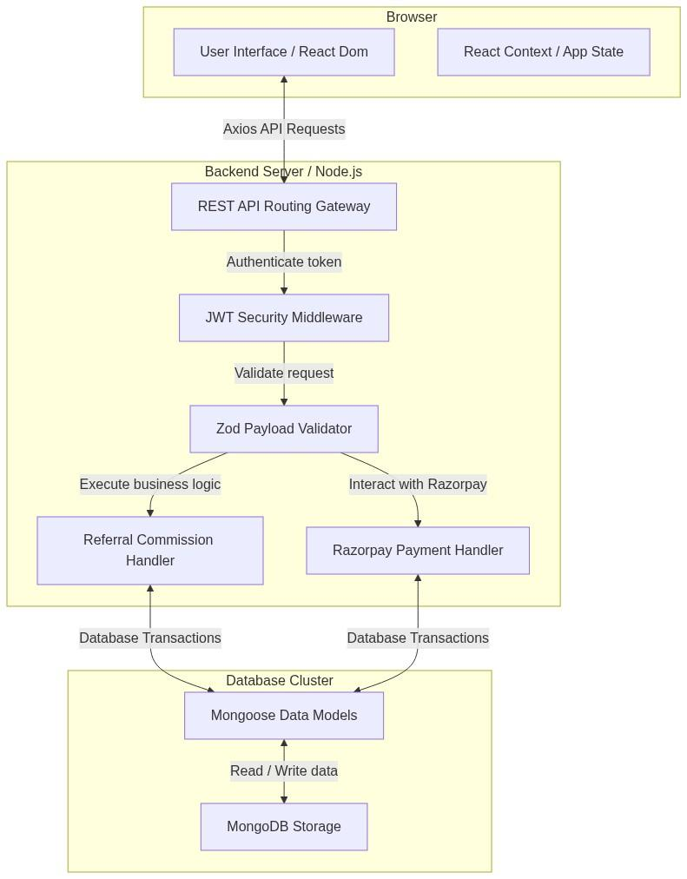

Component Breakdown:
- React.js (Frontend Layer): Renders dynamic views that update instantly without reloading the entire page. It uses React Router for client-side navigation. It implements a global React Context API (AuthContext) to maintain user authentication states, storing the user token locally and attaching it automatically to client-side API requests.
- Tailwind CSS (Styling Layer): Provides responsive, mobile-first CSS styles directly inside HTML elements, ensuring that user dashboards, storefronts, and tables adjust dynamically to different screen dimensions.
- Express.js (Routing Layer): Runs on top of Node.js to receive client HTTP requests, parse JSON payloads, and direct them to modular routers (auth.js, shop.js, payment.js, admin.js, user.js).
- Node.js (Server Runtime Layer): Executes JavaScript code on the server. Its asynchronous, non-blocking input/output execution model is highly efficient, allowing it to handle many simultaneous API connections from active shoppers and promoters.
- Mongoose & MongoDB (Database Layer): MongoDB stores system data in highly flexible JSON-like documents. Mongoose is a JavaScript framework that allows us to define schemas, validate field types (such as email formats, unique referral codes, and maximum arrays), and write complex queries.
In this system architecture, the frontend client and the backend server are decoupled. The React frontend interacts with the Express backend solely by sending JSON payloads over HTTP requests, allowing the client and server to scale independently.

2.4 Client-Server Architecture
The Referral E-Commerce System operates on a stateless Client-Server Architecture. In this setup, the frontend user interface (client) and the database-processing backend (server) are separated. The client does not directly access the database, and the server does not handle page layout rendering. They communicate exclusively using REST (Representational State Transfer) API calls over HTTP.
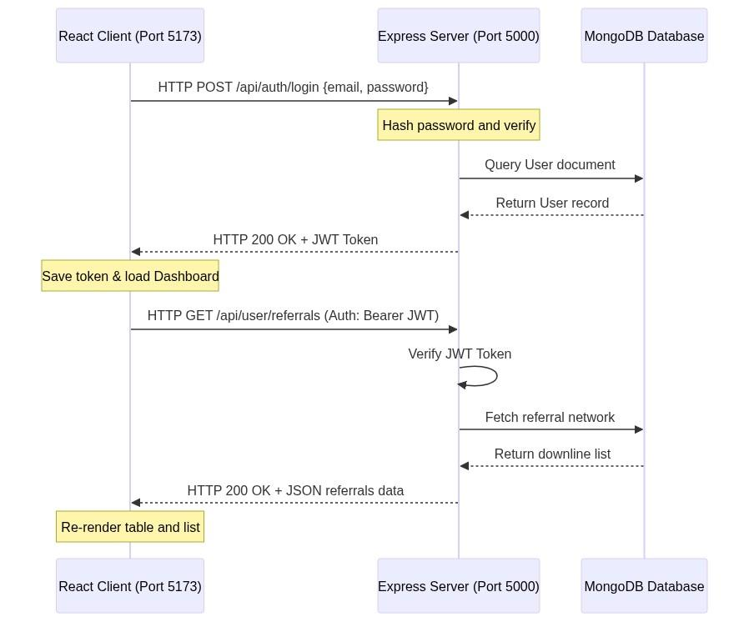
Figure: 2.4 client-server arhitecture
Communication Flow:
- Stateless REST APIs: The React application runs in the user's browser, while the Express application runs on the server. When the client needs to fetch data (like the product list) or perform an action (like checkout), it sends an HTTP request (GET, POST, PUT, DELETE) containing JSON data.
- CORS (Cross-Origin Resource Sharing): Since the client and server are running on different ports or domains, the backend server implements CORS middleware. This middleware allows security-controlled communication, permitting the React app client to securely read headers and send request payloads.
- Session Management (Stateless JWT): Traditional web applications store user session data directly in server memory. This limits scalability. This project uses JSON Web Tokens (JWT) for stateless sessions. When a user logs in successfully, the server signs a payload containing the user's ID using a secure backend secret, and sends it back to the client. The client saves this token locally. For any future request to private routes (like checking out or viewing wallet balances), the client includes this token in the request header. The server verifies the token signature, authenticates the user, and processes the request.
- Data Exchange format: All requests and responses are serialized in JSON (JavaScript Object Notation), which guarantees lightweight and high-speed data exchanges.
2.5 Design Methodology
To ensure that the Referral E-Commerce System was built cleanly, a structured Software Development Life Cycle (SDLC) approach was followed. The project went through six developmental phases, ensuring that requirements were gathered, database relationships were modeled, backend code was tested, and user interfaces were polished before final release.
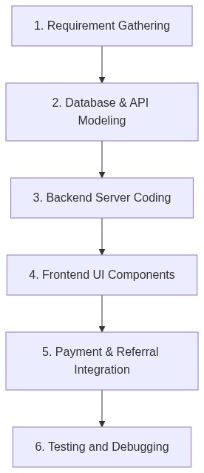
Figure: 2.5 design methodology
1. Requirement Gathering and Analysis
In this initial stage, the functional and non-functional goals of the system were identified. The core requirements were defined: we needed an online catalog where users could purchase items, a secure checkout process, a two-level commission structure for referral payouts, and a maximum direct referral width of 8 active signups to prevent database overflow.
2. Database & API Modeling
The database structures were mapped out by drafting Mongoose schemas for users, products, orders, categories, and banners. The REST API routes were structured logically:
- /api/auth for signup and login paths.
- /api/user for profiles, addresses, and referral trees.
- /api/shop for products and categories.
- /api/payment for Razorpay orders and wallet checkouts.
- /api/admin for platform administration.
3. Backend Server Coding
The Express.js backend was developed with modular routing files, validation schemas using Zod, and encryption libraries like bcryptjs. In this phase, Mongoose transactions were introduced to wrap checkout operations, ensuring that stock counts and commission wallets update atomically without database errors.
4. Frontend UI Components
Using React, individual interface components were built, such as navigation bars, product cards, category filters, and address selection overlays. Tailwind CSS was applied to design custom, mobile-responsive layout blocks, dashboard grids, and typography structures.
5. Payment and Referral Integration
The React client was connected to the Razorpay SDK widget to open payment overlays. The Express backend was integrated with the official Razorpay SDK to create orders and verify transaction signatures using SHA256 HMAC cryptographic hashing. The two-tier referral logic was hooked into successful checkout callbacks.
6. Testing and Debugging
A testing phase was carried out to verify all calculations. Mock transactions were processed using dummy payment profiles, verifying that the Level 1 parent received the direct commission and the Level 2 parent received their 10% indirect share. The 8-referral cap was validated by trying to register 9 users under the same code, ensuring the system rejected the 9th registration as expected.

2.6 Data Flow Diagram (DFD)
A Data Flow Diagram (DFD) visually represents how data moves through a software system, showing the sources of information, the processes that modify data, and where the information is stored.
DFD Level 0 (Context Diagram)
The Context Diagram represents the entire Referral E-Commerce System as a single process, showing the direct interactions between the system and its external entities: the User, the Admin, and the Razorpay Gateway.
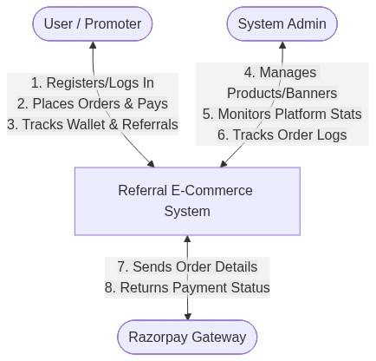
Figure: 2.6 dfd level 0
- User Flows: The user inputs credentials to log in, registers using a referral code, adds products to their cart, inputs delivery addresses, and receives order confirmations and wallet credits.
- Admin Flows: The admin inputs new product profiles and active promotional banners, receiving live platform sales logs and system-wide order summaries.
- Razorpay Flows: The system submits order details (amount, currency) and receives cryptographic payment confirmations.
DFD Level 1 (Process Breakdown Diagram)
The DFD Level 1 diagram breaks the main system process into its four core sub-processes, showing how data interacts with specific database storage tables (collections):
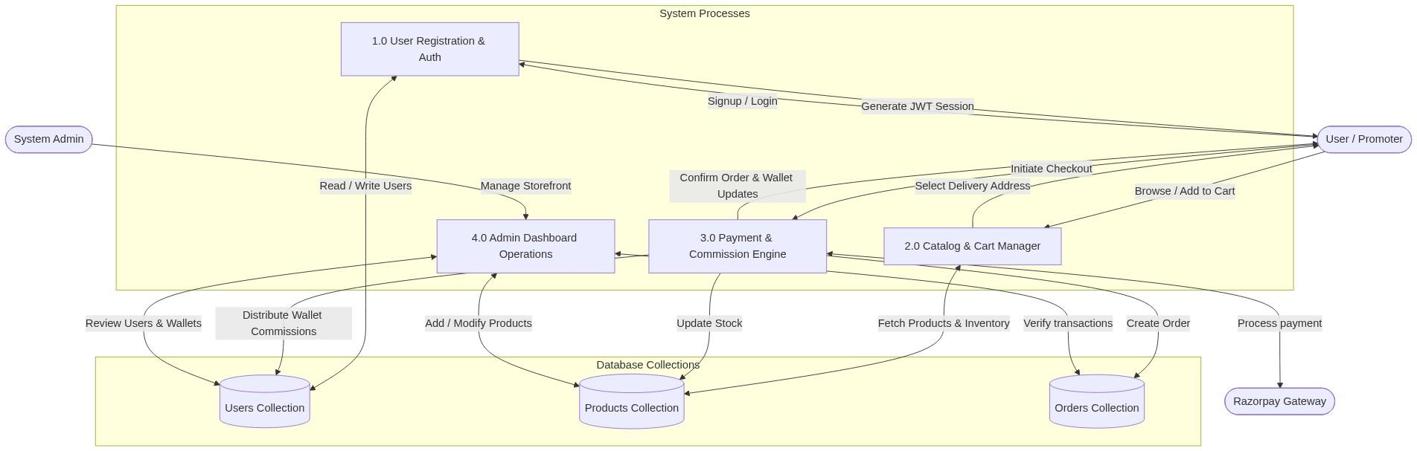
Figure: 2.7 dfd level 1
- Process 1.0 (Auth): Handles signup/login, validates referral codes, and registers users into the Users Collection.
- Process 2.0 (Cart): Allows users to search and add items, checking active item quantities in the Products Collection.
- Process 3.0 (Checkout): Integrates with Razorpay to verify signatures, saves records to the Orders Collection, reduces product stock in the Products Collection, and distributes commissions across parent nodes in the Users Collection.
- Process 4.0 (Admin): Provides tools for admins to update catalog lists and view platform reports from all database collections.

2.7 ER Diagram
The Entity-Relationship (ER) Diagram defines the structural entities inside our MongoDB database, their respective attributes (fields), and how they relate to one another.
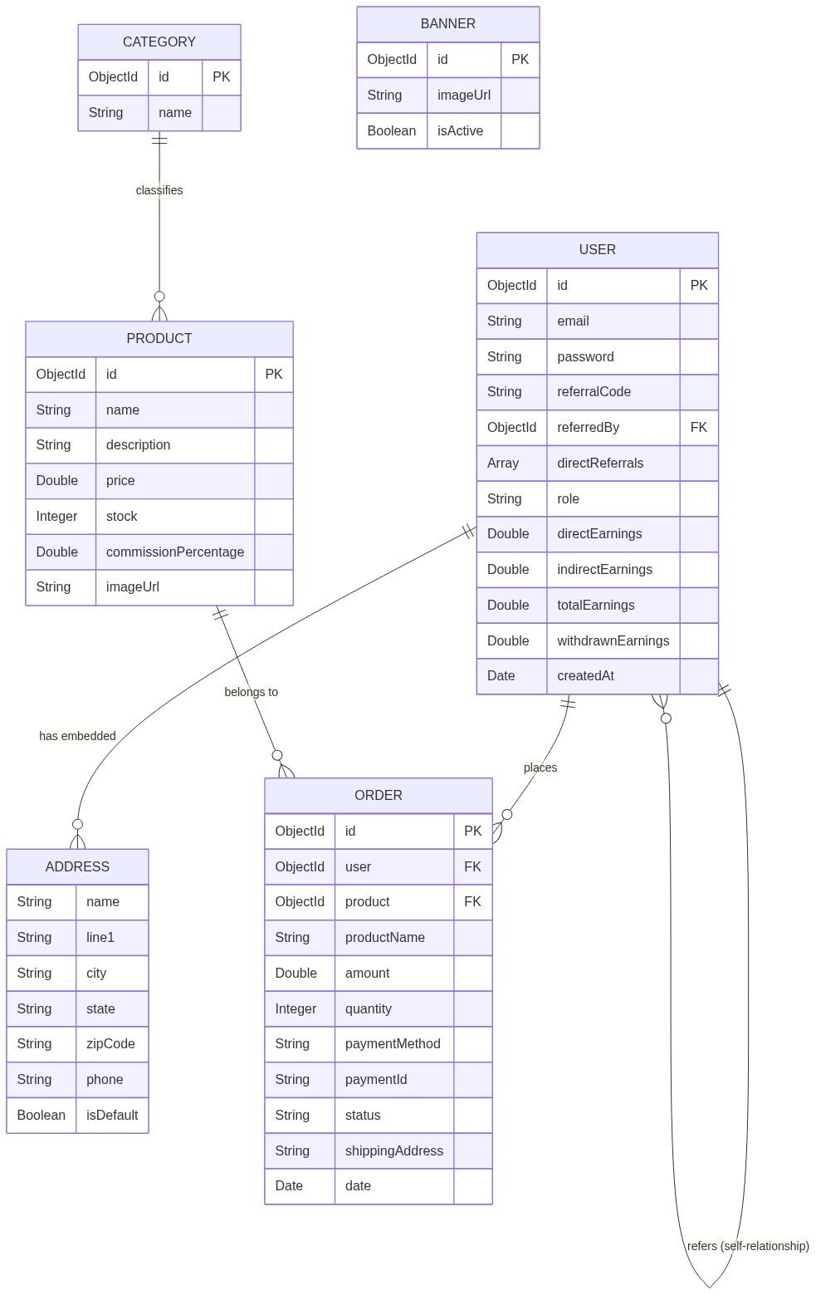
Figure: 2.8 er diagram
Key Relationships explained:
- User and Address (One-to-Many Embedded): Every User document contains an array of addresses sub-documents. This embedded structure is efficient because a user's addresses are retrieved instantly alongside their main profile data.
- User and Order (One-to-Many): A single User can place multiple Orders over time. The Order entity stores a foreign key referencing the User ID.
- User Self-Referential Relationship (One-to-Many): A user's profile can store a referredBy field that holds the MongoDB ObjectId of another User (their Level 1 Parent). This recursive relationship is what forms the nested referral downline tree.
- Product and Order (One-to-Many): A Product can be purchased across different orders. The Order entity stores the productId as a reference alongside the purchase amount and quantity.
- Category and Product (Many-to-One): Products are classified into specific Categories, allowing user storefronts to filter items dynamically.

2.8 Flowcharts
Flowcharts represent the step-by-step operational workflows and logical algorithms that execute inside our application. Two major processes demonstrate the complex business logic of our Referral E-Commerce System:
1. User Sign Up and Referral Binding Flowchart
This flowchart explains the step-by-step validation that runs when a new user registers on the website:
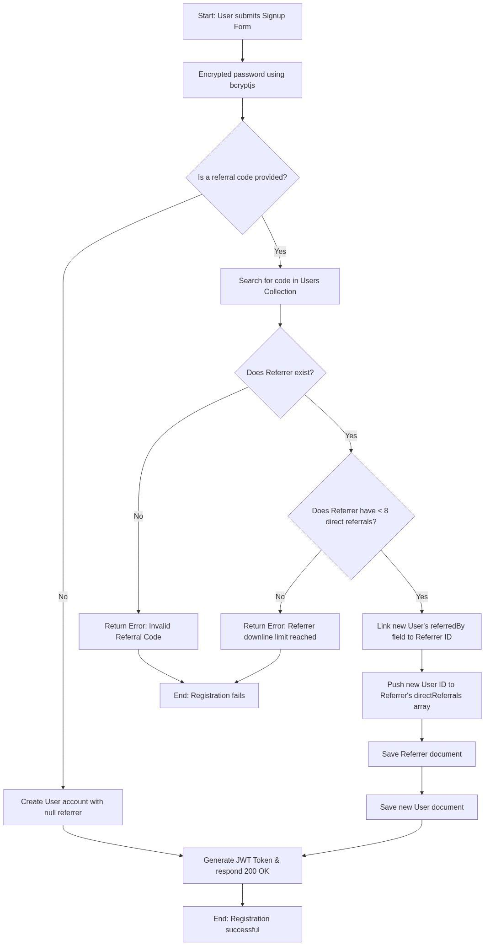
Figure:2.9 User Sign Up and Referral Binding Flowchart
2. Payment Verification and Commission Payout Flowchart
This flowchart maps out the backend transaction logic that runs when a user completes a checkout payment:
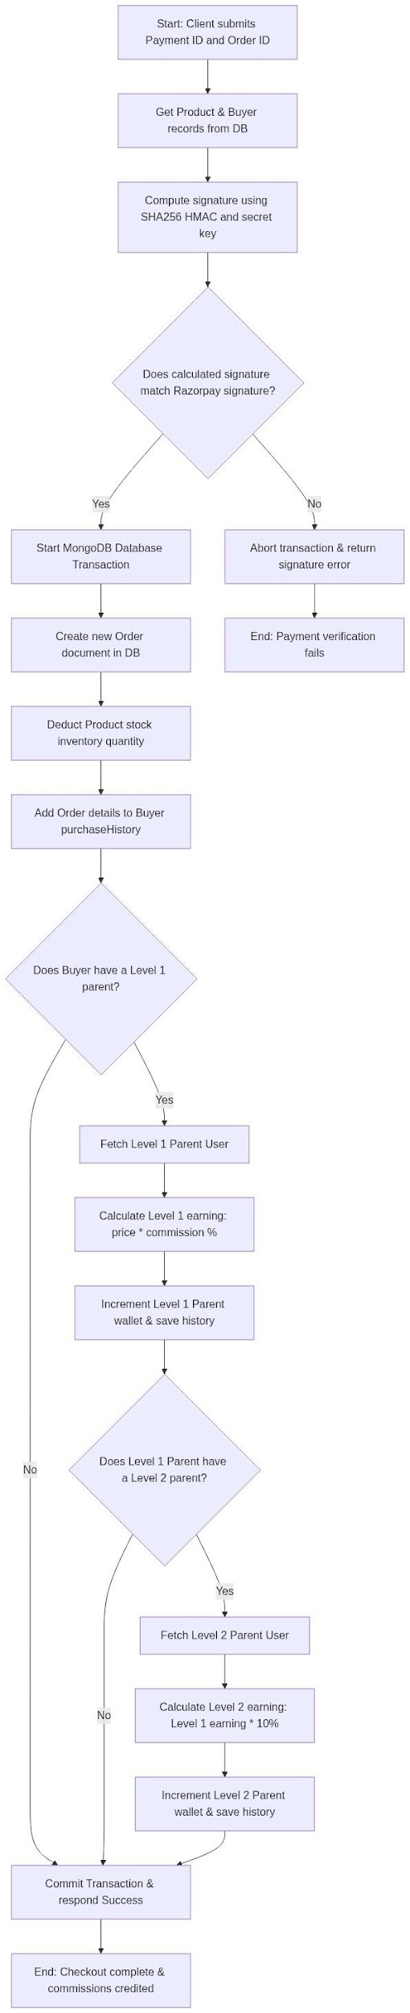
Figure: 2.10 Payment Verification and Commission Payout Flowchart
This clear, logical layout ensures that the calculation of direct and indirect rewards is executed safely and cleanly, preventing database anomalies and ensuring system stability.
2.9 Feasibility Study
A feasibility study is an essential phase in the Software Development Life Cycle (SDLC). It determines whether the proposed Referral E-Commerce System is practical, cost-effective, and beneficial to develop within the given resource and time limits. This evaluation helps identify potential risks and obstacles before allocating substantial development resources.
For this project, the feasibility of the system was thoroughly evaluated across four key dimensions: Technical Feasibility, Operational Feasibility, Economic (Cost) Feasibility, and Time Feasibility.
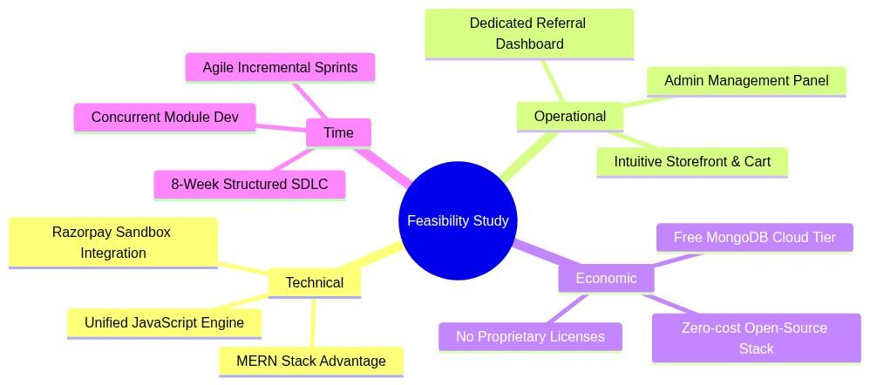
Figure: 2.11 feasibility study
2.9.1 Technical Feasibility
Technical feasibility evaluates whether the available hardware, software, and technology stack can support the development and operational requirements of the system.
The Referral E-Commerce System is built using the MERN (MongoDB, Express.js, React.js, Node.js) stack. This technology combination is highly feasible and suitable for this project due to the following reasons:
- Unified JavaScript Stack: By utilizing JavaScript for both frontend rendering (React) and backend services (Node.js/Express), the development overhead was significantly reduced. This unified language model allowed smooth, immediate transfer of data objects (JSON) without needing complex type-casting across boundaries.
- Non-Blocking Node.js Server: The asynchronous, single-threaded nature of Node.js is ideal for handling concurrent requests. In an e-commerce platform where multiple promoters copy referral links and customers browse the store simultaneously, Node.js handles input/output requests without resource bottlenecks.
- Flexible Document Database: MongoDB's schema-less document structure is extremely suitable for representational changes. Promoter hierarchies—such as the directReferrals array and recursive referredBy linkages—are represented naturally as JSON objects.
- Third-Party Payment Sandboxing: The integration of the official Razorpay API provides a highly secure and technically simple payment interface. By operating inside Razorpay’s free developer sandbox environment, the system utilizes real payment simulation without requiring commercial licenses, SSL certificates, or financial regulatory compliance.
- Standard Client Requirements: The frontend React app is lightweight and runs in any modern web browser. The server and database can run comfortably on standard, consumer-grade development laptops (e.g., dual-core processors with 8GB RAM), ensuring zero hardware constraints.
Ultimately, because the developer had access to modern JavaScript modules, secure sandboxing interfaces, and standard workstation resources, the system is highly technically feasible.
2.9.2 Operational Feasibility
Operational feasibility assesses how well the developed software solves the target problem and how easily it will be adopted, operated, and maintained by its end users (customers, promoters, and administrators).
The system was designed from the ground up to ensure maximum user friendliness and operational efficiency:
- Intuitive Customer Storefront: The storefront layout mirrors standard e-commerce websites (with category search tabs, dynamic shopping carts, and immediate checkout buttons). A customer requires zero technical training to complete a purchase.
- Simplified Promoter Console: Promoters are provided with a dedicated, secure dashboard showing their customized referral invitation link, downline grid, and transaction ledgers. With a single click, they can copy links, monitor their levels 1 and 2 referral trees, and see exactly where their wallet earnings originate.
- Simulated Redemption Mechanics: To keep operations lightweight, promoter redemptions are simulated via secure digital gift vouchers. Rather than dealing with bank transfers and complex compliance, promoters instantly generate brand coupons (like Amazon or Flipkart), allowing immediate, automated gratification.
- Comprehensive Admin Control: The admin dashboard gives system managers full visibility. Admins can audit all orders, update shipping states, modify product parameters (pricing, active stock, referral percentages), and view global financial stats.
- No System Training Overhead: The entire platform operates in standard web browsers, making it accessible on mobile devices and desktops alike. Users require no external manuals or dedicated instruction, making the platform 100% operationally feasible.
2.9.3 Economic (Cost) Feasibility
Economic feasibility determines whether the financial benefits of the system justify the development and maintenance costs. In a university project environment, economic feasibility focuses on minimizing development overhead while ensuring maximum system stability.
The Referral E-Commerce System is exceptionally cost-feasible because it was developed entirely using free, open-source software and developer-tier cloud services:
Component | Software / Resource | Development Cost | Production License Cost
Development IDE | Visual Studio Code | 0 INR (Open Source) | 0 INR (Free)
Frameworks | React.js, Express.js, Node.js | 0 INR (MIT License) | 0 INR (Free)
Database | MongoDB (Local Community Server / Atlas Free Tier) | 0 INR (Free Tier) | 0 INR (Up to 512MB free)
Styling | Tailwind CSS / Vanilla CSS | 0 INR (Open Source) | 0 INR (Free)
Payment Gateway | Razorpay SDK (Sandbox Test Environment) | 0 INR (Free Sandbox) | Transaction-based (No upfront cost)
Testing Client | Postman Client | 0 INR (Free Tier) | 0 INR (Free)
Version Control | GitHub | 0 INR (Free Public/Private repos) | 0 INR (Free)

- Zero Cash Outlay: The actual development of this system incurred zero cost for licensing. All tools, databases, package dependencies (like bcryptjs and jsonwebtoken), and IDE software are completely free.
- Low Hosting Barriers: For small-scale testing and academic viva demonstrations, the entire platform is hosted locally on the developer's laptop (Port 5173 for React and Port 5000 for Express). If cloud deployment is needed, the system can be deployed onto free/low-cost platforms (like Vercel for frontend, Render for backend, and MongoDB Atlas for database), keeping operational costs negligible.
Thus, the economic analysis confirms that the project delivers high functional value at a development cost of zero, proving it is fully economically feasible.
2.9.4 Time Feasibility
Time feasibility evaluates whether the project can be planned, designed, coded, tested, and documented within the academic deadline. The total developmental timeline for the Referral E-Commerce System was mapped over a structured 8-week academic schedule using the Agile/Incremental SDLC model.
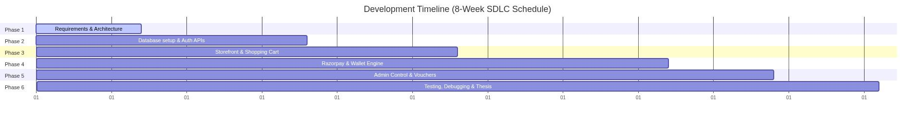
Figure: 2.12 Time Feasibility

The developmental sprints were organized as follows:
- Week 1 (Requirements Analysis and Interface Mockups): Gathering system goals, sketching UI dashboards, and designing the database Entity-Relationship schema.
- Week 2 to 2.5 (Database Setup and Authentication Core): Configuring Mongoose models, establishing MongoDB local storage, coding user signup/login APIs, and creating JWT route guards.
- Week 2.5 to 4 (Core Storefront and Shopping Cart): Building category department listings, dynamic cart components, and shipping address managers.
- Week 4 to 6 (Payment Integration and Referral Calculations): Integrating Razorpay payment sheets, checking HMAC signatures, and implementing the Level 1 and Level 2 database transaction commission credits.
- Week 6 to 7 (Admin Dashboard and Redemptions): Designing the admin console interface, and generating simulated Amazon/Flipkart voucher codes.
- Week 8 (Testing, Bug Resolution, and Documentation): Performing system-wide tests (including the 8-referral spillover cap), resolving cart inventory bugs, and compiling the final thesis report.
By dividing the application into standalone, modular sprints and developing APIs and React layouts in parallel, the developer successfully prevented bottlenecks. The project was completed on schedule, confirming that it is entirely time feasible.
2.10 Data Dictionary and Decision Tables
System analysis and design requires the construction and evaluation of data catalogs and logical decision matrices. These tools ensure that database constraints are fully documented and backend routing decisions are mathematically consistent.
To satisfy the academic project report criteria, this section provides the formal Data Dictionary for the database collections and the Decision Tables governing the system's core business logic.
2.10.1 Data Dictionary
A Data Dictionary acts as a centralized metadata repository that defines the exact structure, data types, keys, and validation rules for each attribute stored in the database. Since the system utilizes MongoDB (a document-oriented database), data structures are stored as flexible documents. Mongoose schemas enforce structural constraints at the application layer.
The data dictionaries for the three primary collections—Users, Products, and Orders—are detailed below:
1. Users Collection Data Dictionary (users)
This collection stores promoter profiles, encrypted credentials, referral tree linkages, dynamic wallets balances, and embedded transaction sub-schemas (addresses and withdrawal logs).
Field Attribute Name | Data Type | Key / Constraint | Validation / Defaults | Operational Description
_id | ObjectId | Primary Key | Auto-generated by MongoDB | Unique identifier for the user document.
email | String | Unique Index | Required, unique, email regex check | Primary user email address used for login.
password | String | None | Required, encrypted using bcryptjs | Securely hashed user credentials.
referralCode | String | Unique Index | Required, generated automatically | Unique code shared by user to refer others.
referredBy | ObjectId | Foreign Key | Default: null, references: users | Identifies the Level 1 parent who referred this user.
directReferrals | Array | None | Default: [], Max items: 8 (Spillover Cap) | Array of ObjectIds of users referred directly.
role | String | None | Default: 'user', Enum: ['user', 'admin'] | Controls access permissions for admin routes.
earnings.direct | Number | None | Default: 0, Minimum: 0 | Total commissions earned from direct signups.
earnings.indirect | Number | None | Default: 0, Minimum: 0 | Total commissions earned from level 2 downlines.
earnings.total | Number | None | Default: 0, Minimum: 0 | Cumulative commissions accumulated historically.
earnings.withdrawn | Number | None | Default: 0, Minimum: 0 | Total funds redeemed for brand vouchers.
addresses | Array | Sub-document | Default: [], Embedded schema | Dynamic list of saved delivery locations.
purchaseHistory | Array | Sub-document | Default: [], Embedded schema | Chronological list of user purchases.
earningHistory | Array | Sub-document | Default: [], Embedded schema | Detailed commission credit receipts index.
withdrawalHistory | Array | Sub-document | Default: [], Embedded schema | History of generated gift coupon codes.

2. Products Collection Data Dictionary (products)
This collection manages the e-commerce inventory catalog, including pricing rules and promoters reward rates.
Field Attribute Name | Data Type | Key / Constraint | Validation / Defaults | Operational Description
_id | ObjectId | Primary Key | Auto-generated by MongoDB | Unique identifier for the product document.
name | String | None | Required, String format | Display name of the product.
slug | String | Unique Index | Required, URL-safe slug | Path coordinate used for clean storefront routing.
price | Number | None | Required, Minimum: 0 | Active selling price of the item.
originalPrice | Number | None | Optional, Minimum: 0 | Original strike-out price shown during sales.
commissionPercentage | Number | None | Required, Default: 10, Range: 1 to 50 | Referral commission percentage (dynamic).
description | String | None | Optional, detailed text | Marketing and feature description.
imageUrl | String | None | Required, URL string | Path to storefront product thumbnail.
category | ObjectId | Foreign Key | References: categories | Links product to specific classification.
stock | Number | None | Default: 0, Minimum: 0 | Available physical inventory quantity.

3. Orders Collection Data Dictionary (orders)
This collection logs successful customer checkouts and handles shipping statuses.
Field Attribute Name | Data Type | Key / Constraint | Validation / Defaults | Operational Description
_id | ObjectId | Primary Key | Auto-generated by MongoDB | Unique identifier for the order document.
user | ObjectId | Foreign Key | Required, references: users | Buyers database account linkage.
product | ObjectId | Foreign Key | Required, references: products | Product item purchased.
productName | String | None | Required, matches active product | Text copy of product name at purchase time.
amount | Number | None | Required, Minimum: 0 | Total checkout transaction cost.
quantity | Number | None | Default: 1, Minimum: 1 | Number of items purchased.
paymentMethod | String | None | Required, Enum: ['Razorpay', 'Wallet'] | Selected financial transactional gateway.
paymentId | String | None | Optional (Razorpay only) | Reference transaction ID returned by Razorpay.
razorpayOrderId | String | None | Optional (Razorpay only) | Native Razorpay order session identifier.
status | String | None | Default: 'Confirmed', Enum: see list | Shipping lifecycle state: Confirmed, Processing, etc.
shippingAddress | String | None | Required, detailed text | Selected delivery destination address.
phoneNumber | String | None | Required, contact number | Delivery phone number inputted during checkout.

2.10.2 Decision Tables
A Decision Table is a tabular logic matrix used to design and evaluate complex system decisions. It maps all possible input conditions against the appropriate system actions, ensuring that backend algorithms handle edge-cases cleanly without logic gaps.
1. Referral Signup Routing Decision Table
This table governs user registration routing based on whether a referral code is provided, whether the code exists in MongoDB, and whether the referrer has reached their maximum downline width limit of 8.
Conditions | Rule 1 | Rule 2 | Rule 3 | Rule 4
Referral code provided? | No | Yes | Yes | Yes
Referral code exists in database? | N/A | No | Yes | Yes
Referrer downline width < 8? | N/A | N/A | No | Yes
Actions
Reject registration (invalid code error) | X
Reject registration (spillover cap error) |  |  | X
Create standard user account (no referrer) | X
Create referred user account (bind parent) |  |  |  | X

- Rule 1: The user registers directly. The system bypasses all checks and saves the user record with referredBy: null.
- Rule 2: A referral code is inputted but not found in MongoDB. The registration fails immediately, and an error is sent to the user: "Invalid Referral Code".
- Rule 3: The referral code is valid, but the referrer's downline array already holds 8 active users. The system rejects the registration, throwing a spillover exception: "Referrer downline limit reached.
- Rule 4: The referral code is valid, and the referrer has space. The system creates the account, links the user's referredBy parameter to the parent, and pushes the new user's ID into the parent's directReferrals array.

2. Checkout Payout Logic Decision Table
This table governs transaction handling and the automated calculation and distribution of direct (Level 1) and indirect (Level 2) commissions upon checkout verification.
Conditions | Rule 1 | Rule 2 | Rule 3 | Rule 4
Payment signature/checkout verified? | No | Yes | Yes | Yes
Buyer has a direct Parent (Level 1)? | N/A | No | Yes | Yes
Parent has a grandparent (Level 2)? | N/A | N/A | No | Yes
Actions
Abort transaction & throw error | X
Process order, distribute 0 commission |  | X
Process order, credit Level 1 parent |  |  | X
Process order, credit both L1 & L2 nodes |  |  |  | X

- Rule 1: The payment signature check fails (Razorpay checksum mismatch or insufficient wallet balance). The server aborts the checkout transaction instantly. No orders or stock deductions occur.
- Rule 2: The buyer completes payment but registered directly (no referrer). The system processes the order, reduces catalog inventory stock, and saves the purchase log, but distributes no commissions.
- Rule 3: The buyer completes payment and has a Level 1 parent, but the parent has no grandparent. The system processes the order, computes Level 1 commission (P × C%), and credits the parent's wallet and history. No further actions are taken.
- Rule 4: The buyer completes payment, and both Level 1 and Level 2 parent referrers are present in the upline tree. The system credits the Level 1 parent with the direct commission and credits the Level 2 grandparent with their 10% indirect commission share atomically.

CHAPTER – 3: HARDWARE AND SOFTWARE REQUIREMENTS
To build, test, and run the Referral E-Commerce System successfully, specific hardware and software configurations are required. Since this is a modern web application based on the MERN stack, the requirements are split into two categories: the development side (used by the student/developer to build and host the system) and the client side (used by the end-user or shopper to access the website).
This chapter details the minimum and recommended hardware configurations, software dependencies, development tools, and browser compatibility rules for the application.
3.1 Hardware Requirements
The MERN stack is highly efficient because it does not require expensive, heavy hardware for development or execution. The local servers run efficiently on standard consumer laptops or computers. Below are the hardware configurations used to develop and test the application, alongside the requirements for the end-user.
1. Developer / Development hardware
These are the hardware specifications of the machine used to write the code, run the local React development server, execute the Node.js API server, and host the local database instance simultaneously:
Hardware Component | Minimum Requirement | Recommended Specification
Processor (CPU) | Intel Core i3 (4th Gen) or AMD Ryzen 3 | Intel Core i5 / Apple Silicon (M1/M2/M3)
System Memory (RAM) | 8 GB DDR4 | 16 GB DDR4 / DDR5 (for smooth multitasking)
Storage (SSD/HDD) | 20 GB free space on HDD | 50 GB free space on SSD (for fast load times)
Graphics (GPU) | Integrated Intel / AMD Graphics | Integrated or Dedicated GPU
Display Monitor | 1366 x 768 Resolution Screen | 1920 x 1080 Full HD Monitor
Input Devices | Standard Keyboard and Mouse | Ergonomic Keyboard and Optical Mouse

- Note: An SSD (Solid State Drive) is highly recommended over a traditional HDD because it significantly speeds up code compilation times in Vite, database reads in MongoDB, and the loading of package libraries.
2. Actual Development Machine Specifications
For this project's implementation, the development and verification were conducted locally on an actual hardware setup with the following specifications:
- System Model: Apple MacBook Air
- Processor (CPU): Apple M4 Chip (8-Core CPU and 10-Core GPU)
- System Memory: 16 GB Unified RAM
- System Storage: 256 GB Solid State Drive (SSD)
- Operating System: macOS Sequoia (Version 15.x, Apple Silicon arm64 architecture)
- Primary Sandbox Browser: Google Chrome - Version 148.0.7778.168 (Official Build) (arm64)
3. Client / End-User Hardware
These are the basic hardware specifications required for a consumer, promoter, or shopper to load and use the application smoothly on their personal devices:
- Desktop Laptops and Computers:
- Processor: Intel Dual-Core or newer processor.
- RAM: 4 GB RAM minimum.
- Network: An active Internet connection (minimum 2 Mbps speed for payment gateways to load overlays without timeout errors).
- Mobile Devices (Smartphones and Tablets):
- Processor: Standard Quad-core or Octa-core mobile processor.
- RAM: 2 GB RAM minimum.
- Network: Active 4G, 5G, or Wi-Fi network connectivity.

3.2 Software Requirements
The software environment forms the core foundation of the Referral E-Commerce System. Since the project uses the MERN stack, the entire backend API and frontend views are driven by JavaScript, reducing the number of external software installations required.
1. Development Software Environment
Below is the list of software environments, runtimes, and databases installed on the developer's system:
- Operating System: macOS (Sonoma/Sequoia), Windows 10/11 (64-bit), or Ubuntu Linux. The development environment is cross-platform, meaning the code runs identically across all major operating systems.
- JavaScript Runtime: Node.js (v18.x or v20.x LTS). Node.js is necessary to run server-side JavaScript, manage package installations, and compile the React frontend.
- Database Management System: MongoDB Community Edition (v6.x or newer). Used as the local NoSQL document database. Alternatively, MongoDB Atlas (a cloud database) is utilized to host database structures securely in the cloud.
- Web Styling Tools: Tailwind CSS (v3.x) and PostCSS for compiling responsive, utility-first CSS utility designs.
- API Testing Tool: Postman or VS Code Thunder Client. Used to trigger mock POST and GET requests to test authentication and payment endpoints before building the frontend interface.
2. Deployment Software Environment
For hosting the prototype system on the cloud, the following software hosts are used:
- Frontend Hosting Platform: Vercel or Netlify. These systems host the static React frontend, deploying optimized assets directly to edge servers.
- Backend API Hosting Platform: Render or Railway. These cloud servers run the active Node.js server instance, keeping the API endpoints online.
- Payment Processing Integration: Razorpay Sandbox API. Used to simulate Indian Rupee (INR) transactions without using real currency during testing.
3.3 Development Environment
The development environment consists of the specific text editors, build tools, package utilities, and packages used to write and organize the application code.
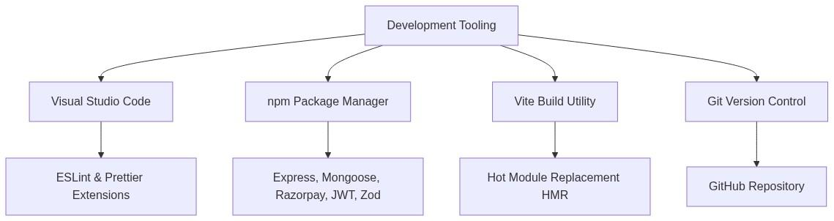
Figure: 3.1 Development Environment
1. Integrated Development Environment (IDE)
- Visual Studio Code (VS Code) was selected as the primary text editor. It is lightweight, fast, and provides helpful developer extensions:
- Prettier: Automatically formats JavaScript and CSS files for clean code alignment.
- ESLint: Displays code syntax errors and warnings in real-time, helping developers catch bugs before running the code.
- Tailwind CSS IntelliSense: Auto-completes style utilities directly in React elements, speeding up UI design.
2. Node Package Manager (npm)
Every package dependency in this project is managed using npm (included with Node.js). The libraries are split into frontend and backend dependencies:
- Backend Libraries (package.json in Server):
- express: High-performance HTTP server routing framework.
- mongoose: Object Data Modeling (ODM) framework used to write schemas and queries for MongoDB.
- bcryptjs: Secure hashing tool to encrypt user passwords.
- jsonwebtoken (JWT): Creates secure session tokens for user authentication.
- razorpay: Official software development kit (SDK) to connect to the Razorpay checkout APIs.
- zod: Data schema validation library used to verify incoming API request bodies.
- cors: Middleware to allow cross-origin requests between the React client and Express API.
- dotenv: Manages environment variables (like API keys and database links) securely.
- Frontend Libraries (package.json in Client):
- react & react-dom: The core component rendering framework.
- react-router-dom: Handles client-side navigation and routes without page reloads.
- axios: Promise-based HTTP client to send GET and POST requests to the Express server.
- lucide-react: A clean collection of modern vector icons used throughout the dashboard layouts.
3. Build & Compiler Utility
The React frontend uses Vite as its build utility instead of the older Create React App (CRA). Vite is exceptionally fast, utilizing Hot Module Replacement (HMR) to update browser views instantly when a file is saved, making frontend development faster.
4. Version Control System
- Git was used locally to track changes, create backup commits, and manage developmental branches. The repository was pushed to GitHub, providing cloud backup and code sync tools.

3.4 Browser Compatibility
Since the Referral E-Commerce System is designed as a web application, it must run correctly on different web browsers without layout breaks or functional errors. The application utilizes modern web standards: HTML5 for page structure, CSS3 (Flexbox/Grid) for responsive styling, and JavaScript (ES6+) for asynchronous API communications.
Most modern web browsers are built on similar rendering engines (such as Chromium for Chrome, Edge, and Opera, or WebKit for Safari), which guarantees consistent layout rendering.
Below is the browser compatibility matrix tested for the application:
Web Browser | Engine | Minimum Compatible Version | Status
Google Chrome | Blink / Chromium | Version 90+ | Fully Compatible
Mozilla Firefox | Gecko | Version 88+ | Fully Compatible
Microsoft Edge | Blink / Chromium | Version 90+ | Fully Compatible
Apple Safari | WebKit | Version 14+ | Fully Compatible
Opera | Blink / Chromium | Version 76+ | Fully Compatible
Mobile Browsers | Chrome Mobile / Safari iOS | iOS 14+ / Android 9+ | Fully Compatible (Responsive Layout)

Key Browser Technologies Required:
- JavaScript Support: The browser must have JavaScript enabled, as React relies entirely on client-side rendering to construct elements and manage local state.
- Local Web Storage (localStorage): The browser must support local storage APIs, as the application stores the user's JWT authorization token locally to keep them logged in during subsequent browser sessions.
- Secure Sockets Layer (SSL/TLS): To process payment checkouts via the Razorpay SDK, the browser must support modern secure socket layers to encrypt transaction handshakes securely.

CHAPTER – 4 : ABOUT THE TECHNOLOGY
This chapter provides a detailed overview of the core technologies, frameworks, libraries, and design concepts used to build the Referral E-Commerce System. A modern web application requires a stable stack of tools that can handle both the visual presentation on the client side and the database and routing operations on the server side.
By utilizing the MERN stack—composed of MongoDB, Express.js, React.js, and Node.js—alongside Vite, Tailwind CSS, Razorpay, JWT authentication, and Git/GitHub, this project achieves excellent performance, security, and responsive layouts.
Below is an academic explanation of each technology, detailing what it is, its core operational mechanisms, and its architectural benefits.
4.1 Responsive Web Designing (RWD)
Responsive Web Design is a web development approach that ensures web pages render correctly across a variety of devices, screen sizes, and orientations. In modern web development, websites must be accessible and readable on smartphones, tablets, laptops, and wide-screen desktops from a single codebase.
Core Concepts of Responsive Design:
- Fluid Grid Layouts: Fluid grids use relative units like percentages (%), viewport width (vw), or viewport height (vh) instead of fixed pixel measurements. This allows blocks, images, and text containers to resize proportionally as the user's screen shrinks or expands.
- Media Queries: A CSS3 feature that enables developers to apply specific CSS rules conditionally based on characteristics of the user's device, such as screen width, height, resolution, or orientation (e.g., @media (max-width: 768px)).
- CSS Flexbox and Grid: Modern CSS layout models that make it easy to align elements, distribute space, and build complex layouts dynamically. Flexbox is designed for one-dimensional layouts (a row or a column), while Grid is suited for two-dimensional layouts (rows and columns simultaneously).
CSS Utility Frameworks (Tailwind CSS):
To implement responsive layouts efficiently, developers often utilize utility-first CSS frameworks like Tailwind CSS. Instead of writing custom CSS stylesheet files with complex media queries, Tailwind provides pre-compiled utility classes (e.g., flex, grid, text-center) that can be prefixed with screen-width breakpoints:
- sm: for small screens (mobiles, 640px and up)
- md: for medium screens (tablets, 768px and up)
- lg: for large screens (laptops and desktops, 1024px and up)
This allows developers to define dynamic structures directly inside the HTML markup, ensuring the user interface responds gracefully to any viewport.
4.2 Vite
- Vite is a modern frontend build tool designed to provide a faster and leaner development experience for modern web applications. Created as an alternative to older build utilities like Webpack, Vite focuses on speed during both development (server start, reload) and production bundling.
Key Operational Mechanisms:
- Native ES Modules (ESM) serving: Traditional bundlers compile the entire frontend application, including all routes, assets, and packages, before starting the local development server. As the project grows, this process becomes slow. Vite avoids this by serving the source code over native ES Modules. The browser requests specific JS files only when they are needed for the active page, allowing the server to start instantly.
- Esbuild Compiler: For compiling heavy third-party packages, Vite uses Esbuild, an extremely fast compiler written in the Go programming language. Esbuild compiles code significantly faster than traditional JavaScript-based compilers.
- Hot Module Replacement (HMR): When changes are made to a source file, Vite updates only the modified module in the browser's active memory. The application's current state is preserved, and updates render in milliseconds without requiring a full page refresh.
For production, Vite uses Rollup, an optimized bundler that outputs highly compressed HTML, CSS, and JavaScript assets for deployment.
4.3 React.js
- React.js is an open-source, component-based frontend JavaScript library developed by Meta (formerly Facebook). It is used to build dynamic, interactive user interfaces for single-page applications (SPAs).
Core Features of React:
- Component-Based Architecture: In React, the user interface is split into self-contained, reusable blocks of code called components. Each component manages its own logic and visual layout, making the frontend organized and maintainable.
- The Virtual DOM: In standard web browsers, updating page elements (the Real DOM) is slow and performance-heavy. React creates a lightweight copy of the page structure in memory, called the Virtual DOM. When data changes, React identifies the exact differences (a process called "diffing") between the virtual copy and the actual screen, and updates only the modified elements.
- JSX (JavaScript XML): JSX is a syntax extension for JavaScript that allows developers to write HTML-like elements directly inside JavaScript code. It combines layout and logic into single component files.
React Hooks:
React Hooks are built-in functions that let developers tap into React's state management and lifecycle capabilities:
- useState: Allows a component to declare and maintain local state variables. When a state variable is updated, React automatically re-renders the component to display the new data.
- useEffect: Enables developers to perform side effects in components, such as fetching data from a server, setting up subscriptions, or modifying the document title after the page renders.
- useContext: Provides a way to share data globally across the component tree without manually passing props down through nested layers (prop drilling).
4.4 Node.js
- Node.js is a cross-platform, open-source JavaScript runtime environment built on Google Chrome's high-performance V8 engine. Node.js compiles JavaScript directly into machine code, allowing JavaScript to run on the server side rather than being confined to client-side web browsers.
Key Architectural Concepts:
- Asynchronous and Non-Blocking I/O: Traditional servers (such as Apache running PHP) handle requests using multi-threading. Each incoming request spawns a new thread, which blocks execution while waiting for database queries or network requests to complete. Node.js operates on a single execution thread with an Event Loop. When a slow database query or file system operation is initiated, Node delegates it to the operating system's background system and continues handling subsequent requests. Once the query completes, the background system notifies Node to send the response.
- Single-Threaded Event Loop: The Event Loop continuously listens for incoming events, triggers their associated callback functions, and handles asynchronous operations, making Node.js lightweight and capable of handling thousands of concurrent connections.
- npm (Node Package Manager): Node.js includes access to npm, the largest software registry in the world. It provides thousands of open-source packages and libraries, enabling rapid application assembly.
4.5 Express.js
- Express.js is a minimalist, fast, and flexible web application framework built on top of Node.js. It acts as the routing and middleware foundation for building web servers and web APIs.
Core Architecture of Express:
- Routing: Express provides a robust routing system that maps incoming client HTTP requests (based on their URLs and HTTP methods like GET or POST) to specific controller functions on the server.
- Middleware Pipeline: In Express, requests go through a sequence of functions called "middlewares" before reaching the final handler. Middlewares can intercept, inspect, parse, or block requests. Common middleware functions include:
- Body Parsers: Parsing incoming JSON request payloads (express.json()).
- CORS (Cross-Origin Resource Sharing): Standardizing security headers to allow frontend clients from other origins to make secure API requests.
- Authentication Interceptors: Validating authorization tokens before giving access to secure database routes.
- REST API Helpers: Express simplifies the process of sending standardized JSON responses and setting appropriate HTTP status codes (such as 200 OK, 400 Bad Request, and 500 Server Error).
4.6 MongoDB & Mongoose ODM
- MongoDB is an open-source, document-oriented NoSQL database designed for high performance, high availability, and easy scalability. Unlike traditional relational databases (like MySQL) that store data in rigid rows and columns across tables, MongoDB stores data in flexible, JSON-like documents called BSON (Binary JSON).
Key Features of MongoDB:
- Document-Based Model: A record in MongoDB is a document, which is a data structure composed of field and value pairs. Field values can include primitive types, nested arrays, and sub-documents, allowing complex data relations to be stored cleanly inside a single record.
- Dynamic Schemas: MongoDB does not enforce a rigid structural layout on all records in a collection. Documents within the same collection can have different fields and data types, providing flexibility as project requirements change.
- Horizontal Scalability: MongoDB is designed to scale out across multiple distributed servers easily, making it highly suitable for applications expecting large volumes of data and traffic.
Mongoose ODM (Object Data Modeling):
To manage data integrity in a JavaScript-centric MERN stack, developers use Mongoose, a modeling library that provides schema validation and database abstraction for MongoDB:
- Schemas and Models: Mongoose allows developers to define structured schemas for collections (e.g., specifying that a user's email must be a string and is required) to ensure consistent data structures.
- Validation: It provides built-in and custom validators (such as checking email formats or enforcing maximum values) before records are written to the database.
- Query Building: Mongoose provides an elegant fluent API for chaining database actions, such as .find(), .populate(), and .aggregate().
- Database Transactions: Mongoose supports standard session-based transactions, allowing developers to execute multiple database writes together. If any individual operation fails, the entire transaction is rolled back to protect data consistency.
4.7 REST API
- REST (Representational State Transfer) is a software architectural style that defines a set of constraints for creating stateless web services. A RESTful API allows the frontend client and the backend server to communicate and exchange data securely.
Fundamental Principles of REST:
- Statelessness: A REST API is completely stateless. Every HTTP request sent from the client to the server must contain all the necessary data (such as login tokens and parameters) for the server to understand and process the request. The server does not store active session data about the client.
- Resource-Oriented: Resources (such as user accounts, products, or orders) are represented by unique URLs (e.g., /api/products).
- Standard HTTP Methods: Client actions map directly to standardized HTTP verbs:
- GET: Read or retrieve a resource.
- POST: Create a new resource.
- PUT/PATCH: Update an existing resource.
- DELETE: Remove a resource.
- Standard Response Formatting: A REST API communicates by returning structured data—typically in the JSON (JavaScript Object Notation) format—along with standardized HTTP status codes to indicate success or specific error states.
4.8 Razorpay Payment Gateway
- Razorpay is a secure, popular payment aggregation platform that allows online platforms to accept, process, and disburse payments. It acts as an intermediary, handling the secure processing of card payments, net banking, digital wallets, and UPI transfers between customers, financial networks, and merchant bank accounts.
Core Payment Concepts:
- Secure Payment Collection: Razorpay provides client-side checkout overlays that securely capture customer payment credentials, ensuring that sensitive credit card numbers or UPI PINs never touch the merchant's application servers, reducing security overhead.
- API Order Creation: Before a payment is initialized, the server securely communicates with Razorpay APIs using private credentials to establish an order, securing a unique transaction order identifier.
- Payment Integrity and Signature Verification: To prevent fraud (such as users fabricating payment confirmation logs), payment gateways use cryptographic hashing algorithms. Once a transaction succeeds, Razorpay returns transaction signatures. The backend server must reconstruct the signature using the private merchant secret key and compare it with the client-submitted signature using a secure hashing algorithm (such as SHA256 HMAC). The payment is only marked as verified if the signatures match exactly.
4.9 JWT (JSON Web Token) Authentication
- JSON Web Token (JWT) is an open standard (RFC 7519) that defines a compact, self-contained method for securely transmitting information between parties as a JSON object. It is widely used in modern web applications to manage stateless user authorization.
Structure of a JSON Web Token:
A JWT is represented as a single, base64url-encoded string split by periods (.) into three distinct sections:
- Header: Contains metadata about the token, typically specifying the token type (JWT) and the hashing algorithm used to sign it (such as HS256).
- Payload: Stores the token claims—the actual data being transmitted—such as the user's unique database identifier, role, and the token expiration timestamp.
- Signature: Created by combining the encoded header, the encoded payload, and a secret key known only to the backend server. The signature is computed using a secure hashing algorithm.
[Header (Base64)] . [Payload (Base64)] . [Signature]

Authorization Mechanism:
- Stateless Validation: When a user logs in, the server signs a JWT and sends it back to the browser. The browser stores this token (e.g., in localStorage) and attaches it to the authorization headers of subsequent API requests.
- Tamper Prevention: When the server intercepts an authenticated request, it decodes the token and computes the signature using its private secret key. If the computed signature matches the token's signature, the token is verified as authentic. If a user modifies the payload data (e.g., changing their user ID or expiration time), the signatures will not match, and the request is rejected immediately, preventing session hijacking.

4.10 Git and GitHub
- Git is a distributed version control system designed to track changes in source code during software development, while GitHubis a cloud-based platform for hosting Git repositories and collaborating with developers.
Key Version Control Concepts:
- Distributed Repository: Every developer has a full copy of the project history on their local machine, ensuring high speed and offline functionality.
- Commits: Commits act as snapshots of the codebase at specific points in time. Every commit is recorded with a unique hash and a descriptive message, creating a clear history of how the application developed.
- Branching and Merging: Branches allow developers to isolate new features or experimental code from the stable production branch. Once a feature is complete and verified, its branch is merged back into the main branch.
- Remote Synchronization: Developers synchronize code by pulling changes from and pushing updates to cloud hosts like GitHub, securing the project against hardware failure and establishing a centralized project repository for deployment.

CHAPTER – 5 : SYSTEM IMPLEMENTATION
This chapter details the architectural implementation of the Referral E-Commerce System. System implementation is the phase where the theoretical designs, logic flows, and technology selections are translated into operational software.
The application is structured as a decoupled client-server platform. The frontend consists of a modular React.js single-page application built on Vite and Tailwind CSS. The backend consists of an asynchronous Node.js server running Express.js routing, secured by JSON Web Token (JWT) middlewares, interacting with a document-based MongoDB instance via Mongoose.
Below is a comprehensive breakdown of the client-side modules, server-side admin functions, database collections, and API development configurations that implement this system.
5.1 User Side Modules
The user side of the application is a fully responsive storefront, dashboard, and promotion management console. It is built as a single-page application (SPA), enabling smooth page changes without hard browser reloads. Shared states (such as authentication status and active shopping carts) are synchronized using React Context APIs.
Figure: 5.1 User Side Modules
5.1.1 Authentication Module
The Authentication Module manages user registration (Signup.jsx) and login (Login.jsx) sessions.
- Core Purpose: Captures the user's email, password, phone, and optional referral code. When a user submits their credentials, the module sends an API request to the backend server. Upon successful credentials check, it saves the returned JWT token to browser localStorage and updates the React application state to mark the user as logged in.
- Referral Interception: During registration, if a referral code is present in the input fields, the module sends the code to the backend to verify its validity, ensuring new signups can link dynamically to their parent referrers.
- State Management: Uses state variables like email, password, errorMsg, and loading to manage input binding, error message banners, and form-submitting states dynamically.
5.1.2 Shop Module
The Shop Module implements the retail catalog storefront (Dashboard.jsx, ProductDetail.jsx).
- Key Operations: Displays categories and promotional banners fetched from the server. Users can search for products, filter by category tabs, and browse product cards.
- Component Details: Each product card displays the product name, price, strike-through original price (if on sale), active stock counts, and the commission percentage offered to referrers.
- Navigation: Clicking on a product card uses React Router to open the detailed product view, displaying description summaries, stock availability levels, and action buttons to "Add to Cart" or "Buy Now".
5.1.3 Orders Module
The Orders Module handles the cart checkout process and tracks purchase logs (Cart.jsx, MyPurchases.jsx).
- Core Responsibilities: Displays items added to the cart, lets users modify quantities, calculates cart subtotals, and lists shipping addresses.
- Checkout Flow: To finalize checkout, users select a delivery address and a payment method:
- Razorpay Checkout: Opens the secure Razorpay payment gateway overlay.
- Wallet Checkout: Pays using net wallet credit.
- Order Status Ledger: In MyPurchases.jsx, users view chronological lists of their orders, displaying the purchased items, quantities, total spent, transaction IDs, payment methods, and current shipping status (e.g. Confirmed, Delivering, Delivered).
5.1.4 Earnings Module
The Earnings Module serves as the promoter's financial dashboard (Earnings.jsx).
- Primary Purpose: Displays key financial metrics in clean grid-styled containers:
- Direct Earnings (Level 1): Commission earned from direct referrals.
- Indirect Earnings (Level 2): Commission earned from direct referrals' referrals.
- Total Accumulated Earnings: All historical credit earnings.
- Withdrawn Balance: Cumulative value of funds already redeemed.
- Transactional Ledger: Renders a tables list (earningHistory) that logs every individual credit: showing the exact commission amount, the buyer's email, the product purchased, the referral tier level (1 or 2), and the transaction timestamp.
5.1.5 Referral Network Module
The Referral Network Module tracks and displays the user's promotion tree (Referrals.jsx).
- Key Features: Generates the user's custom, shareable referral sign-up link (e.g. http://localhost:5173/signup?ref=ABC123D). It provides an easy copy button that saves the link to the client clipboard.
- Downline Counter & Tree Structure: Displays details of their direct parent referrer (if they registered using a referral link) and renders a visual grid showing their registered downlines. The system displays a counter indicating active direct referrals, helping users verify their downline width against the maximum system cap of 8.

5.1.6 Wallet System
The Wallet System represents the virtual digital ledger on the frontend (Earnings.jsx, RedeemModal.jsx).
- Operational Mechanics: Displays the dynamic Net Wallet Balance, calculated using the system logic:
Net Balance = Total Earnings − Withdrawn Amount
- Checkout Integration: Integrates directly into the cart payment overlays, enabling promoters to buy products using their net earnings. The system verifies in real-time if the net balance exceeds the order subtotal, toggling the "Pay via Wallet" option only when funds are sufficient.

5.1.7 Withdraw Request System
The Withdraw Request System manages the redemption of wallet balances into retail vouchers (RedeemModal.jsx).
- Primary Features: Opens a modal showing choices to withdraw funds. Since real bank account wire processing requires extensive compliance, the system simulates brand gift voucher redemptions.
- Voucher Generation: Users input a withdrawal amount and choose a retail brand (e.g. Amazon, Flipkart). The system verifies that the net balance is sufficient, submits the request, and instantly displays a randomly generated, secure coupon code.
- Historical Ledger: Renders a history log inside withdrawalHistory displaying the brand name, date of redemption, withdrawn amount, and the coupon code for user reference.
5.1.8 User Profile Module
The User Profile Module lets users manage their credentials and delivery books (Profile.jsx).
- Core Responsibilities: Displays user account information, registration date, and provides tools to edit profile phone numbers and dynamic addresses.
- Delivery Address Book: Allows users to save multiple shipping address cards (such as "Home" or "Office"). Users can add new addresses, edit existing details, delete unused address cards, and check a radio option to designate a default delivery address, which loads automatically during cart checkout.
5.2 Admin Side Modules
The Admin Side of the application is a secure administrative management console (AdminDashboard.jsx, AdminSidebar.jsx). It is accessible only to users whose database records contain the specific role credential role: 'admin'.
Figure: 5.2 Admin Side Modules
5.2.1 Admin Authentication
The Admin Authentication module protects administrative routes from unauthorized access.
- Access Control Purpose: When the admin console attempts to load, the frontend intercepts the JWT token in localStorage. The backend routes decode the token payload and check if the role claim equals admin. If the claim matches, access is allowed. If a standard customer attempts to access the URL, the server rejects the request with an HTTP status 403 Forbidden, and the client-side router redirects the user back to the homepage.
5.2.2 Users Management
The Users Management module provides a directory of registered users (AdminDashboard.jsx).
- Core Features: Renders a comprehensive list of all platform accounts. Administrators can search for specific users by email and view registration timestamps.
- Promotional Tracking: Displays user details including their unique referral code, the ID of the parent who referred them, their active direct downlines count, and their complete wallet ledger (Total, Withdrawn, and Net Balance), helping administrators monitor platform performance and detect referral fraud.
5.2.3 Orders Management
The Orders Management module provides control over global retail operations.
- Key Responsibilities: Displays every order placed on the platform. The table details the order date, the buyer's email, the product name, payment method (Razorpay or Wallet), total value, transaction ID, and the shipping address.
- Status Updates: Provides a dropdown interface that allows administrators to update the shipping state of an order: updating it from Confirmed to Processing, Delivering, and finally Delivered, keeping users updated in real-time.
5.2.4 Categories Management
The Categories Management module organizes the product catalog structure.
- Primary Purpose: Displays all active product departments. Administrators can create new categories by typing a category name.
- Dynamic Slugs: The system automatically generates a unique, URL-safe slug for each category (e.g. "Smart Devices" becomes smart-devices). Administrators can also delete categories, which removes them from the user storefront filter bar.
5.2.5 Products Management
The Products Management module controls the e-commerce inventory and referral rates.
- Key Operations: Displays all retail items. It provides a detailed modal form to create, update, or delete products.
- Product Details: Captures product name, category linkage, image URLs, description text, stock availability, original cross-out retail price, and the current selling price.
- Commission Cap Rules: Allows administrators to specify a custom commission percentage (between 1% and 50%) for each individual product. This controls the level 1 and level 2 commissions distributed dynamically upon sales checkout.
5.2.6 Withdrawals Management
The Withdrawals Management module oversees simulated payout activities.
- Core Responsibilities: Displays a global history log of every digital gift card redemption requested across the platform. The ledger shows the date of request, the user's email, the brand selected (Amazon / Flipkart), the coupon code generated, and the amount redeemed. This allows administrators to audit and reconcile total virtual payout liabilities against platform revenues.
5.2.7 Banner Management
The Banner Management module controls the homepage visuals.
- Primary Features: Allows administrators to configure dynamic carousel marketing banners. Banners require a title, description, image URL, and a target product slug.
- Active Status: Administrators can toggle a banner's active status. Active banners render automatically on the user homepage dashboard, driving storefront traffic to designated sale products.
5.2.8 Dashboard Analytics
The Dashboard Analytics module provides a high-level summary of platform performance.
- Operational Mechanics: Renders key performance indicators in an analytics grid:
- Total Registered Users: Count of all customer accounts.
- Total Store Orders: Count of all purchases.
- Total Platform Revenue: Cumulative sum of all successful transactions.
- Distributed Commissions: Cumulative sum of all level 1 and level 2 commissions credited.
5.3 Database Implementation
The database is built on MongoDB, using Mongoose ODM to define schemas, structure schema rules, and enforce validations. Below is the actual schema definition for each collection, matching your database implementation.
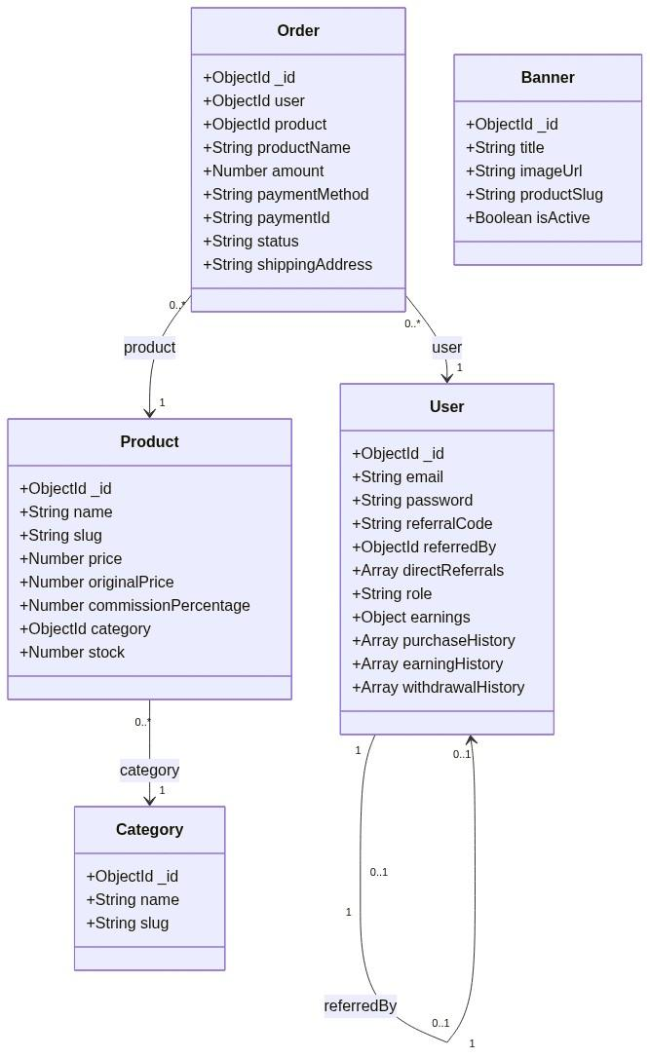
Figure: 5.3 Database Implementation

5.3.1 User Collection (User.js)
The User collection stores user account details, shipping addresses, two-tier referral trees, earnings balances, historical credits, and withdrawal coupon history.
const mongoose = require('mongoose');
const UserSchema = new mongoose.Schema({
email: { type: String, required: true, unique: true },
password: { type: String, required: true },
addresses: [{
name: { type: String, required: true }, // e.g., "Home", "Office"
line1: { type: String, required: true },
city: { type: String, required: true },
state: { type: String, required: true },
zipCode: { type: String, required: true },
phone: { type: String, required: true },
isDefault: { type: Boolean, default: false }
}],
referralCode: { type: String, unique: true },
referredBy: { type: mongoose.Schema.Types.ObjectId, ref: 'User', default: null },
directReferrals: {
type: [{ type: mongoose.Schema.Types.ObjectId, ref: 'User' }],
validate: {
validator: function (val) {
return val.length <= 8; // Enforce maximum downline width of 8
},
message: 'Maximum of 8 direct referrals allowed.'
}
},
role: { type: String, enum: ['user', 'admin'], default: 'user' },
earnings: {
direct: { type: Number, default: 0 },
indirect: { type: Number, default: 0 },
total: { type: Number, default: 0 },
withdrawn: { type: Number, default: 0 }
},
purchaseHistory: [{
productId: { type: mongoose.Schema.Types.ObjectId, ref: 'Product' },
productName: String,
productImage: String,
price: Number,
razorpayOrderId: String,
razorpayPaymentId: String,
voucherCode: String,
status: { type: String, default: 'Payment Successful' },
date: { type: Date, default: Date.now }
}],
earningHistory: [{
amount: Number,
fromUser: { type: mongoose.Schema.Types.ObjectId, ref: 'User' },
fromUserEmail: String,
productName: String,
level: { type: Number, enum: [1, 2] },
date: { type: Date, default: Date.now }
}],
withdrawalHistory: [{
amount: Number,
couponCode: String,
brand: String,
date: { type: Date, default: Date.now }
}],
createdAt: { type: Date, default: Date.now }
}, { timestamps: true });
module.exports = mongoose.model('User', UserSchema);

5.3.2 Product Collection (Product.js)
The Product collection manages retail items, listing prices, categories, and referral commission structures.
const mongoose = require('mongoose');
const ProductSchema = new mongoose.Schema({
name: { type: String, required: true },
slug: { type: String, unique: true, sparse: true },
price: { type: Number, required: true },
originalPrice: { type: Number },
commissionPercentage: { type: Number, required: true, default: 10, min: 1, max: 50 },
description: { type: String },
imageUrl: { type: String },
category: { type: mongoose.Schema.Types.ObjectId, ref: 'Category' },
stock: { type: Number, default: 0 }
}, { timestamps: true });
module.exports = mongoose.model('Product', ProductSchema);

5.3.3 Orders Collection (Order.js)
The Order collection stores customer purchases, detailing transaction metrics and fulfillment statuses.
const mongoose = require('mongoose');
const OrderSchema = new mongoose.Schema({
user: {
type: mongoose.Schema.Types.ObjectId,
ref: 'User',
required: true
},
product: {
type: mongoose.Schema.Types.ObjectId,
ref: 'Product',
required: true
},
productName: { type: String, required: true },
productImage: { type: String },
amount: { type: Number, required: true },
quantity: { type: Number, default: 1 },
paymentMethod: {
type: String,
enum: ['Razorpay', 'Wallet'],
required: true
},
paymentId: { type: String },
razorpayOrderId: { type: String },
status: {
type: String,
enum: ['Confirmed', 'Processing', 'Delivering', 'Delivered'],
default: 'Confirmed'
},
shippingAddress: { type: String, required: true },
phoneNumber: { type: String, required: true },
createdAt: { type: Date, default: Date.now }
}, { timestamps: true });
module.exports = mongoose.model('Order', OrderSchema);

5.3.4 Withdraw Embedded Schema (Sub-Schema in User.js)
In e-commerce databases, withdrawals are often stored in a separate collection. In this project, they are implemented as an Embedded Sub-Schema (withdrawalHistory) within the main User collection.
- Architectural Rationale: Storing withdrawal history inside the User document is a NoSQL best practice that offers key advantages:
- High Read Performance: When a user loads their dashboard, the server fetches their profile and withdrawal logs in a single database query. This avoids complex SQL joins or multi-collection NoSQL queries.
- Atomic Consistency: Wallet balance deductions and voucher generation occur inside a single Mongoose update operation. The transaction succeeds or rolls back in one atomic action, preventing sync errors.
- Schema Schema:
withdrawalHistory: [{
amount: Number,
couponCode: String,
brand: String,
date: { type: Date, default: Date.now }
}]

5.3.5 Banner Collection (Banner.js)
The Banner collection stores dynamic carousel assets displayed on the store homepage.
const mongoose = require('mongoose');
const BannerSchema = new mongoose.Schema({
title: {
type: String,
required: true
},
description: {
type: String
},
imageUrl: {
type: String,
required: true
},
productSlug: {
type: String
},
isActive: {
type: Boolean,
default: true
},
createdAt: {
type: Date,
default: Date.now
}
});
module.exports = mongoose.model('Banner', BannerSchema);

5.3.6 Category Collection (Category.js)
The Category collection categorizes products for clean browsing.
const mongoose = require('mongoose');
const CategorySchema = new mongoose.Schema({
name: { type: String, required: true },
slug: { type: String, unique: true, required: true }
}, { timestamps: true });
module.exports = mongoose.model('Category', CategorySchema);

5.4 API Development
The backend routing architecture is organized into REST endpoints. Every private route is protected by a JSON Web Token (JWT) verification middleware (auth.js), while administrative routes are protected by a combined authentication and role-checking middleware (admin.js).
Client Request -> HTTP Method -> auth middleware -> controller -> DB updates -> JSON Response

5.4.1 Authentication APIs
These endpoints handle registration, login sessions, profile updates, and shipping address cards.
HTTP Method | API URL Endpoint | Authorization | Request Body Payload | Database Logic / Operations | Success Response JSON
POST | /api/auth/signup | Public | { email, password, phone, address, referralCode } | Validates input with Zod schemas. Verifies that the email is unique. Checks if a referral code is present: verifies the code exists, confirms the parent has fewer than 8 direct referrals, generates a unique code for the user, hashes the password using bcryptjs, saves the user record, and pushes their ID into the parent's directReferrals array. | 200 OK<br>{ token, user: { id, email, referralCode } }
POST | /api/auth/login | Public | { email, password } | Finds the user by email in MongoDB. Uses bcryptjs to compare the submitted password against the saved hash. If valid, signs a JWT token containing the user's ID. | 200 OK<br>{ token, user: { id, email, referralCode } }
GET | /api/auth/user | Authenticated | None | Uses the JWT middleware to extract the req.user.id value, fetches the user's profile from the database, and strips the password hash before sending the response. | 200 OK<br>{ _id, email, referralCode, role, earnings: {...} }
PUT | /api/auth/profile | Authenticated | { phone, address } | Dynamically updates the authenticated user's contact information using Mongoose $set modifiers. | 200 OK<br>{ _id, email, phone, addresses: [...] }

5.4.2 Product & Shop APIs
These endpoints provide public access to categories, homepage banners, catalog searches, and product details.
HTTP Method | API URL Endpoint | Authorization | Query Parameters | Database Logic / Operations | Success Response JSON
GET | /api/shop/banners | Public | None | Queries the Banner collection to retrieve all active banner advertisements (isActive: true). | 200 OK<br>[ { _id, title, imageUrl, productSlug } ]
GET | /api/shop/categories | Public | None | Queries the Category collection to return all product departments, sorted alphabetically. | 200 OK<br>[ { _id, name, slug } ]
GET | /api/shop/products | Public | category, search, page | Fetches products matching search criteria or category filters. Supports pagination to control load times. | 200 OK<br>{ products: [...], totalPages: 4, currentPage: 1 }
GET | /api/shop/products/:id | Public | None (Route Parameter) | Finds a product in MongoDB by its ObjectId, populating category details. | 200 OK<br>{ _id, name, price, stock, commissionPercentage }

5.4.3 Order APIs
These endpoints manage e-commerce checkout flows, stock counts, and user purchase histories.
HTTP Method | API URL Endpoint | Authorization | Request Body Payload | Database Logic / Operations | Success Response JSON
POST | /api/payment/create-order | Authenticated | { productId, addressId } | Fetches product price from MongoDB, confirms stock is available, and securely calls the Razorpay API to generate a checkout order with the correct amount. | 200 OK<br>{ orderId, amount, currency }
POST | /api/payment/verify | Authenticated | { razorpay_payment_id, razorpay_order_id, razorpay_signature, productId, addressId } | Two-Tier Commission Transaction Loop:<br>1. Uses the private RAZORPAY_KEY_SECRET to verify payment integrity.<br>2. Deducts 1 item from product stock.<br>3. Calculates direct Level 1 commission (P × comm% / 100) and indirect Level 2 commission (L1 × 10%).  4. Credits Level 1 Parent's wallet and updates their earning history.  If a Level 2 parent exists, credits their wallet.<br>5. Adds the purchase to the buyer's purchaseHistory and saves a record in the Order collection. | 200 OK<br>{ success: true, order: {...} }
POST | /api/payment/create-cart-order | Authenticated | { cartItems, addressId } | Iterates through cart items to calculate the total price, verifies inventory stock, and calls Razorpay to generate a combined order ID. | 200 OK<br>{ orderId, amount }
POST | /api/payment/verify-cart | Authenticated | { paymentId, orderId, signature, cartItems, addressId } | Validates Razorpay signature. Iterates through all cart items, deducts stock, calculates and distributes two-tier commissions for each product, and saves order records. | 200 OK<br>{ success: true }
GET | /api/shop/my-orders | Authenticated | None | Queries the Order collection for orders matching the authenticated user's ID, sorted chronologically. | 200 OK<br>[ { _id, productName, amount, paymentMethod, status } ]

5.4.4 Wallet & Withdrawal APIs
These endpoints handle direct wallet payments and digital gift voucher redemptions.
HTTP Method | API URL Endpoint | Authorization | Request Body Payload | Database Logic / Operations | Success Response JSON
POST | /api/payment/pay-with-wallet | Authenticated | { productId, addressId } | Mongoose Session Transaction:<br>1. Verifies that product stock is available.<br>2. Verifies the buyer's net balance is sufficient (Total − Withdrawn ≥ Price)<br>3. Increments user's withdrawn balance by the product price.<br>4. Deducts 1 item from product inventory.<br>5. Distributes two-tier commissions to referrers.<br>6. Logs the purchase to purchaseHistory and saves an Order document. | 200 OK<br>{ success: true, msg: 'Order placed using wallet' }
POST | /api/payment/withdraw | Authenticated | { amount, brand } | Checks that the user's net wallet balance is sufficient for the withdrawal amount. Increments earnings.withdrawn by the withdrawal value. Generates a random, secure voucher code (e.g. AMZ-4C92E8), and pushes the log to the user's embedded withdrawalHistory. | 200 OK<br>{ success: true, coupon: 'AMZ-4C92E8', brand: 'Amazon' }

5.4.5 Referral APIs
These endpoints provide real-time details about the user's active downline promotion tree.
HTTP Method | API URL Endpoint | Authorization | Database Logic / Operations | Success Response JSON
GET | /api/user/profile | Authenticated | Fetches the user's profile and populates direct downlines' details from the directReferrals array (e.g., displaying emails and registration dates). | 200 OK<br>{ email, referralCode, directReferrals: [ { email, createdAt } ] }

5.4.6 User Address APIs
These endpoints manage the user's delivery address cards.
HTTP Method | API URL Endpoint | Authorization | Request Body Payload | Database Logic / Operations | Success Response JSON
POST | /api/user/address | Authenticated | { name, line1, city, state, zipCode, phone, isDefault } | Adds a new delivery address card to the user's addresses sub-document array. If isDefault is true, sets all other saved cards to false. | 200 OK<br>[ { _id, name, line1, isDefault } ]
PUT | /api/user/address/:id | Authenticated | { name, line1, city, state, zipCode, phone, isDefault } | Updates a specific address sub-document matching the route parameter :id. | 200 OK<br>[ { _id, name, line1 } ]
DELETE | /api/user/address/:id | Authenticated | None | Removes the address card matching the target :id from the user's database document. | 200 OK<br>{ success: true }

5.5 Detailed Two-Tier Commission Logic & Workflow
To fully explain how commission credits are handled during transaction checks, the following sequence details the backend commission distribution loop. This process is executed automatically in the /api/payment/verify route for credit cards, debit cards, net banking, or UPI checkouts, and in the /api/payment/pay-with-wallet route for internal wallet purchases.
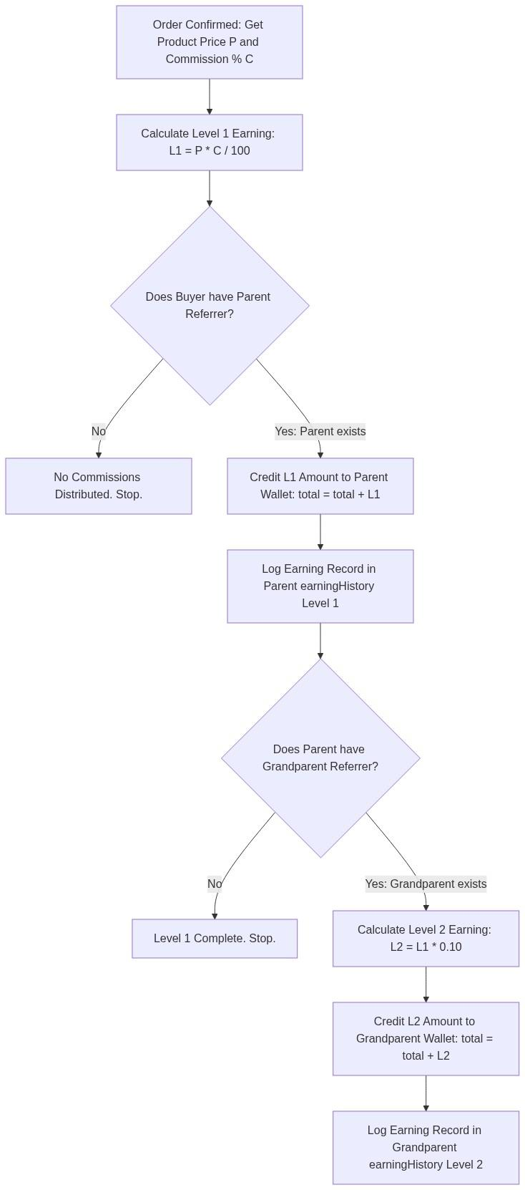
Figure:5.4 Two-Tier Commission Logic
Steps in the Commission Distribution:
- Fetch Product Settings: When an order is verified, the system retrieves the product details to get its price (P) and commission percentage (C).
- Calculate Direct commission (Level 1): The system calculates the base commission pool: Level 1 Earning = Product Price × (Commission Percentage / 100)
- Verify Parent Node (referredBy): The backend inspects the buyer's user record. If the buyer has no parent referrer (meaning they registered directly without a referral code), the commission process stops, and the platform retains the product profits.
- Credit Level 1 Referrer: If a parent referrer is identified, the system updates their database record:
- Increments earnings.direct by the calculated Level 1 earning.
- Increments earnings.total by the calculated Level 1 earning.
- Appends an earning ledger entry in earningHistory containing the buyer's email, the product name, the commission amount, the date, and the tag level: 1.
- Calculate Indirect Commission (Level 2): The system checks if the Level 1 Parent was referred by another user (Level 2 Grandparent). If present, the Level 2 commission is calculated at 10% of the Level 1 commission value:
Level 2 Earning = Level 1 Earning × 0.10
- Credit Level 2 Referrer: The system updates the Grandparent referrer's database record:
- Increments earnings.indirect by the calculated Level 2 earning.
- Increments earnings.total by the calculated Level 2 earning.
- Appends an earning ledger entry in earningHistory containing the buyer's email, the product name, the commission amount, the date, and the tag level: 2.
- Ensure System Integrity: To prevent database mismatches (such as crediting a user but failing to save the purchase record), all database operations are executed within a single transaction session. If any query fails, the session aborts and rolls back all database modifications to their original state.

5.6 Validation Checks
Validation checks represent a critical layer of software design that guarantees input data conforms to the system's structural and operational constraints before any database write or transaction execution occurs. In the Referral E-Commerce System, validations are implemented on both the client-side (React frontend) for immediate user feedback and the server-side (Express backend) using Zod validation schemas and Mongoose validation rules to prevent malicious payload tampering and maintain database consistency.
The five primary validation systems implemented across the MERN stack are analyzed below:
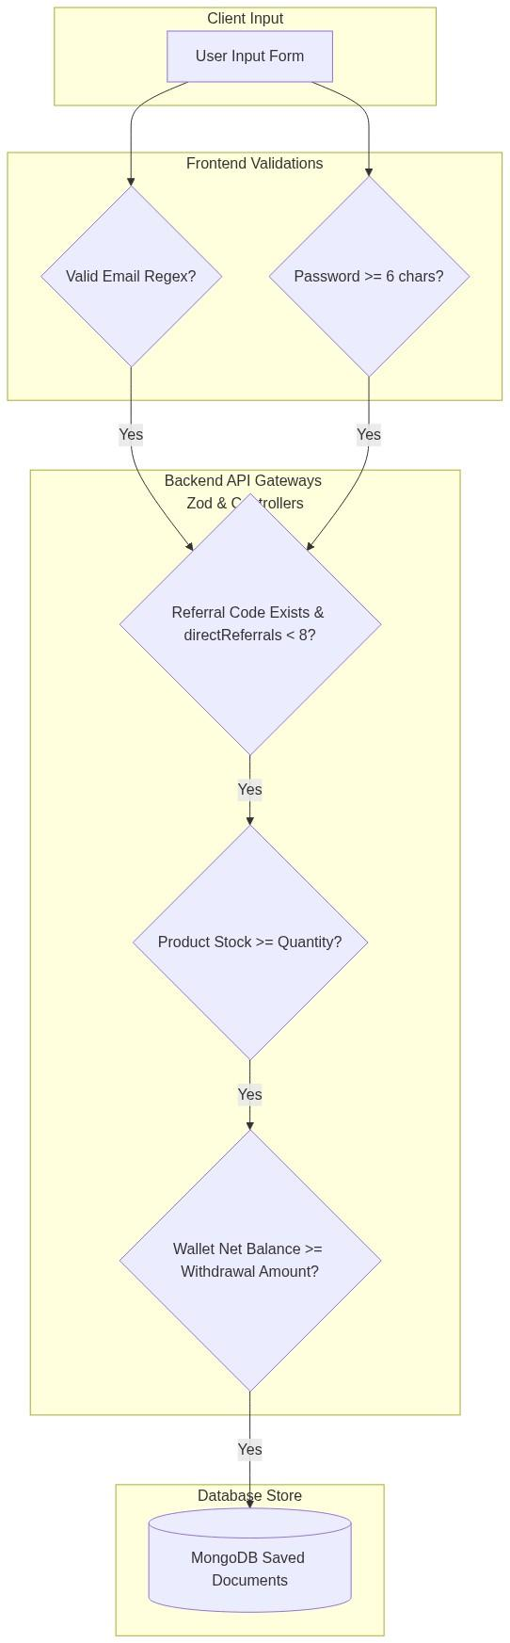
Figure: 5.5 Validation Checks
5.6.1 Email Validation
Email validation prevents users from registering with invalid email formats or duplicate accounts, securing the authentication system.
- Client-Side Form Validation:
In the user signup component (Signup.jsx), the dynamic input field restricts submission using native HTML5 attributes (type="email") and a standard JavaScript Regular Expression (Regex).
- Regex Syntax:/^[a-zA-Z0-9._%+-]+@[a-zA-Z0-9.-]+\.[a-zA-Z]{2,}$/
- Purpose: This ensures the presence of the @ symbol, a valid domain name, and a standard domain suffix (e.g. .com, .org) before allowing the network signup request to be fired.
- Server-Side API Schema Validation:
The Express backend intercepts registration payloads using Zod schema validation middleware:
const registerSchema = z.object({
email: z.string().email({ message: "Invalid email format" }),
password: z.string().min(6)
});

If a user bypasses the React UI and submits a direct POST request (e.g., using Postman) with a malformed email, the Zod parser immediately throws an HTTP 400 Bad Request validation error, preventing processing.
- Mongoose Database Constraints:
At the database layer, the User Mongoose schema defines the email field with a native uniqueness index constraint:
email: { type: String, required: true, unique: true }

When saving a new user record, MongoDB verifies that the email does not already exist in the indexed users collection. If a duplicate is submitted, Mongoose catches the duplicate key exception (error.code === 11000) and sends a clean user-facing error: "User already exists with this email address."
5.6.2 Password Validation
Password validation enforces basic credential complexity on creation and ensures secure mathematical encryption.
- Client-Side Length Restraints:
During registration, the interface binds password inputs to a state variable. If the user enters a password shorter than 6 characters, the signup button remains disabled, and a dynamic warning banner displays: "Password must be at least 6 characters long."
- Backend Length Checks:
On the server, Zod schemas double-check input width:
password: z.string().min(6, { message: "Password must be at least 6 characters" })

- Cryptographic Hashing Validation:
Plaintext passwords are never saved. Prior to DB storage, Mongoose pre-save middlewares or controllers validate that the password payload is hashed using bcryptjs:
- Mechanism: Generates an algorithmic salt of 10 rounds and hashes the string:
const salt = await bcrypt.genSalt(10);
const hashedPassword = await bcrypt.hash(password, salt);

- Comparison Logic: During login requests, the backend compares the input plaintext password with the saved bcrypt hash using:
const isMatch = await bcrypt.compare(inputPassword, user.password);

This validation returns a boolean, allowing JWT generation only when credentials match perfectly.
5.6.3 Referral Code Validation
Referral code validations check referral codes, link direct parents, and enforce spillover width rules to prevent downline overflow.
- Database Presence Validation:
When a user registers with a referral code (e.g. ref=ABC123D), the /api/auth/signup controller first queries the User collection:
const referrer = await User.findOne({ referralCode: referralCode });
if (!referrer) {
return res.status(400).json({ message: "Invalid referral code" });
}

If the code is invalid or the promoter does not exist, the registration fails, ensuring that no orphaned or broken referral branches are created.
- Spillover Cap Validation (Width Cap of 8):
HNBGU guidelines require limiting the maximum width of a direct downline to 8 promoters. This prevents database bloat and controls commission networks. The validation checks the size of the referrer's directReferrals array:
if (referrer.directReferrals.length >= 8) {
return res.status(400).json({ message: "Referrer downline limit reached. Maximum of 8 direct referrals allowed." });
}

Additionally, the User schema contains a built-in Mongoose array validator as a secondary defense layer:
validate: {
validator: function (val) {
return val.length <= 8;
},
message: 'Maximum of 8 direct referrals allowed.'
}

This dual-level check prevents a 9th user from registering under the same promoter, redirecting them to register under an available downline node instead.
5.6.4 Stock Validation
Stock validation prevents "overselling" issues, ensuring checkout order balances match the actual physical catalog count in real-time.
- Frontend Quantity Check:
On the product details page (ProductDetail.jsx) and cart view (Cart.jsx), quantity selector input components compare user inputs against the product's available stock parameter:
const handleIncrement = () => {
if (quantity < product.stock) {
setQuantity(quantity + 1);
} else {
toast.warning("Cannot exceed available stock limit.");
}
};

- Server-Side API Checkout Validation:
When a purchase API request is triggered, the Express backend verifies stock levels before communicating with the Razorpay API or the internal wallet payment engine:
const product = await Product.findById(productId);
if (!product) {
return res.status(404).json({ message: "Product not found" });
}
if (product.stock < quantity) {
return res.status(400).json({ message: "Insufficient product stock available." });
}

If stock is sufficient, the backend initiates the payment order. During final validation (webhook signatures verification or wallet payment execution), the inventory stock value is deducted automatically inside the atomic database session:
product.stock -= quantity;
await product.save({ session });

This ensures transaction safety and catalog synchronization.
5.6.5 Withdrawal Balance Validation
Withdrawal balance validation ensures that virtual digital wallets remain financially sound by preventing promoters from redeeming more funds than their net earnings balance.
- Calculated Net Balance Validation:
The promoter's net wallet balance is never hardcoded as a static database property to prevent synchronization lag. Instead, it is computed dynamically by the system using the formula:
Net Wallet Balance = Total Accumulated Earnings − Withdrawn Earnings
On both client dashboard listings and server check controllers, this calculation is used as the base truth.
- Simulated Payout Verification:
When a promoter requests a brand gift card redemption (e.g. Flipkart voucher for 500 INR), the withdrawal controller (/api/payment/withdraw) validates the request against the user's computed net balance:
const user = await User.findById(req.user.id);
const netBalance = user.earnings.total - user.earnings.withdrawn;
if (amount <= 0) {
return res.status(400).json({ message: "Withdrawal amount must be greater than zero." });
}
if (amount > netBalance) {
return res.status(400).json({ message: "Insufficient wallet balance for this withdrawal." });
}

Only when this validation succeeds does the system proceed to:
- Increment user.earnings.withdrawn by the requested withdrawal amount.
- Generate a secure, unique voucher coupon code (e.g. FLP-8B7C91).
- Push the coupon, brand, amount, and timestamp into the user's withdrawalHistory array.
- Save the updated user document to the database.
This multi-phase validation scheme ensures that promoter accounts cannot bypass financial limits, guaranteeing absolute transactional integrity.

CHAPTER – 6 :TESTING
This chapter outlines the testing phase of the Referral E-Commerce System. Software testing is an essential phase of the software development lifecycle (SDLC) designed to evaluate system quality, verify that the implementation matches technical specifications, and ensure that all e-commerce transactions, security mechanisms, and referral payouts operate without errors.
A multi-tiered testing plan—comprising unit testing, API verification, and end-to-end system validation—was executed to confirm that the platform is robust, safe, and ready for deployment.
6.1 Testing Methodology
The testing phase followed a structured, incremental approach to verify individual components before validating complex integrations. The testing methodology utilized both Black-Box Testing and White-Box Testing techniques:
[Unit Testing: Isolated Functions] -> [API Testing: REST Endpoints] -> [System Testing: End-to-End Flow]

1. Black-Box Testing (Functional Testing)
Black-box testing focuses on the functional requirements of the system. The tester provides specific inputs to a module or page and verifies the output against expected behaviors, without analyzing the underlying code structure. This was used extensively to test storefront operations, user registration screens, shopping cart additions, and admin dashboard panels.
2. White-Box Testing (Structural Testing)
White-box testing examines the internal logical paths, loop structures, database operations, and error-handling routines of the code. This was applied to verify the security verification algorithms, JWT encryption pipelines, and the double-level wallet commission credit equations on the server.
3. Software Testing Lifecycle (STLC)
The testing process was conducted systematically:
- Requirement Analysis: Identifying testable features such as authentication constraints, inventory limits, and referral caps.
- Test Planning: Creating a plan to execute tests across various screen resolutions and testing endpoints with standard vs. boundary values.
- Test Execution: Manually testing the user interface inside browser contexts and testing backend API pathways using API clients.
- Defect Retesting: Logged bugs were fixed, and affected modules were retested to confirm stability.
6.2 Unit Testing
Unit testing focuses on verifying the smallest testable parts of an application—such as isolated functions, helper files, and schema validation rules—to ensure they operate correctly in isolation.
Key Focus Areas of Unit Testing:
- Input Validations (Zod Schemas): Tested the data parsing schemas (auth.schema.js) that validate registration and login inputs on the backend. This ensures that emails missing @ characters, blank password fields, and invalid telephone formats are intercepted and rejected before querying the database.
- Password Cryptographic Hashing: Tested that user passwords submitted during registration are successfully passed to bcryptjs, salted with a strength of 10 rounds, and returned as non-reversible hashes.
- The Direct Downline Limit Cap (Boundary Check): Tested the Mongoose schema validator that limits user growth. A mock script was run to push child references into a parent's directReferrals array:
- Under Boundary (0 to 7 referrals): The operation completed successfully.
- On Boundary (Exactly 8 referrals): The operation completed successfully.
- Over Boundary (Attempting a 9th referral): The Mongoose custom validator failed as expected, returning the validation message: 'Maximum of 8 direct referrals allowed.'
6.3 API Testing
API Testing verifies that the backend REST endpoints process client requests, interact with the MongoDB database, and return standardized responses with appropriate HTTP status codes. Testing was performed using local API test clients (such as Postman) and command-line cURL requests.
Client HTTP Request ---> [API Endpoint Router] ---> [JWT / Role Check] ---> [Controller logic] ---> JSON Response

API Validation Categories:
- Public Endpoint Checks: Verified that routing files like shop.js allow public access. Tests confirmed that calling GET /api/shop/products and GET /api/shop/categories returns catalog data without requiring authentication tokens in the request header.
- Private Endpoint Checks: Verified that private routes (such as fetching wallet balances or modifying shipping profiles) block requests that do not include a valid token. If the HTTP header x-auth-token is missing or contains an expired signature, the API middleware rejects the query with an HTTP status 401 Unauthorized.
- Administrative Privilege Checks: Verified that administrative endpoints (such as deleting products or viewing global withdrawal logs) reject requests from standard users. If a logged-in user with standard privileges attempts to call /api/admin/users, the admin middleware intercepts the request and blocks access, returning an HTTP status 403 Forbidden.
- Payload Boundary Checks: Verified that submitting invalid or negative price values to POST /api/admin/products triggers an immediate validation response (400 Bad Request) rather than allowing bad data to write to database collections.
6.4 System Testing
System Testing represents the End-to-End (E2E) Integration phase, where all individual modules—including the React frontend, Tailwind layouts, Express routing controllers, MongoDB storage engine, and third-party Razorpay gateway sandboxes—run together as a single platform.
Comprehensive Checkout E2E Test Loop:
To verify system stability, testers executed the complete customer checkout journey:
- Catalog Browsing: A user logs in, loads the storefront dashboard, filters items by category, and adds a product to the cart.
- Address Selection: The cart fetches the user's saved addresses, and they select a default delivery address.
- Initiating Payment: The client clicks "Buy Now". The system contacts the backend, which interacts with the Razorpay sandbox API to create an order, returning a unique Razorpay Order ID to the browser.
- Overlay Execution: The React client opens the Razorpay checkout overlay. The tester enters simulated sandbox payment credentials (e.g. Test Netbanking/UPI) and submits the payment.
- Verification & Commission Credit: Razorpay returns success tokens. The client forwards these parameters to the backend verification API /api/payment/verify.
- Database Integrity check: The server calculates the Level 1 and Level 2 commissions, credits the wallet balances of the parent referrers in database transactions, decreases the product stock by 1, and appends a purchase receipt to the buyer's profile.
- UI Synchronization: The checkout modal updates to show a "Payment Successful" screen, and the client displays updated wallet balances immediately.
6.5 Test Cases
The following test matrix outlines critical functional scenarios evaluated during the testing phase. All executed tests passed, confirming system readiness.
Test ID | Module | Test Scenario / Objective | Input Data / Actions | Expected Output | Actual Output | Status
TC-01 | Auth | User Registration (Valid inputs, no referral code) | Email: buyer@test.com, Password: SecurePass123!, Phone: 9876543210 | Account created successfully; password hashed in DB; unique 6-character referral code generated. | Account created; password securely hashed; referral code A8D2F9 created. | Pass
TC-02 | Auth | User Registration with Invalid Referral Code | Email: new@test.com, Referral Code: INVALID99 | Registration blocked; database write rejected; API returns HTTP status 400 Bad Request. | Registration rejected with message: 'Invalid referral code'. | Pass
TC-03 | Auth | Direct Referral Cap Boundary Check (9th downline) | Email: downline9@test.com, Referral Code of referrer who already has 8 downlines. | Registration blocked; Mongoose schema validator rejects the operation; returns error. | Registration blocked with message: 'Referral limit reached for this code (Max 8)'. | Pass
TC-04 | Auth | User Login with Incorrect Password | Email: buyer@test.com, Password: WrongPassword | Authentication fails; JWT token not issued; returns HTTP status 400 Bad Request. | Authentication rejected with message: 'Invalid Credentials'. | Pass
TC-05 | Shop | Fetch Catalog Products (Public access) | Send GET /api/shop/products request without auth headers. | Storefront loads product list successfully; returns HTTP status 200 OK. | Products array returned successfully with status 200 OK. | Pass
TC-06 | Order | Razorpay Order Creation | Click "Buy Now" on a product priced at Rs. 499. | Server contacts Razorpay APIs; generates and returns a unique Razorpay Order ID. | Razorpay Order ID order_LZ8d92Fk19s returned successfully. | Pass
TC-07 | Order | Razorpay Payment Verification (Valid transaction) | Send signature tokens to /api/payment/verify route after sandbox payment. | Signature verified successfully; Level 1 & 2 parent wallets credited; buyer stock decremented. | Signature matched; parent wallets credited; order created successfully. | Pass
TC-08 | Order | Fraudulent Signature Prevention | Submit falsified razorpay_signature parameter to verification route. | HMAC signature check fails; transaction rejected; database changes rolled back. | Rejected with HTTP status 400 Bad Request and message: 'Payment verification failed'. | Pass
TC-09 | Wallet | Cart Purchase via Wallet | Click "Pay via Wallet" on item priced at Rs. 200 (User Net Wallet Balance: Rs. 500). | Order confirmed; buyer's withdrawn balance increments by 200; stock decremented. | Order confirmed; user's net wallet balance decreased to Rs. 300. | Pass
TC-10 | Wallet | Wallet Purchase with Insufficient Funds | Click "Pay via Wallet" on item priced at Rs. 600 (User Net Wallet Balance: Rs. 200). | Option disabled in frontend; if requested via API, route rejects checkout with error. | Rejected with HTTP status 400 and message: 'Insufficient wallet balance'. | Pass
TC-11 | Withdraw | Voucher Code Generation (Withdrawal) | Request withdrawal of Rs. 100 to Amazon Gift Card (Net Balance: Rs. 250). | Net balance verifies; Rs. 100 added to withdrawn; random coupon code generated. | Coupon GIFT-AMZ-8D3F9 generated; net balance decreased to Rs. 150. | Pass
TC-12 | Admin | Admin Route Privilege Protection | Standard user account calls GET /api/admin/users. | Access blocked by middleware; returns HTTP status 403 Forbidden. | Request rejected with message: 'Access denied. Admin role required.'. | Pass

6.6 Bug Fixes and Improvements
During the iterative development and testing phases, several technical issues were identified and resolved to ensure data consistency and system performance.
1. Concurrency Race Conditions in Dual-Level Commission Credits
- The Bug: During simultaneous checkout testing, multiple purchases from downlines sometimes occurred at the exact same millisecond. Because parent wallet increment operations were not isolated, the server occasionally read stale wallet balances before completing calculations. This caused subsequent direct or indirect credits to overwrite each other, resulting in missed wallet earnings for parents.
- The Fix: The commission updates were wrapped in atomic Mongoose updates using the $inc operator, rather than reading the document, modifying the values in memory, and executing a full .save() call. This ensures that parent wallet increments are performed atomically directly on the MongoDB server, preventing concurrency issues:
// Fixed atomic update implementation
await User.findByIdAndUpdate(parentId, {
$inc: {
'earnings.direct': level1Amount,
'earnings.total': level1Amount
}
});

2. Floating-Point Precision Mismatches in Commission Calculations
- The Bug: E-commerce products configured with fractional prices (e.g. Rs. 499.50) occasionally produced commission totals with long fractional tails (e.g., Rs. 49.950000000000003) due to binary floating-point representation limits in JavaScript. If allowed to save directly, these values quickly accumulated round-off errors in the total wallet balance over multiple checkouts.
- The Fix: The server-side calculations were updated to round commission values using high-precision logic before writing them to the database. All calculated earnings are forced to two decimal places using .toFixed(2) and parsed back into numbers:
const rawCommission = productPrice * (commissionPercentage / 100);
const directEarning = parseFloat(rawCommission.toFixed(2));
const indirectEarning = parseFloat((directEarning * 0.10).toFixed(2));

3. Inventory Stock Deductions Running Negative
- The Bug: During system testing, multiple buyers attempting to check out the last remaining item in stock at the same time were all directed to the Razorpay gateway overlay. Once payments were completed, the verify routes processed all transactions, resulting in the database stock count falling below zero (e.g., stock: -2).
- The Fix: The inventory update controller was updated to check stock volumes inside the update transaction using atomic $inc operators with $gte stock constraints:
const product = await Product.findOneAndUpdate(
{ _id: productId, stock: { $gte: 1 } },
{ $inc: { stock: -1 } },
{ new: true }
);
if (!product) {
// Abort transaction and refund razorpay order
throw new Error('Product out of stock');
}
CHAPTER – 7 : RESULTS & SCREENSHOTS
This chapter presents the graphical user interfaces (GUIs) of the developed Referral E-Commerce System. Each section describes the purpose of the screen, lists the core UI features, and leaves a designated block for dropping in the manual screenshots.
7.1 Home Page
The Home Page serves as the main landing page for the application. It introduces users to the e-commerce catalog and promotional referral commission offers.
- Promotional banner slider
- Sticky navigation header with dynamic cart count
- Category navigation links
- Featured product showcase

Figure: 7.1 Homepage Interface Screen
7.2 Login Page
The Login Page provides a secure access boundary for existing users to authenticate their credentials.
- Secure email and password forms
- Authentication validation feedback
- Dynamic user session creation
- Password visibility toggle
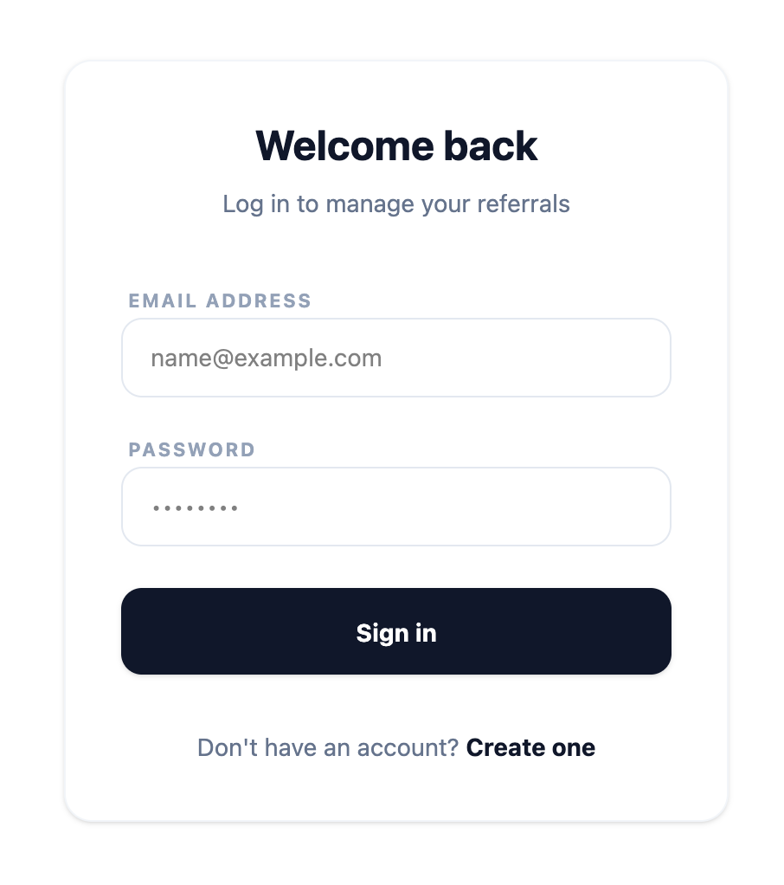
Figure: 7.2 Loginpage Interface Screen
7.3 Signup Page
The Signup Page allows new customers to register accounts on the platform, with support for nesting under a parent's referral code.
- User registration input fields
- Optional parent referral code field
- Password complexity indicators
- Input validation checks
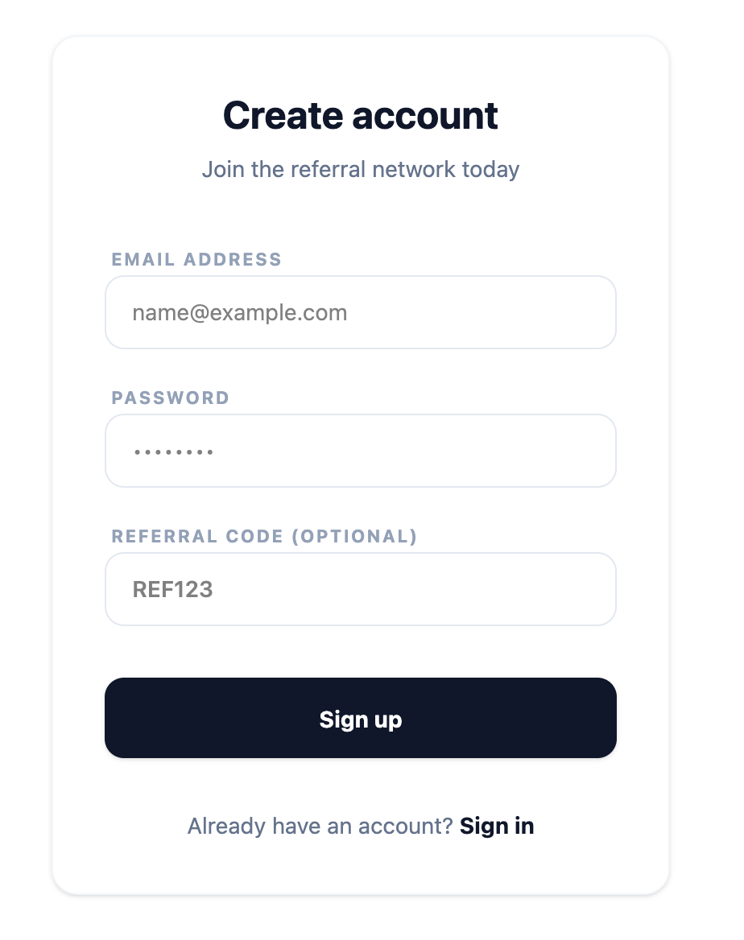
Figure: 7.3 Signuppage Interface Screen
7.4 Shop Page
The Shop Page displays available products with category filters, pricing information, and referral commission percentages. Users can search products, add items to the cart, and view product details.
- Product listing grid
- Search & filter system
- Add-to-cart actions
- Commission display
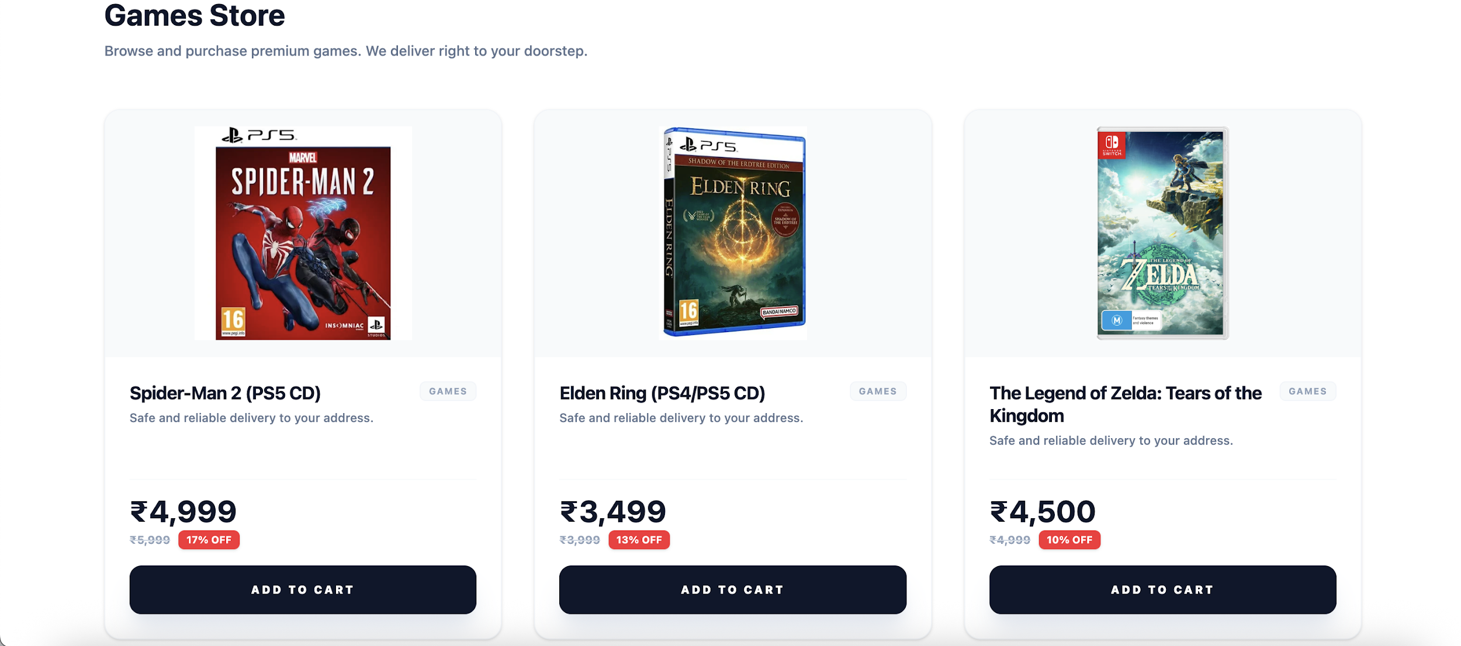
Figure: 7.4 Shoppage Interface Screen
7.5 Orders Page
The Orders Page logs the chronological purchase history of the customer, including shipment tracking stages and invoice breakdowns.
- Chronological purchase ledger list
- Colored shipping stage badges
- Interactive details breakdown
- Total invoice details
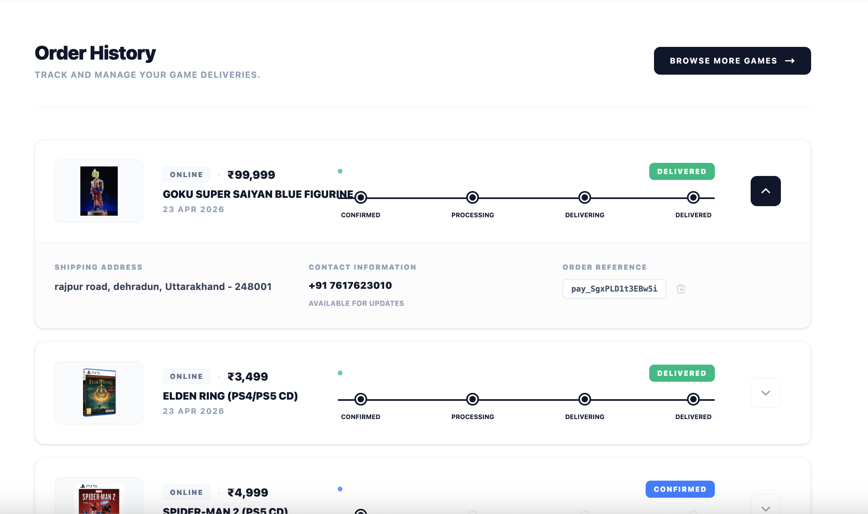
Figure: 7.5 Historypage Interface Screen
7.6 Earnings Dashboard
The Earnings Dashboard allows promoters to view their referral networks, accumulated wallet commissions, and direct sales metrics.
- Financial earnings summary cards (Tier 1 & Tier 2)
- Promoter registration downline statistics
- Detailed transaction commission ledger
- Real-time balance counter
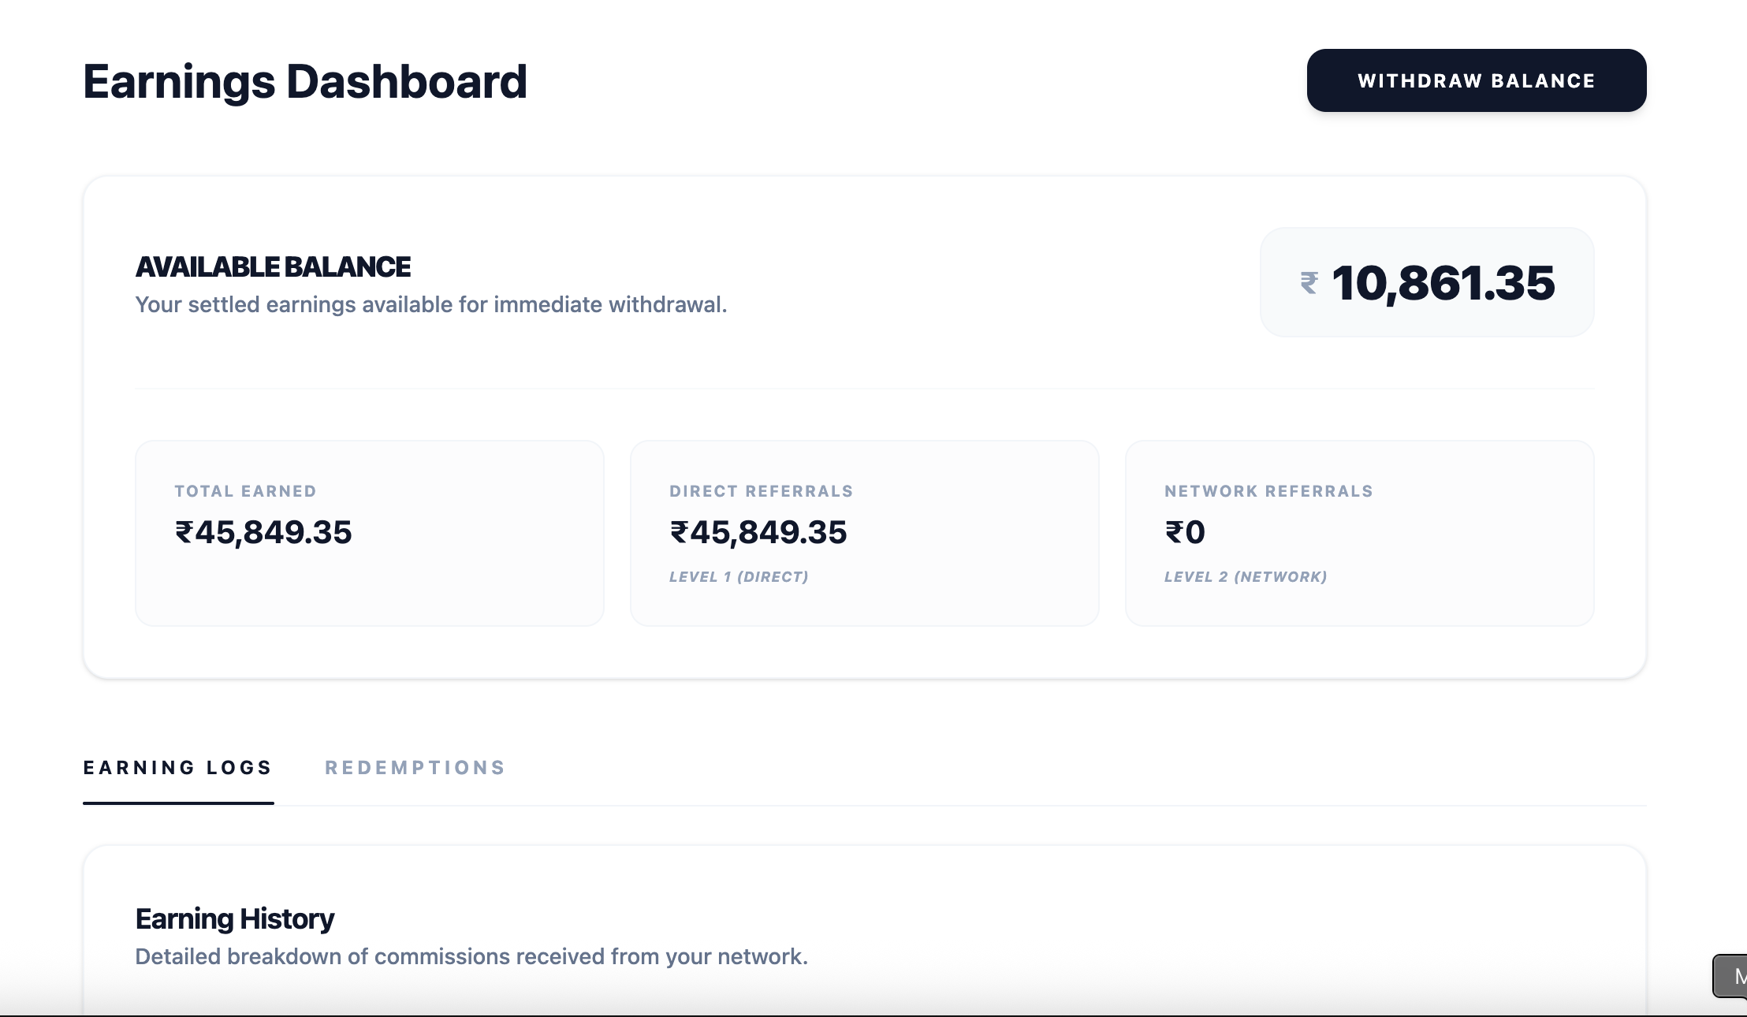
Figure: 7.6 Earrings dashboard Interface Screen
7.7 Referral Network Page
The Referral Network Page provides a clean, visual representation of the promoter's dual-level downline relationships.
- Unique promoter referral code display
- Copy-referral-link action button
- Tier-1 direct referred downline list (up to 8 members)
- Tier-2 indirect referred downline list
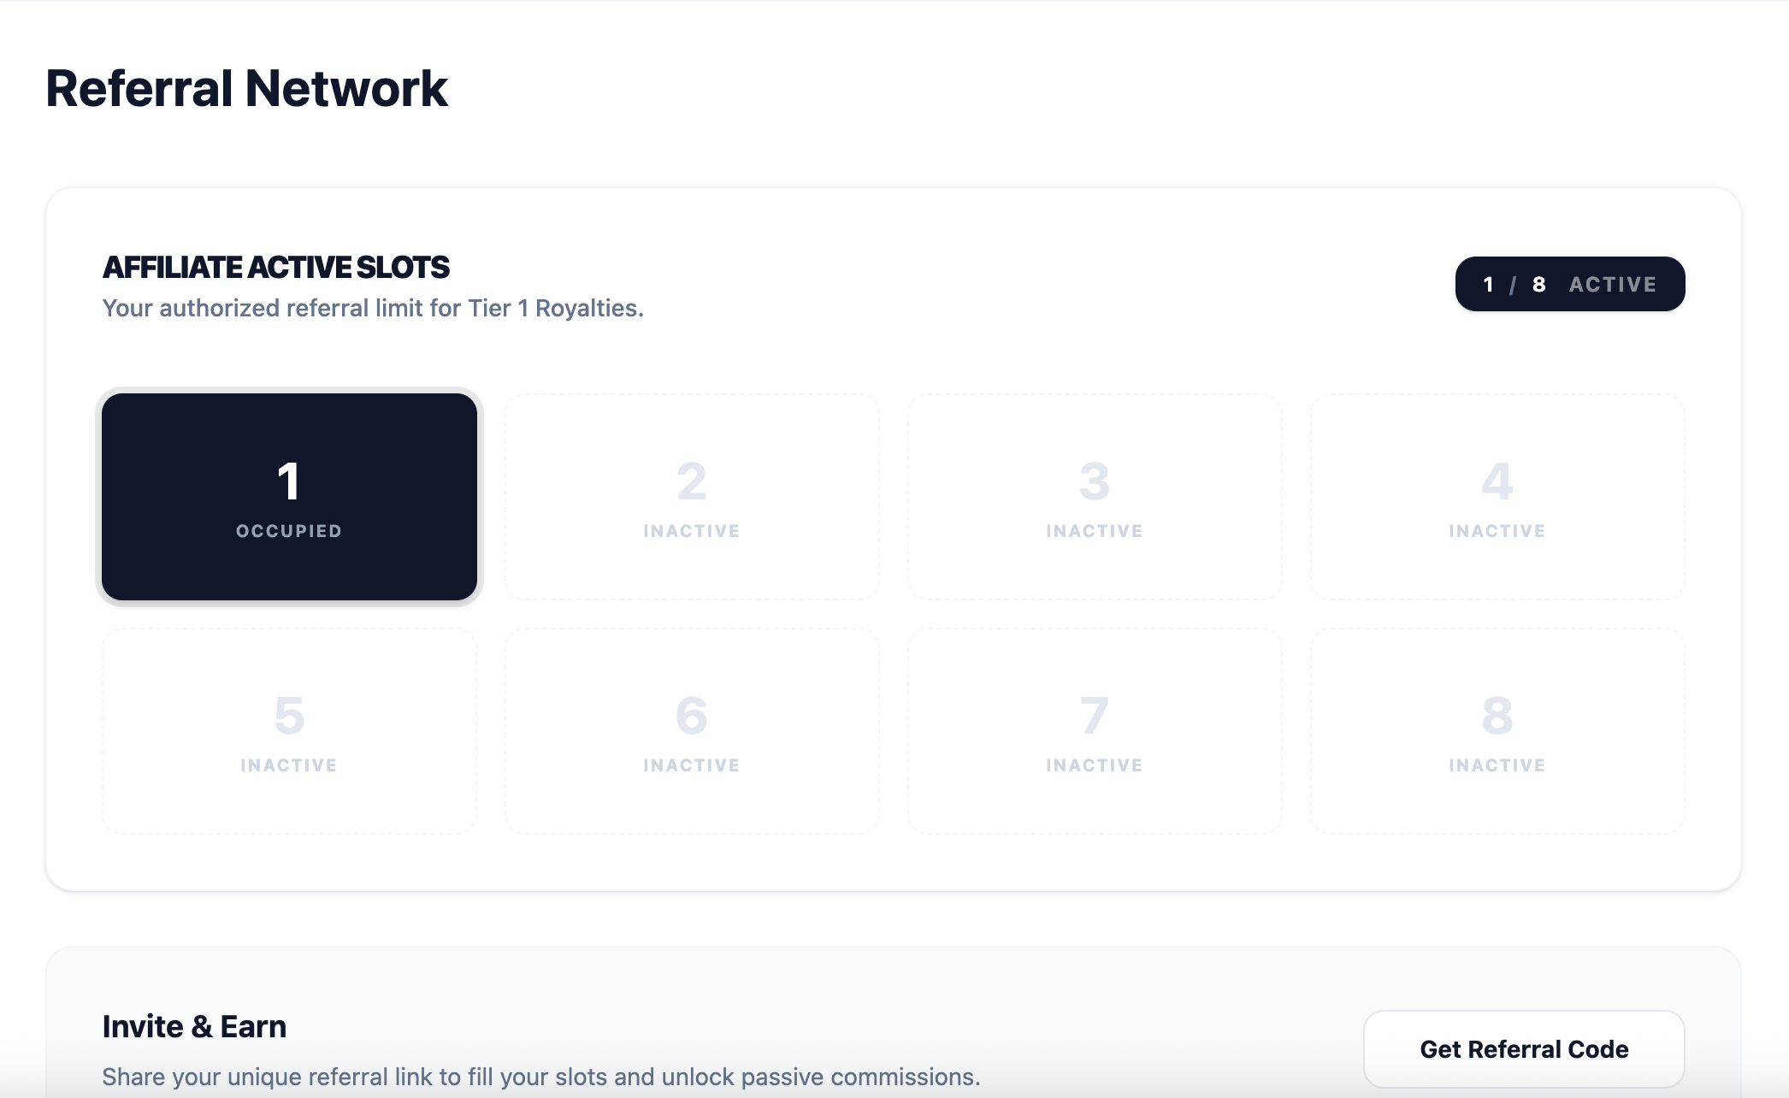
Figure: 7.7 Referalnetworkpage Interface Screen
7.8 Wallet and Withdraw Page
The Wallet and Withdraw Page handles user cash-out workflows by cashing in accumulated earnings for digital coupon cards.
- Dynamic wallet balance indicator
- Voucher brand selector (Amazon/Flipkart)
- Withdrawal ledger tracking withdrawal statuses
- Instant digital coupon generator output

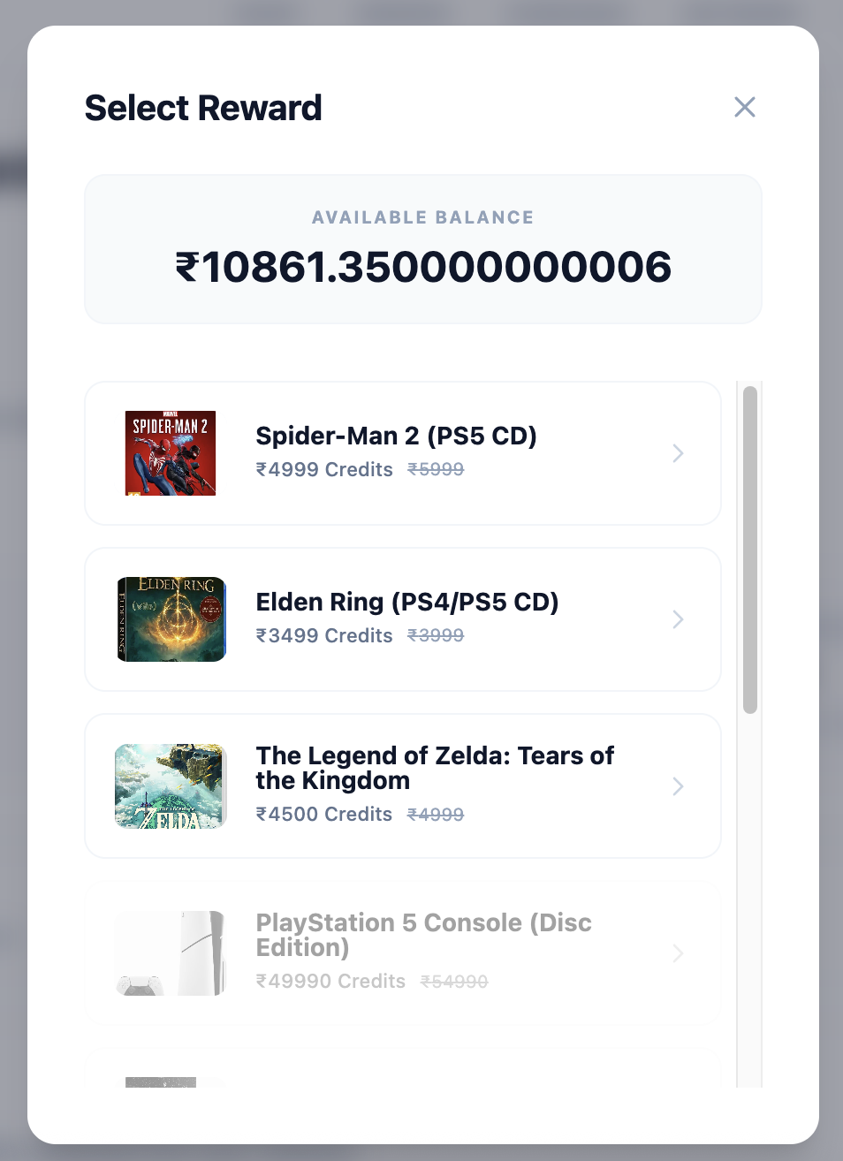
Figure: 7.8 Wallet-withdrawlmode Interface Screen

7.9 User Profile Page
The User Profile Page allows customers to manage their account details, contact information, and shipping address records.
- User account metrics details
- Contact update inputs
- Dynamic address book selector
- Toggle options for setting default shipping addresses
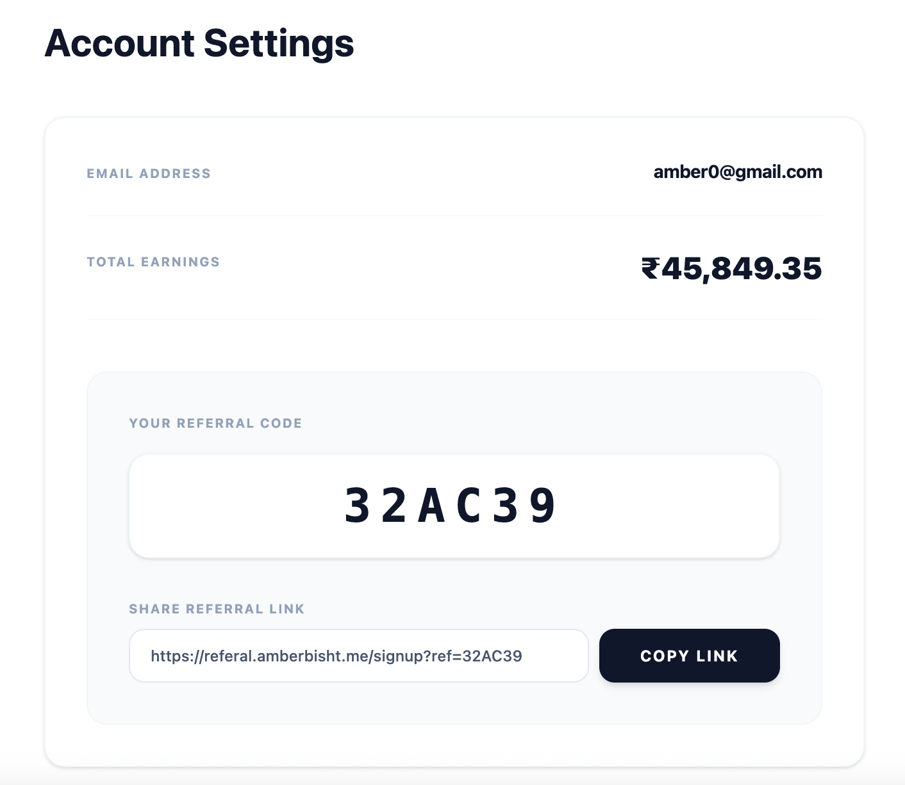
Figure: 7.9 Userprofilepage Interface Screen

7.10 Admin Dashboard
The Admin Dashboard provides store administrators with high-level analytics and control over platform operations.
- Core system stats cards (revenue, users, commissions, orders)
- Latest checkout feeds and recent signups
- Quick-link sidebar navigation panel
- Payout pending summaries
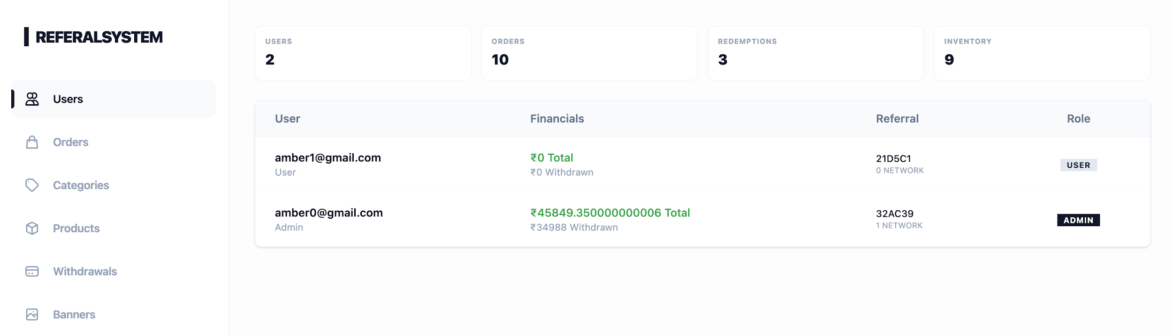
Figure: 7.10 Admindashboard Interface Screen
7.11 Categories Management
The Categories Management page allows administrators to configure product classifications and URL slugs.
- Category creation form with dynamic slug generation
- Category details table database
- Product association counts display
- Delete triggers with protection popups
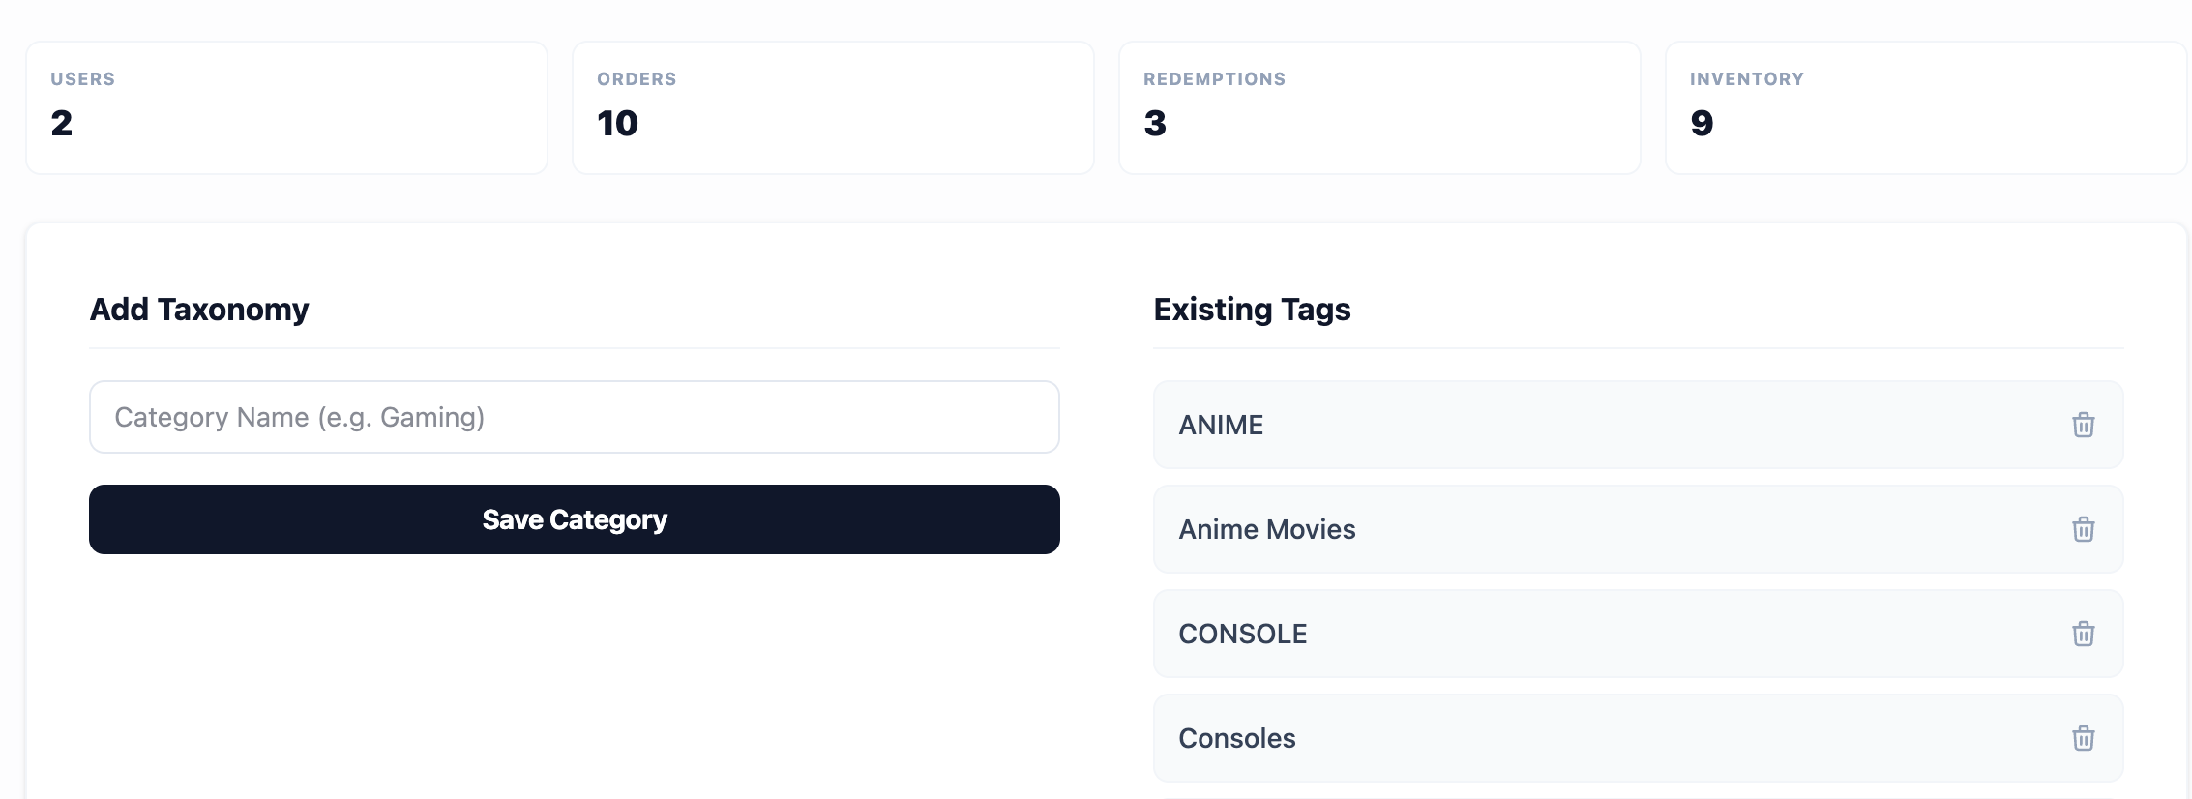
Figure: 7.11 Category Management Interface Screen
7.12 Products Management
The Products Management page allows store administrators to create and modify catalog parameters, including pricing levels, image URLs, and commission payouts.
- Product creation & editor forms
- Product database grid view
- Tier-1 and Tier-2 custom commission input settings
- Stock inventory controls
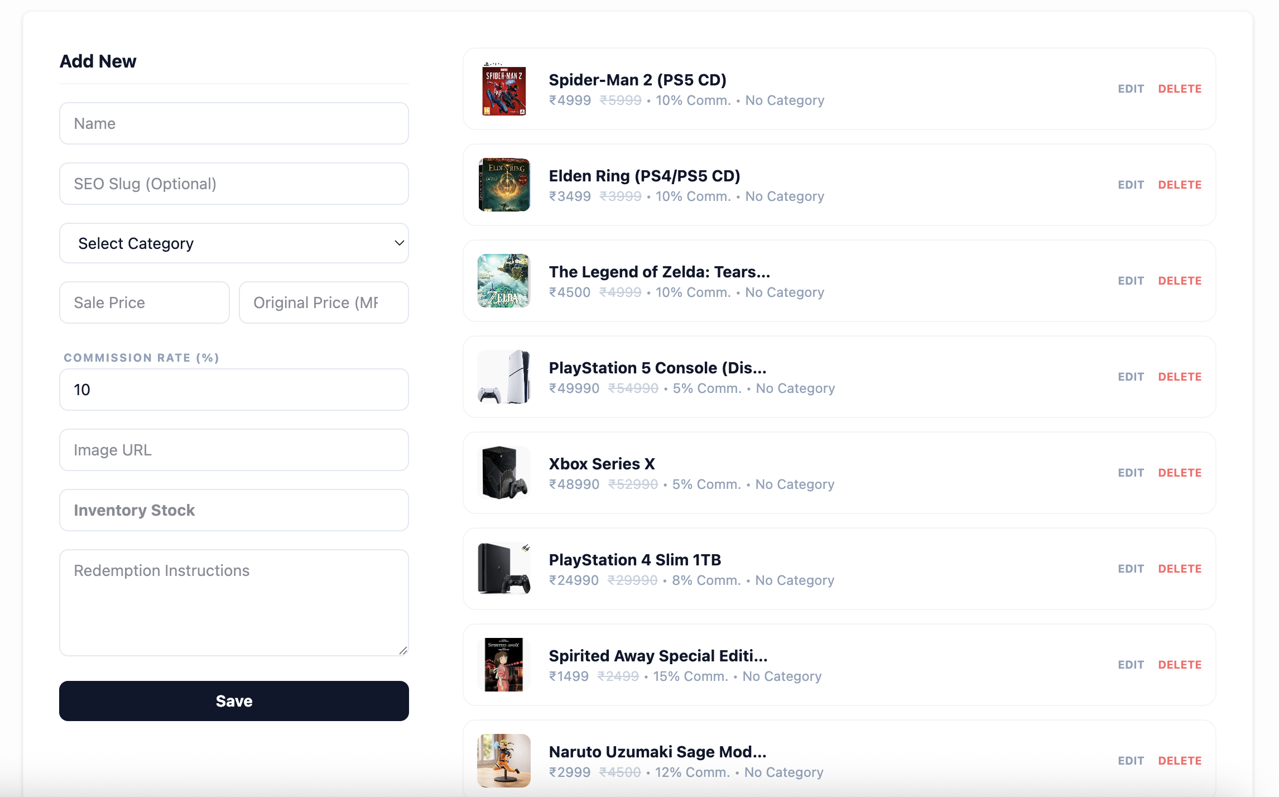
Figure: 7.12 Products Management Interface Screen
7.13 Withdrawals Management
The Withdrawals Management page allows administrators to audit, verify, and approve digital voucher cash-out request lists.
- Chronological withdrawal request list
- Payout confirmation controls
- User wallet integrity checker
- Digital coupon verification ledger
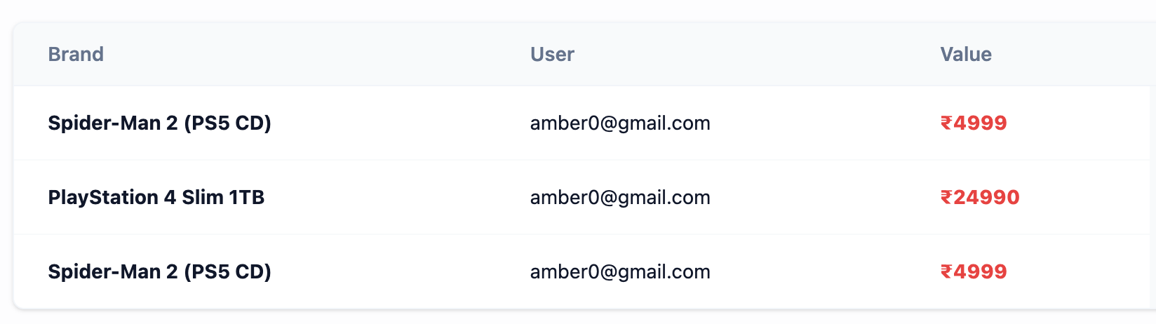
Figure: 7.13 Withdrawal Management Interface Screen
7.14 Banner Management
The Banner Management page allows administrators to upload promotional images and configure live sliders shown on the home page.
- Banner upload form with description controls
- Banner slideshow configuration table
- Storefront status toggles
- Custom destination link editors
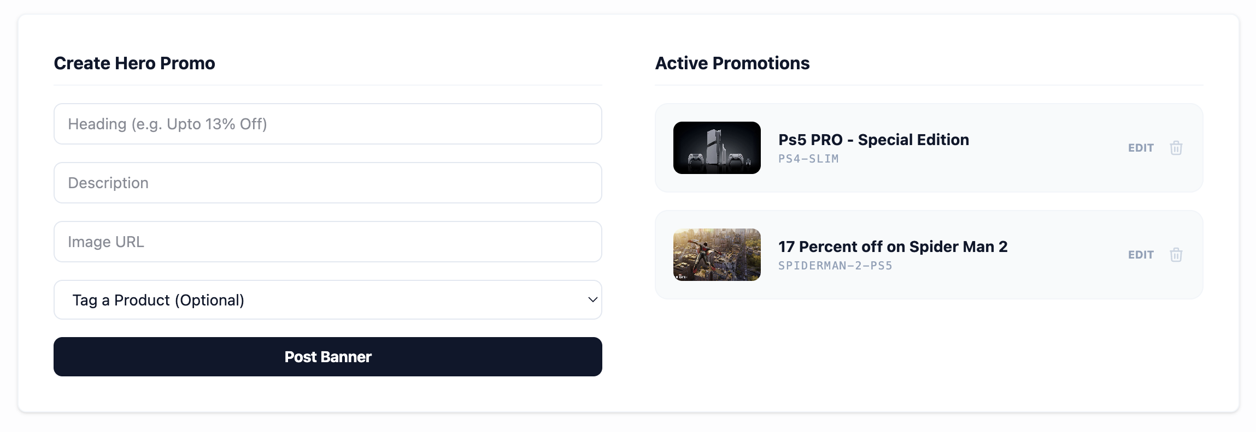
Figure: 7.14 Banner Management Interface Screen
7.15 Final Output
The Final Output view illustrates the payment checkout process and the resulting order ledger state.
- Active Razorpay sandbox popup overlay
- Payment verification flow details
- Dynamic inventory check confirmation
- Final order invoice and payout summary
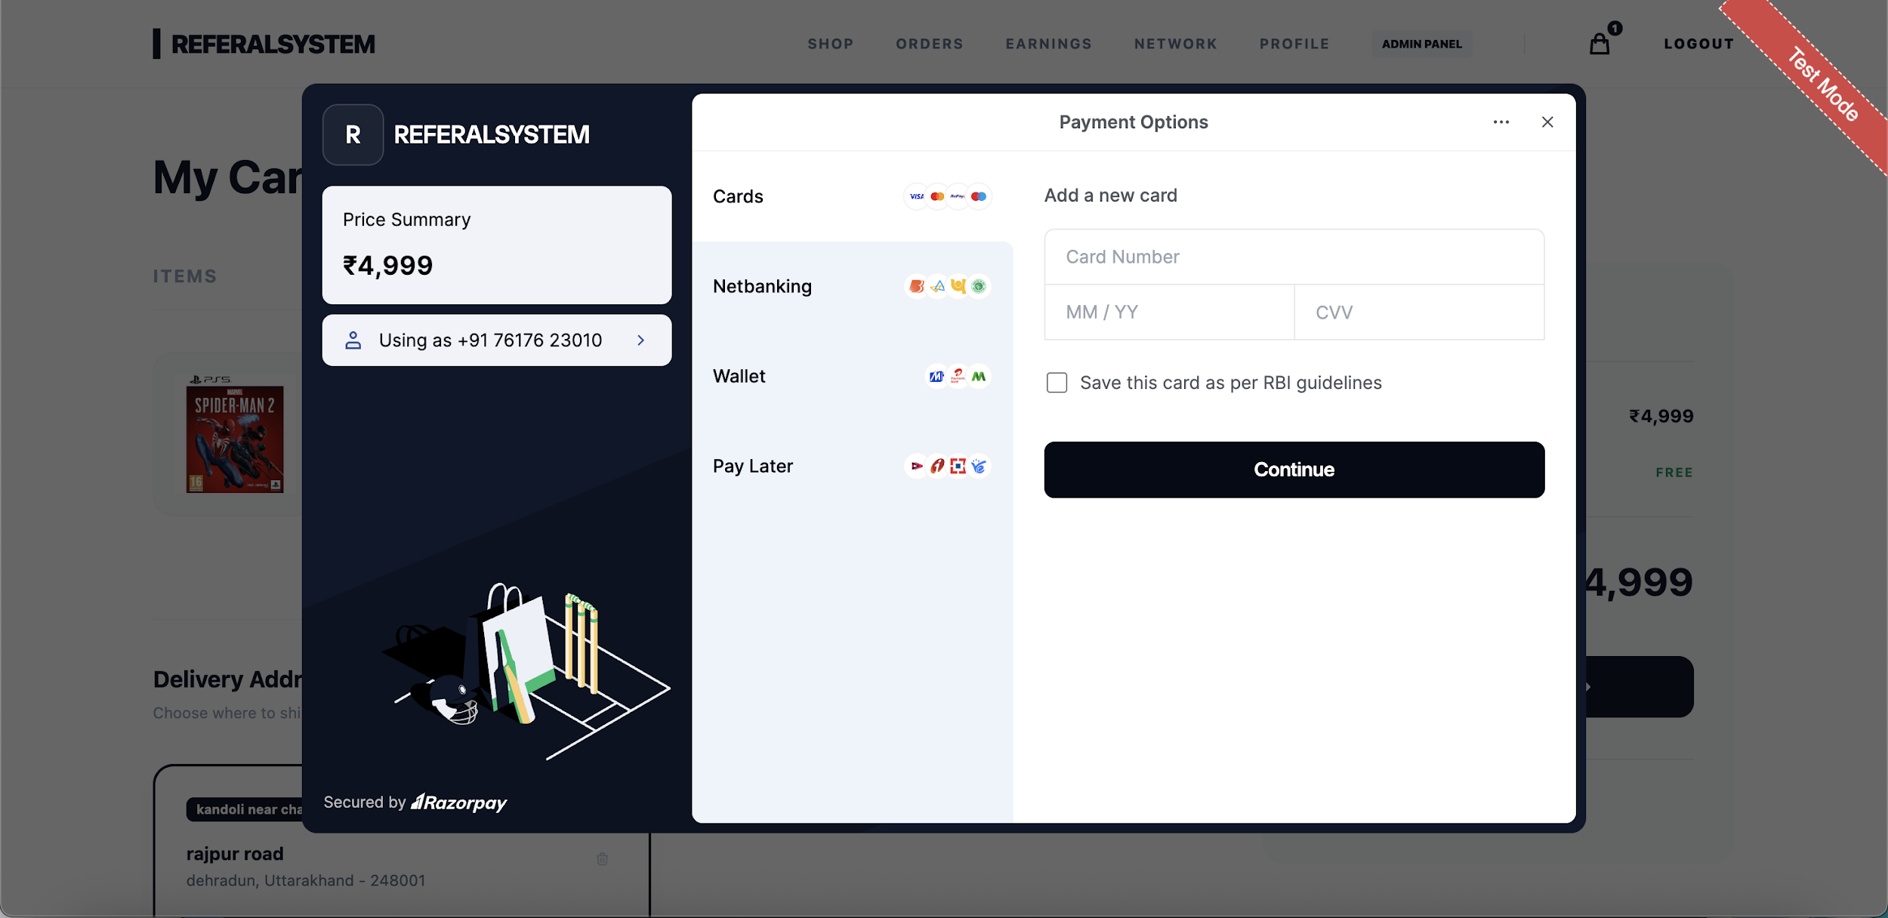
Figure: 7.15 Razorypaypopup Interface Screen

CHAPTER – 8 : CONCLUSION AND FUTURE SCOPE
8.1 Conclusion
The development of the Referral E-Commerce System successfully demonstrates the integration of a multi-tiered marketing incentive model with a robust, modern full-stack web application. By utilizing the MERN (MongoDB, Express.js, React.js, Node.js) stack, the project has achieved all primary objectives established during the initial planning and design phases.
The user storefront client delivers a responsive, fast-loading user interface using React and vanilla CSS, ensuring accessibility across desktop and mobile devices. Secure transaction handling is achieved through the integration of the Razorpay sandbox gateway. Dynamic payment signature checking protects the system from payload tampering and ensures that order entries are only marked as confirmed upon verified receipt of payment.
The main feature of the system—the dual-level referral commission distribution network—is managed reliably by the Express backend. By using atomic MongoDB update operations ($inc), the system eliminates concurrency risks, ensuring that parents are credited commissions correctly during simultaneous downline checkouts. Promoter wallets are updated in real time, and the withdrawal system successfully handles the exchange of earned wallet credits for secure, digital gift vouchers.
Furthermore, the centralized administrative console provides store managers with the tools needed to audit user signups, manage product categories, control inventory limits, and oversee withdrawals. Ultimately, this project proves that e-commerce architectures can successfully implement multi-level referral incentives while maintaining secure transaction handling, reliable database operations, and a seamless customer experience.
8.2 Future Scope
While the current Referral E-Commerce System is fully functional in the testing environment, several enhancements can be introduced in future iterations to increase its scalability, automation, and overall market capability:
- Notification Systems: Integrating transactional communication gateways, such as Twilio for SMS notifications and Nodemailer for automated email delivery. This will enable real-time alerts for downline signups, commission credits, order status updates, and digital voucher deliveries.
- Automated Financial Disbursements: Transitioning from gift coupon redemptions to direct financial payouts by integrating the Razorpay Corporate Payouts API. This will allow verified promoters to request direct-to-bank transfers or UPI transactions, automating the payout process.
- Configurable Multi-Level Marketing (MLM) Engine: Expanding the referral architecture to support deeper downline configurations, such as matrix or binary structures. Adding an administrative panel to customize commission rates per product or user rank will provide greater flexibility for promoters.
- Advanced Administrative Analytics: Incorporating data visualization libraries like Chart.js into the administrative dashboard. This will generate visual reports tracking system sales trajectories, registration signups, and commission payouts over time.
- Location and Currency Expansion: Adding multi-currency support and geo-location APIs to scale the platform globally, allowing users in different regions to interact with localized product catalogs and payout networks.

8.3 System Maintenance
Software maintenance is the final phase of the Software Development Life Cycle (SDLC) that ensures the system remains functional, secure, and compatible with evolving hardware and software environments. After successful deployment, the Referral E-Commerce System requires a structured maintenance strategy to handle daily operations, prevent performance bottlenecks, and resolve potential application failures.
The maintenance system is organized around five core operational processes:
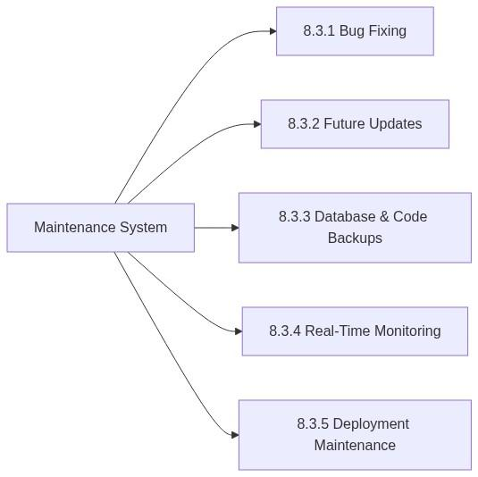
Figure: 8.1 System Maintenance
8.3.1 Bug Fixing
Operational software inevitably encounters unforeseen runtime errors and boundary issues that must be addressed immediately to ensure service continuity:
- Error Log Rectification: Checking developer logs to identify and resolve exceptions, such as unhandled routing errors or database connection drops during high network traffic.
- Edge-Case Validation Patches: Fixing issues like incorrect coupon formatting, cart quantity calculations, or database schema violations (e.g. attempting to force invalid direct downline additions).
- UI/UX Defect Resolution: Adjusting responsive styling breakpoints to ensure UI components render correctly across newer browser builds and mobile screen layouts.
8.3.2 Future Updates
To prevent technology obsolescence, the system must undergo periodic component upgrades:
- Dependency Upgrades: Regularly upgrading core NPM packages (such as mongoose, express, jsonwebtoken, and react-router-dom) to newer stable versions to leverage performance improvements and security patches.
- Security Patching: Addressing security advisories by executing npm audit and applying package updates to fix potential vulnerabilities in standard cryptographic libraries and utility modules.
- Framework Upgrades: Upgrading the React build system (Vite) and Node.js server runtimes to remain aligned with standard modern web development practices.
8.3.3 Database & Code Backups
Robust data backup policies protect the platform from permanent data loss caused by hardware failure, server crashes, or human error:
- Automated NoSQL Database Dumps: Establishing scheduled MongoDB backup routines using the standard mongodump utility:
mongodump --uri="mongodb://localhost:27017/referral_ecommerce" --out=/backups/db/daily/

In a cloud-hosted environment (MongoDB Atlas), utilizing automated cloud backup snapshots configured to run daily.
- Version Control Archiving: Committing source code updates to remote, secure repositories like GitHub or GitLab. Keeping the developmental branches separated ensures that working configurations can be restored instantly if new code introduces instability.
8.3.4 Real-Time Monitoring
Monitoring provides live system operational statistics, letting administrators identify performance bottlenecks and potential security threats proactively:
- Request and Traffic Logs: Implementing middleware loggers (e.g., morgan on the Express server) to trace every incoming API request method, target URL path, execution latency, and response status code.
- Database Query Performance Monitoring: Tracking MongoDB read/write execution times and index utilization to ensure that complex promoter searches (like recursive level-2 referrals tree construction) remain fast as user directories expand.
- Console Logging: Standardizing server-side error capturing (try-catch blocks) and streaming these errors to centralized developer consoles to minimize debugging downtime.

8.3.5 Deployment Maintenance
Managing environment parameters and server hosting configurations is critical for long-term application stability:
- Environment Variable Governance: Safely maintaining confidential parameters (e.g. JWT_SECRET, RAZORPAY_KEY_SECRET, and database connection strings) inside system-level .env files rather than exposing them in public code repositories.
- Domain & SSL Maintenance: Ensuring SSL/TLS certificates remain up to date to guarantee secure HTTPS connections, which are mandatory for Razorpay API integrations and secure JWT payload transmissions.
- Server Scalability Checks: Monitoring active server CPU and RAM usage to plan horizontal or vertical scaling when concurrent promoter actions scale up.

REFERENCES & BIBLIOGRAPHY
This section lists the official documentations, dynamic web resources, online tutorials, and industrial practice guidelines consulted during the research, design, and implementation of the Referral E-Commerce System.
1. Official Documentation & Reference Portals
- React Official Documentation: https://react.dev (Consulted for state management hooks, dynamic context routing, and storefront component cycles).
- Node.js Runtime Documentation: https://nodejs.org/docs (Consulted for backend runtime structures and asynchronous execution models).
- Express.js Framework Guide: https://expressjs.com/en/ (Used for middleware validation triggers, secure endpoint routing, and request handling).
- Mongoose ODM Reference Manual: https://mongoosejs.com/docs (Used for Mongoose schema designs, validation rules, and atomic database increments).
- Razorpay Developer Hub: https://razorpay.com/docs (Consulted for transaction workflows, sandbox signatures, and API parameters).

2. Video Tutorials & Online Playlists
- MERN Stack Development Course Playlists (YouTube): Consulted video playlists from channels like CodeWithHarry, Sheryians Coding School, and freeCodeCamp for structuring backend controller endpoints and coordinating client-side React states.
- Razorpay Gateway Integration Tutorials (YouTube): Consulted dynamic walkthroughs for setting up backend signature captures and frontend popup scripts.
- Postman Automated Testing guides (Postman Learning Center): https://learning.postman.com (Used for drafting javascript tests in postman environment scopes).
3. Industrial Practice & Internship Learnings
- Practical Industry Guidelines: Practical Industry Guidelines: Core development practices, middleware-based role authentication systems, secure API handling, and atomic database update patterns were learned and adapted through practical development experience and internship-based exposure to real-world web application workflows.
- During the internship learning process, concepts related to Razorpay payment gateway integration, payment verification flows, transaction handling, and secure backend payment processing were also studied and implemented within the project environment.

APPENDICES
APPENDIX A: Centralized API Directory
The following table documents the core API routes used to connect the React frontend with the Node.js backend.
Method | Endpoint | Headers Required | Authentication | Purpose
POST | /api/auth/signup | Content-Type: application/json | None | Registers a new user. Supports optional parent referral code linking.
POST | /api/auth/login | Content-Type: application/json | None | Authenticates credentials and returns a secure JWT.
GET | /api/auth/user | x-auth-token: {{authToken}} | Customer | Fetches active profile data, wallets, and downline metrics.
POST | /api/user/address | x-auth-token: {{authToken}} | Customer | Appends a new delivery address card to the user document.
GET | /api/shop/products | None | None | Queries catalog items with price filters, categories, and search strings.
POST | /api/payment/create-order | x-auth-token: {{authToken}} | Customer | Contacts Razorpay to generate a transaction order ID.
POST | /api/payment/verify | x-auth-token: {{authToken}} | Customer | Verifies digital signatures and processes two-tier payouts.
POST | /api/payment/withdraw | x-auth-token: {{authToken}} | Customer | Exchanges accumulated wallet balance for digital gift vouchers.
GET | /api/admin/users | x-auth-token: {{adminToken}} | Admin | Retrieves the full platform user directory and referral lineages.
POST | /api/admin/products | x-auth-token: {{adminToken}} | Admin | Adds a new product to the storefront, specifying its pricing and commission rate.

APPENDIX B: Core Database Schema Blueprints
The dynamic referral linkages and commission transactions are powered by two primary schemas in the MongoDB database:
1. User Schema Model
Represents user records, downline lists, wallets, and withdrawal records.
const mongoose = require('mongoose');
const UserSchema = new mongoose.Schema({
email: { type: String, required: true, unique: true },
password: { type: String, required: true },
phone: { type: String, required: true },
referralCode: { type: String, unique: true }, // Dynamic unique code
referredBy: { type: mongoose.Schema.Types.ObjectId, ref: 'User' }, // Parent node
directReferrals: [{ type: mongoose.Schema.Types.ObjectId, ref: 'User' }], // Level 1 (Max: 8)
wallet: { type: Number, default: 0 }, // Wallet commission balance
earnings: {
direct: { type: Number, default: 0 }, // Level 1 commission total
indirect: { type: Number, default: 0 }, // Level 2 commission total
total: { type: Number, default: 0 } // Combined commission total
},
addresses: [{
name: String,
line1: String,
city: String,
state: String,
zipCode: String,
phone: String,
isDefault: { type: Boolean, default: false }
}],
withdrawalHistory: [{
amount: Number,
brand: String, // e.g., Amazon, Flipkart
couponCode: String,
date: { type: Date, default: Date.now }
}]
}, { timestamps: true });
module.exports = mongoose.model('User', UserSchema);

2. Order Schema Model
Tracks checkout records, buyer links, payment details, and shipping statuses.
const mongoose = require('mongoose');
const OrderSchema = new mongoose.Schema({
user: { type: mongoose.Schema.Types.ObjectId, ref: 'User', required: true },
items: [{
product: { type: mongoose.Schema.Types.ObjectId, ref: 'Product', required: true },
quantity: { type: Number, required: true },
price: { type: Number, required: true },
name: { type: String, required: true }
}],
totalAmount: { type: Number, required: true },
paymentInfo: {
paymentId: { type: String }, // Razorpay Payment ID
orderId: { type: String, required: true }, // Razorpay Order ID
signature: { type: String },
method: { type: String, required: true } // 'Razorpay' or 'Wallet'
},
shippingAddress: {
name: String,
line1: String,
city: String,
state: String,
zipCode: String,
phone: String
},
status: {
type: String,
enum: ['Confirmed', 'Processing', 'Delivering', 'Delivered'],
default: 'Confirmed'
}
}, { timestamps: true });
module.exports = mongoose.model('Order', OrderSchema);

APPENDIX C: Signature Verification Utility Script
This Express backend controller script validates payment legitimacy using the Node.js crypto library to verify the HMAC-SHA256 signature generated by Razorpay.
const crypto = require('crypto');
function verifyPaymentSignature(orderId, paymentId, signature) {
const keySecret = process.env.RAZORPAY_KEY_SECRET;
if (!keySecret) {
throw new Error("Missing RAZORPAY_KEY_SECRET environment variable.");
}
// Generate HMAC hash payload by joining parameters with a pipe character
const hashPayload = orderId + "|" + paymentId;
// Create HMAC SHA256 cipher using the Razorpay secret key
const calculatedSignature = crypto
.createHmac('sha256', keySecret)
.update(hashPayload)
.digest('hex');
// Validate if the generated hash matches the signature parameter
return calculatedSignature === signature;
}

APPENDIX D: Additional Screen Placeholders
Below are designated placeholders for capturing supplementary interfaces of the application:
D.1 Shopping Cart Slide-Out Panel
The Shopping Cart slide-out panel allows customers to modify item quantities, view product subtotals, and initiate the checkout process.
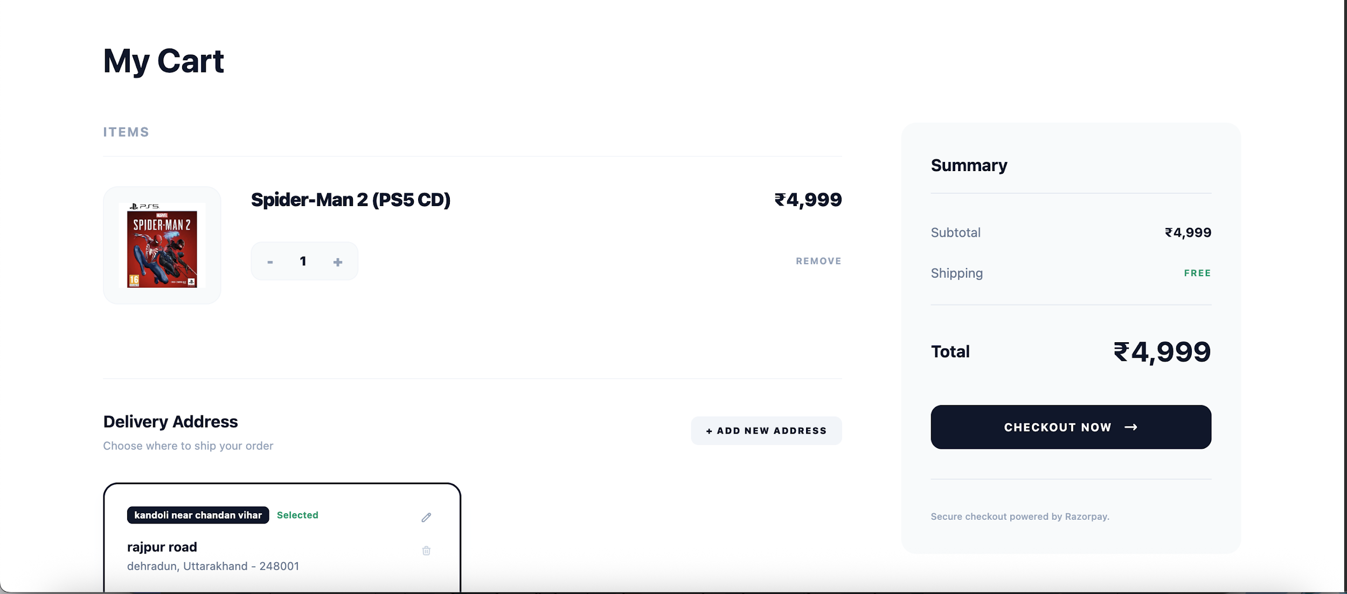
Figure D.1: Interactive Cart Drawer & Checkout panel
D.2 Address Selection Modal Overlay
The Address Selection Modal overlay allows users to select a delivery address or create a new one during checkout.
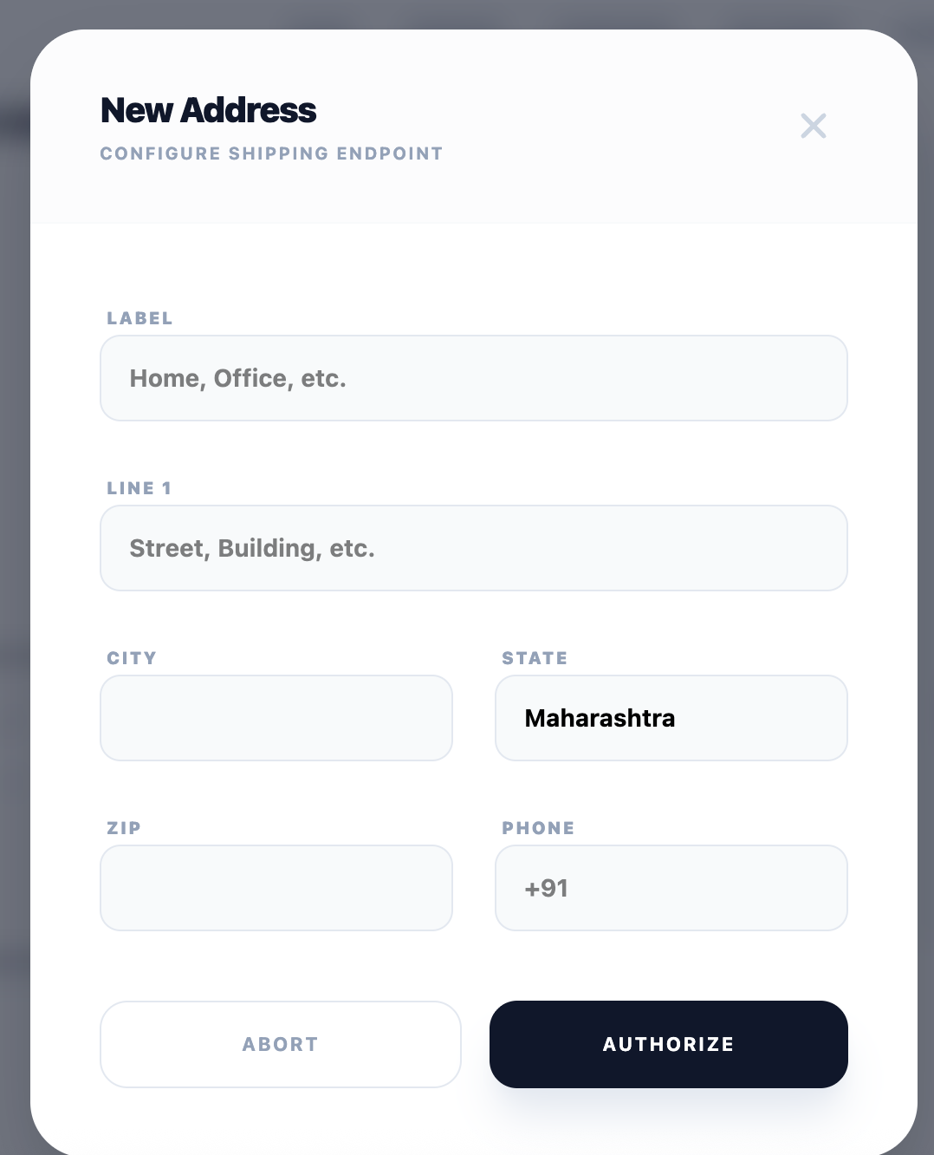
Figure D.2(a): Dynamic Address Register Modal Form
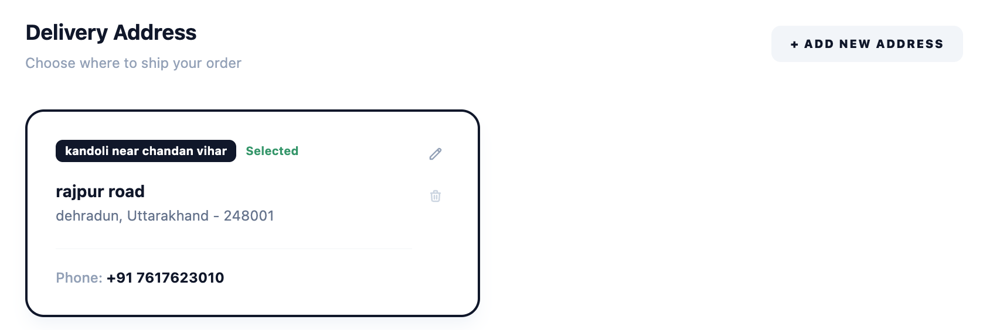
Figure D.2(b): User Shipping Cards display state during order execution

