COMP 4711

FALL 2019

Lab 2: Artist App

Over the course of the coming labs our aim will to be develop a web app which will enable us to create, delete new artists in our app. The UI for this lab needs to look similar to the one below:

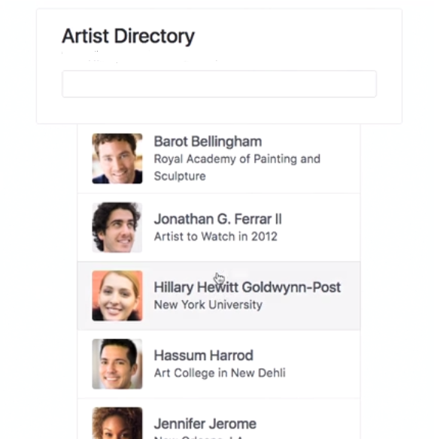

You can obtain images for the artists to be used in the app via Random user (the numbers go from 1 - 99)

<https://randomuser.me/api/portraits/med/women/1.jpg>

<https://randomuser.me/api/portraits/med/men/1.jpg>

Hovering over any artist will change the background color. For now please show atleast 5 artists on the page.

Make use of css classes, no inline or internal styles, all your css should reside in a separate css file (external sheet)

Marking breakdown:

* 2 Marks for providing a link to the hosted lab.
* 2 Marks for using external stylesheets, using classes
* 2 Marks for using different fonts (e.g.: can use google fonts)
* 2 Marks for making UI close to the mock-up
* 1 Mark for hover effect
* 1 Mark for centering the UI on the page