# Quick Help Guide – Pi Kiosk

Contents

Quick Help Guide – Pi Kiosk 1

Pi Kiosk email login 1

Online OneDrive login 1

Computer login: 1

Mobile login: 1

File Explorer OneDrive set up 1

Creating a PowerPoint Video 1

File System 1

Connecting to VNC (Virtual Network Connecter) 1

Pi Logins 2

Setting Up A New Raspberry Pi 2

Instructions Part 1 – OS system download and power on: 2

Instructions Part 2 – Connecting to OneDrive 2

Instructions Part 3 – Mounting OneDrive 4

Instructions Part 4 – Adding the Pi-Kiosk-App to the Raspberry Pi desktop 4

Instructions Part 5 – Getting Files ready for use 4

Instructions Part 6 – Start the Startup files 5

Developer Information 5

## Pi Kiosk email login

Email: (protected) password: (protected)

## Online OneDrive login

### Computer login:

If you do not want to connect to the pi-kiosks via file explorer, then login online to OneDrive.

* Go to <https://www.microsoft.com/en-us/microsoft-365/onedrive/online-cloud-storage>
* A screenshot of a computer

  Description automatically generatedClick Sign In
* Login with the Pi-kiosk email address and password
* If it goes directly to your personal or Fort account:
  + Click your profile in the upper right corner.
  + Click “Sign in with a different account”
  + Enter the pi-kiosk information and login
* From here you can edit the files/folders

### Mobile login:

Adding the pi-kiosk to your mobile device can be helpful for monitoring and doing easy changes for the pi-kiosks.

* If the OneDrive mobile app has not been downloaded to your phone, download the app.
  + After downloading the app, sign in to the pi-kiosk using the information above
* If it is already downloaded:
  + Tap home
  + Tap the profile circle in the upper left corner
  + Tap “Add Account”
  + Enter the pi-kiosk information and login
* Now you should have access to the OneDrive files.
* Edit what is shown on the screens by moving the file you want to have play into the correct folder and move the other files in that folder to the day folder for storage.
* **Note:** Anything in the day folder will never be accessed to play. Example below:

Uses:

With this now on your phone, you can move files around within the file system. If you need to make a big change to the video that is playing it is best to go on a computer and change what needs to be changed.

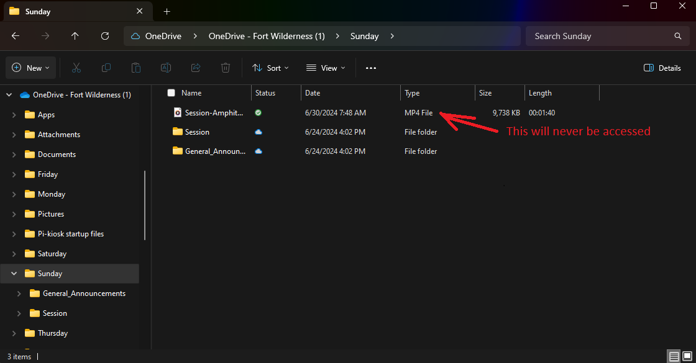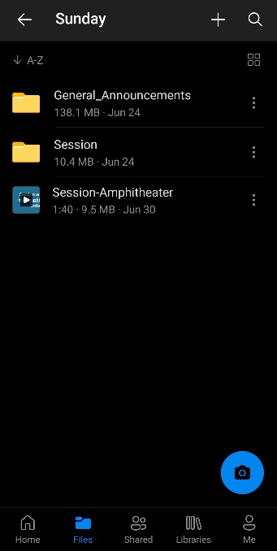

## File Explorer OneDrive set up

1. Go to your current OneDrive on file explorer
2. Click the OneDrive file heading

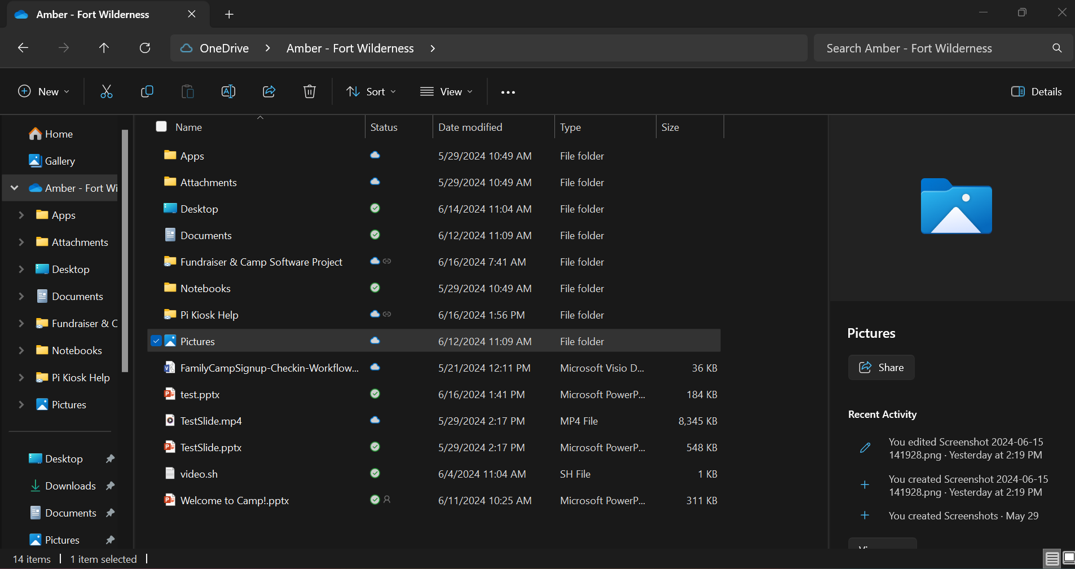

1. Click the settings icon

1. Click “Add an account”

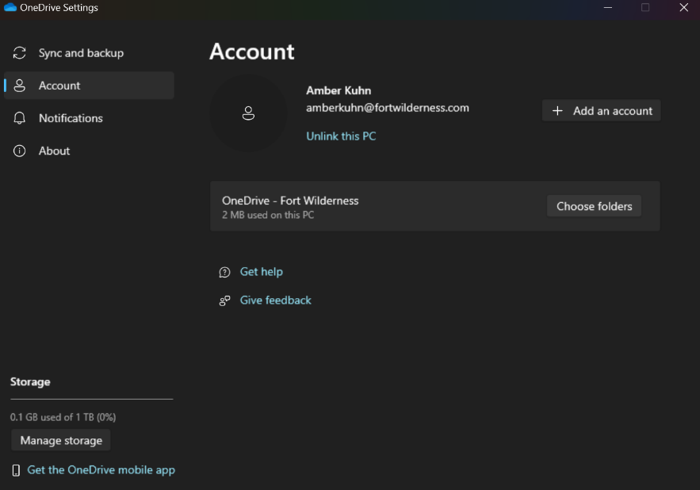

1. Type the (protected) email address in the type of box

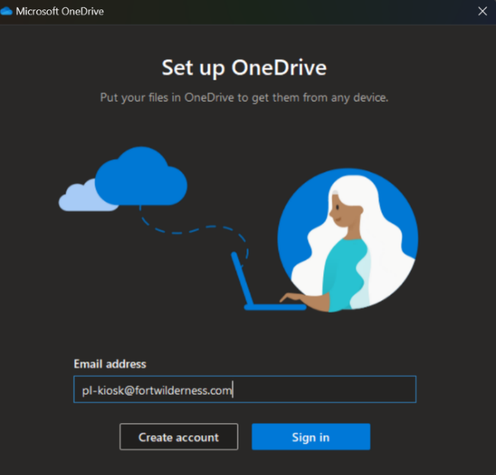

1. Put in password as needed (protected)
2. If below pop up shows up – click “Use this folder”

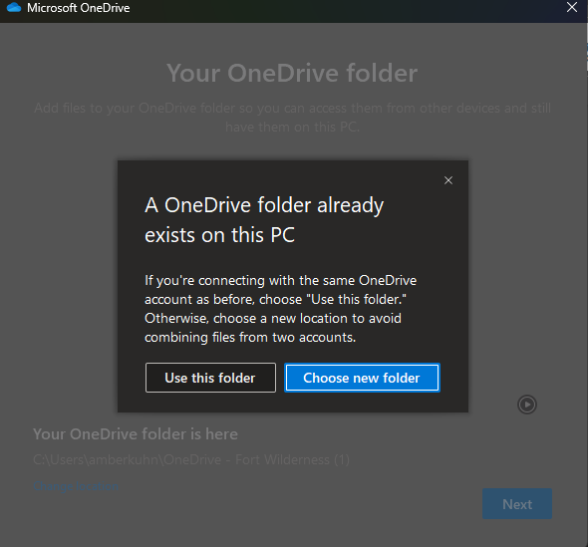

1. After scanning – click “next” (If the warning occurs still click “next”)

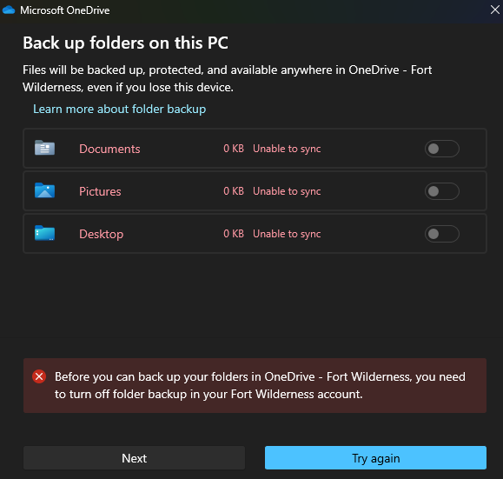

1. Click next until the end and open the file for the pi kiosk OneDrive

You should be set to add PowerPoint .mp4 videos to the correct day file.

## Creating a PowerPoint Video

* Export the presentation as a video and change the time per slide to the time you would like
  + File > Export > Create a Video > Second spent on each slide > Create video
* Save the .mp4 file in pi-kiosk file explorer and in the correct day and category file (ex. Tuesday > Session). If the .mp4 file has been added to the current day (i.e. “Monday”, “Tuesday”, etc.), it should update to the tvs in about 5 min. If the file was added to a future day file, then it will begin displaying at midnight that night.
* Possible errors:
  + If after 5 min and the tvs are not updated:
    - Right click the file in the pi-kiosk OneDrive > towards the bottom of the command list click “Free up space”
    - The file should now have a little cloud associated with it.
  + If it still does not connect:
    - Manually power off the pi’s > wait 2 minutes > power on the pis
    - It will take the device 5-10 minutes to reboot and show the slide show.

## File System

The Pi-Kiosk File System is separated into days and categories.

Days:

Saturday, Sunday, Monday, Tuesday, Wednesday, Thursday, Friday

Folders and times played:

**General_Announcements** – Plays all the time except when timed folders must play

**Evening_Session** – Plays Saturday and Thursday before the opening and closing sessions from 5PM to 7PM

**Session** – Plays before the morning sessions from 7AM to 10AM

**Celebration_Video** – Plays the camp video from 7PM to 10PM on Thursdays only

**NOTE:**

* If there is nothing in the General_Announcement Folder and if it is not within the time for the special Folders then the system will play a “Welcome to Fort” slide show.
* If there is nothing in the Special Folders (i.e. evening session or session or celeation_video) and if there is something in the general announcement folder then the system will play the file in the general announcement folder.

## Connecting to VNC (Virtual Network Connecter)

If you want to have virtual access to the raspberry pis then Virtual Network Connecter is the way to do it.

* Download “VNC viewer” and put in the pi kiosk email and email password
* It should automatically show all three pis but if not the IP addresses can be found below
  + Pi = (protected)
  + Pi 2 = (protected)
  + Pi 3 = (protected)
  + Pi 4 = (protected)
* Type the ip addresses into the search bar and hit enter > It should try to connect
  + If connections fails
    - Close VNC and reopen VNC
    - Try pinging the ip address through your computer command prompt
      * Start > type “Command Prompt” > enter “ping <ip address of the raspberry pi>”
    - Try VNC again
    - If all else fails, shutdown the pis and turn them back on….. and wait

## Pi Logins

These are the pi logins for if the pis get locked out of need to be updated

* Pi 1 – Username: (protected) Password: (protected)
* Pi 2 – Username: (protected) Password: (protected)
* Pi 3 – Username: (protected) Password: (protected)
* Pi 4- Username: (protected) Password: (protected)

## Setting Up A New Raspberry Pi

If the need arises that a new raspberry pi to be set up with this same format, follow the below instructions.

Resources - Raspberry Pi with Wifi, microSD card, mouse/keyboard and monitor connections.

### Instructions Part 1 – OS system download and power on:

1. Download the Raspberry Pi Imager for downloading the OS system to your computer (<https://www.raspberrypi.com/software/>)
2. Insert the microSD card into your computer. (Online help: <https://docs.viam.com/get-started/prepare/rpi-setup/>)
   1. Open the Raspberry Pi Imager.
   2. Select the version of raspberry pi you are using in the “Choose Device”
   3. Choose the most recent version of the Raspberry Pi OS in “Choose OS”
   4. Find the microSD card in “Choose Storage”
   5. Click “Next”
   6. The next screen will ask if you want to “Use OS customization” settings.
      1. If you want to automatically connect to the wifi:
         1. Ask the IT/Security Manager for the wifi information to set up in the preset settings
         2. Add this information to the preset settings information by clicking “Edit Settings”
         3. “Save” the settings and click “yes” to use the setting you just edited
         4. Wait until the OS is done being downloaded
      2. If there are no setting you want to preset to the raspberry pis then click “No”
      3. On the warning page click “Yes” to acknowledge that all the information on the microSD card will be erased.
3. Insert the SD card into the Raspberry Pi.
   1. Connect the monitor, mouse and keyboard to the Raspberry Pi
   2. Power on the Raspberry Pi and let it completely boot up

### Instructions Part 2 – Connecting to OneDrive

1. Install Rclone to the raspberry pi (<https://pimylifeup.com/raspberry-pi-rclone/>)
   1. Open the Terminal
   2. Check to see if the latest unzip package is installed

sudo apt install unzip

* 1. Install the latest version of Rclone from their website

wget <https://downloads.rclone.org/rclone-current-linux-arm.zip>

* 1. Now unzip the package

unzip -j -d rclone-temp rclone-current-linux-arm.zip

* 1. Move the extracted files

sudo mv ~/rclone-temp/rclone /usr/bin/rclone

* 1. Set up the manual pages

sudo mv ~/rclone-temp/rclone.1 /usr/share/man/man1/rclone.1

* 1. Make the root user as owner

sudo chown root: /usr/bin/rclone

* 1. Clean up unneeded files

rm ~/rclone-current-linux-arm.zip

rm -r -f ~/rclone-temp

1. Connect to OneDrive using Rclone
   1. Create a new rclone configuration

rclone config

* 1. The system will ask what you want to do – type **n** and hit enter

2021/01/19 02:15:20 NOTICE: Config file “/home/pi/.config/rclone/rclone.conf" not found - using defaults

No remotes found - make a new one

n) New remote

s) Set configuration password

q) Quit config

n/s/q>

* 1. Give your remote the name “pi-onedrive”

name> pi-onedrive

* 1. There is now a list of various backends that Rclone can connect to (<https://rclone.org/onedrive/>)
     1. Find the number associated with “Microsoft OneDrive” (as of right now the number is 33)

Storage> 33

* 1. Leave the client_id> blank by hitting enter
  2. Leave client_secret> blank by hitting enter
  3. Do not edit advanced configurations by entering **n** and hitting enter
  4. Use the web browser to automatically authenticate rclone with remote

Yes

* 1. The web browser should open to Microsoft OneDrive login.

Login with the Pi-Kiosk information

Click “Remember Me”

* 1. Once the email has been verified, choose the type of drive it is: Type the number associated with OneDrive Personal or Business

Your Choice> 1

* 1. It will find two drives, test both to see which one is associated with personal-Documents

Chose drive to use:> 1

* 1. Once it’s the right OneDrive location, enter yes to “Is that ok?”
  2. It will then display the information to you, and you can decide whether to keep it or not.
  3. Now that you created a remote to the pi-kiosk OneDrive then you can mount this to a file on the Raspberry Pi Desktop.

### Instructions Part 3 – Mounting OneDrive

1. Check connection to the OneDrive by listing the contents of the remote

rclone lsd pi-onedrive:

1. Now create a OneDrive folder on the Raspberry Pi Desktop

mkdir OneDrive

1. Now you need to mount the pi-kiosk onedrive to the OneDrive folder

rclone --vfs-cache-mode writes mount pi-onedrive: ~/OneDrive

1. Once the mount is connected open the OneDrive folder on the Raspberry Pi Desktop

/home/fortadmin/Onedrive

### Instructions Part 4 – Adding the Pi-Kiosk-App to the Raspberry Pi desktop

1. Navigate to the Pi-kiosk startup files

Home > fortadmin > OneDrive > Pi-kiosk startup files

1. Copy the Pi-Kiosk-App folder to the Raspberry Pi Desktop

### Instructions Part 5 – Getting Files ready for use

1. Make connectrclone.sh file executable
   1. In the terminal type: chmod +x [the file path]

chmod +x /home/fortadmin/Desktop/Pi-Kiosk-App/connectrclone.sh

1. Make the startup files
   1. Next you need to make systemd files to run on start up
      1. Navigate to the to python-start.txt (/home/fortadmin/Desktop/Pi-Kiosk-App/python-start.txt)
      2. Open the file and copy the first line into the terminal

sudo nano /etc/systemd/system/python-start.service

* + 1. Once the file is created, copy the contents under the “infile:” line

[Unit]

Description=Start the Python file

After=network-online.target rclone-mount.service graphical-session.target

[Service]

Type=simple

User=fortadmin

Environment="DISPLAY=:0"

#Environment="XDG_RUNTIME_DIR=/run/user/1000"

WorkingDirectory=/home/fortadmin/Desktop/Pi-Kiosk-App/

ExecStart=/usr/bin/python3 startVideo.py

Restart=always

[Install]

WantedBy=multi-user.target

* + 1. Save and Exit the file
  1. Now do this with the rclone-mount.txt file
     1. Navigate to the rclone-mount.txt file ((/home/fortadmin/Desktop/Pi-Kiosk-App/rclone-mount.txt)
     2. Open the file and copy the first line into the terminal

sudo nano /etc/systemd/system/rclone-mount.service

* + 1. Once the file is created, copy the contents under the “infile:” line

[Unit]

Description=Rclone OneDrive Mount

After=network-online.target

[Service]

Type=simple

User=fortadmin

ExecStart=/home/fortadmin/Desktop/Pi-Kiosk-App/connectrclone.sh

Restart=on-failure

RestartSec=5s

[Install]

WantedBy=multi-user.target

* + 1. Save and exit the file

### Instructions Part 6 – Start the Startup files

Now you must start the files to have them automatically start on power on.

1. You will want to start the rclone-mount.service file first

sudo systemctl daemon-reload

sudo systemctl enable rclone-mount.service

sudo systemctl start rclone-mount.service

1. Next start the python-start.service file

sudo systemctl daemon-reload

sudo systemctl enable python-start.service

sudo systemctl start python-start.service

At this point, wait until the files run and then reboot the raspberry pi. Now your pi should be completely set up!

## Developer Information

If issues arise in any area regarding the raspberry pi’s that cannot be fixed, contact the developer.

Name: Amber Kuhn

Mobile Phone: (protected)

E-Mail: (protected)

Linked-In: [www.linkedin.com/in/amber-kuhn-05040722b](http://www.linkedin.com/in/amber-kuhn-05040722b)