**AIMS GRID**

1. **Purpose/Benefits**
2. **Clients/Stakeholders**
3. **Success Criteria**
4. **End Result**

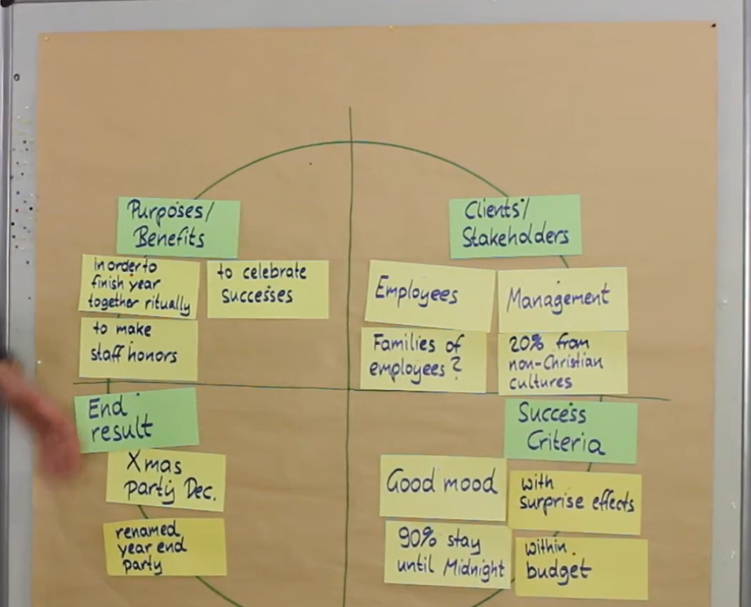Example

STAR SCHEMA

