SET UP REDUX
npm install @reduxjs/toolkit react-redux

CREATE A STORE (TO PASS IN TOP LEVEL COMPONENT TO MAKE ANY COMPONENTS UNDER TO THE ACCESS TO STORE)

new folder → store
new file → store.js

Go to redux toolkit page to copy this:

import { configureStore } from '@reduxjs/toolkit'
export const store = configureStore({
reducer: {},
})

as your project grows bigger, you have to have different stores for different things

Go to app.js to insert Provider and import things

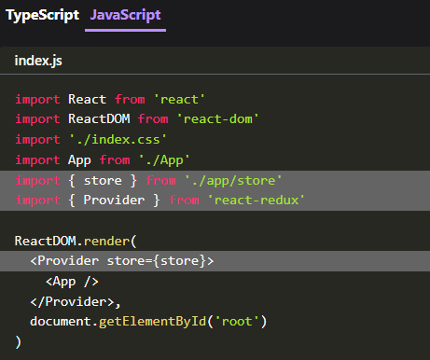

import React from 'react'
import ReactDOM from 'react-dom'
import './index.css'
import App from './App'
import { store } from './app/store'
import { Provider } from 'react-redux'
ReactDOM.render(
<Provider store={store}>
<App />
</Provider>,
document.getElementById('root')
)

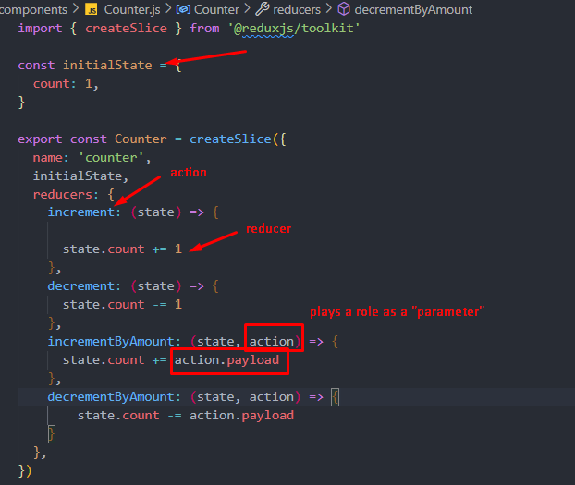
Create a slice (includes state, action, and reducer)

Everytime you have a new reducer, you have to import it to “store”
Then give that counter a name
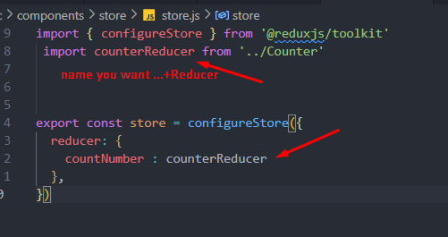

Then go back to the component you want to use State
In order to use REDUX, we have to use react hook → useSelector (I want to read this variable from this reducer) + useDispatch

Choose the variable (initial state) you want to use from “slice” (counter.js) , in this case, it’s “count”. Then connect it with its reducer, in (store). In another word, I want to take this variable (count) from redux state (store), specifically “countNumber – counterReducer”

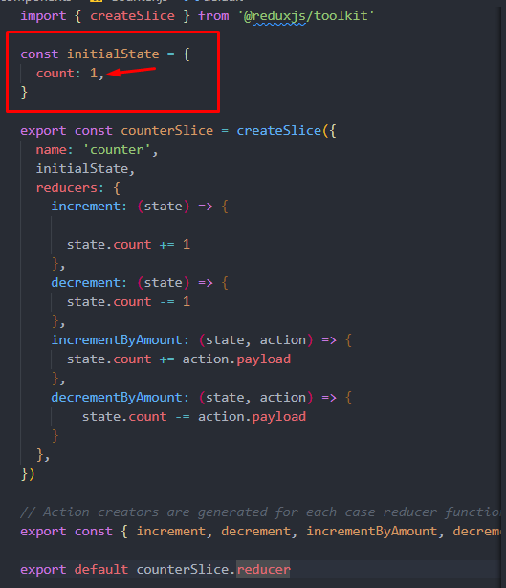
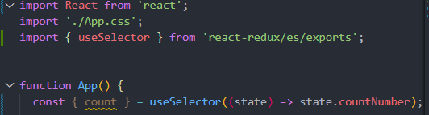

Before we can call a redux action, we have to use useDispatch(). We can use disPatch hook to call any actions in redux
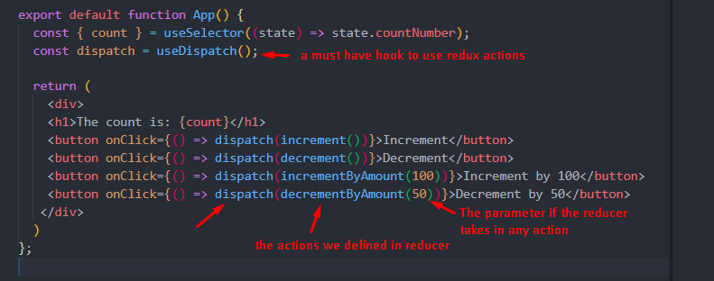

For input text → word change when you type

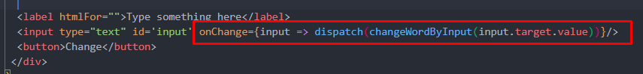
For input text → word change when you finished typing + click change

