**Hmwk#0**

**Shengxin Qian**

**1. Probability of a fatal (died) lightning strike in the USA**

1). Conclusion [1]:

Odds of being struck by lightning and died in the USA in 2014 ≈ 1/9,636,363

2). Method:

Assuming the average of population of the USA in 2014 ≈ 318,000,000 [1]

Number of deaths actually reported in 2014 = 33 [1]

Odds of fatal lightning strike in United States ≈ 33/318,000,000 ≈ 1/9,636,363

3). More accurate Conclusion and Method (In a long period):

Assuming the average of population of the USA in a long period (05~14) [2]

≈ 307,622,000

Number of deaths actually reported in a long period (05~14) = 322 [3]

Odds of fatal lightning strike in United States ≈ 322/10/307,622,000

≈ 1/9,553,478

4). Comment:

Because the population of United States is growing and the method about preventing lightning strike works in recent years, the number of lightning fatalities dropped in 2008 [P1]. The probability of a fatal lightning strike is going down.

All the conclusion above is based on the fact that fatal lightning strike distributes uniformly. However, the fatal lightning strike is more likely occur in several states [P2]. So, the probability above could be higher in several states in United States especially in southern United States.

The fatal lightning strike is related to:

1 Geographical location and climatology

2 Diurnal and annual climatology

3 Personal lifestyle

So, it is impossible to assign one single probability to every person in every situation

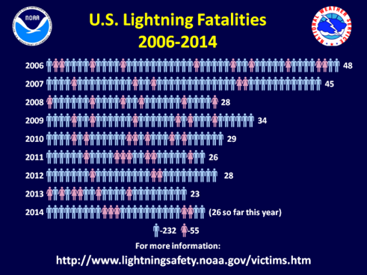

P1: U.S. lightning Fatalities in 06~14 [4] P2: Lightning Fatalities by State

in 05~14 [3]

**2. Probability of a fatal (died) shark attack in the USA**

1). Conclusion:

Odds of fatal shark attack in United States in 2014 ≈ 0/318,000,000

(Since the last fatal shark attack was in 2013) [5]

2). Method:

Assuming the average of population of the USA in 2014 ≈ 318,000,000

Number of deaths actually reported in 2014 = 0

Odds of fatal shark attack in United States ≈ 0/318,000,000

3). More accurate Conclusion and Method (excluding some impossible situation):

Obviously, shark attack only happens in coastal area and only U.S. surfing people may encounter shark attacks. More than that, fatal shark attack may not happen in several years, so an average number of fatal shark attack in long period would be more accurate to calculate the probability.

Estimated surfing population = 264,156,728 [6]

Fatal shark attack per year (average) = 0.5 [7]

Odds of fatal shark attack = 1/528,313,456

**3. Reference**

[1]. How Dangerous is Lightning? – NATIONAL WEATHER SERVICE

<http://www.lightningsafety.noaa.gov/odds.shtml>

[2]. Demographics of the United States – WIKIPEDIA

<https://en.wikipedia.org/wiki/Demographics_of_the_United_States>

[3]. Lightning Deaths by State and Deaths Population Weighted 2005-2014 -- NATIONAL WEATHER SERVICE

<http://www.lightningsafety.noaa.gov/stats/05-14deaths_by_state_maps.pdf>

[4]. Details on U.S. Lightning Deaths: 2014 – NATIONAL WEATHER SERVICE

<http://www.lightningsafety.noaa.gov/fatalities/fatalities14.shtml>

[5]. Shark attack – WIKIPEDIA

<https://en.wikipedia.org/wiki/Shark_attack>

[6]. Year 2000 USA Beach Injuries and Fatalities – ICHTHYOLOGY

<http://www.flmnh.ufl.edu/fish/sharks/statistics/beachattacks.htm>

[7]. A Comparison of Unprovoked Shark Attacks with the Number of Lightning Fatalities in Coastal United States: 1959-2010 -- ICHTHYOLOGY

<http://www.flmnh.ufl.edu/fish/sharks/attacks/2004lightning.html>