**Hmwk#1.1**

**Shengxin Qian**

**1. Fundamental analysis and setting**

Information 1: Total signal energy of image: $E_{s}=\sum_{i,j}{s_{i,j}^{2}=4}$; Only one straight line from corner to corner has nonzero and equal value in a 1024 x 1024 image.

Conclusion 1: Which means $s_{i,j}=\frac{1}{16}$

Information 2: Statistically independent Gaussian noise; Mean=0, Variance=1

Conclusion 2: Gaussian noise with N (0, 1) distribution; $SNR=10lg⁡\frac{E_{s}}{σ^{2}}$

Setting 1: The imshow() command in Matlab could only show the image matrix with $s_{i,j}∈[0,1]$. Any $s_{i,j}$ belong this range will be reset to 0 or 1. Of course, the max energy in the image required is 1024 which may cause some issues if we change the signal energy of image.

Setting 2: I would show three subplots under same condition in one picture for comparison which would be Noise free image, Noise alone image and Noise add image. *Noise add matrix* = *Noise alone matrix* + *Noise free matrix*

**2. Image generation and analysis**

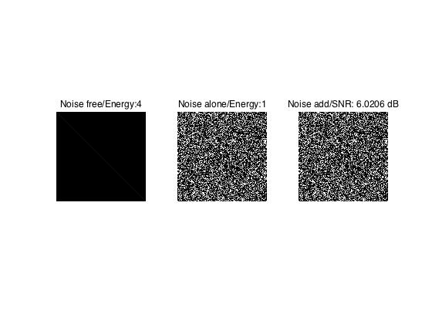 **1). Image in step(a) and step(b)**

As we know in the picture above (Noise free subplot), because the pixel intensity is too low, we could not see the diagonally straight line from corner to corner. Even without any noise – infinite SNR, we still could not recognize the signal in the picture because our eye has signal threshold. Obviously, when we add some Noise, we still could not see the diagonally straight line.

**2). Image energy change method to show the straight line strategy**

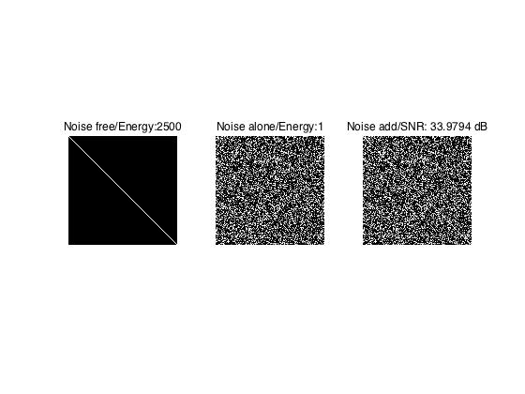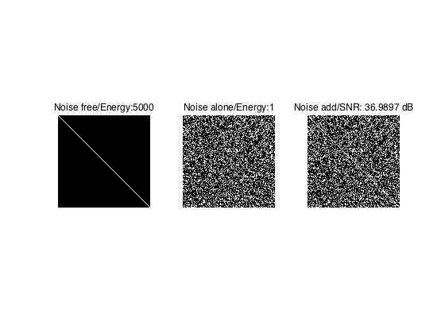 The two pictures above show required situations if the image signal energy $E_{s}=2500$, $E_{s}=5000$. Obviously, I could not say I could recognize the line in these two Noise added images.

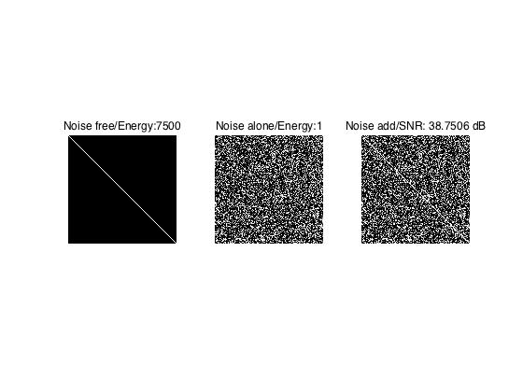

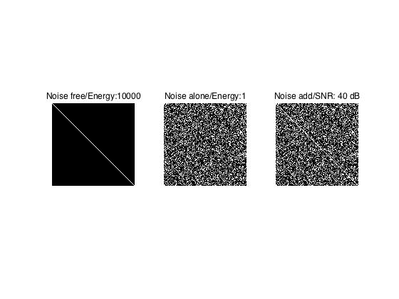

The two pictures above show required situations if the image signal energy $E_{s}=7500$, $E_{s}=10000$. Maybe for me, I could say I could recognize the line in these two Noise added images. So the recognizable SNR for me is 38 dB.

Analysis:

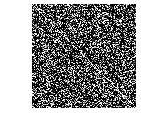 As I said in the setting 1, the max signal energy of the image required is 1024. So, how could an image with much higher energy improve the ‘quality’ when adding noise? The Noise free subplots above are all same no matter how high signal energy is as long as it higher than 1024. If we add N (0,1) noise, things would be totally different. The noise we create could be smaller than -1 (or much smaller), which could let the $s_{i,j}>1$ works. So, if we keep increasing the signal energy, theoretically, the straight line could be more recognizable in Noise add subplot. We could also find out the best Noise add image (picture left) if we only change the signal energy of Noise free image.

Because of the limit of input signal energy of Noise free image, the SNR of Noise add image above is not accurate. However, the SNR could be changed if we increase the energy of Noise free image even that is beyond the max input energy.

**3). Noise energy change method to show the straight line strategy**

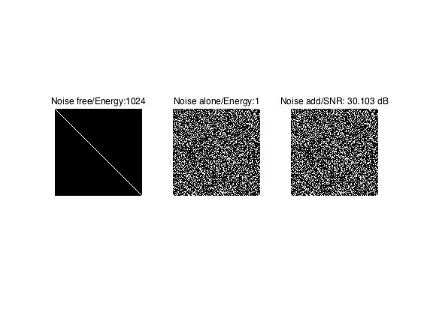

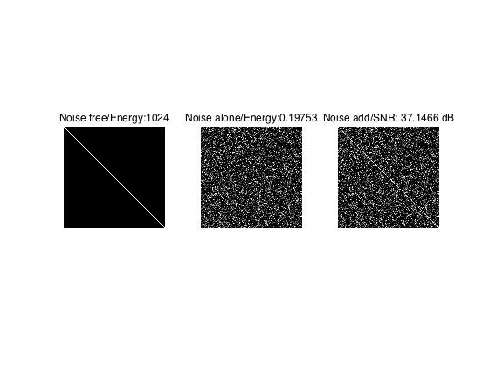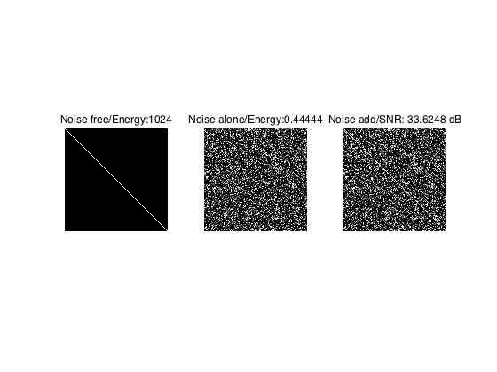

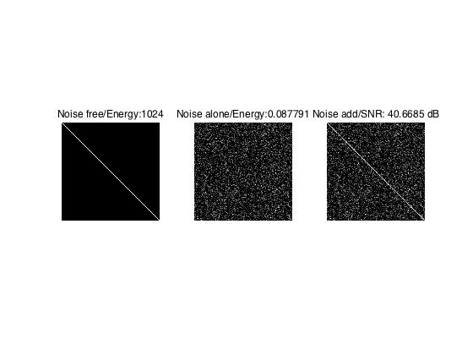

The four pictures above show the situation that the input noise energy is changed.

For me, the bottom line of recognizable SNR is 37dB which is much more clear than the 38dB image in the other strategy. The SNR in pictures is accurate because the input noise free image energy is 1024.

Matlab code:

%==========================

% ECE 581 Homework1

% Shengxin Qian

%==========================

% Workspace clear

%==========================

clear

clear all

nu=1;

set(figure,'NumberTitle','off','Name','Part(a),(b)'); %set figure name

%***********************************************************

%==========================

% Original noise-free image generation

%==========================

Image_energy=4; %input signal energy of image

Noise_free=eye(1024)*sqrt(Image_energy/1024);%generate noise free image

subplot(1,3,nu); %put the original noise free image on the first position

imshow(Noise_free) %show the original noise free image

title('Noise free/Energy:4'); %set subplot name

nu=nu+1;

%==========================

% (0,1) Gaussian white Noise generate

%==========================

Noise0=normrnd(0,1,1024); %Generate (0,1) Gaussian white Noise0

Noise_add=Noise0+Noise_free;%Mix Noise0 and original noise-free image

subplot(1,3,nu);

imshow(Noise0) %show the noise alone image

title('Noise alone/Energy:1');

nu=nu+1;

%==========================

% (0,1) Gaussian white Noise mix

%==========================

subplot(1,3,nu);

imshow(Noise_add) %show the noise mix image

title(['Noise add/SNR: ',num2str(10*log10(4)),' dB']);

nu=nu+1;

%****************************************************************

%==========================

% Image energy change and output image comparision

%==========================

for i=1:4

set(figure,'NumberTitle','off','Name',['Image energy change',num2str(i)]) ;

nu=1;

%==========================

% Energy changed noise-free image generation

%==========================

Energy_change_free(:,:,i)=eye(1024)*sqrt(i*2500/1024); %set the image energy with i*2500

subplot(1,3,nu);

imshow(Energy_change_free(:,:,i)); %show noise free image

title(['Noise free/Energy:',num2str(i*2500)]); %show the energy in the subplot title

nu=nu+1;

%==========================

% (0,1) Gaussian white Noise generate

%==========================

Noise_nochange(:,:,i)=normrnd(0,1,1024); %set the noise energy with constant 1

subplot(1,3,nu);

imshow(Noise_nochange(:,:,i)) %show noise alone image

title(['Noise alone/Energy:',num2str(1)]); %show the energy in the subplot title

nu=nu+1;

%==========================

% (0,1) Gaussian white Noise mix

%==========================

Energy_change_add(:,:,i)=Noise_nochange(:,:,i)+Energy_change_free(:,:,i); %mix the noise and noise-free image

subplot(1,3,nu);

imshow(Energy_change_add(:,:,i)); %show noise mix image

title(['Noise add/SNR: ',num2str(10*log10(i*2500)),' dB']); %show the SNR in the subplot title

nu=nu+1;

end

%**************************************************************

%==========================

% Noise energy change and output image comparision

%==========================

for i=1:4

set(figure,'NumberTitle','off','Name',['Noise energy change',num2str(i)]) ;

nu=1;

%==========================

% Energy changed noise-free image generation

%==========================

Noise_change_free(:,:,i)=eye(1024)*sqrt(1024/1024); %set the image energy with constant 2500

subplot(1,3,nu);

imshow(Noise_change_free(:,:,i));

title(['Noise free/Energy:',num2str(1024)]); %show the energy in the subplot title

nu=nu+1;

%==========================

% Energy changed Gaussian white Noise generate

%==========================

Noise(:,:,i)=normrnd(0,1/1.5^(i-1),1024); %set the noise energy with (1/1.5^(i-1))^2

subplot(1,3,nu);

imshow(Noise(:,:,i))

title(['Noise alone/Energy:',num2str((1/1.5^(i-1))^2)]);%show the energy in the subplot title

nu=nu+1;

%==========================

% Energy changed Gaussian white Noise mix

%==========================

Noise_change_add(:,:,i)=Noise(:,:,i)+Noise_change_free(:,:,i);

subplot(1,3,nu);

imshow(Noise_change_add(:,:,i));

title(['Noise add/SNR: ',num2str(10*log10(1024*(1.5^(i-1))^2)),' dB']);%show the SNR in the subplot title

nu=nu+1;

end

Best_energy_change_add=(Energy_change_add(:,:,1).*(ones(1024)-eye(1024)))+eye(1024);

set(figure,'NumberTitle','off','Name','Best possible image energy change solution');

imshow(Best_energy_change_add);