**Impact of Operating Auspice and Subsidy Availability on the Capacity of Child Care Centers in Toronto**

Roderick Hongxuan Shuai

*INF2178 - A2*

*03-09-2024*

**Introduction**

In Toronto, the diversity and availability of childcare services have been pivotal in supporting families, especially those needing subsidized care. Childcare services directly affect families’ welfare as they are an almost inevitable pathway to raising a child. An average family living in Toronto can not surpass having their children placed in the childcare system since the parents will be needed at work. For a mega city like Toronto, These services will directly impact the Torontonian’s well-being and economic stability. This concern calls for this study, which investigates licensed child care centers, focusing on how the operating auspice (e.g., Non-Profit, Commercial, Public) and the availability of subsidies influence their capacity.

This dataset, the INF2178-A2-data, consists of information on data of the recorded childcare facilities and their information on subsidies and operating auspices. In this particular report, we are only focusing on three aspects of the dataset: Child care spaces for all age groups (TOTSPACE), whether the center has a fee subsidy contract (subsidies), Operating auspice (Commercial, Non-Profit or Public) (AUSPICE).

**Research Question**

Our research explores the following question: How do operating auspices and subsidy availability affect the capacity of childcare centers in Toronto?

By aiming to answer this question, we will shed light on the research aspect of how each type of childcare system runs. Do the resources given or the different operating natures affect the spaces they offer to the public? In other words, do these alternative factors affect Toronto's ultimate contribution to the childcare system?

**Data Preparation**

The data cleaning process involved handling missing values, particularly in the building name variable, which was optional to our analysis as the primary focus was on the AUSPICE, subsidy, and TOTSPACE (total space) variables. We have carefully examined and found that none of these variables contain missing values.

**Statistical Analysis**

*Fit-test*

First, a one-way ANOVA was conducted to understand the total space distributions over each type of auspices within Toronto’s childcare system. We found some normality assumption violations for the auspices' data distributions by running a fit test. For AUSPICE, the p-values associated with Non-Profit, Commercial, and Public Agency groups were far below the typical alpha level of 0.05, indicating that the distribution of TOTSPACE within these groups significantly deviates from a normal distribution.

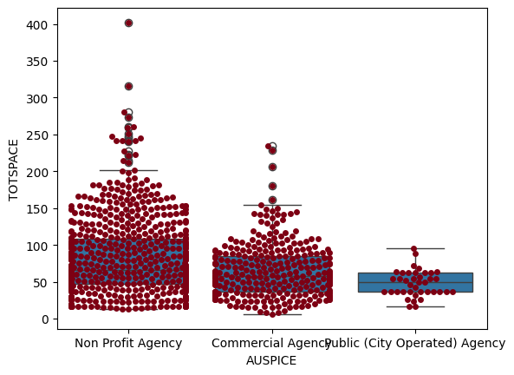

Figure 1: the distribution of total spaces (TOTSPACE) across different auspices (AUSPICE)

As Figure 1 shows, most childcare agencies are clustered within the bottom of the Y-axis, resulting in a non-normal distribution set-up. However, this is relatively reasonable as there’s no expectation of an agency having a lower capacity skewed towards zero, which practically does not make sense. This report will not modify the dataset regardless of this test result but will proceed cautiously in the upcoming analysis.

One-way ANOVA: the differences in total space across different auspices.

*Results*

The results indicated a significant difference in total space capacity across different operating auspices, with an F-statistic of 21.843051 and a highly significant p-value (p < 0.00001). This suggests that the operating auspice significantly affects the total space capacity of childcare centers in Toronto.

A boxplot demonstrating the mean TOTSPACE by auspice is created to illustrate this significant effect further. See Figure 2.

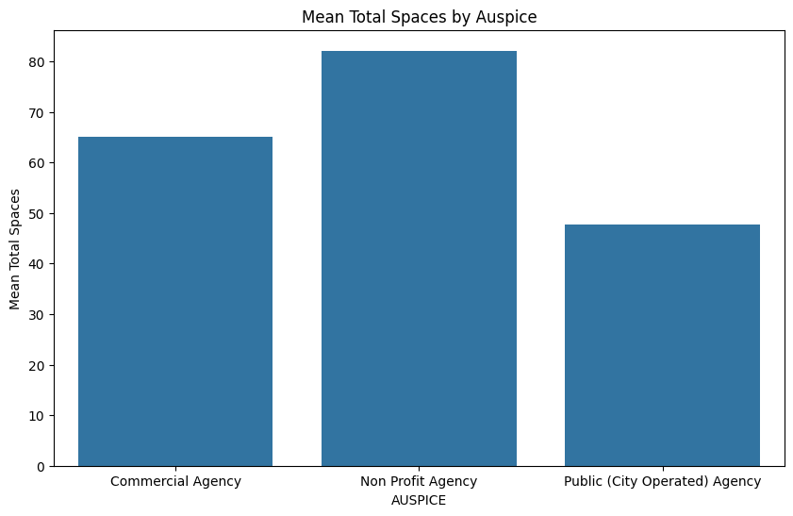

Figure 2 Mean Total Spaces By Auspice

Two-way ANOVA: Utilized to investigate the interaction between operating auspice and subsidy availability on total space.

*Results*

A significant interaction effect between operating auspice and subsidy availability on total space capacity, with an F-statistic of 13.456555 and a p-value (p < 0.00001), suggests that subsidy availability's impact on total space capacity varies depending on the operating auspice.

Figure 3 Interaction Effect Of Auspice And Subsidy On Totalspace

With careful examination of the visualization of the interaction effect (Figure 3), we can conclude the following findings:

1. Subsidies significantly affect space availabilities in all three types of auspices. Public agencies, which are entirely run with the help of subsidies, have the lowest mean space availability. This notable decrease in total space for agencies with subsidies compared to those without might indicate that operational or funding differences in public agencies eventually affect their ability to expand capacities.
2. The interaction effect here suggests that the impact of subsidies on total space is not uniform across different types of childcare agencies. For Non-Profit agencies, the difference in capacity between subsidized and non-subsidized centers is more pronounced than for Commercial Agencies.
3. Figure 3 suggests that subsidies do not have as clear an effect on capacity as they do with non-profit agencies. The convergence of the two lines indicates that both subsidized and non-subsidized agencies seem to offer similar capacities.

Figure 4 further illustrates this insight, clearly indicating the abovementioned interaction effect in the boxplot.

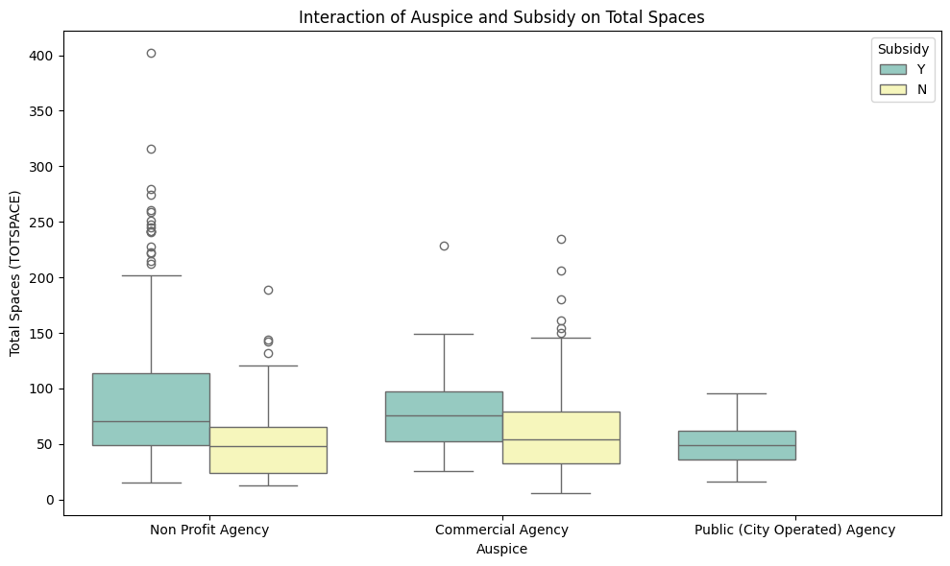

Figure 4 Interaction of Auspice and Subsidy on Total Spaces

*Assumption Violations*

The Shapiro-Wilk test suggested that the total spaces within each group of the auspice variable deviated significantly from a normal distribution, with p-values far below the standard alpha threshold of 0.05. This was also true for the 'subsidy' variable, indicating that both subsidy-available and non-available groups did not follow a normal distribution. This was explained and rationalized in previous sections.

Post Hoc Analysis using Tukey HSD

*Post Hoc Analysis*

A post hoc Tukey HSD test was performed to understand where the differences lay. The test highlighted some comparisons with significant mean differences:

1. There was a significant difference in total space between non-profit agencies with subsidy available and those without (Mean Difference = 44.99, p < 0.001).
2. Conversely, no significant difference was observed between the mean total space of non-profit and commercial agencies with subsidy available (Mean Difference = 0.145, p = 0.900).

These findings indicate that subsidy availability may impact total space differently depending on the childcare system's operating auspices.

**Conclusions**

Our statistical analysis of childcare centers in Toronto revealed notable effects of operating auspices and subsidy availability on center capacity. The one-way ANOVA confirmed that the total space varies significantly across different auspices. The two-way ANOVA further demonstrated a significant interaction between auspice types and subsidy status, underscoring that the benefit of subsidies on increasing capacity is most pronounced in non-profit agencies.

In light of these results, policymakers and childcare providers in Toronto should consider the types of agencies and the availability of subsidies to expand capacity and increase access to childcare services. Our study confirms that operating auspices and subsidy availability influence childcare centers' capacity, which has significant implications for planning and policymaking in this sector.