DAS: Security Assignment

Name: Amber Harrison

This lab covers security in MySQL and MongoDB.

MySQL

1. Create a new user with only local access. The username should be your first initial and last name.

Deliverable: Paste the text of the SQL statement(s) below and a screenshot of the results. Remember, screenshots must not be cropped. The statement and results image are worth 50% each.

CREATE USER 'aharrison'@'localhost' IDENTIFIED BY 'yourpassword';
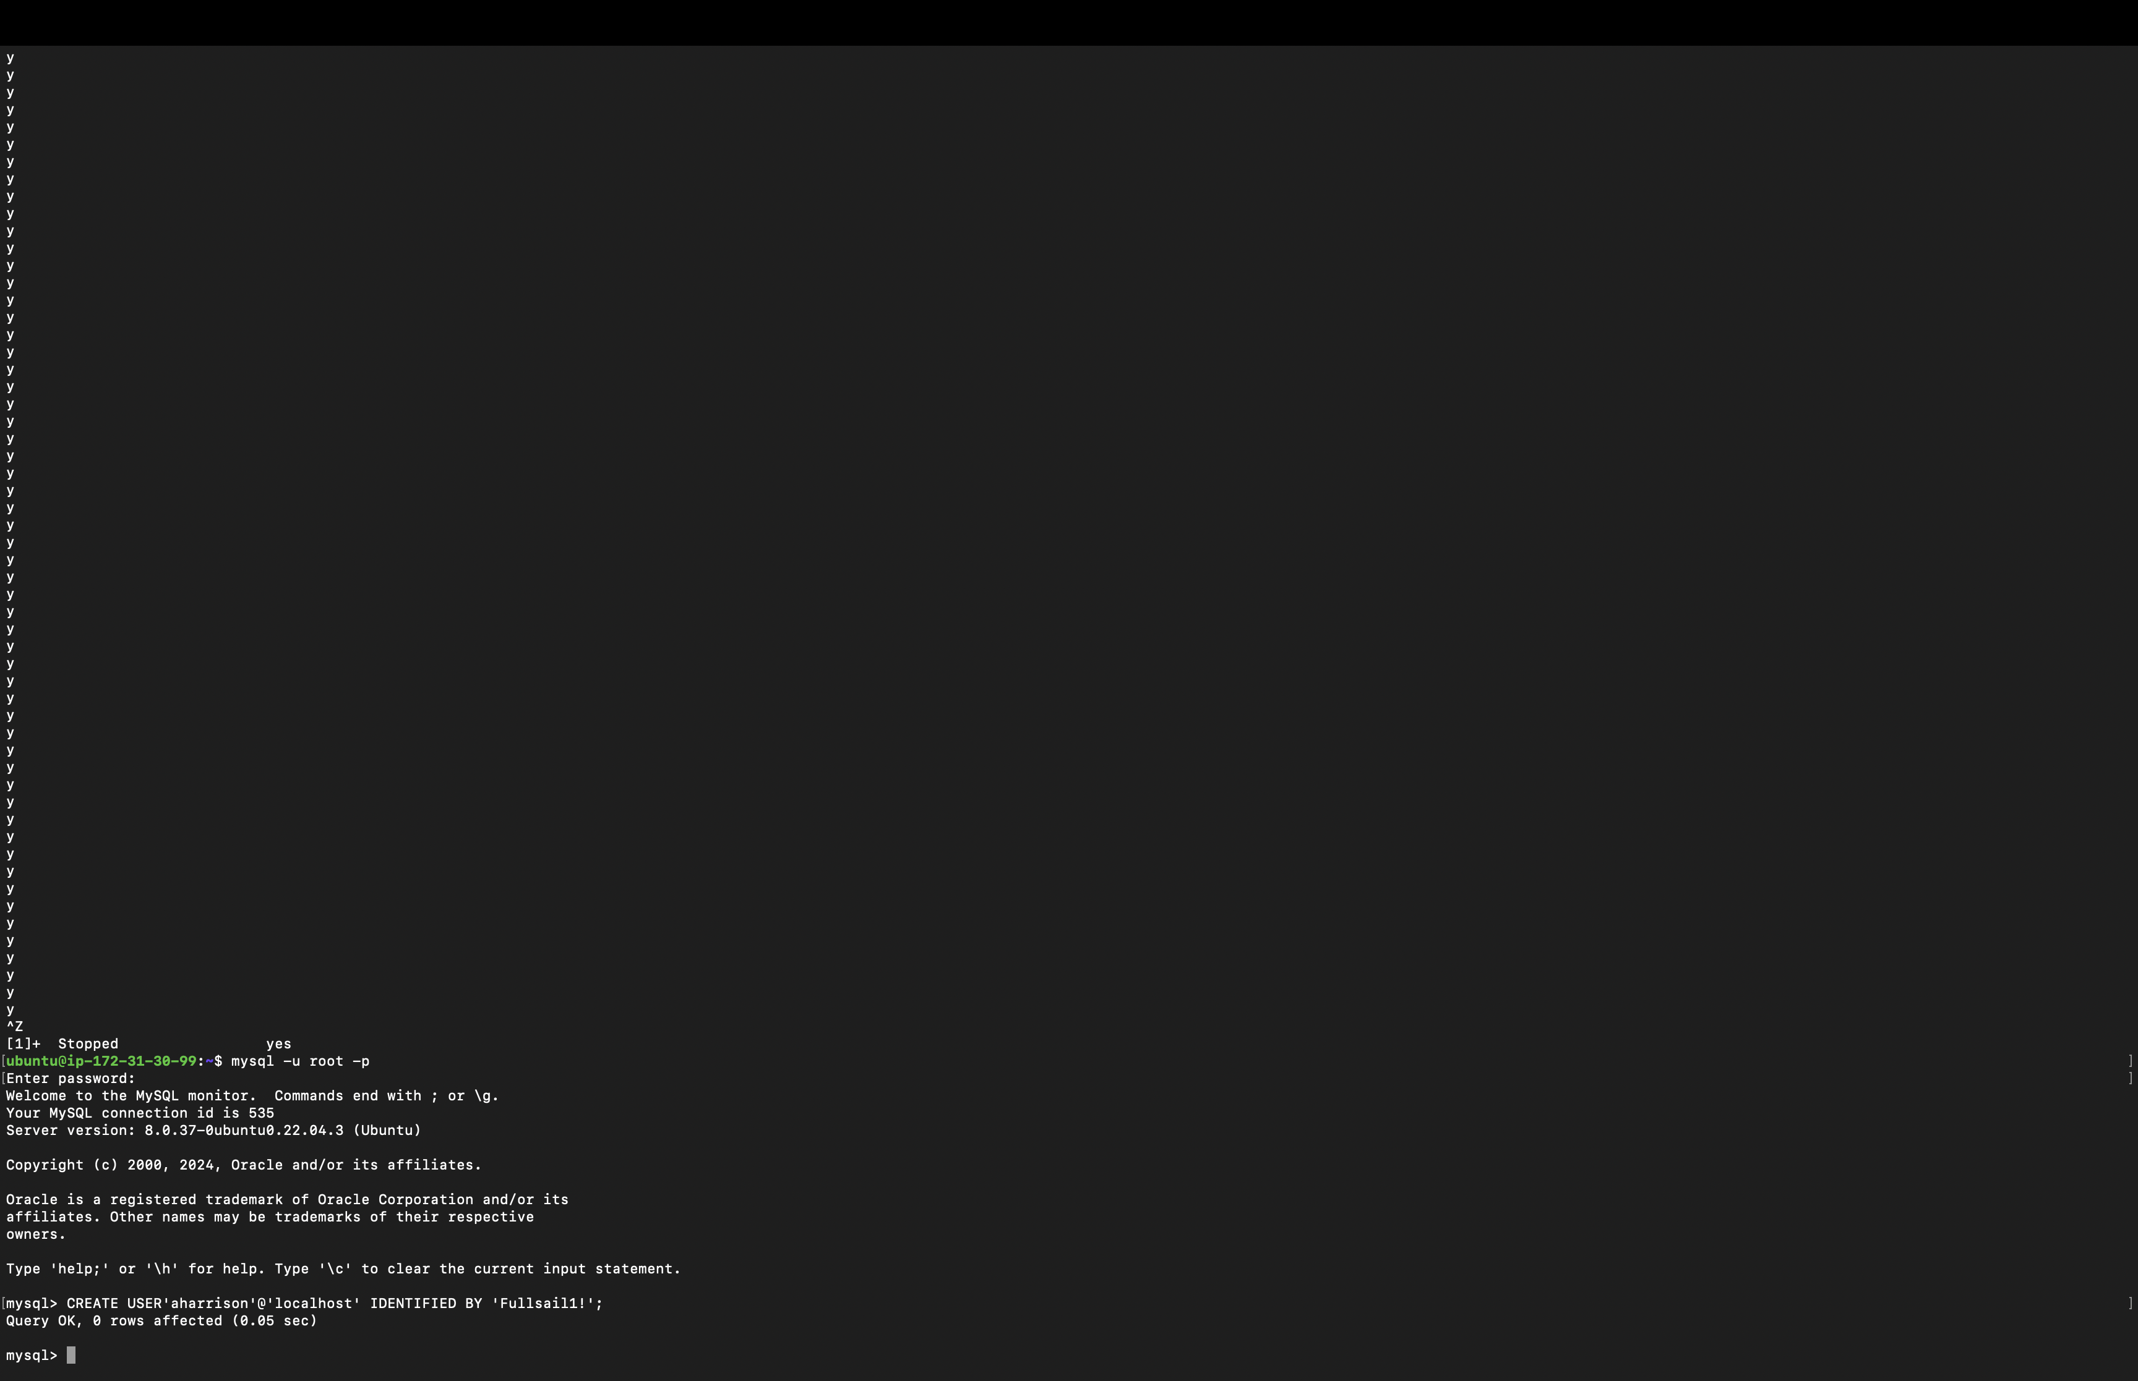

2. For the user created in question 1, grant this user all permissions to the acme database. This should include the ability to grant these permissions to other users.

Deliverable: Paste the text of the SQL statement(s) below.

GRANT ALL PRIVILEGES ON acme.* TO 'aharrison'@'localhost' WITH GRANT OPTION;

3. For the user created in question 1, grant this user select permission to the country table in the sampleData database. This should NOT include the ability to grant this permission to other users.

Deliverable: Paste the text of the SQL statement(s) below.

GRANT SELECT ON sampleData.country TO 'aharrison'@'localhost';
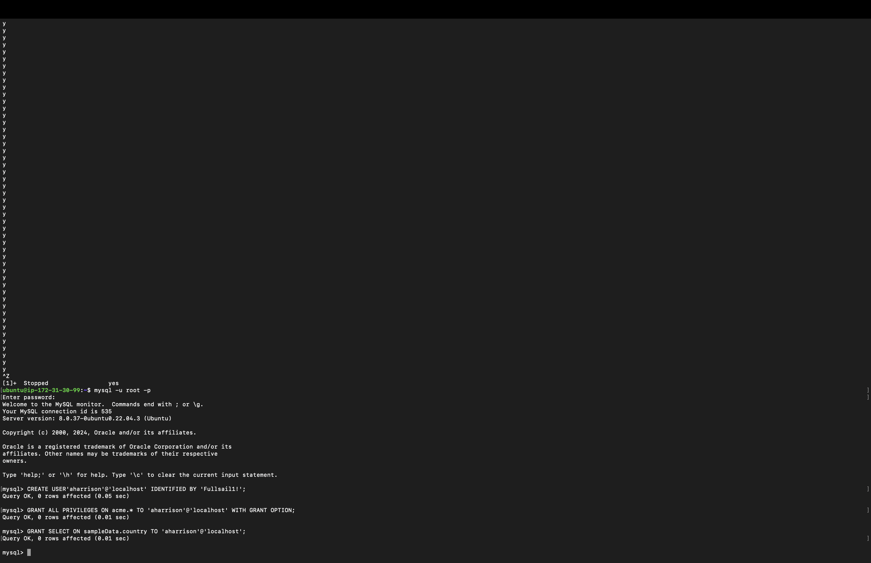

4. Using MySQL Workbench, open the “Users and Privileges” tab. Click on the new user, then click on Schema Privileges.

Deliverable: Submit an image of MySQL Workbench with the user & privileges section showing.

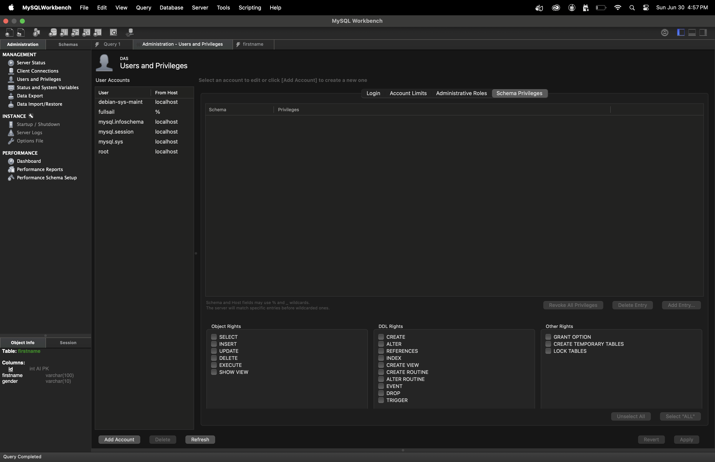

5. Look at the “Users and Privileges” tab from the previous question then review questions 1-3. What is missing or inaccurate in MySQL Workbench? Hint: GUIs although great for their quick access and simplicity do not always do into the same detail as the command line.

Deliverable: List what important detail is missing from the “Users and Privileges” tab.

The Users and Privileges tab of MySQL Workbench gives a simplified outline of user permissions. Still, it might not display all intricate rights that are shown by flags like WITH GRANT OPTION. In addition, some advanced configurations as well as unique access rights could remain hidden unless direct interaction through command lines is used to confirm and set up.

To complete this assignment, upload this completed document to FSO.

