Restaurant CRM System – Salesforce Project Documentation

This document outlines the complete Salesforce CRM implementation for a Restaurant Management System. It serves as a blueprint covering business requirements, configuration, data modeling, automation, and testing, ensuring system scalability, maintainability, and alignment with business objectives.

# Project Overview

The Restaurant CRM System is designed to streamline restaurant operations and improve customer experience. It provides an integrated platform for managing customer information, table reservations, online orders, menu inventory, billing, feedback collection, and reporting. By leveraging Salesforce CRM, restaurants can automate workflows, enhance customer engagement, and achieve operational excellence.

# Objectives

The main objective of this CRM is to create a centralized system for handling all restaurant-related operations. The system ensures seamless coordination between front-end reservations, order management, and back-end analytics. Key goals include improving customer satisfaction, minimizing manual errors, automating bookings and payments, and providing insightful reports for data-driven decision-making.

# Phase 1: Problem Understanding & Industry Analysis

• Requirement Gathering – Conducted stakeholder meetings to identify core processes such as reservations, orders, and payments.

• Stakeholder Analysis – Primary users include restaurant staff, managers, and customers.

• Business Process Mapping – Mapped reservation-to-billing workflows for automation in Salesforce.

• Industry-specific Use Case – Designed features like table booking confirmation and order tracking.

• AppExchange Exploration – Reviewed third-party apps for POS and menu integration.

# Phase 2: Org Setup & Configuration

Salesforce Edition: Enterprise Edition  
Company Profile Setup: Defined Restaurant operating hours, holidays, and fiscal year.  
Users: Created profiles for Admin, Manager, and Staff.  
Login Access: Configured trusted IP ranges for security.

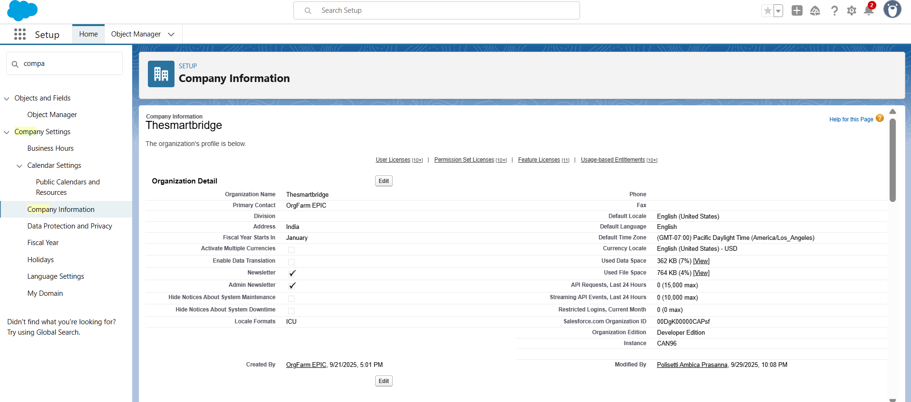

# Phase 3: Data Modeling & Relationships

Custom Objects: Customer, Table Reservation, Online Order, Menu Item, Payment, Feedback.  
Relationships: Master-Detail between Customer → Reservation and Lookup between Reservation → Payment.  
Record Types: Used for dine-in and online orders.  
Page Layouts and Compact Layouts customized for each profile.

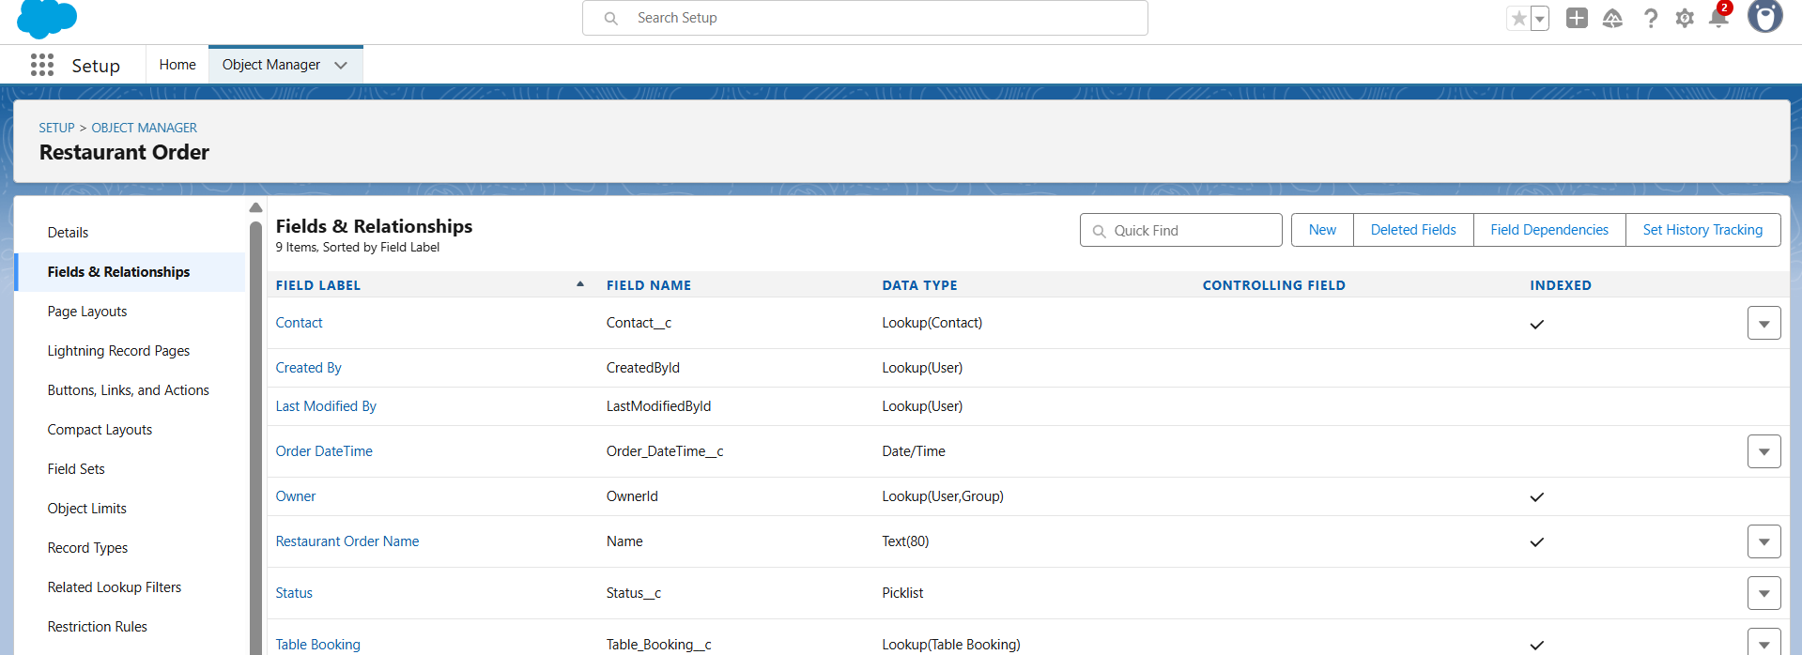

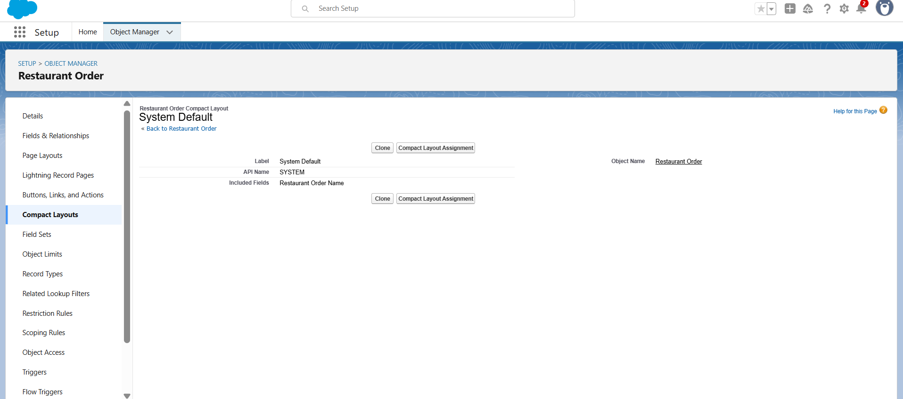

# Phase 4: Process Automation (Admin)

Validation Rules: Prevent duplicate reservations and incomplete orders.  
Flows: Implemented screen flows for booking and cancellation.  
Approval Process: Used for high-value catering requests.  
Workflow Rules: Automated booking confirmation email alerts.  
Tasks: Auto-generated tasks for staff follow-ups.

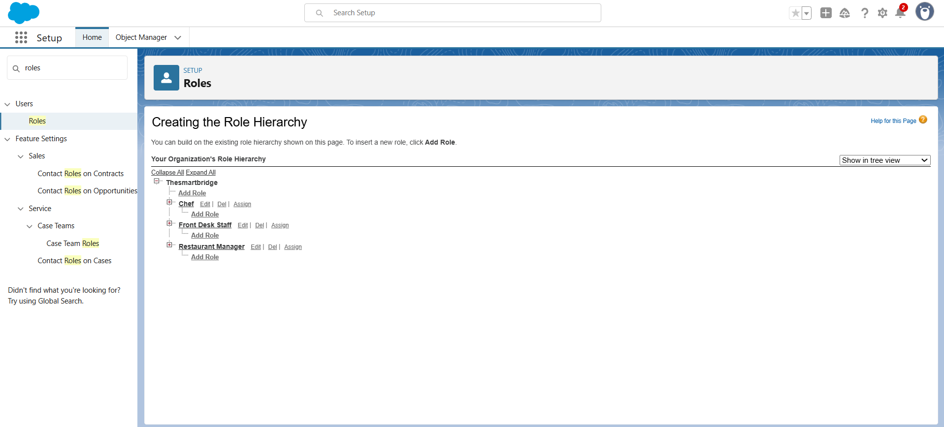

# Phase 5: Apex Programming (Developer)

Apex Triggers: Implemented before insert triggers to check reservation conflicts.  
SOQL Queries: Used to fetch related customer and order data.  
Batch Apex: For end-of-day sales report generation.  
Future Methods: For sending asynchronous email confirmations.

# Phase 6: User Interface Development

Lightning App Builder: Created custom Restaurant Management App.  
Record Pages: Customized for Reservation and Payment objects.  
Tabs: Added for Menu, Orders, and Feedback.  
LWC: Built dynamic table availability component using Apex and LWC.  
Navigation Service: Implemented smooth navigation between records.

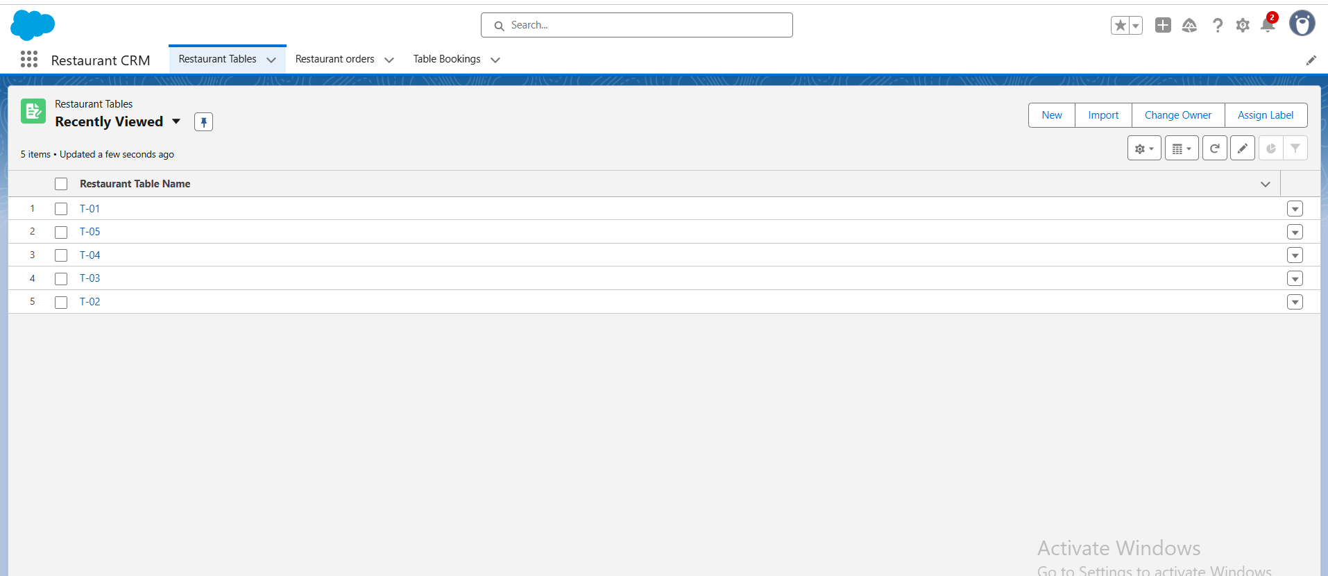

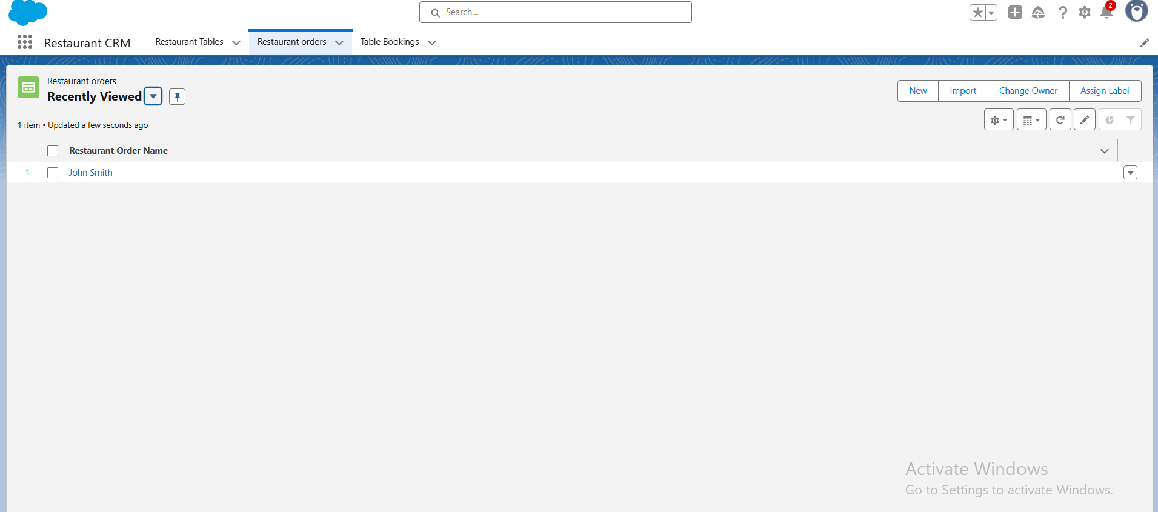

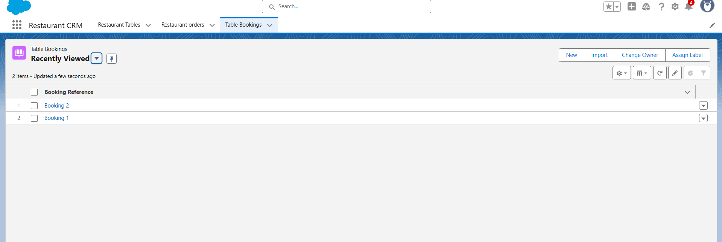

# Phase 7: Integration & External Access

Named Credentials: Configured for email API integration.  
Web Services: Created REST API endpoints for external food delivery platforms.  
Platform Events: Used to notify staff of new online orders.  
OAuth Authentication: Enabled for secure third-party integrations.

# Phase 8: Data Management & Deployment

Data Import Wizard: Imported initial customer and menu data.  
Duplicate Rules: Prevented duplicate customer records.  
Change Sets: Used for deployment from sandbox to production.  
Data Backup: Configured weekly data export schedules.

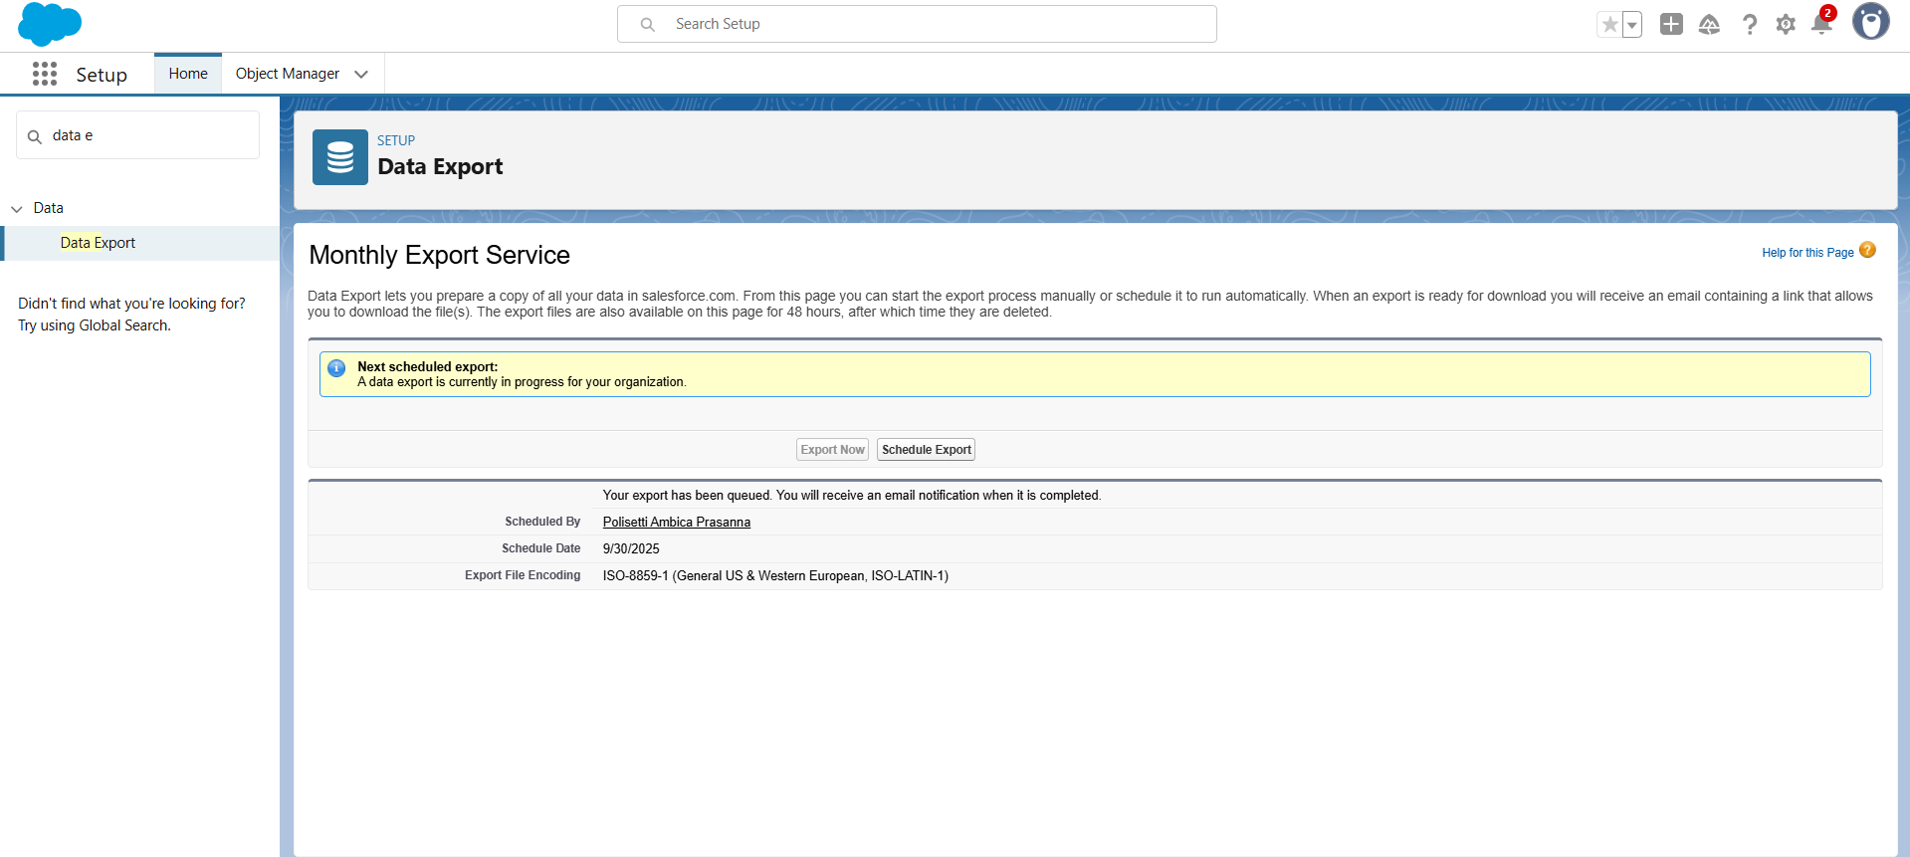

# Phase 9: Reporting, Dashboards & Security Review

Reports: Created summary reports for daily sales and reservations.  
Dashboards: Built interactive dashboards for revenue insights.  
Profiles & Roles: Defined role hierarchy – Admin > Manager > Staff.  
Permission Sets: Granted custom access for reporting.  
OWD & Sharing Rules: Configured private model with selective sharing.

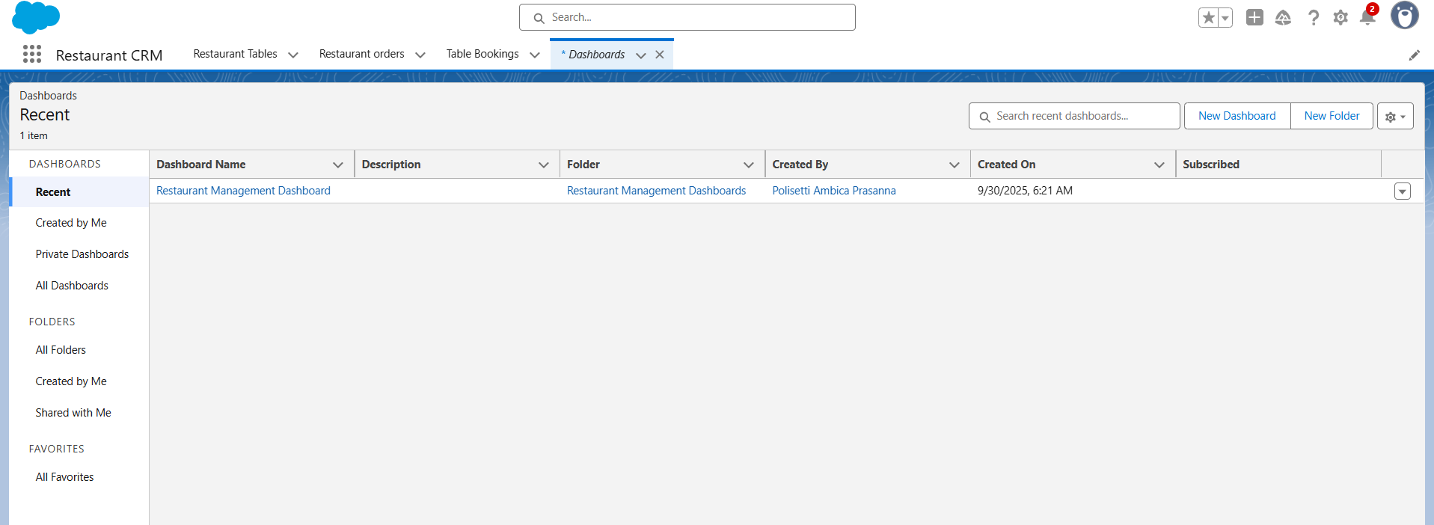

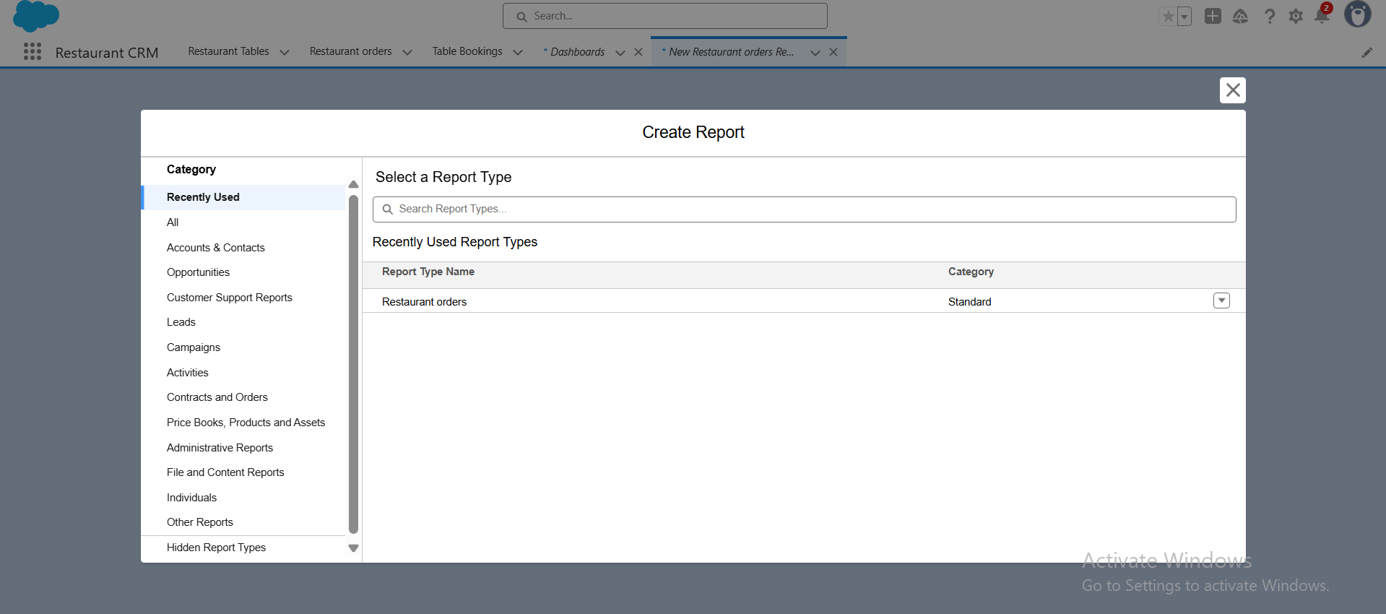

# Phase 10: Quality Assurance Testing

Test cases were prepared for flows, validation rules, triggers, and approval processes.  
Each test case included input data, expected results, and actual outcomes.  
All functionalities such as booking automation, payment updates, and reports were validated successfully.

# 

# Conclusion

The Restaurant CRM System successfully automates the restaurant’s operational workflows, improving customer experience and managerial decision-making. The Salesforce platform provides scalability, data security, and extensibility for future enhancements such as AI-based recommendations and chatbot integrations. The project demonstrates an end-to-end CRM lifecycle from requirement gathering to deployment and testing.

# Vedio Link: <https://drive.google.com/file/d/13xX6U35qaWeglibXg85WD_20QjxsP8Ll/view?usp=sharing>

# Future Enhancementsvedio link

• Integration with WhatsApp or chatbot for customer support.  
• Predictive analytics using Einstein AI for demand forecasting.  
• Loyalty management and personalized offers for regular customers.  
• Mobile app integration for quick order and reservation tracking.