**Project: Restaurant Booking & Order Management System**

**Phase 2: Organization & Setup Configuration**

**Problem Statement:**

Restaurants face challenges in managing tables, tracking customer reservations, and coordinating orders effectively. Manual processes such as spreadsheets or paper-based records cause delays, errors, and lack of real-time visibility. This results in double bookings, confused staff, slow service, and limited insights for restaurant managers and owners.

The **Restaurant Booking & Order Management System** aims to overcome these issues by providing a Salesforce-based application that:

* Centralizes tables, bookings, customer, and order records.
* Tracks table status and order progress in real-time.
* Improves table assignment and reservation management.
* Offers dashboards and reports for operational insights.

**Salesforce Edition & Environment Setup:**

* **Edition:** Salesforce Developer Edition
* **Instance:** NA45
* **Purpose:** Development environment dedicated to building and testing the Restaurant Booking & Order Management System

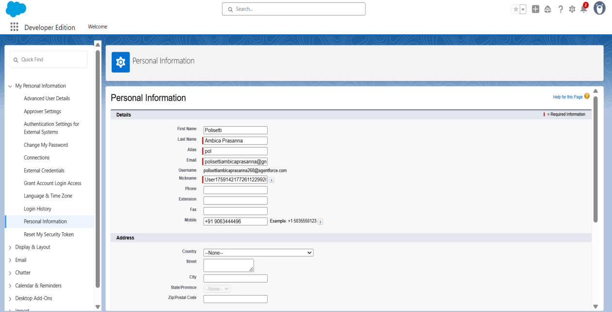

**Company Profile Configuration:**

* **Organization Name:** restaurant name
* **Industry:** Restaurant
* **Primary Contact:** System Administrator
* **Default Locale:** English (India)
* **Default Language:** English
* **Default Time Zone:** (GMT +5:30) Asia/Kolkata
* **Currency:** Indian Rupee (INR)

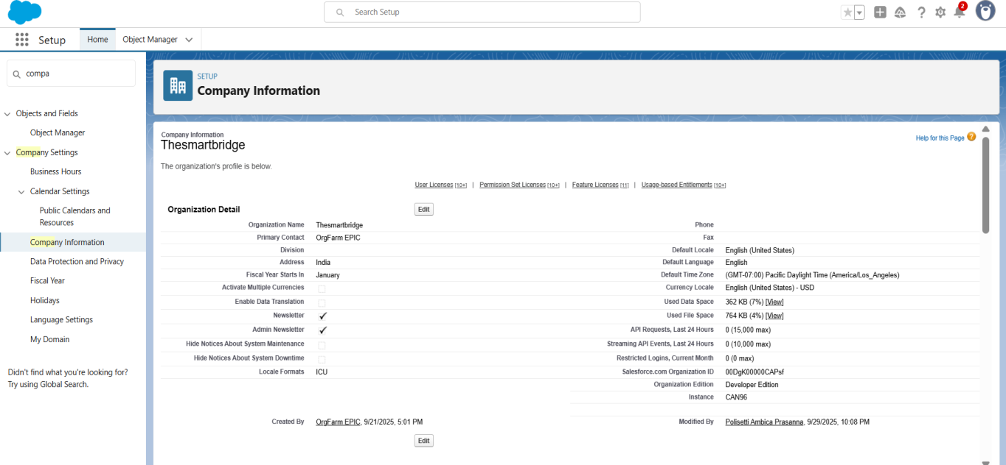

**Restaurant Role Hierarchy Setup:**

**Role Structure:**

Restaurant Manager (Top Level)

│

├── Front Desk Staff / Host

│

└── Chef / Kitchen Staff

**Responsibilities:**

* **Restaurant Manager:** Oversees table management, bookings, and orders; monitors dashboards and reports.
* **Front Desk Staff / Host:** Manages customer bookings and updates table status.
* **Chef / Kitchen Staff:** Monitors orders and ensures timely preparation.

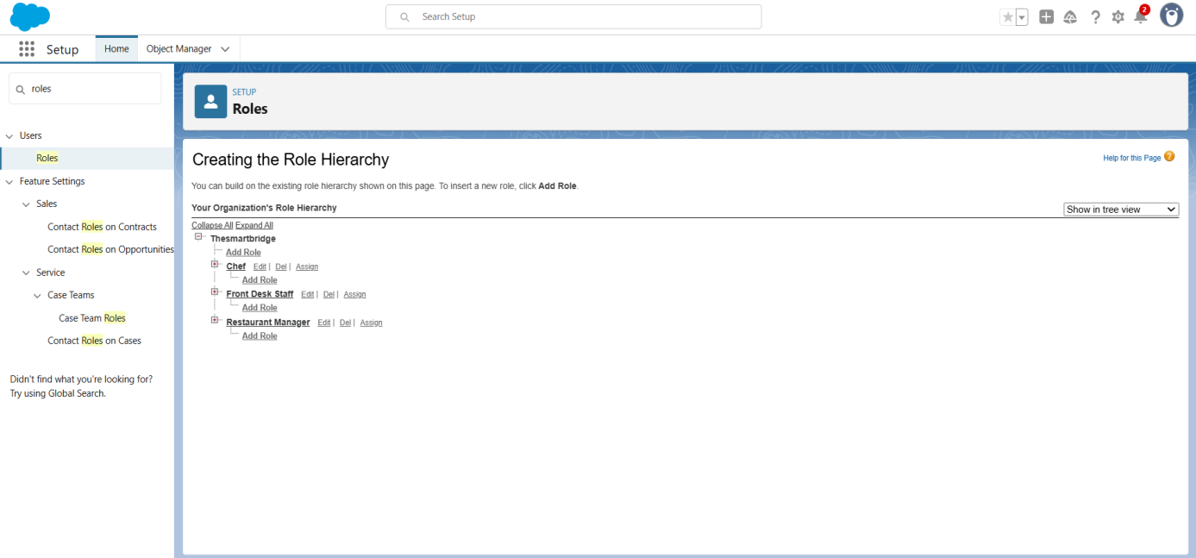

**User Profiles Created:**

* Restaurant Manager
* Front Desk Staff / Host
* Chef / Kitchen Staff

**Business Hours Configuration:**

* **Operating Hours:**
  + Monday – Friday: 10:00 AM – 10:00 PM
  + Saturday – Sunday: 10:00 AM – 11:00 PM
* **Purpose:** Ensures that automated workflows and processes respect restaurant operating hours.

**User License Management:**

* **Salesforce Platform Licenses:** Allocated to restaurant staff.
* **System Administrator License:** For IT and CRM management.

**Security Foundation:**

* **Organization-Wide Defaults (OWD):** Set to Private for custom objects (Restaurant Tables, Table Bookings, Restaurant Orders).
* **Role Hierarchy:** Configured to allow record visibility based on roles.
* **Sharing Rules:** Role-based sharing model applied to ensure secure but collaborative data access.