**Project: Restaurant Booking & Order Management System**

**Phase 3: Custom Object Creation & Configuration**

**Standard & Custom Objects**

**1. Standard Objects Used:**

* **Contact → Represents Customers** (reuse instead of creating a custom Customer object).

**2. Custom Objects Created:**

* **Restaurant Table** – Tracks table details and availability.
* **Table Booking** – Stores customer reservations linked to tables.
* **Restaurant Order** – Tracks customer orders linked to bookings.

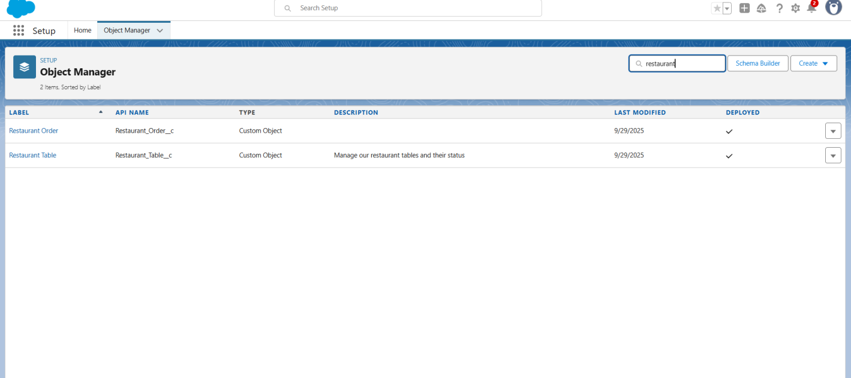

**3.2 Fields**

**Restaurant Table Fields:**

* **Table Number** (Text) → Unique identifier for each table
* **Capacity** (Number) → Number of seats per table
* **Location** (Picklist: Indoor, Outdoor, Private Room)
* **Status** (Picklist: Available, Reserved, Occupied)

**Table Booking Fields:**

* **Customer** (Lookup to Contact)
* **Table** (Lookup to Restaurant Table)
* **Booking Date** (Date)
* **Booking Time** (Picklist: 6:00 PM, 7:00 PM, 8:00 PM, 9:00 PM)
* **Party Size** (Number)
* **Status** (Picklist: Confirmed, Seated, Completed)

**Restaurant Order Fields:**

* **Customer** (Lookup to Contact)
* **Table Booking** (Lookup to Table Booking)
* **Order DateTime** (DateTime)
* **Total Amount** (Currency)
* **Status** (Picklist: Placed, In Progress, Ready, Served, Paid)

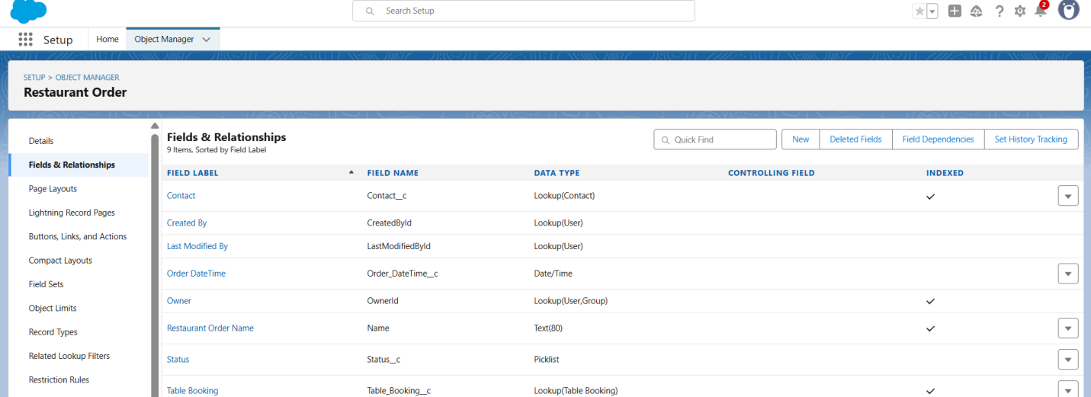

**3.3 Record Types (Optional)**

* Can create **Order Record Types** to categorize orders:
  + Dine-In Order
  + Takeaway Order

**3.4 Page Layouts**

**Restaurant Table Page Layout:**

* **Top Section:** Table Number, Capacity
* **Middle Section:** Location, Status
* **Bottom Section:** Notes (optional)

**Table Booking Page Layout:**

* **Top Section:** Booking Reference, Customer, Table
* **Middle Section:** Booking Date, Booking Time, Party Size
* **Bottom Section:** Status

**Restaurant Order Page Layout:**

* **Top Section:** Customer, Table Booking
* **Middle Section:** Order DateTime, Total Amount
* **Bottom Section:** Status

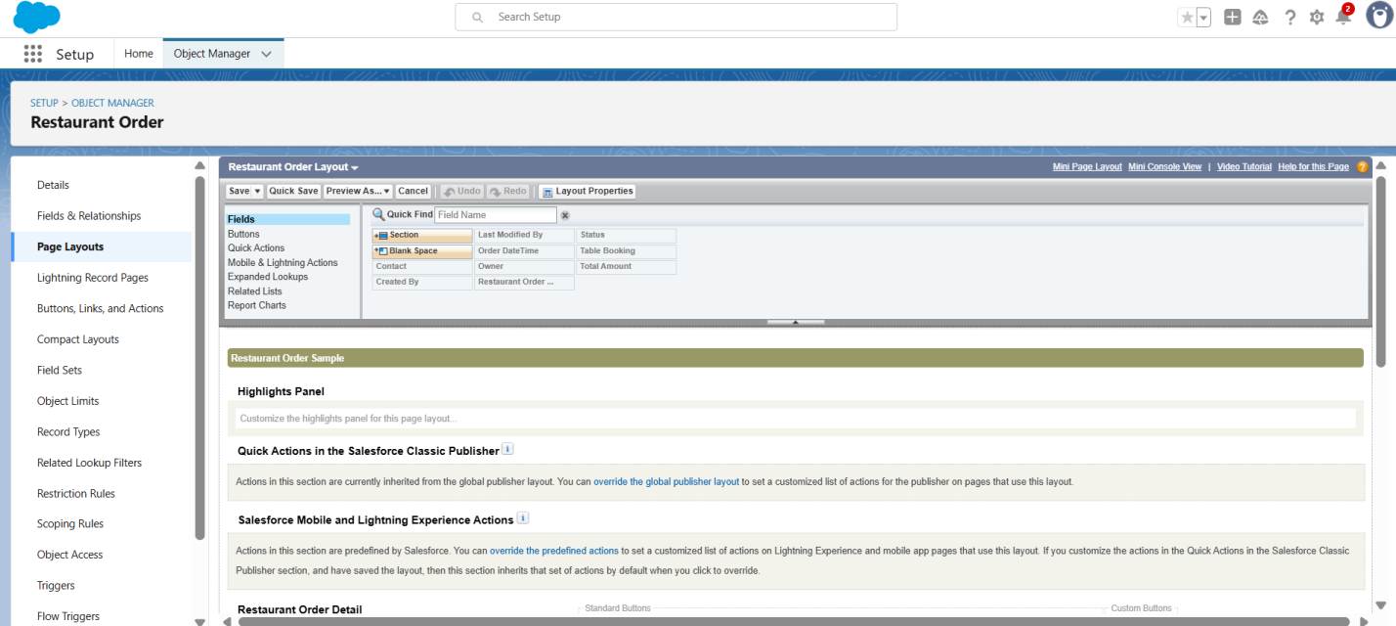

**3.5 Compact Layouts**

* **Restaurant Table Compact Layout:** Table Number, Capacity, Status
* **Table Booking Compact Layout:** Booking Reference, Customer, Table, Status
* **Restaurant Order Compact Layout:** Customer, Table Booking, Total Amount, Status

**3.6 Relationships**

* **Table Booking → Contact (Lookup):** Links booking with customer
* **Table Booking → Restaurant Table (Lookup):** Links booking with table
* **Restaurant Order → Contact (Lookup):** Links order with customer
* **Restaurant Order → Table Booking (Lookup):** Links order with booking
* **Restaurant Table → Table Booking (Master-Detail/Lookup optional):** Tracks table usage

**3.7 Schema Builder (Visual Data Model)**

* Open **Schema Builder**: Setup → Schema Builder
* Add **Objects**: Contact, Restaurant Table, Table Booking, Restaurant Order
* Show **relationships** with connecting lines:
  + Contact ↔ Table Booking
  + Contact ↔ Restaurant Order
  + Table Booking ↔ Restaurant Order
  + Table Booking ↔ Restaurant Table