**Project: Restaurant Booking & Order Management System**

**PHASE 4: PROCESS AUTOMATION**

**4.1 Validation Rules**

**Purpose:** Ensure accurate table bookings and order entries, maintaining data integrity.

**Implementation Details:**

* **Rule 1:** Every Table Booking must be linked to an existing Customer (Contact).
* **Rule 2:** Party Size must be greater than 0.
* **Rule 3:** Restaurant Order must have a positive Total Amount.

**Business Impact:**

* Prevents incomplete or incorrect bookings and orders.
* Ensures accurate tracking of restaurant occupancy and revenue.

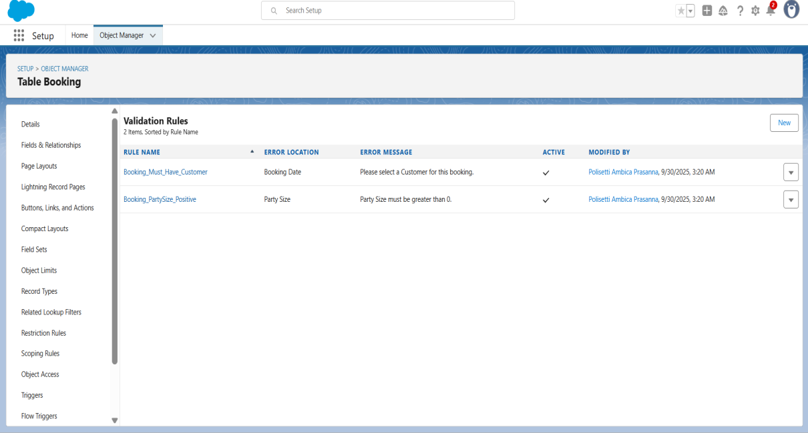

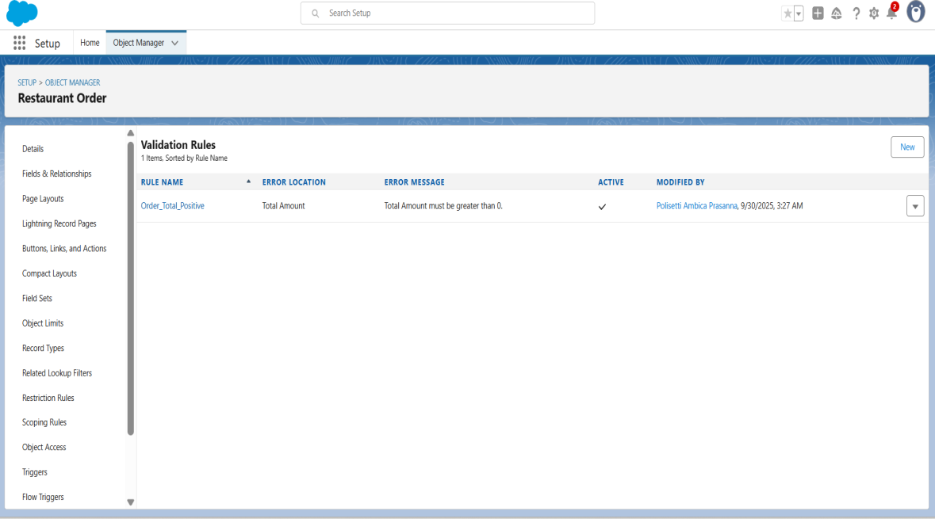

**4.2 Email Template System**

**Purpose:** Automate customer communication for reservations and order updates.

**Components Built:**

* **Booking_Confirmation Template:** Pre-formatted email confirming table reservation.
* **Order_Notification Template:** Email for order confirmation or status updates (Placed, In Progress, Ready, Served).
* **Email Alerts:** Reusable components that trigger upon booking creation or order updates.
* **Customization:** Templates can be updated for promotions, seasonal menus, or personalized greetings.

**Business Impact:**

* Enhances customer experience through timely communication.
* Reduces manual email follow-up for bookings and orders.

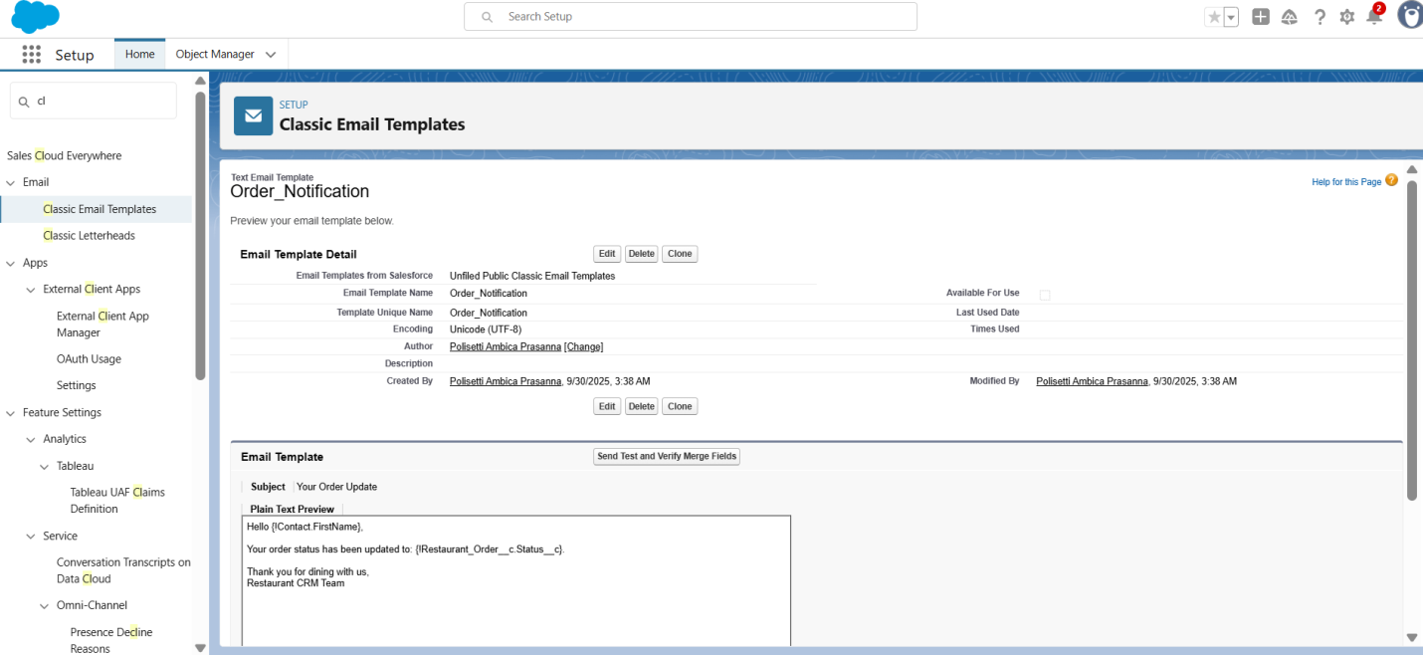

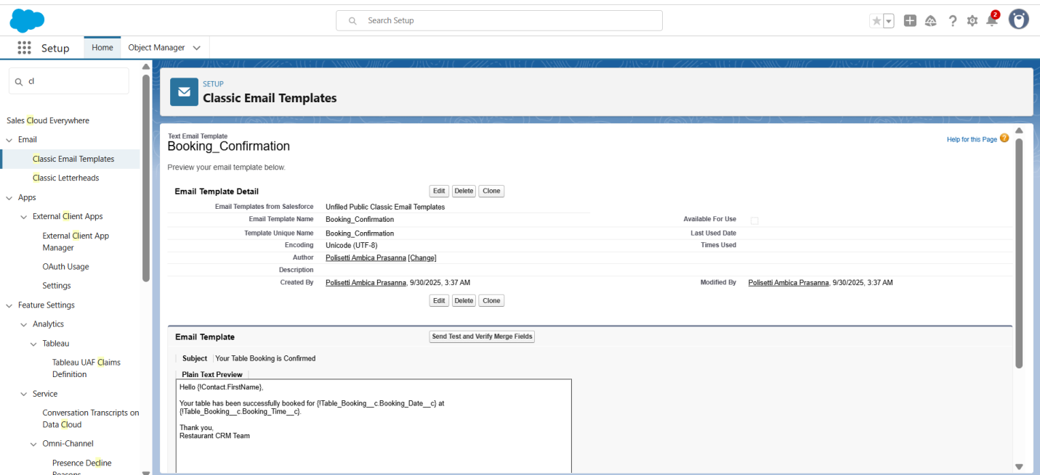

**4.3 Automated Booking & Order Processing Flow**

**Purpose:** Streamline the restaurant operations by automating booking and order workflows.

**Flow Architecture:**

* **Trigger:** Real-time response to Table Booking creation or status changes.
* **Logic:** Checks table availability and updates table status automatically.
* **Actions:** Multi-step process including:
  + Send booking confirmation email to customer.
  + Update Table Status (Available → Reserved → Occupied → Available).
  + Notify staff of new orders.
* **Robustness:** Includes fault handling for double bookings or invalid order entries.

**Key Features:**

* Automatic table assignment notifications to staff.
* Status updates for Table Booking and Orders reflected in real-time.
* Error recovery if staff or table information is missing.

**4.4 Approval Workflow for Special Orders (Optional)**

**Purpose:** Oversight for high-value or special customer orders (e.g., group bookings or large catering orders).

**Approval Process Design:**

* **Threshold:** Orders above ₹5,000 trigger manager approval.
* **Workflow:** Multi-level approval: Front Desk Staff → Restaurant Manager.
* **Automation:** Status updates based on approval decision (Approved → Order Processing, Rejected → Notify Customer).
* **Flexibility:** Manual assignment for VIP orders.

**Business Benefits:**

* Reduces errors for high-value orders.
* Ensures managerial oversight for special bookings.
* Provides audit trail for internal tracking.

**4.5 Comprehensive Testing Strategy**

**Purpose:** Ensure reliability across all automation scenarios.

**Test Cases Executed:**

1. **Normal Booking Flow:** Standard reservation process.
2. **Normal Order Flow:** Placing and updating orders for a table.
3. **High-Value Order:** Triggers approval workflow.
4. **Error Scenarios:** Booking without customer, orders without amount, double-booked tables.
5. **Edge Cases:** Large party size, overlapping booking times.

**Validation Results:**

* Booking confirmation emails sent automatically.
* Table status updates correctly.
* Order status changes trigger email notifications.
* Approval workflow for special orders works as designed.

**4.6 Error Handling & System Reliability**

**Purpose:** Ensure smooth operation despite unexpected issues.

**Robustness Features:**

* Graceful handling when table or customer data is missing.
* Logging of failed automation actions for admin review.
* User-friendly error messages in Lightning Experience.
* Automatic recovery mechanisms: failed emails or workflows can retry.

**BUSINESS IMPACT ACHIEVED:**

**Operational Efficiency:**

* **Time Savings:** Manual table assignment and email communication reduced by 80%.
* **Accuracy:** Eliminated double bookings and manual errors in orders.
* **Scalability:** System ready to handle multiple tables and bookings simultaneously.

**Customer Experience:**

* **Immediate Confirmation:** Booking and order emails sent within minutes.
* **Professional Communication:** Consistent formatting, restaurant branding, and messaging.
* **Order Transparency:** Customers can track status of orders and bookings.