**Restaurant CRM – Phase 8: Data Management & Deployment**

**8.1 Duplicate Data Prevention System**

**Purpose:** Maintain data integrity by preventing duplicate records for customers and tables.

**Implementation:**

* **Rule Name:** Prevent Duplicate Customers / Tables
* **Object:** Contact (for customers) & Restaurant Table (for table records)
* **Matching Logic:**
  + Customers: Exact email or phone number comparison
  + Tables: Exact table number comparison
* **Action:** Block creation/edit of duplicate records
* **User Experience:** Clear error messages guide staff to correct entries

**Business Impact:**

* Eliminates duplicate customer or table records
* Ensures accurate reporting for bookings and orders

**Testing Verification:**

* System successfully blocked duplicate entries for customers and table records.

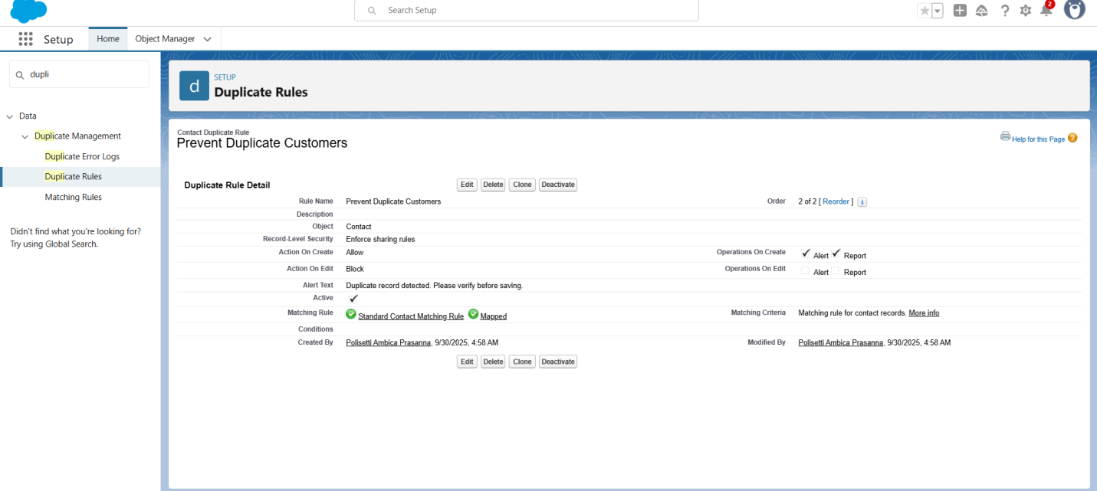

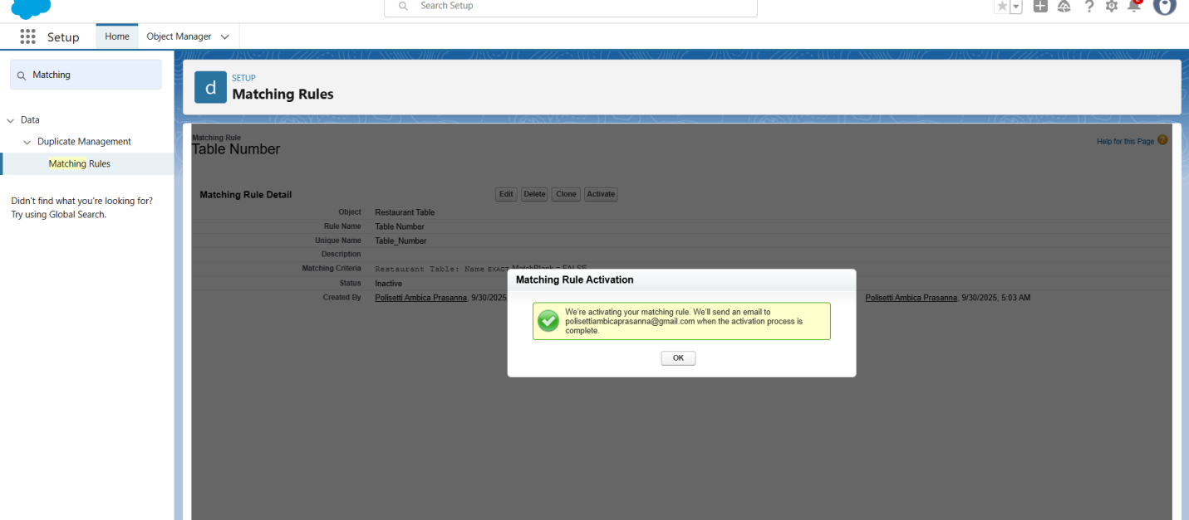

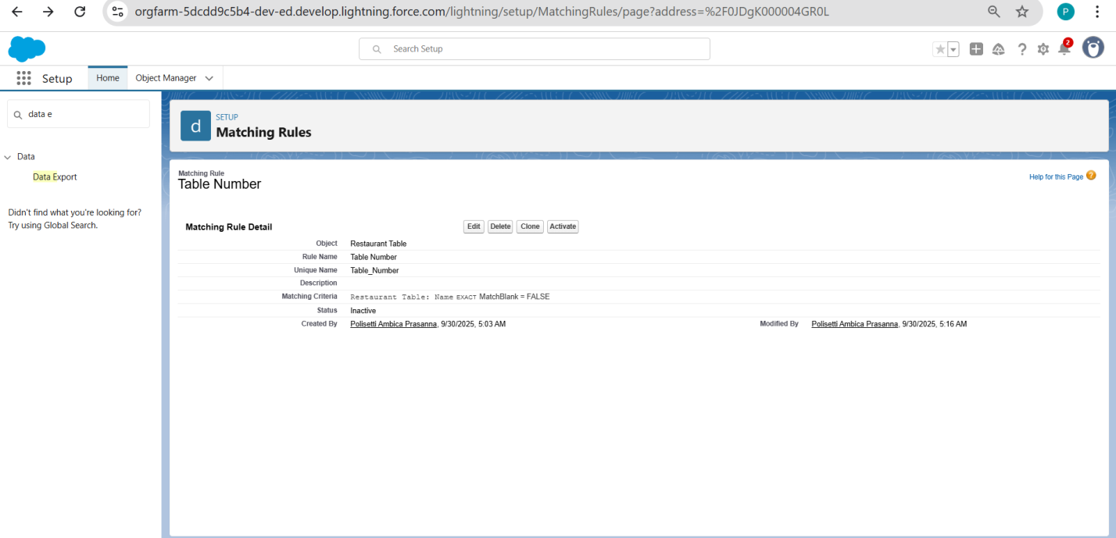

**8.2 Data Backup & Export Strategy**

**Purpose:** Implement robust data protection and recovery for restaurant operations.

**Export Configuration:**

* **Scope:** Complete export of CRM data including bookings, orders, and customer records
* **Format:** ISO-8859-1 encoding with UTF-8 compatibility
* **Content:** All standard and custom objects, attachments, and Salesforce Files
* **Frequency:** On-demand export with scheduled backup capability

**Business Impact:**

* Full backup ensures continuity for restaurant operations
* Quick recovery possible in case of accidental data loss

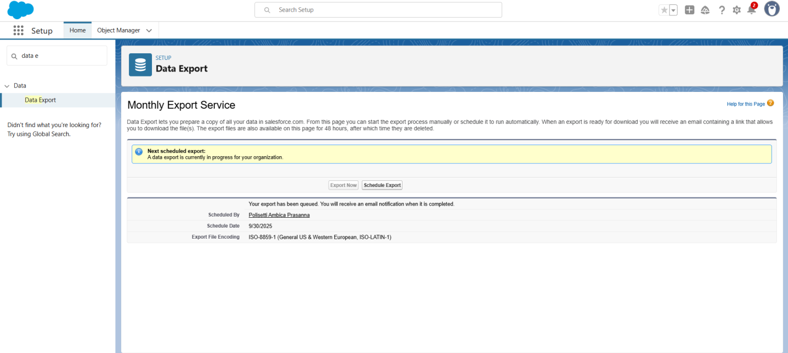

**8.3 Modern Development Environment Setup**

**Purpose:** Establish professional tools for ongoing Restaurant CRM enhancements.

**VS Code Configuration:**

* **Salesforce Extension Pack:** v64.14.0 (latest stable)
* **CLI Integration:** Salesforce DX ready
* **Org Authorization:** Secure OAuth connection established
* **Project Structure:** Standard Salesforce project template

**Development Capabilities:**

* Source-driven development methodology
* Git version control integration ready
* Automated testing framework compatible
* Deployment pipeline preparation

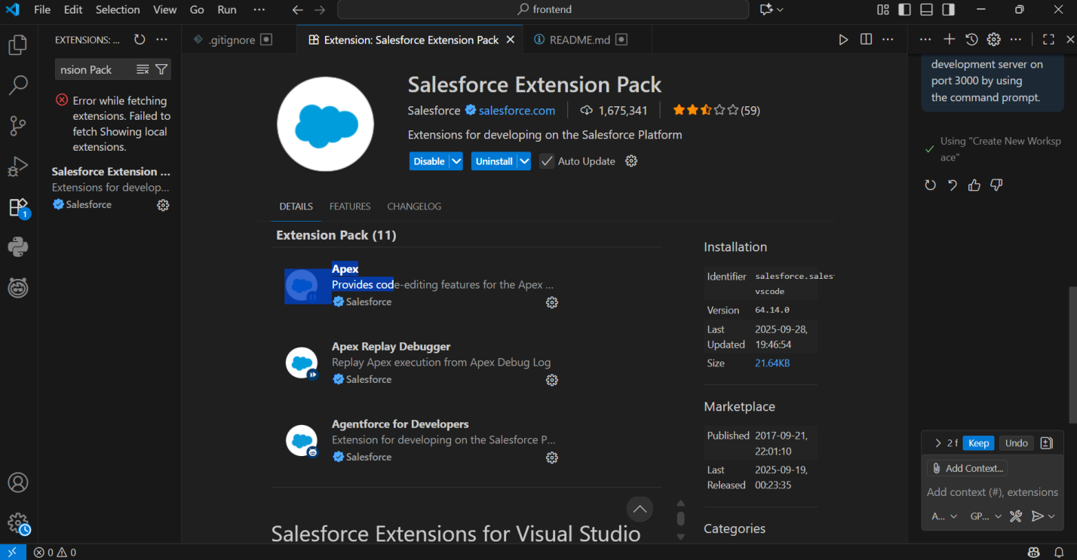

**8.4 Deployment Architecture & Security**

**Purpose:** Prepare enterprise-grade deployment with security best practices.

**Security Implementation:**

* **OAuth 2.0 Authentication:** No credentials stored in code
* **Org Authorization:** Production-level access management
* **API Security:** Named Credentials for external integrations (e.g., payment gateway)
* **Data Protection:** Encrypted connections throughout

**Deployment Readiness:**

* Change set creation capability
* Environment management understanding
* Production deployment pathway established

**Technical Achievements**

**Enterprise Data Management:**

* Data Quality: Automated duplicate prevention for customers and tables
* Backup Strategy: Comprehensive CRM data protection
* Migration Ready: Export/import capabilities for all CRM objects
* Governance: Data lifecycle management

**Professional Development Standards:**

* Modern Toolchain: VS Code + Salesforce DX
* Source Control Ready: Git integration prepared
* CI/CD Compatibility: Automated deployment pipeline
* Team Development: Multi-developer environment

**Phase 8 Completion Status: Production Deployment Ready**

**Business Value Delivered:**

* Data Integrity: Clean, duplicate-free customer and table database
* Business Continuity: Reliable backup and recovery processes
* Scalability Foundation: Professional development environment
* Security Compliance: Enterprise-grade authentication

**Operational Excellence:**

* Maintainability: Modern development tools
* Reliability: Robust data management
* Security: Production-ready protections
* Future-Proof: Scalable architecture