**9.1 Sales & Order Reporting System**

**Purpose:** Track restaurant orders, table bookings, and customer activity for management insight.

**Steps:**

1. **Create a Custom Report**
   * Setup → Reports → New Report
   * Select **Report Type:** Restaurant Order or Table Booking
   * Format: **Tabular**
   * Columns to include:
     + Order/Booking Name
     + Customer (Contact)
     + Table Number
     + Order Amount / Party Size
     + Date / Time
     + Status (Confirmed, Completed, Cancelled)
   * Filters: Include only relevant date ranges or order status if needed
   * Save as: Restaurant Order Summary
2. **Test Report**
   * Run report for last month/week
   * Check sorting, filters, and all columns display correctly
   * Ensure report is **accessible to Manager and Admin roles**

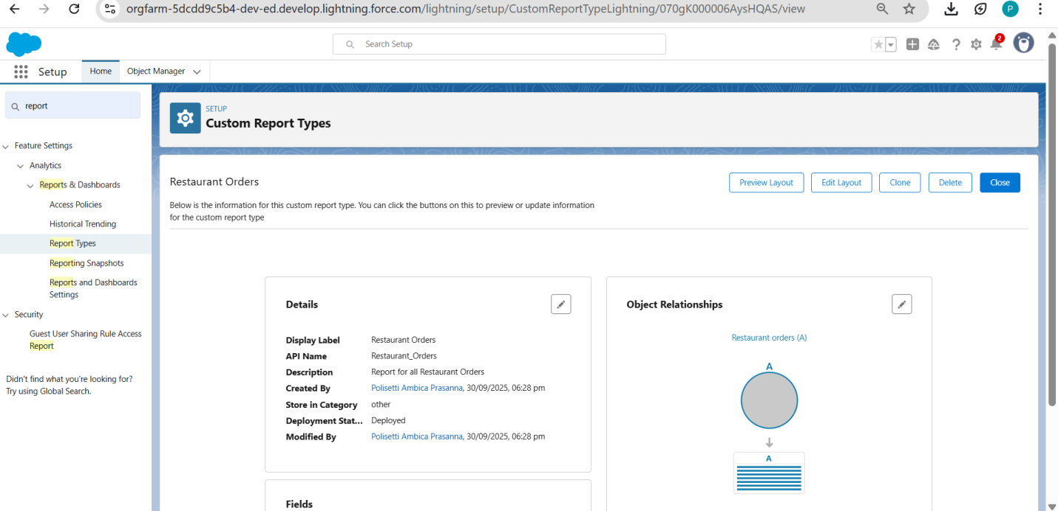

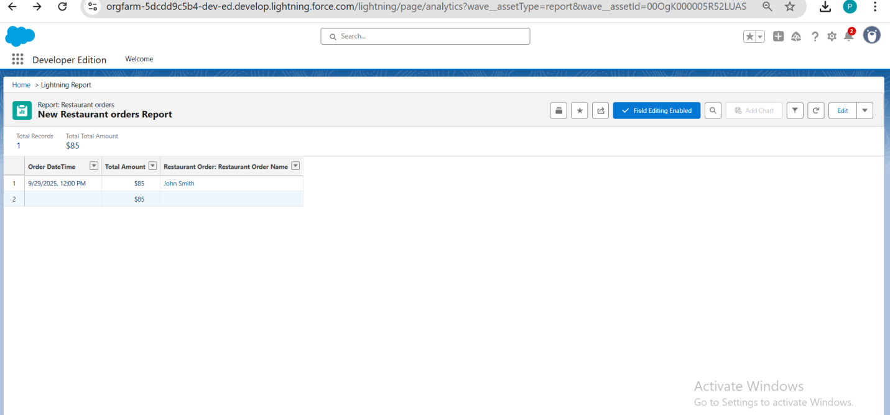

**9.2 Dashboard Visualization Setup**

**Purpose:** Provide quick, visual insight into restaurant operations.

**Steps:**

1. **Create Dashboard**
   * Setup → Dashboards → New Dashboard
   * Name: Restaurant Management Dashboard
   * Folder: Role-based folder (e.g., Managers, Admins)
2. **Add Components**
   * **Bar chart:** Orders by Status (Confirmed, Completed, Cancelled)
   * **Pie chart:** Bookings per Table or Table Utilization
   * **Metric widget:** Total Revenue / Orders Today
   * **Summary tables:** Top customers, popular menu items
3. **Set Access**
   * Role-based visibility: Manager, Admin
   * Ensure staff without admin rights cannot view financial metrics
4. **Test Dashboard**
   * Refresh data
   * Verify metrics, charts, and filters update correctly

**9.3 Security Configuration Review**

**Purpose:** Protect sensitive restaurant and customer data.

**Steps:**

1. **Check Sharing Settings**
   * Setup → Security → Sharing Settings
   * Recommended: **Private** for Customer and Order objects
2. **Verify Object Permissions**
   * Profiles / Permission Sets → Ensure role-based access:
     + Admin: Full access
     + Manager: Read/Write Orders, Table Booking
     + Staff: Read-only or limited access
3. **Field-Level Security**
   * Sensitive fields like Payment Info or Total Amount → Masked for non-admin roles
4. **Audit & Compliance**
   * Setup → Security → Field Audit Trail (if available)
   * Enable **Login History** & session timeout policies

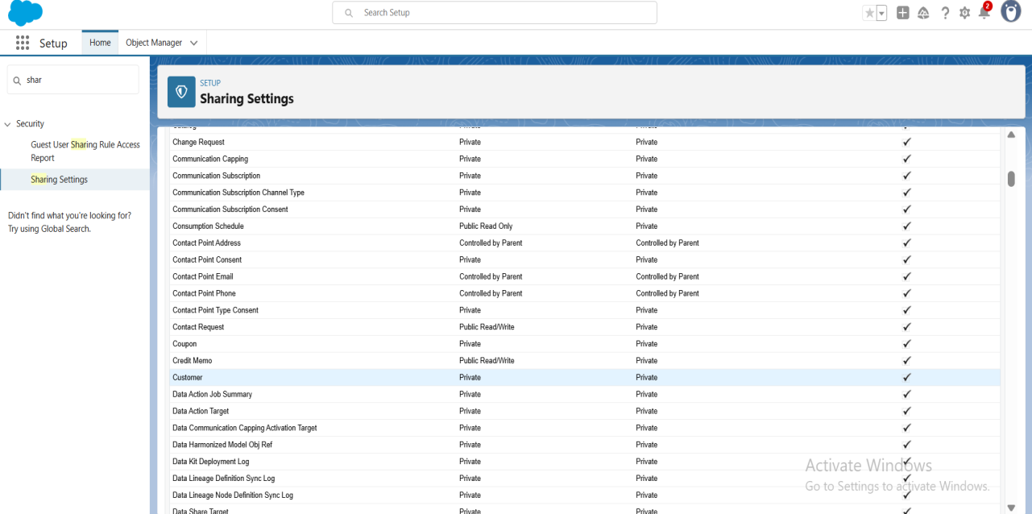

**9.4 Audit Trail & Compliance Documentation**

**Purpose:** Track system changes for accountability and compliance.

**Steps:**

1. **Enable Audit Trail**
   * Setup → Security → View Setup Audit Trail
   * Records all admin configuration changes for the last 6 months
2. **Track Key Field Changes**
   * Enable Field History Tracking for:
     + Order Amount
     + Table Status
     + Customer Contact Info
3. **Monitor User Activity**
   * Setup → Login History → Verify IP-based logins
   * Session security → Timeout & allowed IP ranges
4. **Compliance Documentation**
   * Maintain screenshots and logs of:
     + Security settings
     + Audit trail
     + Role-based access

**✅ Business Intelligence Achievements**

* **Reporting Excellence:** Live tracking of bookings, orders, and revenue
* **Management Insights:** Dashboards provide at-a-glance operational metrics
* **Security & Compliance:** Enterprise-grade access controls, audit trail maintained
* **Operational Efficiency:** Reduced manual reporting, easier KPI monitoring